"Local-based associations and scholarship foundations join forces to cultivate future science and technology talent" The Ko Gwangju-Jeonnam Jongmunhoe Scholarship Foundation donated 50.25 million won to GIST
- A donation ceremony was held at 10:30 AM on Tuesday, the 10th, in the GIST President's Office
- Yoon-geun Ko, Chairman of the Scholarship Foundation, has continued to make meaningful scholarship donations since 2017
- Hong-cheon Ko, Chairman of the Jongmun Association, continues to contribute to the local community through scholarship programs
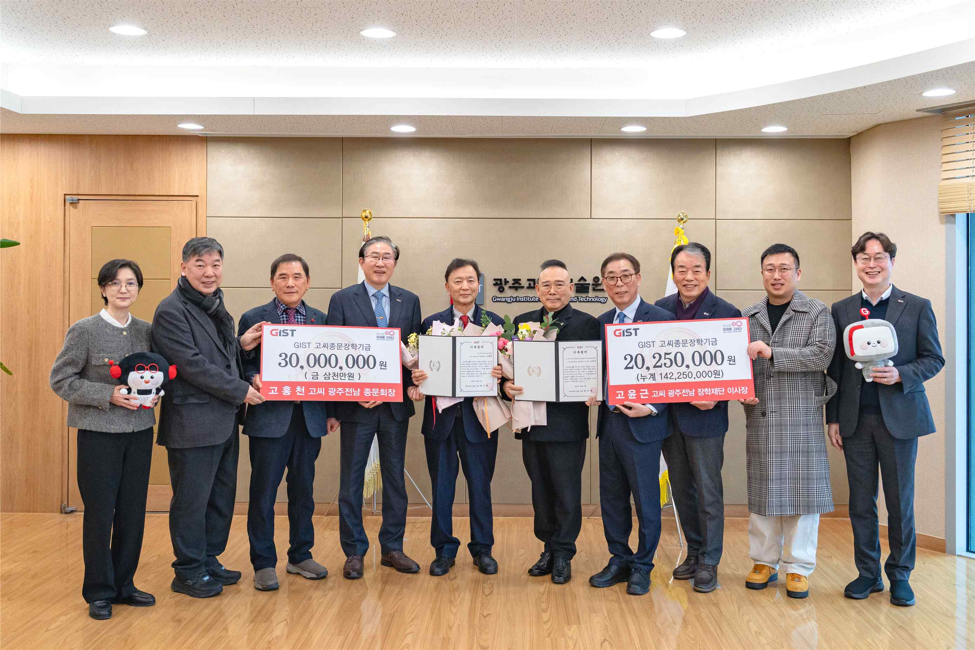

▲ Attendees pose for a commemorative photo after the donation ceremony for the Ko Gwangju-Jeonnam Jongmun Association and Scholarship Foundation held in the GIST President's Office on Tuesday, February 10th.
The long-standing tradition of sharing in the community continues to nurture future scientific talent.
The Gwangju Institute of Science and Technology (GIST, President Kichul Lim) announced that it held a donation ceremony for the Ko Gwangju-Jeonnam Jongmun Association and Scholarship Foundation Scholarship Fund at 10:30 AM on Tuesday, February 10th, 2026, in the President's Office.
On that day, the family association and the scholarship foundation donated a total of 50.25 million won to GIST.
This scholarship donation was made by the Ko Gwangju-Jeonnam Jongmun Association and Scholarship Foundation, which shared the commitment to fostering future science and technology talent in collaboration with the local community. This donation is particularly significant because it marks the local association's direct involvement in fostering science and technology talent.
Notably, Yoon-geun Ko, Chairman of the Ko Gwangju-Jeonnam Scholarship Foundation, is a prominent senior donor in the Gwangju-Jeonnam region. Beginning with a donation of 20 million won in 2017, he has consistently donated amounts commensurate with the year of his donation. He has made meaningful donations each year, including 20.19 million won in 2019, 20.21 million won in 2021, and 20.22 million won in 2022. Including this donation, his cumulative donations now exceed 140 million won.
Hong-cheon Ko, Chairman of the Ko Family Association of the Gwangju-Jeonnam Province, also expressed his support for the donation and expressed his commitment to fostering future talent through scholarship programs on behalf of the association.
Chairman Ko, with his extensive experience at the National Agricultural Cooperative Federation, has spearheaded the development of local agriculture. As chairman of the association, he has consistently contributed to the community and expanded scholarship programs.
The combined efforts of the two donors make this donation a significant example of the community and the university joining forces to foster talent.
The donation ceremony was attended by GIST President Kichul Lim, Vice President for R&DB Yong-Chul Kim, Office of Student Affairs and Admissions Dean Soo Jong Lee, GIST Development Foundation officials, Hong-cheon Ko, Chairman of the Ko Jongmun Association of the Gwangju-Jeonnam Province, and Yoon-geun Ko, Chairman of the Ko Family Scholarship Foundation. The ceremony was attended by members of the association and key officials.
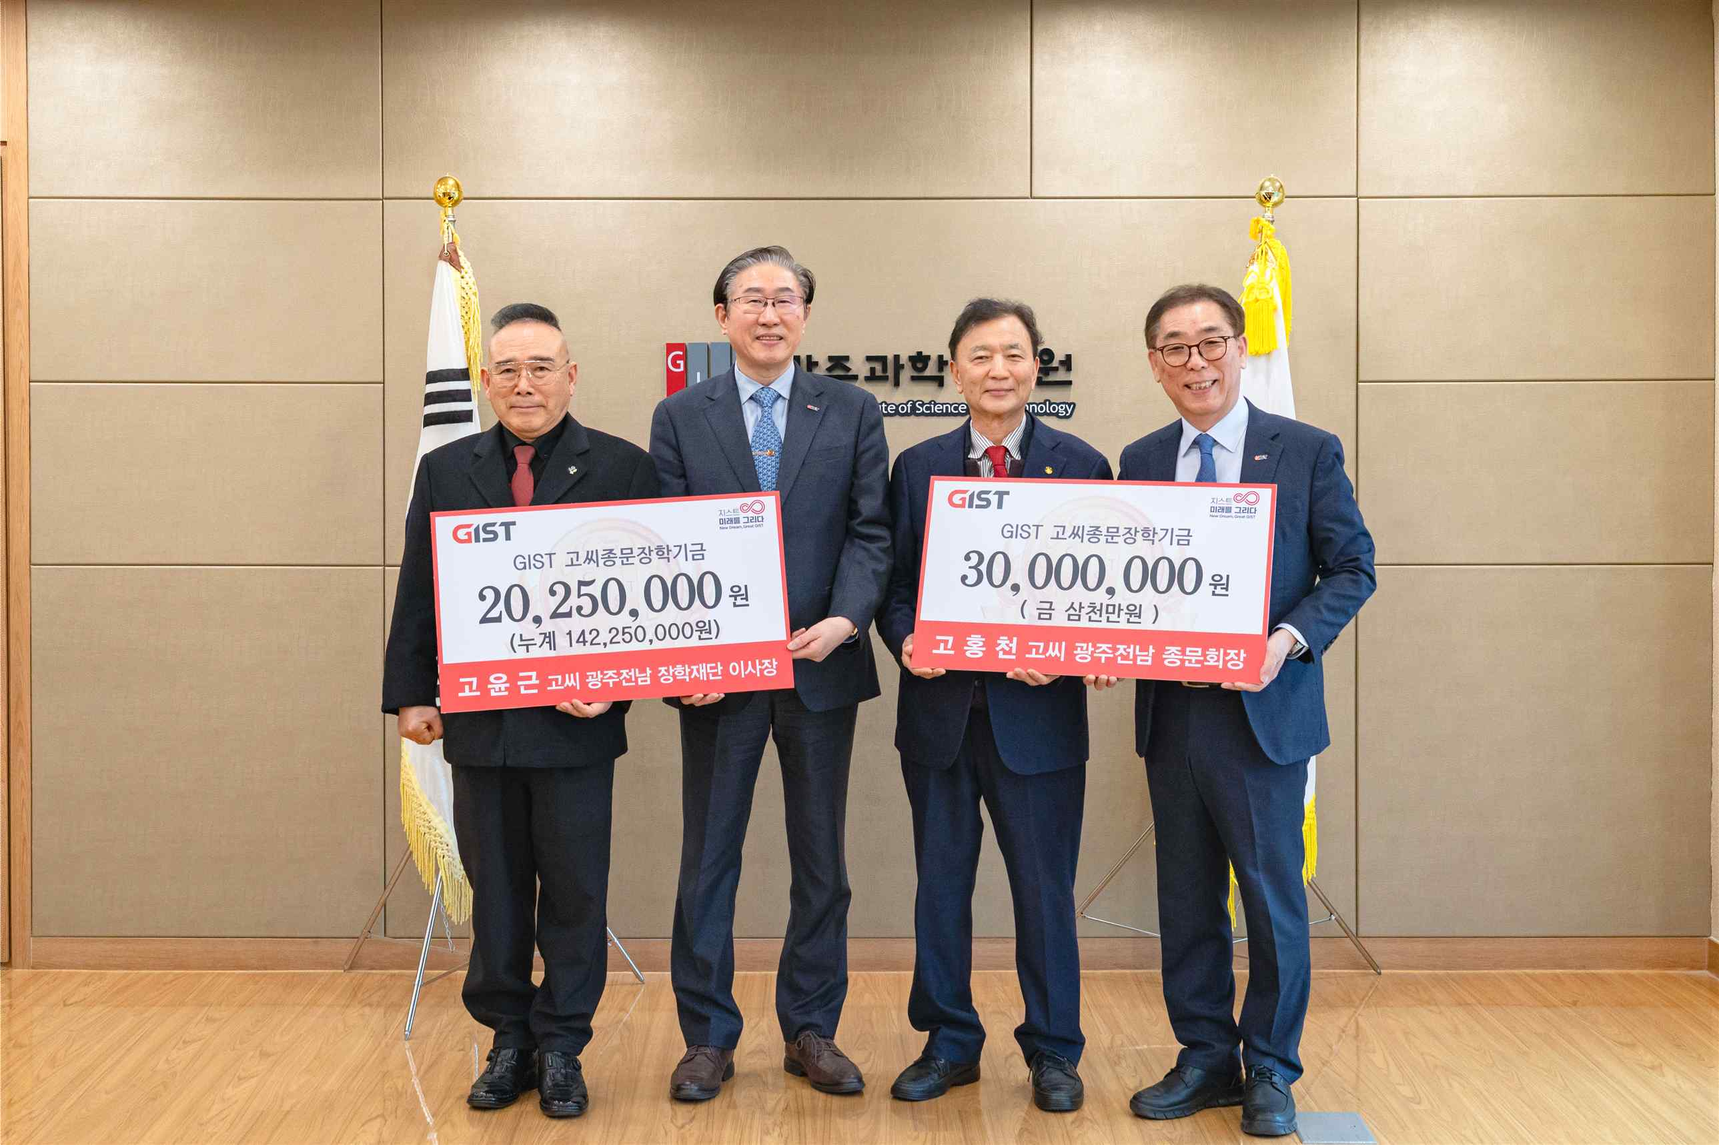

▲ A commemorative photo taken after the donation ceremony for the Ko Family Association of the Gwangju-Jeonnam Province and Scholarship Foundation in the GIST President's Office. (From left) Scholarship Foundation Chairman Yoon-geun Ko, GIST President Kichul Lim, Jongmun Association Chairman Hong-cheon Ko, and GIST Development Foundation Chairman Eun-mo Choi
President Kichul Lim stated, "The long-standing partnership between the Jongmun Association and the Scholarship Foundation is deeply meaningful in that it has led to the development of talented individuals at GIST." He added, "This donation is an exemplary case of the community and the university working together based on trust. We will use the donor's generosity to foster the growth of our students."
Scholarship Foundation Chairman Yoon-geun Ko stated, "Today's donation is for scientific talent as part of the practice of Buddha's compassion, the upholding of the spirit of Admiral Gyeong-myeong Ko, and the practice of the Gwangju Spirit." He added, "Cultivating talent through education is the most reliable investment for the future of the region and the nation. I hope this scholarship will be a small contribution to GIST's efforts to cultivate outstanding science and technology talent."
Chairman Hong-cheon Ko of the Jongmun Association stated, "I hope this donation, made jointly by the Jongmun Association and the scholarship foundation, will serve as an opportunity to spread the value of sharing throughout the community." He added, "We will continue to serve as a strong partner in education and talent development."
Meanwhile, GIST plans to continuously strengthen its collaborative model for fostering local scholarship funds and spreading a culture of giving, with the vision of fostering talent through a virtuous cycle of cooperation with the local community, where these talents, in turn, lead the future of the region and society.

