GIST unveils results of participatory energy education with "Challenge, Energy Golden Bell!"
- The GIST RISE Project Group shared the results of its six-month "Children and Youth Energy Literacy & Makerthon Program"... The program was successfully held at the "2025 Gwangju RISE Results Sharing Event (G-RISE FESTA)" on February 5-6
- Participants from elementary school to adults participated, and awards were presented to participants of various ages, fostering intergenerational cooperation and communication... The project presented "integrating science and culture" as its operating direction for the next year, with plans to expand citizen-participatory and popular education programs
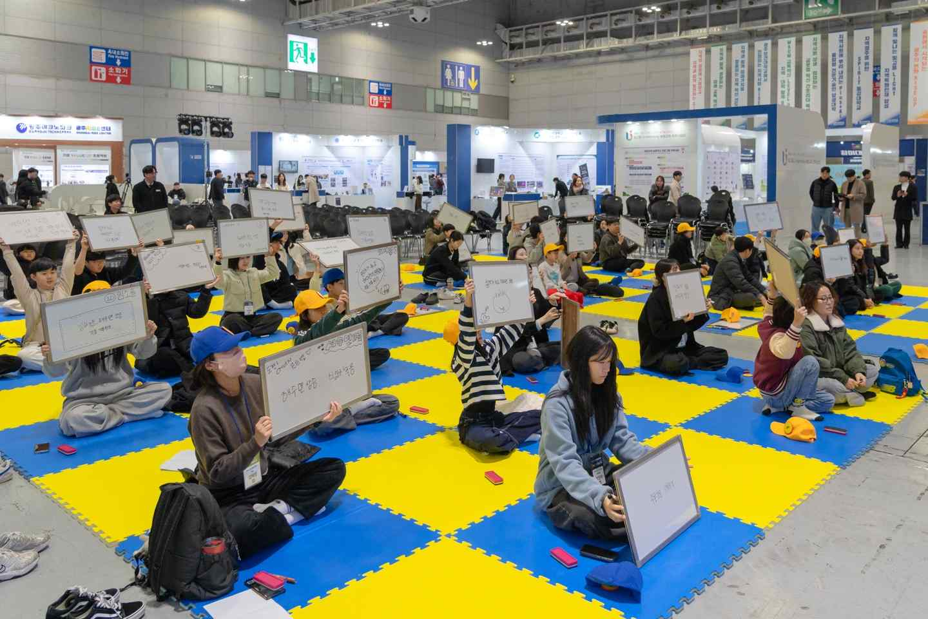

▲ The GIST RISE Project's "Challenge, Energy Golden Bell!" program was successfully held at the "2025 Gwangju RISE Results Sharing Conference (G-RISE FESTA)."
The Gwangju Institute of Science and Technology (GIST, President Kichul Lim) announced that the GIST RISE Project's participatory program, "Challenge, Energy Golden Bell!", successfully held at the "2025 Gwangju RISE Results Sharing Conference (G-RISE FESTA)" held from February 5th to 6th, sharing with citizens the value of intergenerational communication and cooperation through energy.
Hosted by Gwangju Metropolitan City and co-hosted by Gwangju Technopark, Gwangju RISE Center, and 17 universities in the Gwangju area, the "2025 Gwangju RISE Results Sharing Conference" is a regional innovation festival where local universities, companies, organizations, students, and citizens participate to share the achievements of the Gwangju RISE Project.
"Challenge, Energy Golden Bell!" was a key event marking the start of the Results Sharing Conference, sharing the results of the GIST RISE Project's youth energy education program, which ran for six months from September 2025 to February 2026.
This event was planned as the final follow-up to the "Youth Energy Literacy & Makerthon Program," part of the GIST RISE Project's "Urban Campus Living Lab" project.
The program expanded the scope of participation to include elementary school students and adults, and designed the program to address the somewhat abstract concept of "energy" in a quiz format, making it easy and engaging for citizens to understand.
From October to December of last year, the program successfully conducted four integrated energy education courses, encompassing core areas of the future energy industry, from solar energy and battery energy literacy training to hydrogen energy and power systems.
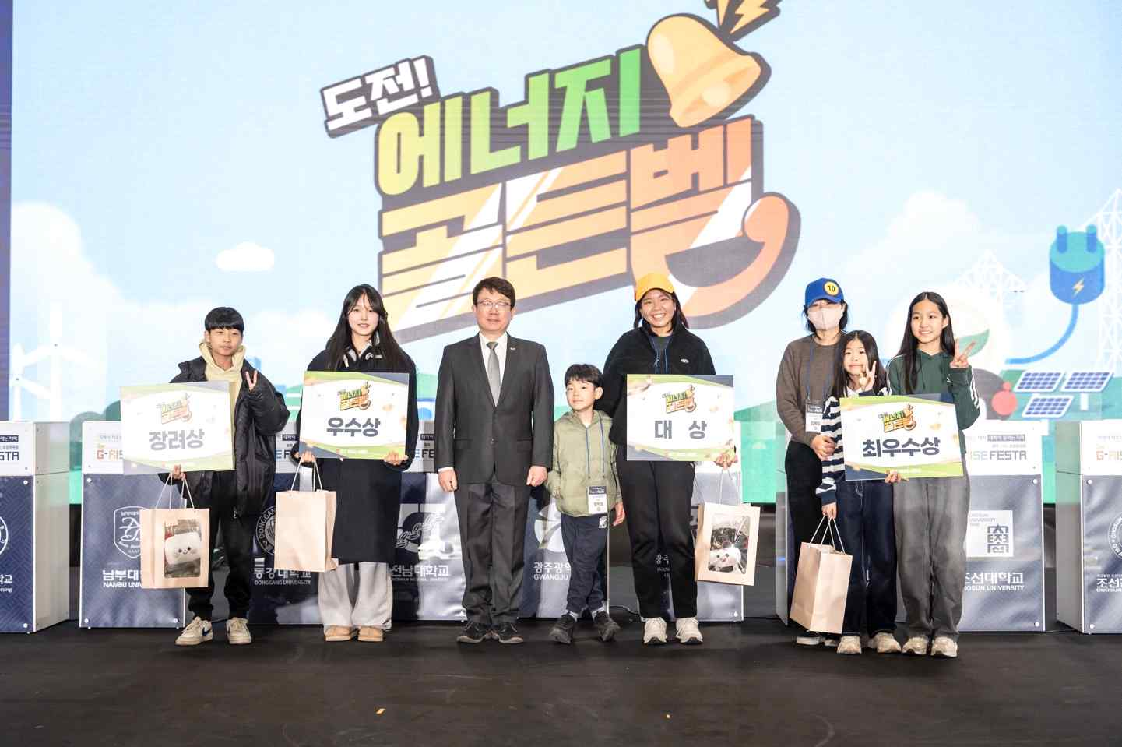

▲ Winners of the GIST RISE program's "Challenge, Energy Golden Bell!" event pose for a commemorative photo at the "2025 Gwangju RISE Results Sharing Event (G-RISE FESTA).
The event itself yielded a variety of award winners, bolstered by the enthusiastic participation of students and the enthusiastic response of the public.
The winners are: ▲ Grand Prize winner Ji-ho Yang (1st grade, Bitnuri Elementary School) and Hye-yeon Lee (mother); ▲ Excellence winner Seo-yeon Ki (5th grade, Jangdeok Elementary School) and Hye-rim Kim (mother); ▲ Excellence winner So-yul Lim (3rd grade, Gosil Middle School); and Encouragement winner Chan-yul Lim (6th grade, Gosil Elementary School).
Grand Prize winner Ji-ho Yang, who teamed up with his mother Hye-yeon Lee, garnered attention from middle and high school students and the general public for their outstanding performance. The two winners worked together throughout the event, symbolically demonstrating the program's mission of intergenerational cooperation and communication.
So-yul Lim, the Excellence Award recipient, diligently participated in all educational programs run by the GIST RISE Project Team and also achieved outstanding results in the "Energy Golden Bell" competition, earning her the honor of a double award, including a special award from the Gwangju Mayor.
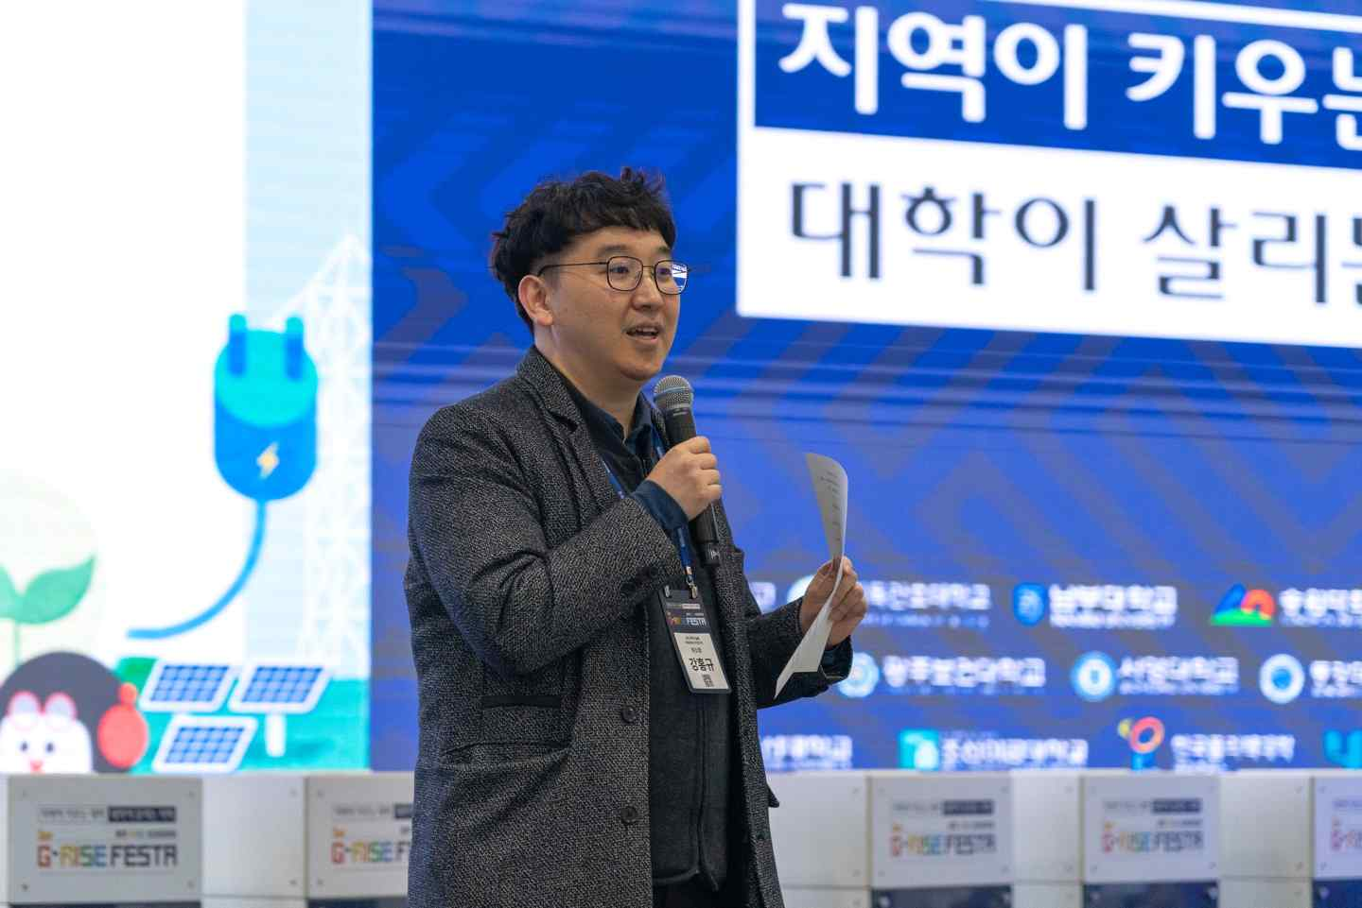
▲ Hongkyu Kang, Assistant Director of the GIST Research Institute for Solar and Sustainable Energies, who oversaw the GIST RISE Project's "Children and Youth Energy Literacy & Makerthon Program"
Hongkyu Kang, Assistant Director of the GIST Research Institute for Solar and Sustainable Energies, who oversaw the program, said, "It's meaningful that the six months of experimentation and exploration-focused education have culminated in a participatory event for the public to enjoy together. I hope this program has provided an opportunity for various generations to become more familiar with energy technology, and we will continue to build a foundation for future generations to lead the way in scientific and technological change."
Meanwhile, the GIST RISE Project's "Children and Youth Energy Literacy & Makerthon Program" is part of the RISE project, hosted by the Ministry of Education and the National Research Foundation of Korea. It is recognized as a leading educational model that fosters collaboration among local governments, universities, and research institutions to enhance the understanding of science and technology among future generations.
This program began recruiting trainees in September of last year. In October, participants covered basic solar energy theory, built a solar cell robot kit, assembled lithium-ion battery cells, and conducted electrochemical experiments. In November, they studied the principles of water electrolysis and fabricated membrane electrode assemblies (MEAs) for hydrogen fuel cells. In December, they simulated power flow and toured next-generation solar power generation and monitoring facilities. This systematic six-month, step-by-step, experiential training program was planned and implemented.
Based on the 2025 project performance, the GIST RISE Project Group proposed "integrating science and culture" as its operational direction for the next year. Beyond simply imparting knowledge, the program aims to develop into a more popular and creative program that allows citizens to enjoy energy as a cultural experience.

