GIST alumnus Cheol-woong Jeong donates 100 million won to the Life Sciences and Chemistry Development Fund
- Cheol-woong Jeong, a Life Sciences alumnus and director of the ADC Research Center at Riga ChemBio, donated 50 million won to his alma mater's Life Sciences Department and another 50 million won to his son's chemistry department, further strengthening academic ties between generations
- Encouraging the challenges of junior researchers: "I hope this will contribute to a research environment where they can take on challenges without fear of failure"
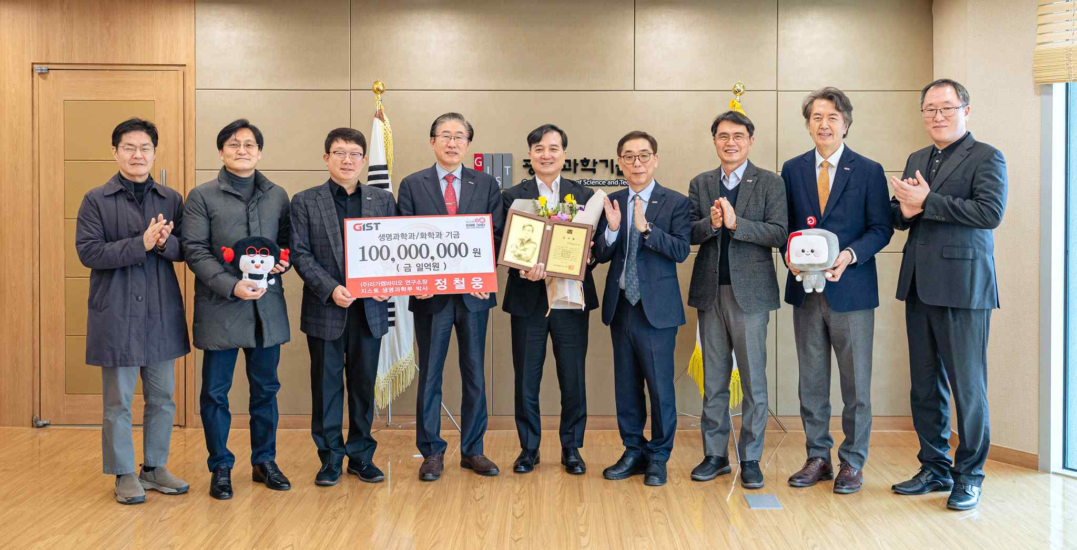

▲ On Friday, January 30th, after the donation ceremony for the development fund of alumnus Cheol-woong Jeong was held on the 5th floor of the GIST administration building, attendees took a commemorative photo.
The Gwangju Institute of Science and Technology (GIST, President Kichul Lim) announced that it held a donation ceremony for the Development Fund for alumnus Cheol-woong Jeong of the Department of Life Sciences on the 5th floor of the Administration Building on Friday, January 30th.
Jeong, currently the Director of the ADC Research Institute at Ligachembio, a research-oriented pharmaceutical company leading the global R&D of new drugs, donated 50 million won each to the Department of Life Sciences and the Department of Chemistry, for a total of 100 million won.
Jeong previously donated 11 million won to the Development Fund in 2016, along with fellow Life Sciences alumni, to commemorate GIST's 23rd anniversary.
The donation ceremony was attended by alumnus Cheol-woong Jeong and his family, as well as GIST President Kichul Lim, Vice President for Academic Affairs Sungho Jeong, Vice President for Public Affairs Yonghwa Chung, Dean of the College of Life Sciences and Medical Engineering Young-Joon Kim, Dean of the Department of Chemistry Jiwon Seo, Professor of Chemistry Jin Hee Ahn, and GIST Foundation Chairman Eun-mo Choi.
Alumnus Cheol-woong Jeong said, "As a child, I dreamed of becoming a scientist studying diseases, inspired by the work of French biochemist Louis Pasteur. My research experience at GIST shaped me. I hope this will contribute, even in a small way, to creating an environment where junior researchers can focus on challenging research without fear of failure."
He continued, "Many young researchers choose relatively safe research due to the burden of failure. This not only weakens the competitiveness of the pharmaceutical industry, but also reduces their satisfaction as researchers." He added, "My personal goal is to have at least three new drugs approved by the U.S. Food and Drug Administration (FDA), and I want to pass on the experience I've gained along the way to my juniors."
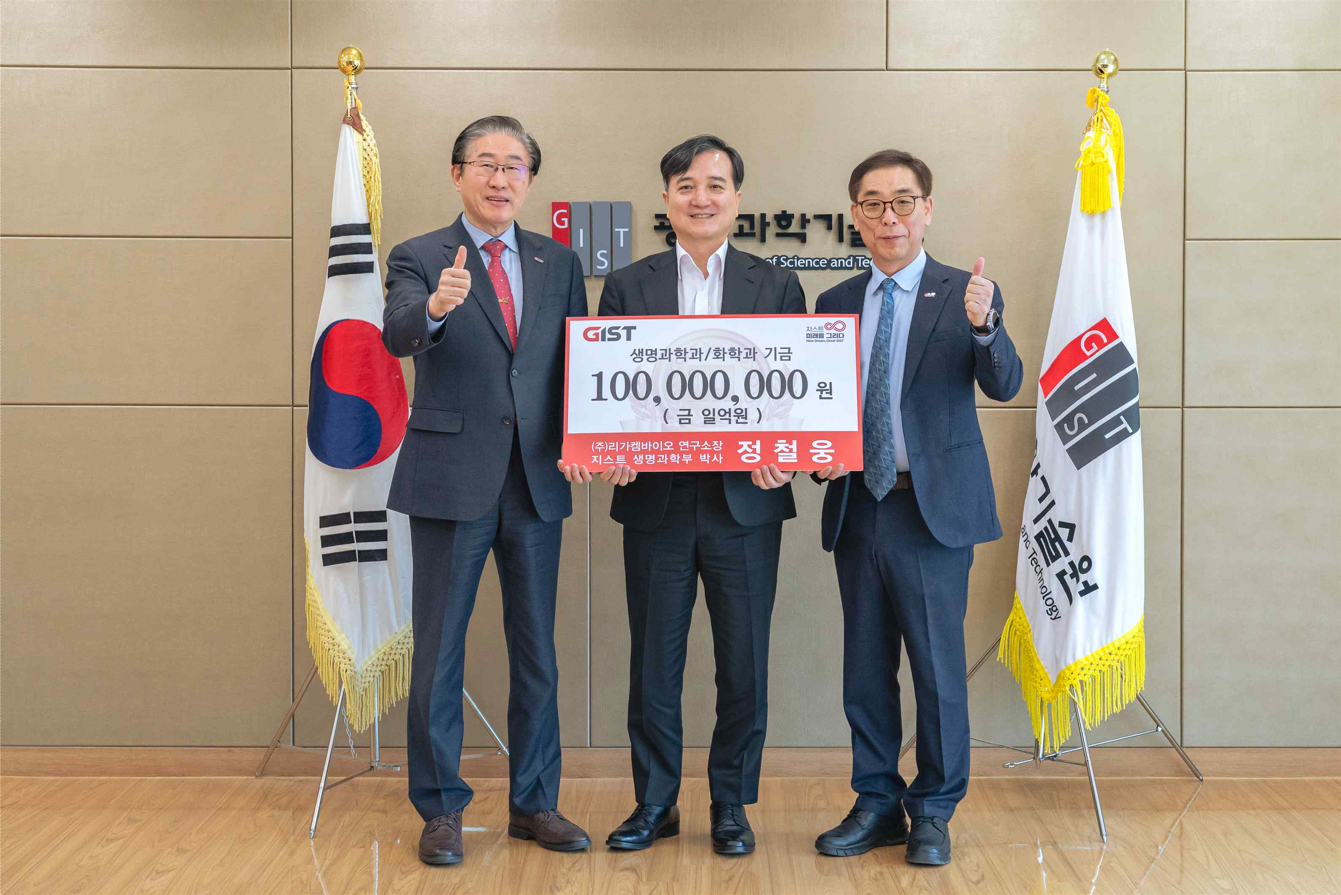

▲ A commemorative photo taken after the donation ceremony for alumnus Cheol-woong Jeong's development fund held on the 5th floor of the GIST administration building on Friday, January 30th. (From left) GIST President Kichul Lim, alumnus Cheol-woong Jeong, and GIST Development Foundation Chairman Eun-mo Choi
President Kichul Lim stated, "Alumnus Cheol-woong Jeong's donation goes beyond providing research experience. It is a meaningful act of support for the challenges and growth of junior researchers, as he is currently leading research at the forefront of global new drug development. We will ensure that the donor's intentions serve as a practical foundation for supporting challenging research in the fields of life sciences and chemistry."
Alumnus Cheol-woong Jeong received his master's degree in 1999 and his doctorate in 2003 from the Department of Life Sciences at GIST (under his advisor, Professor Yong-Keun Jung). He also served as a research fellow at the Mayo Clinic in the United States and as a researcher at LG Life Sciences, building his expertise in new drug research and development.
His child is currently enrolled in the undergraduate program in the Department of Chemistry at GIST, and this donation also reflects his support for the university's educational and research development as both an alumnus and the mother of a student.
In 2014, he joined LigaChemBio (formerly LegoChemBio) with the goal of “developing global new drugs” and is currently a key executive in charge of research and development at the company.
LigaChemBio Inc. is a research-oriented pharmaceutical company focusing on global new drug R&D. Its core competitiveness lies in ADC* technology, which combines the selectivity of antibodies with the anticancer effects of synthetic drugs.
* ADC (antibody-drug conjugate): This next-generation treatment approach combines a potent therapeutic drug with an antibody that selectively recognizes disease-causing antigens, maximizing therapeutic efficacy while minimizing damage to normal cells.
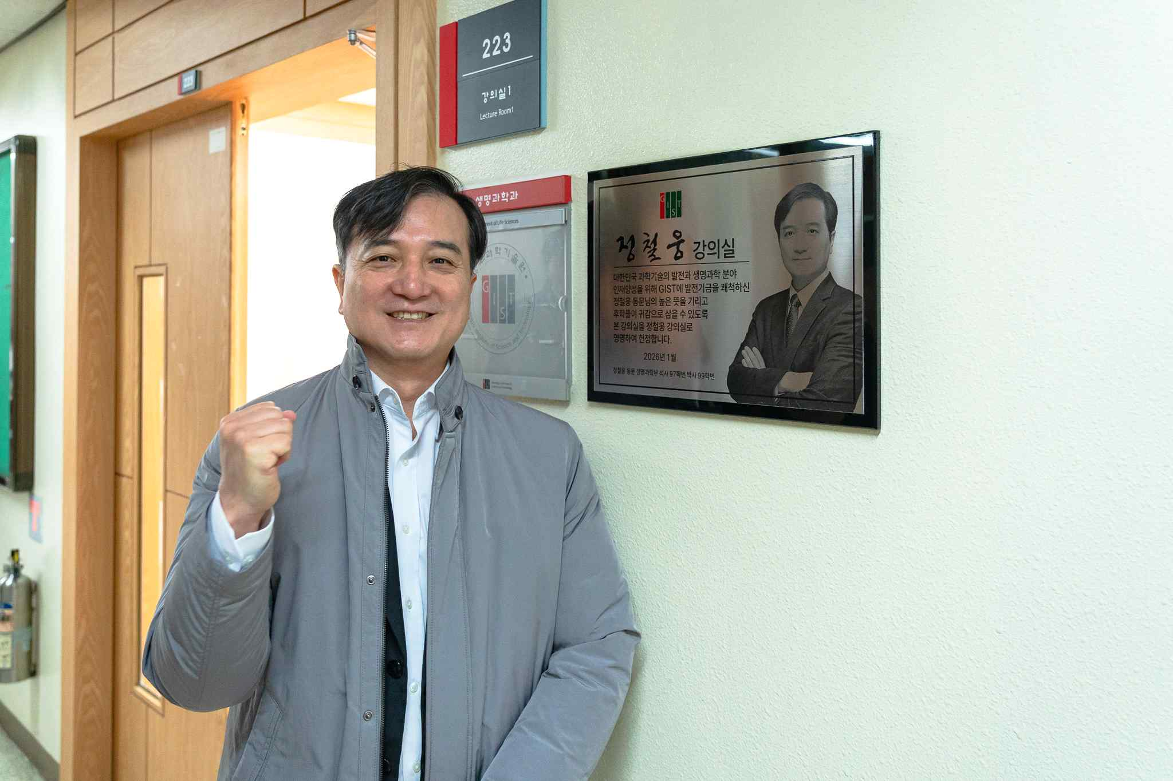

▲ Alumnus Cheol-woong Jeong, who visited GIST for the development fund donation ceremony, poses for a commemorative photo in front of the Cheol-woong Jeong Lecture Room on the second floor of the Department of Life Sciences.
With this donation, GIST plans to further strengthen its education and research environment in life sciences and chemistry, and continuously expand the foundation for outstanding researchers to focus on challenging research.

