GIST hosts the 26th Environment and Energy Olympiad: A residential research program to cultivate future researchers in the environmental and energy fields… sponsored by the Ministry of Climate, Energy and Environment
- A three-week residential research and experimentation program under the close supervision of professors and researchers from the Department of Environment and Energy Engineering at GIST, this program has been ongoing since 2001... Participants will conduct individual research projects and practice using cutting-edge laboratory equipment
- At the presentation and awards ceremony held on Friday, the 23rd, winners of four categories were announced, including the Minister of Climate, Energy and Environment Award... GIST student Ah-hyun Yoo said, "I want to grow into a professional researcher in the field of environment and energy and contribute to society."
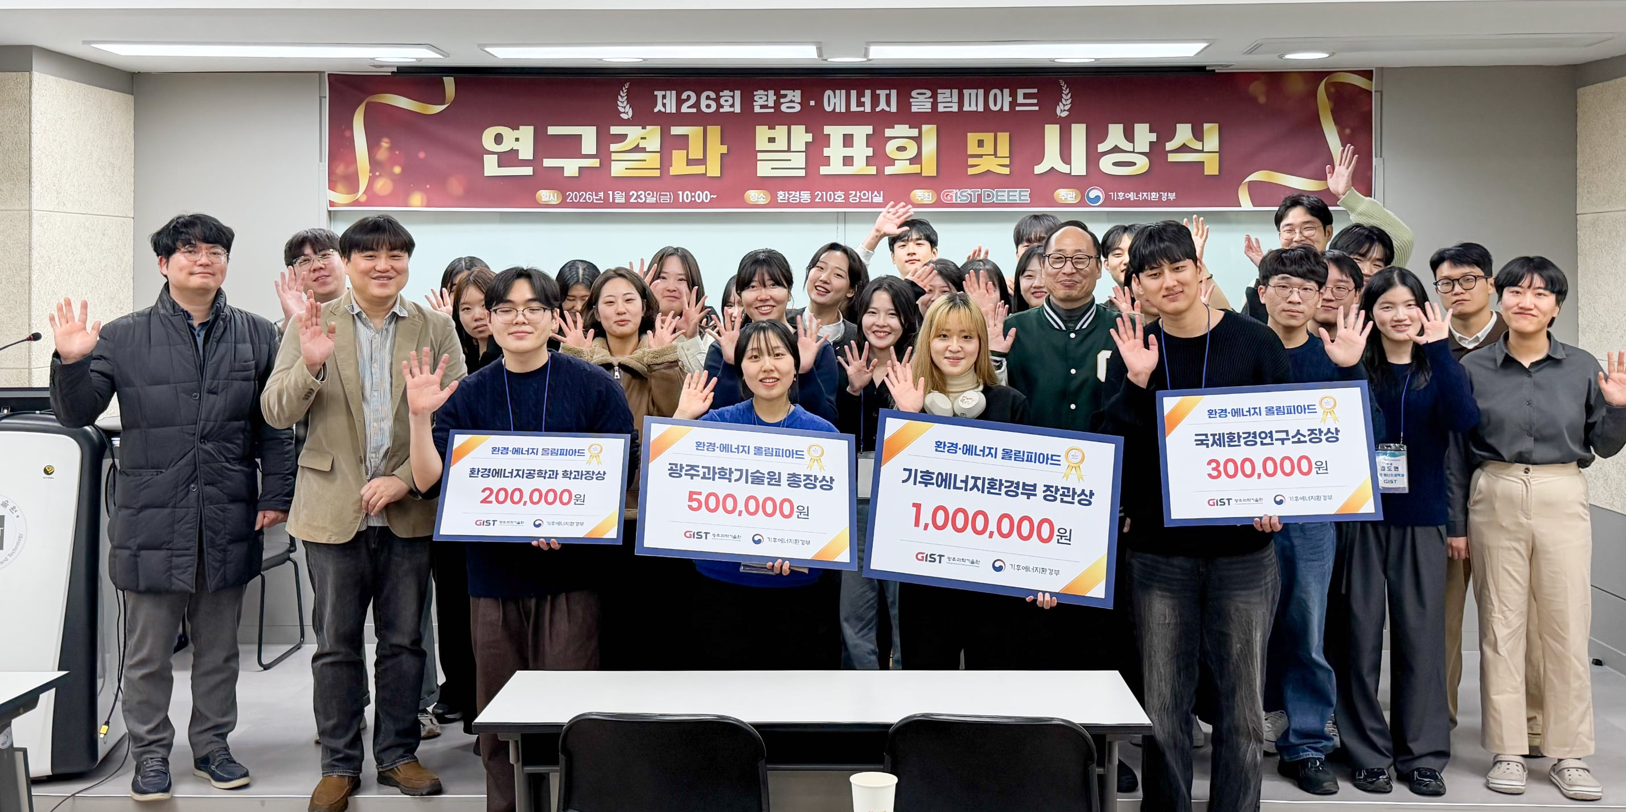

▲ Winners and participating students pose for a commemorative photo at the "26th Environment and Energy Olympiad Presentation and Awards Ceremony," held at the GIST Environment and Energy Engineering Building on Friday, January 23rd.
The Gwangju Institute of Science and Technology (GIST, President Kichul Lim) announced that the Department of Environment and Energy Engineering (Dean Youngjune Park) recently held the "26th Environment and Energy Olympiad Presentation and Awards Ceremony."
The Environment and Energy Olympiad, hosted by the GIST Department of Environment and Energy Engineering and sponsored by the Ministry of Climate, Energy, and Environment, provides undergraduate students interested in the field of environment and energy engineering with educational opportunities focused on laboratory experience, experiments, and hands-on training. Held annually since 2001, the Olympiad aims to identify and nurture talented individuals at an early stage.
This year's Olympiad took place at the GIST Environment and Energy Engineering Building for three weeks, from Friday, January 2nd to Friday, January 23rd, with 31 university students participating from across the country.
During their stay at GIST, participating students pursued individually assigned research topics and experienced the process of conducting actual research projects under the guidance of faculty in their respective fields. They also developed their research capabilities by participating in hands-on training using a variety of cutting-edge experimental equipment alongside researchers from their departments.
The final presentation took place on Friday, January 23rd, from 10:00 AM to 3:00 PM, featuring presentations on a total of 31 research projects. Winners were selected based on a combination of written evaluations (research reports and presentation materials) and presentation evaluations. A total of four recipients received awards, including the Minister of Climate, Energy, and Environment Award.
▴ The Minister of Climate, Energy, and Environment Award (1 million won) went to Ah-hyun Yoo, a student in the Department of Environment and Energy Engineering at GIST, for her research titled "Evaluation of Whitlockite as an Adsorbent for Various Heavy Metals and Anions." Next, the GIST President's Award (500,000 won) went to Soo-kyung Choi, a student in the Department of Life Sciences at Chung-Ang University, for her research on "Comparison of Native Plant Growth (Biomass) Depending on the Presence of Invasive Plants." The GIST International Environmental Research Institute Director's Award (300,000 won) went to Chang-ho Kim, a student in the Department of Chemical Engineering at Chung-Ang University, for his research on "The Effect of Electrode Surface Topography on Resistance and Performance in Anion Exchange Membrane Electrolysis (AEMWE)." The GIST Department of Environmental and Energy Engineering Director's Award (200,000 won) went to Woo-sung Jeon, a student in the Department of Environmental Engineering at Chungnam National University, for his research on "Analysis of the Correlation Between Weather and Agricultural Product Prices: Focusing on the Biological Characteristics of Crops."
Ah-hyun Yoo, the recipient of the Minister of Climate, Energy and Environment Award, said, "I am delighted that my dedicated research efforts have led to such positive results. I will continue to strive for greater diligence, reminding myself of this award experience, even when facing difficult times."
She continued, "I would like to express my gratitude to my advisor and everyone who helped me. I hope to grow into a professional researcher in the field of environment and energy and contribute to society."
GIST Department of Environment and Energy Engineering Dean Youngjune Park stated, "I hope this Olympiad experience provided students with practical research experience and an opportunity to expand their potential. I hope this will be a valuable asset for their future careers and research activities."

