GIST-FAO (Food and Agriculture Organization of the United Nations) launch strategic partnership, sign LOI (Letter of Intent) and hold joint workshop: Joint response to climate change and food security begins in earnest
- On Friday, January 16th, the "GIST-FAO LOI Signing and Joint Workshop" was held at GIST… Combining GIST's AI and environmental research capabilities with the FAO global agenda to jointly address sustainable agricultural and food systems.
- Establishing a testbed in the Honam region and promoting the international expansion of Korean agricultural and food solutions through research, policy, and field collaboration.
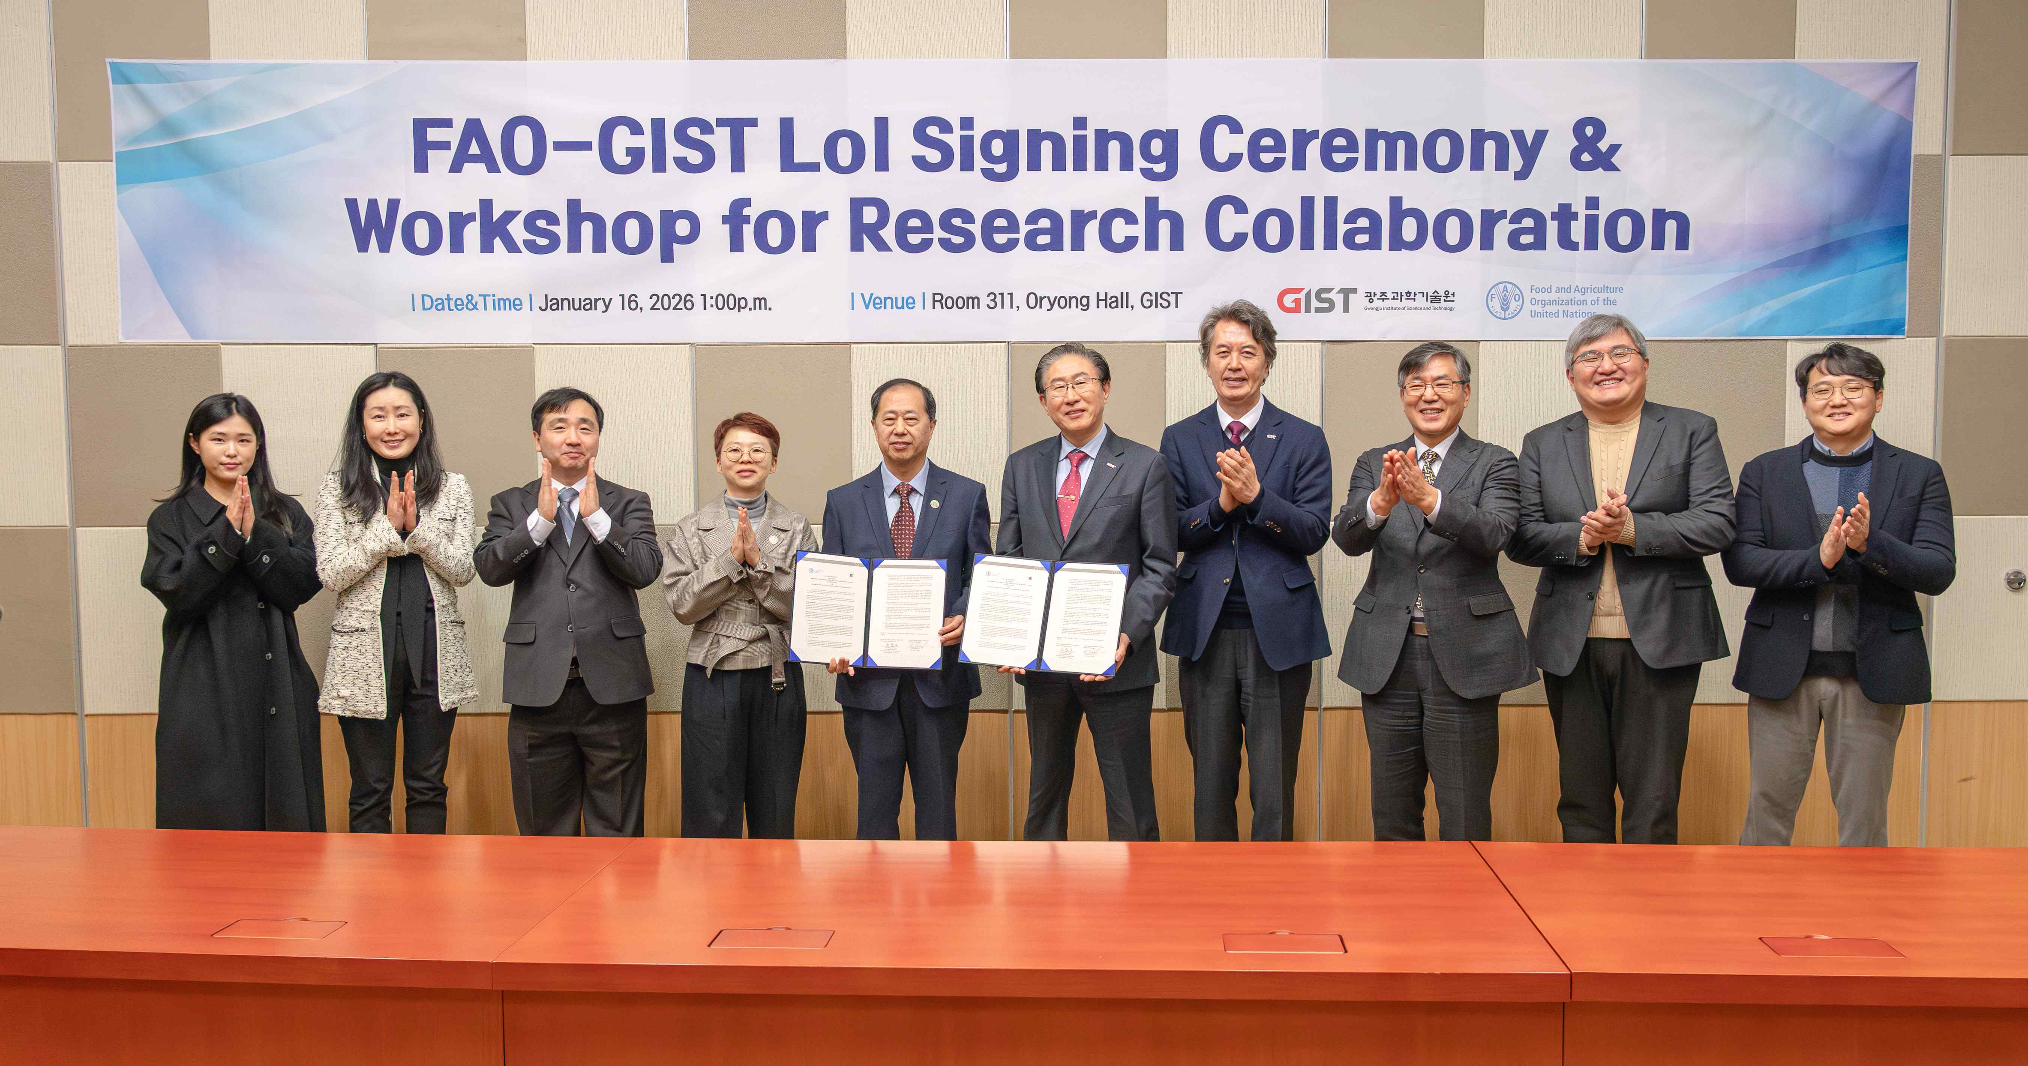

▴ GIST and the Food and Agriculture Organization of the United Nations (FAO) signed a Letter of Intent (LOI) on January 16th, and attendees pose for a commemorative photo.
The Gwangju Institute of Science and Technology (GIST, President Lim Ki-cheol) announced on Friday, January 16th that it signed a Letter of Intent (LOI) with the Food and Agriculture Organization of the United Nations (FAO), marking the start of full-scale collaboration in the areas of food security and sustainable agricultural and food systems, which face increasing uncertainty due to climate change.
This collaboration is part of a strategic partnership built on GIST's advanced science and technology education and research capabilities in the fields of environment, life sciences, and artificial intelligence (AI). This strategic partnership aims to support the FAO's global food and agriculture agenda with science and technology, strengthening the domestic agricultural and food ecosystem and contributing substantially to the international community.
The signing ceremony was attended by key GIST officials, including President Kichul Lim, Vice President for Public Affairs Yonghwa Chung, and the Graduate School of Management of Technology Dean Sangho Kim, as well as FAO Korea Liaison Office Director Shengyao Tang and Deputy Director Na-ra Lee, among others.
GIST and FAO agreed to collaborate on linking Korea's cutting-edge technologies with food and agriculture policy needs to jointly produce innovative research results and develop these into a model of cooperation applicable to international policies and practices.
With this agreement, GIST plans to establish a collaborative network connecting domestic universities, national research institutes, farmers, and businesses in the Honam region and initiate the development of Korean-style agricultural and food solutions.
In particular, the Honam region will serve as a field demonstration base (test bed) and, after conducting a verification process, will pursue a strategy of disseminating the results to the international community (FAO member countries). By strengthening AI-based climate and agricultural technology capabilities, GIST aims to contribute to achieving FAO's global goals.
This LOI signing is a tangible outcome of ongoing exchanges and collaborative discussions between the two organizations.
In April 2025, GIST hosted a special lecture on "AI-based Resilient Food and Agriculture Systems" by inviting Tang Shengyao, Director of the FAO Korea Liaison Office, to the event. In September, GIST hosted the Inter-Regional Digital Agriculture Solutions Forum (IDASF), hosted by FAO, and hosted a session on "Digital Technology and Sustainable Livestock Management Innovation," confirming the potential for further collaboration.
Following the LOI signing ceremony, a "GIST-FAO Joint Workshop" was held to discuss specific cooperation plans for applying cutting-edge technologies to climate change, food security, and sustainable food systems.
The workshop consisted of a special lecture session, a research and technology session, and a panel discussion.
The special lecture session presented strategies and technology utilization plans for structural transformation in the climate and agriculture-food sectors.
▴ Professor Kibae Kim (Graduate School of Al Policy and Strategy) at GIST proposed a "Grand Architecture" for GIST-FAO cooperation to address climate change. ▴ Chang-won Ahn, Project Manager for Digital Convergence at the National IT Industry Planning and Evaluation Institute, presented a plan to utilize AI-based digital twins to address climate change and uncertainty in the food and agriculture sectors. Following this, ▴ Sang-jin Oh, Director of the Artificial Intelligence Industry Convergence Center (AICA), introduced a strategy for creating an AI industry ecosystem based on AI infrastructure.
The research and technology session presented various research achievements by GIST researchers integrating AI with environmental and agricultural technologies.
▴ Professor Eunsuk Kim (Department of Environment and Energy Engineering) introduced the principles of plant-microorganism interactions, and ▴ Professor Hyunglok Kim (Department of Environment and Energy Engineering) presented a plan to address water resource uncertainty caused by climate change using satellite image analysis to detect water resource distribution.
In addition, ▴ Dr. Woo-Young Song (Professor Tae-Young Kim's research team, Department of Environment and Energy Engineering) presented research results on the topic of 'Microplastics and Soil Contamination', and ▴ Dr. Young-joo Lee (Professor Jae Gwan Kim's research team, Department of Biomedical Science and Engineering) presented research results on the topic of 'Meat Spoilage Inspection Using AI and Spectroscopy Technology'.
The final panel discussion discussed the domestic and international significance of the GIST-FAO collaboration and its potential for future expansion.
Na-ra Lee, Deputy Director of the FAO Korea Liaison Office, and Seong-woong Hwang, Director of the Gwangju Institute's AI Policy Research Center, shared the potential of a "Korean-style agricultural and food digital transformation model" centered on the Honam region and emphasized the strategic significance of this regional collaboration developing into a model for international expansion.
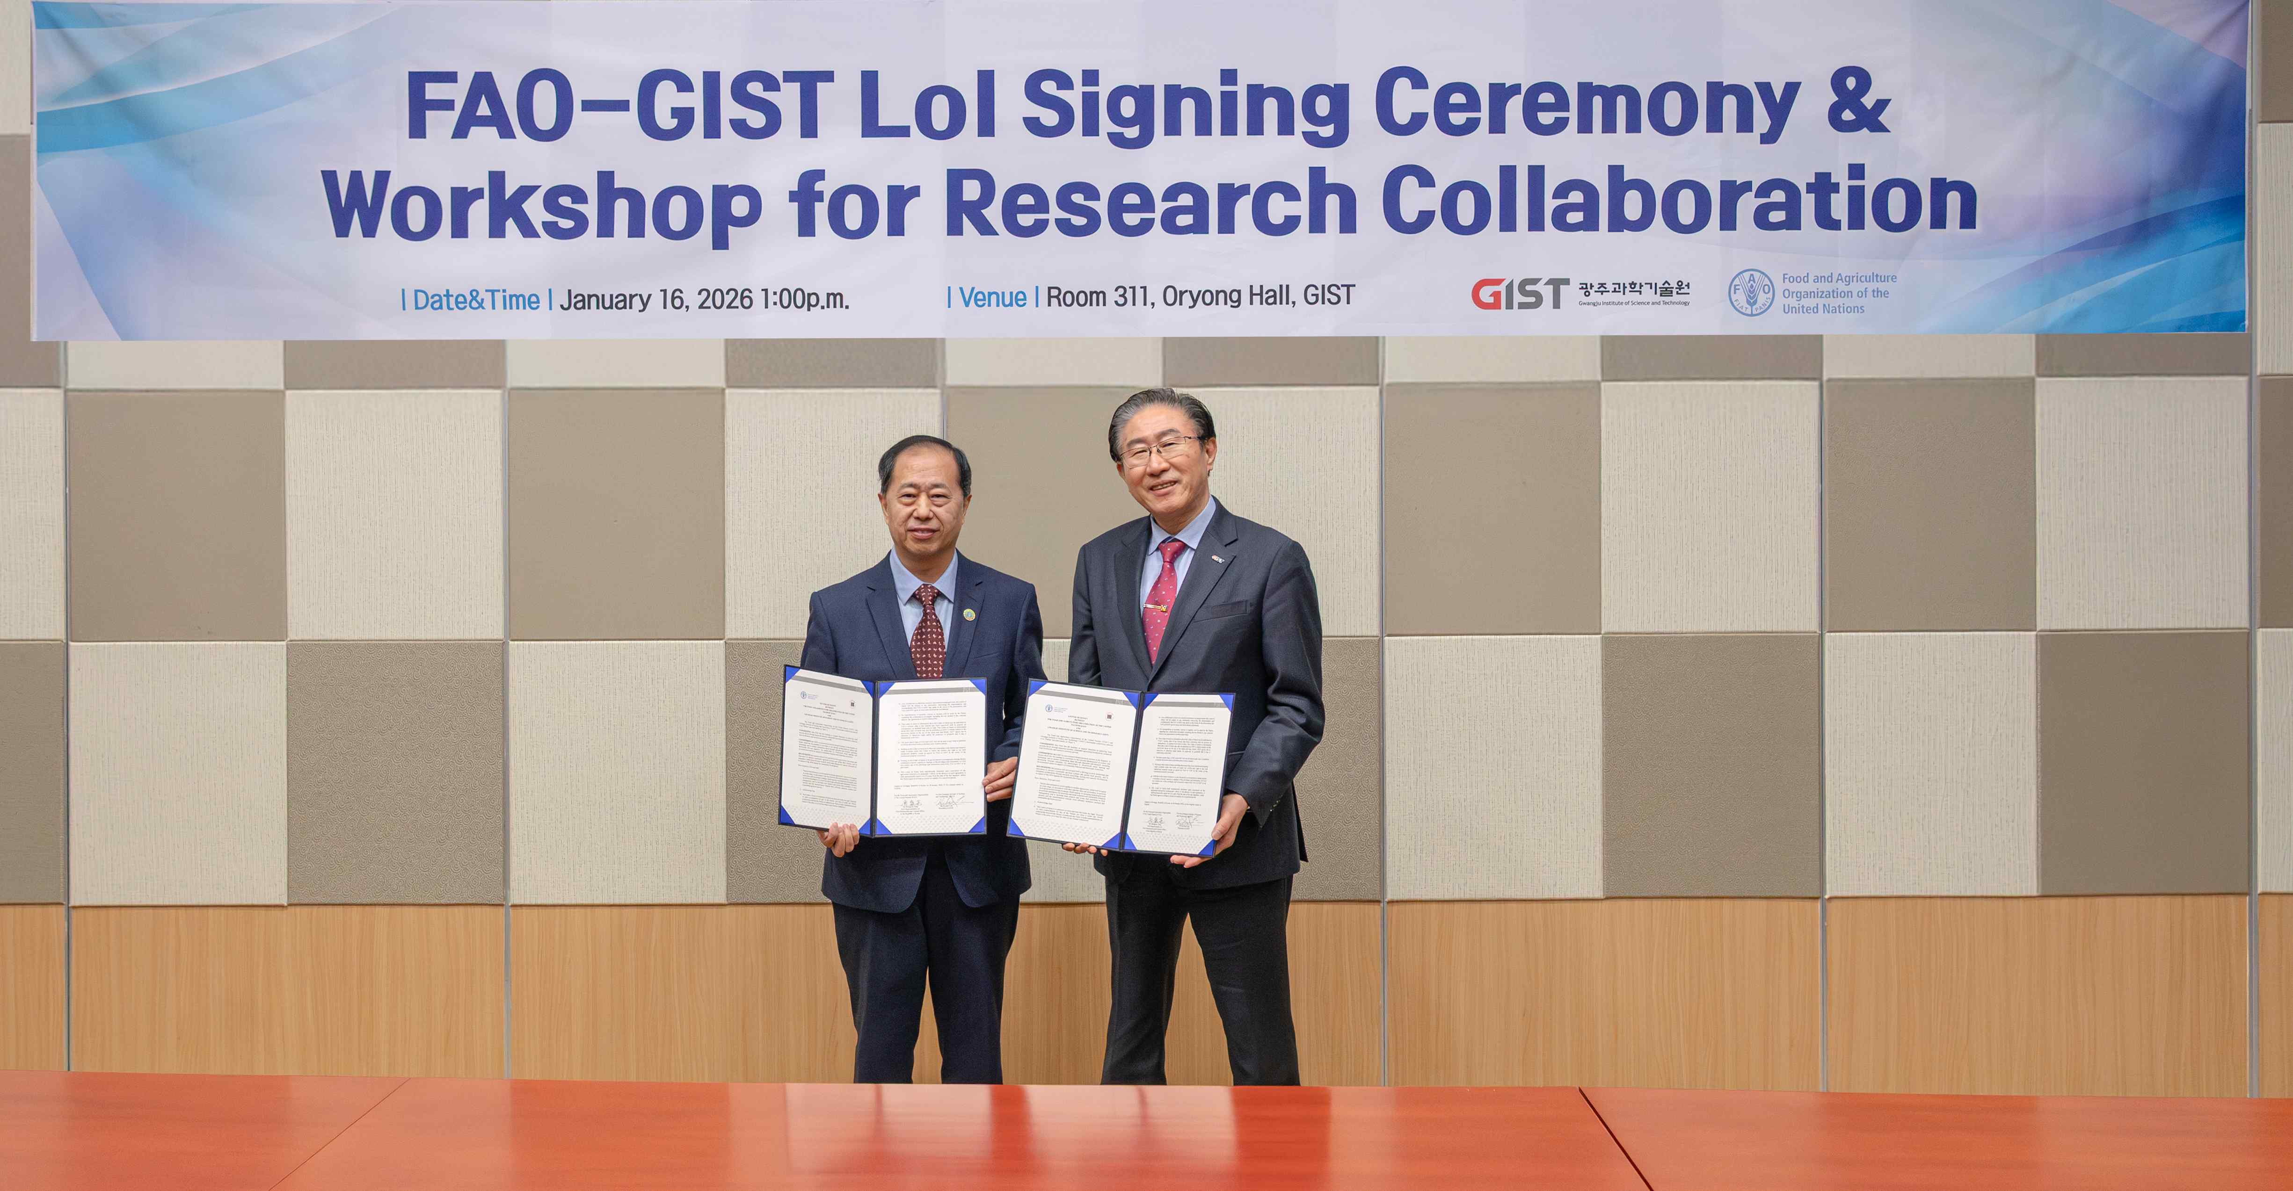

▴ (From right) GIST President Kichul Lim and FAO Korea Liaison Office Director Shengyao Tang pose for a commemorative photo after signing a Letter of Intent (LOI).
GIST President Kichul Lim stated, "This is the starting point for international cooperation, sharing our cutting-edge technological capabilities with the international community to address the unprecedented challenges of climate change, aging populations, and population decline." He added, "GIST will fulfill its responsible role as a national science and technology institution in addressing the agricultural and food crisis facing the international community."
Shengyao Tang, Director of the FAO Korea Liaison Office, emphasized that "the combination of GIST’s scientific and technological capabilities and FAO’s global agenda will make a significant contribution to improving the world’s food production, nutrition, environment, and quality of life."

