GIST and Gwangju Soongeui Science and Technology High School sign MOU to develop specialized high schools

- On Monday, the 19th, at the GIST Administration Building, expectations for cultivating customized technical talent aligned with regional and national industrial needs through a high school–university cooperation system... Providing learning and career support even after employment, establishing a continuous growth path

- President Kichul Lim: "The era of AI transformation cannot be completed without technical talent who understand the field."

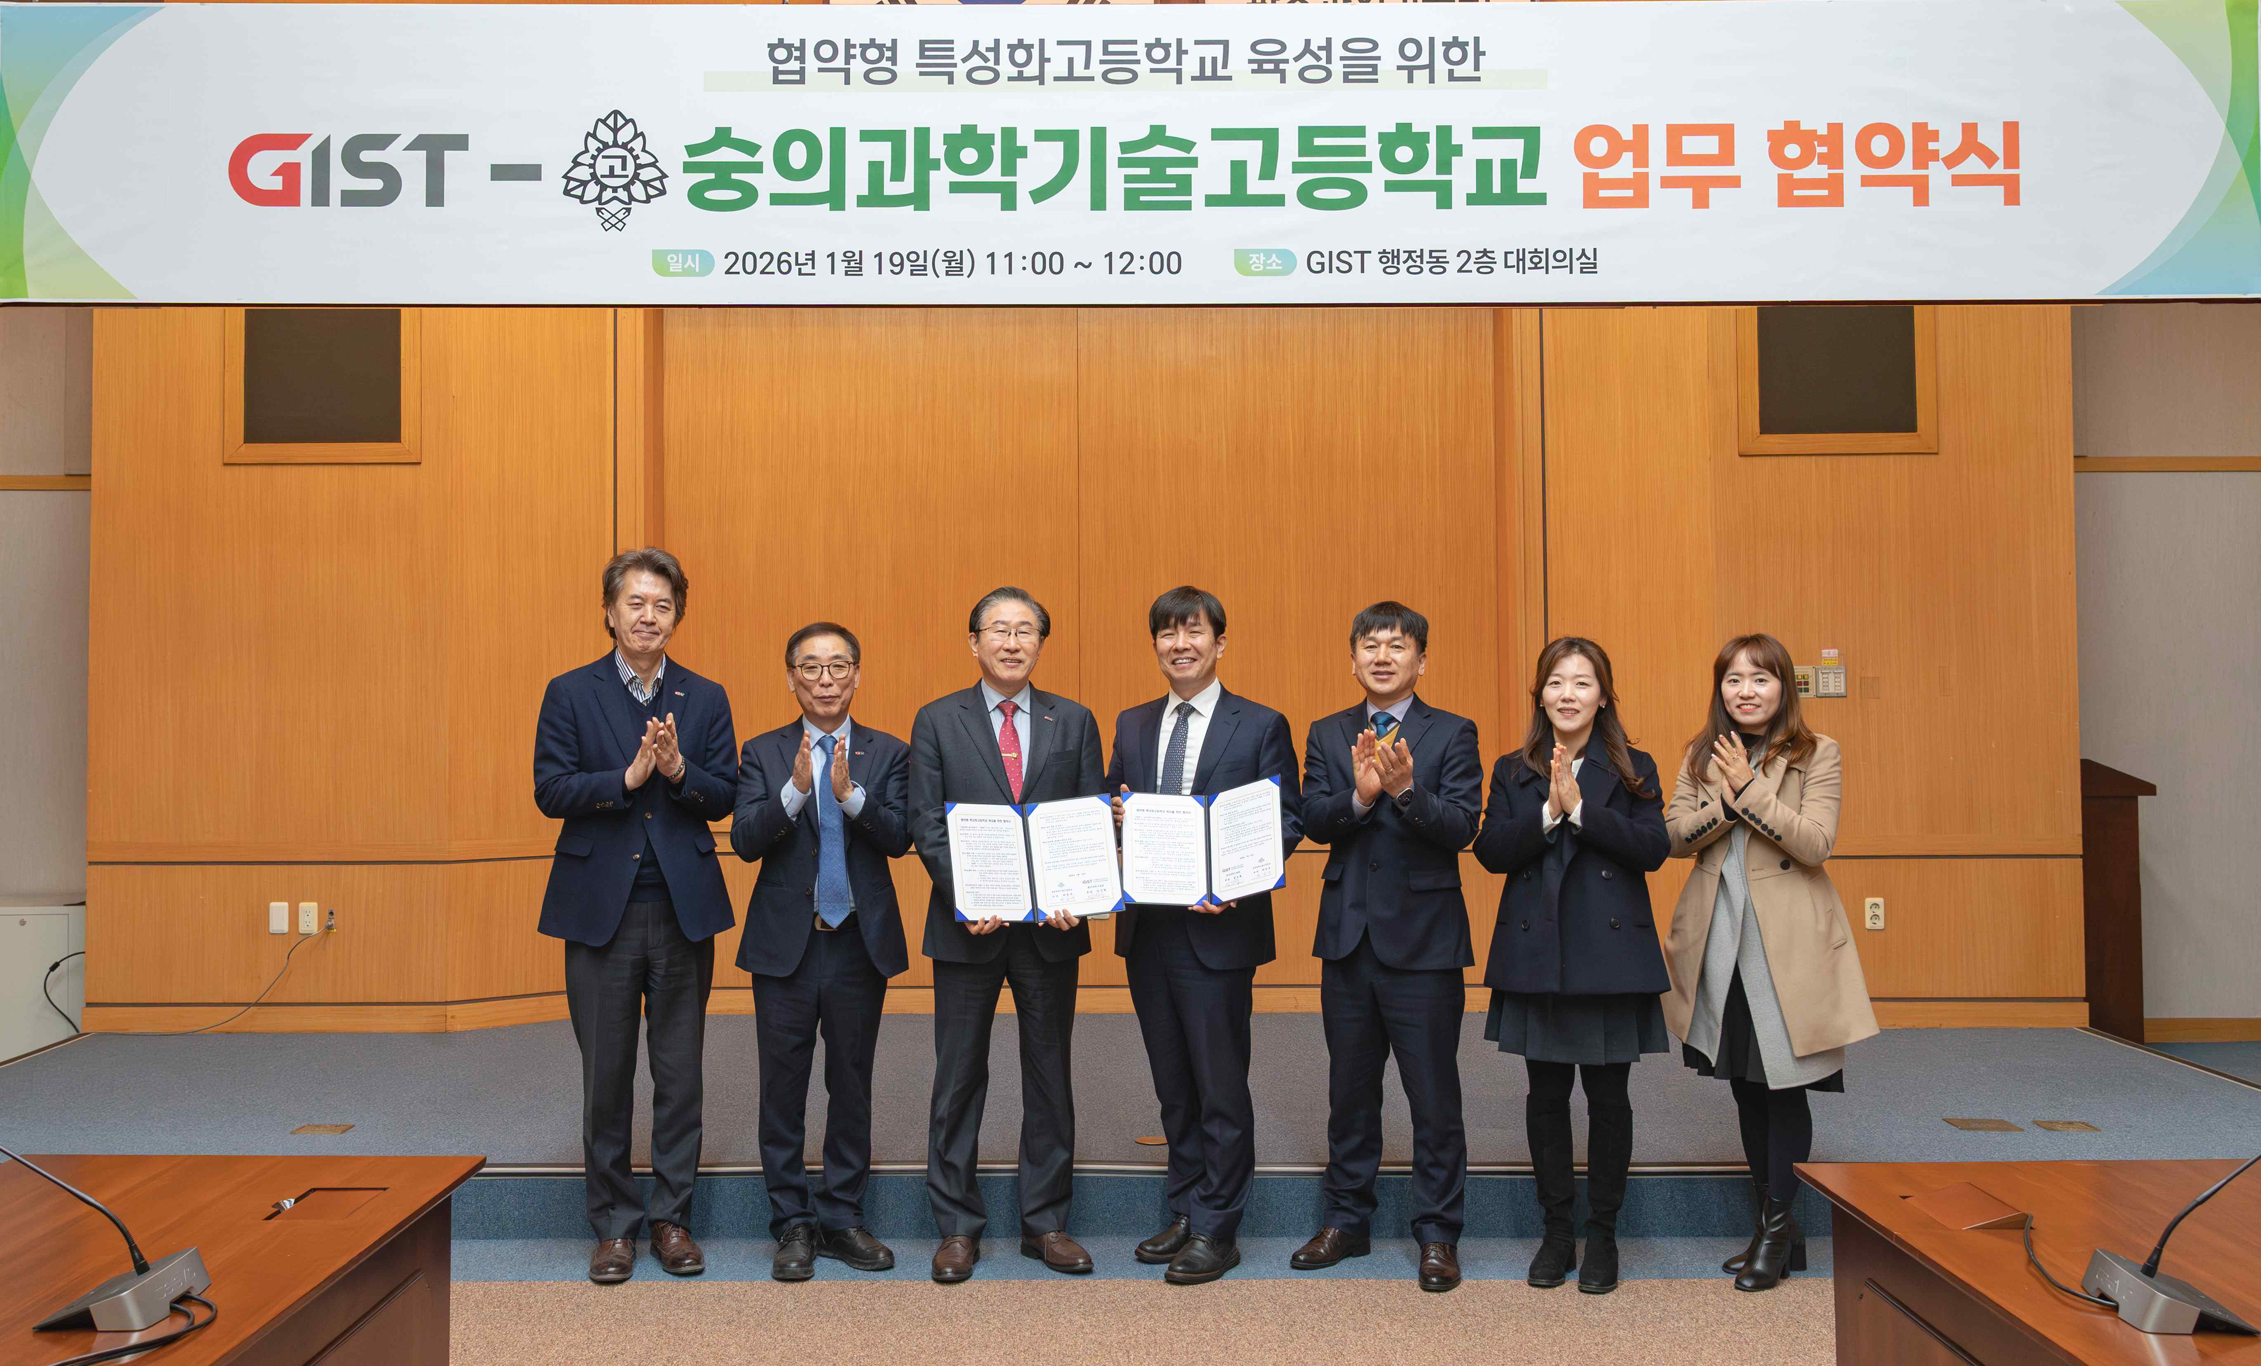

▲ Participants pose for a commemorative photo after GIST and Soongeui Science and Technology High School signed a Memorandum of Understanding (MOU) on January 19th in the conference room on the second floor of the GIST administration building to foster specialized high schools.

The Gwangju Institute of Science and Technology (GIST, President Kichul Lim) announced on Monday, January 19th, that it signed a Memorandum of Understanding (MOU) with Soongeui Science and Technology High School (Principal Sung-woo Park) in the conference room on the second floor of the GIST administration building to foster specialized high schools.

This agreement aims to systematically cultivate practical technical talent that meets regional and national industrial needs. It also aims to establish a linked education system between high schools and universities and expand support for growth pathways that enable continuous learning and competency development even after employment.

GIST and Soongeui Science and Technology High School plan to gradually expand their cooperation, encompassing curriculum integration, career paths, and industry-driven talent development. They will jointly establish a collaborative model linking high schools, universities, and industry.

The signing ceremony was attended by approximately ten officials from both institutions, including GIST President Kichul Lim, Vice President for Public Affairs Yonghwa Chung, Director of External Cooperation Eunji Lee, GIST Foundation Chairman Eun-mo Choi, and Soongeui Science and Technology High School Seong-woo Park, Vice Principal Jeong-hoon Kim, teachers I-hwa Jeong and Se-hee Lim, and Apprenticeship Team Leader Jin-mi Jang.

The key terms of the agreement include: ▴ operating a high school-university integrated curriculum; ▴ supporting post-employment learning paths and career paths; ▴ collaborating on curriculum design and operation, as well as departmental reform to foster talent in specialized regional industries.

GIST will play a university-level role, operating a high school-university integrated curriculum, supporting education by leveraging the university's research and education infrastructure, and establishing career pathways that enable students to continue their studies after graduation. Through these initiatives, students will indirectly experience a university-level educational environment while still in high school and be supported in designing long-term growth paths.

Soongeui Science and Technology High School will be responsible for fostering practical technical talent through curriculum restructuring that reflects the needs of regionally specialized industries and designing and operating a field-oriented curriculum. Specifically, through a curriculum linked to industry, GIST plans to enhance students' major competencies and enhance their employment and entrepreneurial competitiveness, fostering talent capable of contributing to the development of local industries.

GIST President Kichul Lim emphasized, "South Korea has entered an era of economic security that extends beyond national defense to encompass the economy, energy, and food. Key to this are the talents who implement technology in industrial settings. The era of AI transformation cannot be achieved without technical talent who understand the field."

He continued, "While AI can supplement knowledge, actual production and system operation must be handled by those with technical expertise." He added, "This agreement with Soongeui Science and Technology High School is significant because it signifies GIST's commitment to fostering field-oriented technical talent."

Principal Seong-woo Park stated, "This collaboration with GIST will serve as a solid foundation for our students to grow beyond 'simple technicians' into 'technological innovators' who create job-related inventions." He added, "Through a strong public-private-academic cooperation system spanning the Nam-gu Office of Gwangju Metropolitan City, Gwangju Global Motors (GGM), Howon, and GIST, we will be selected as a partner specialized high school and establish a successful model for regional education."

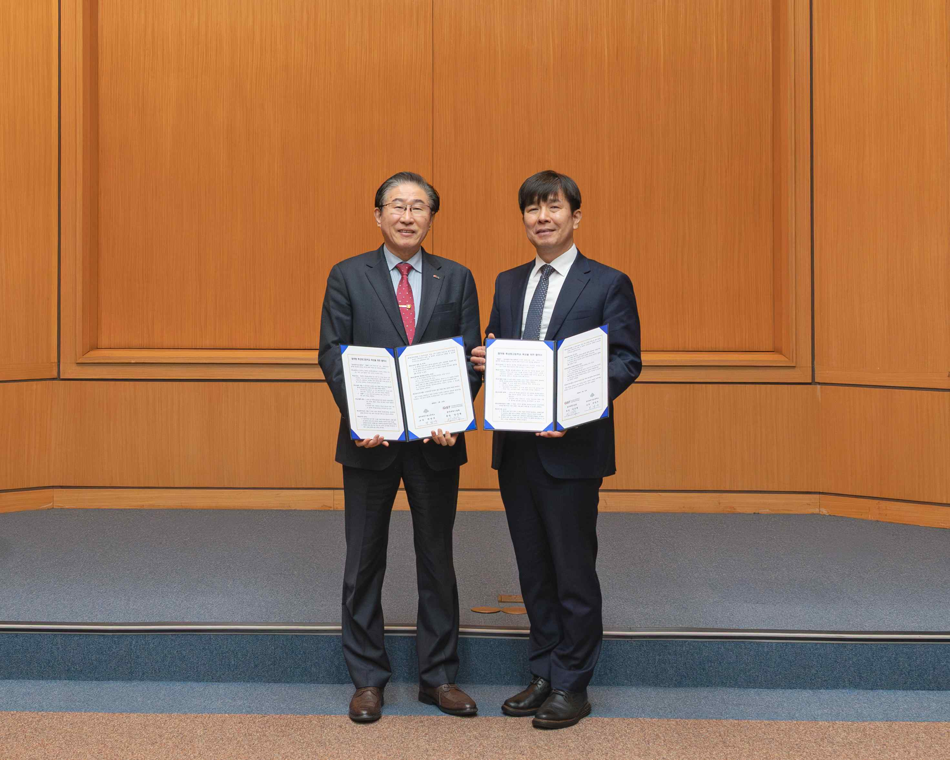

▲ (From left) GIST President Kichul Lim and Soongeui Science and Technology High School Seong-woo Park pose for a commemorative photo after signing a business agreement to foster specialized high schools.

Meanwhile, the two organizations plan to continuously monitor and manage the performance of the agreement-type specialized high schools and gradually expand the scope of cooperation to encompass education, research, and industry in the future.



