GIST opens Graduate School of Management of Technology (MOT) to cultivate global technology management talent to lead the AI ​​transition era

- The opening ceremony was held at the GIST Industry-Academia Cooperation Research Center on Friday, January 16th... Following a year of preparation following selection for the Ministry of Trade, Industry and Energy's professional training program, the center officially launched and will operate a practice-oriented curriculum, including project-based learning (PBL) that integrates industry, academia, and research with global collaborations

- 15 new master's students (both employed and full-time) are being recruited for the spring semester of 2026... Full-time students will receive a full scholarship

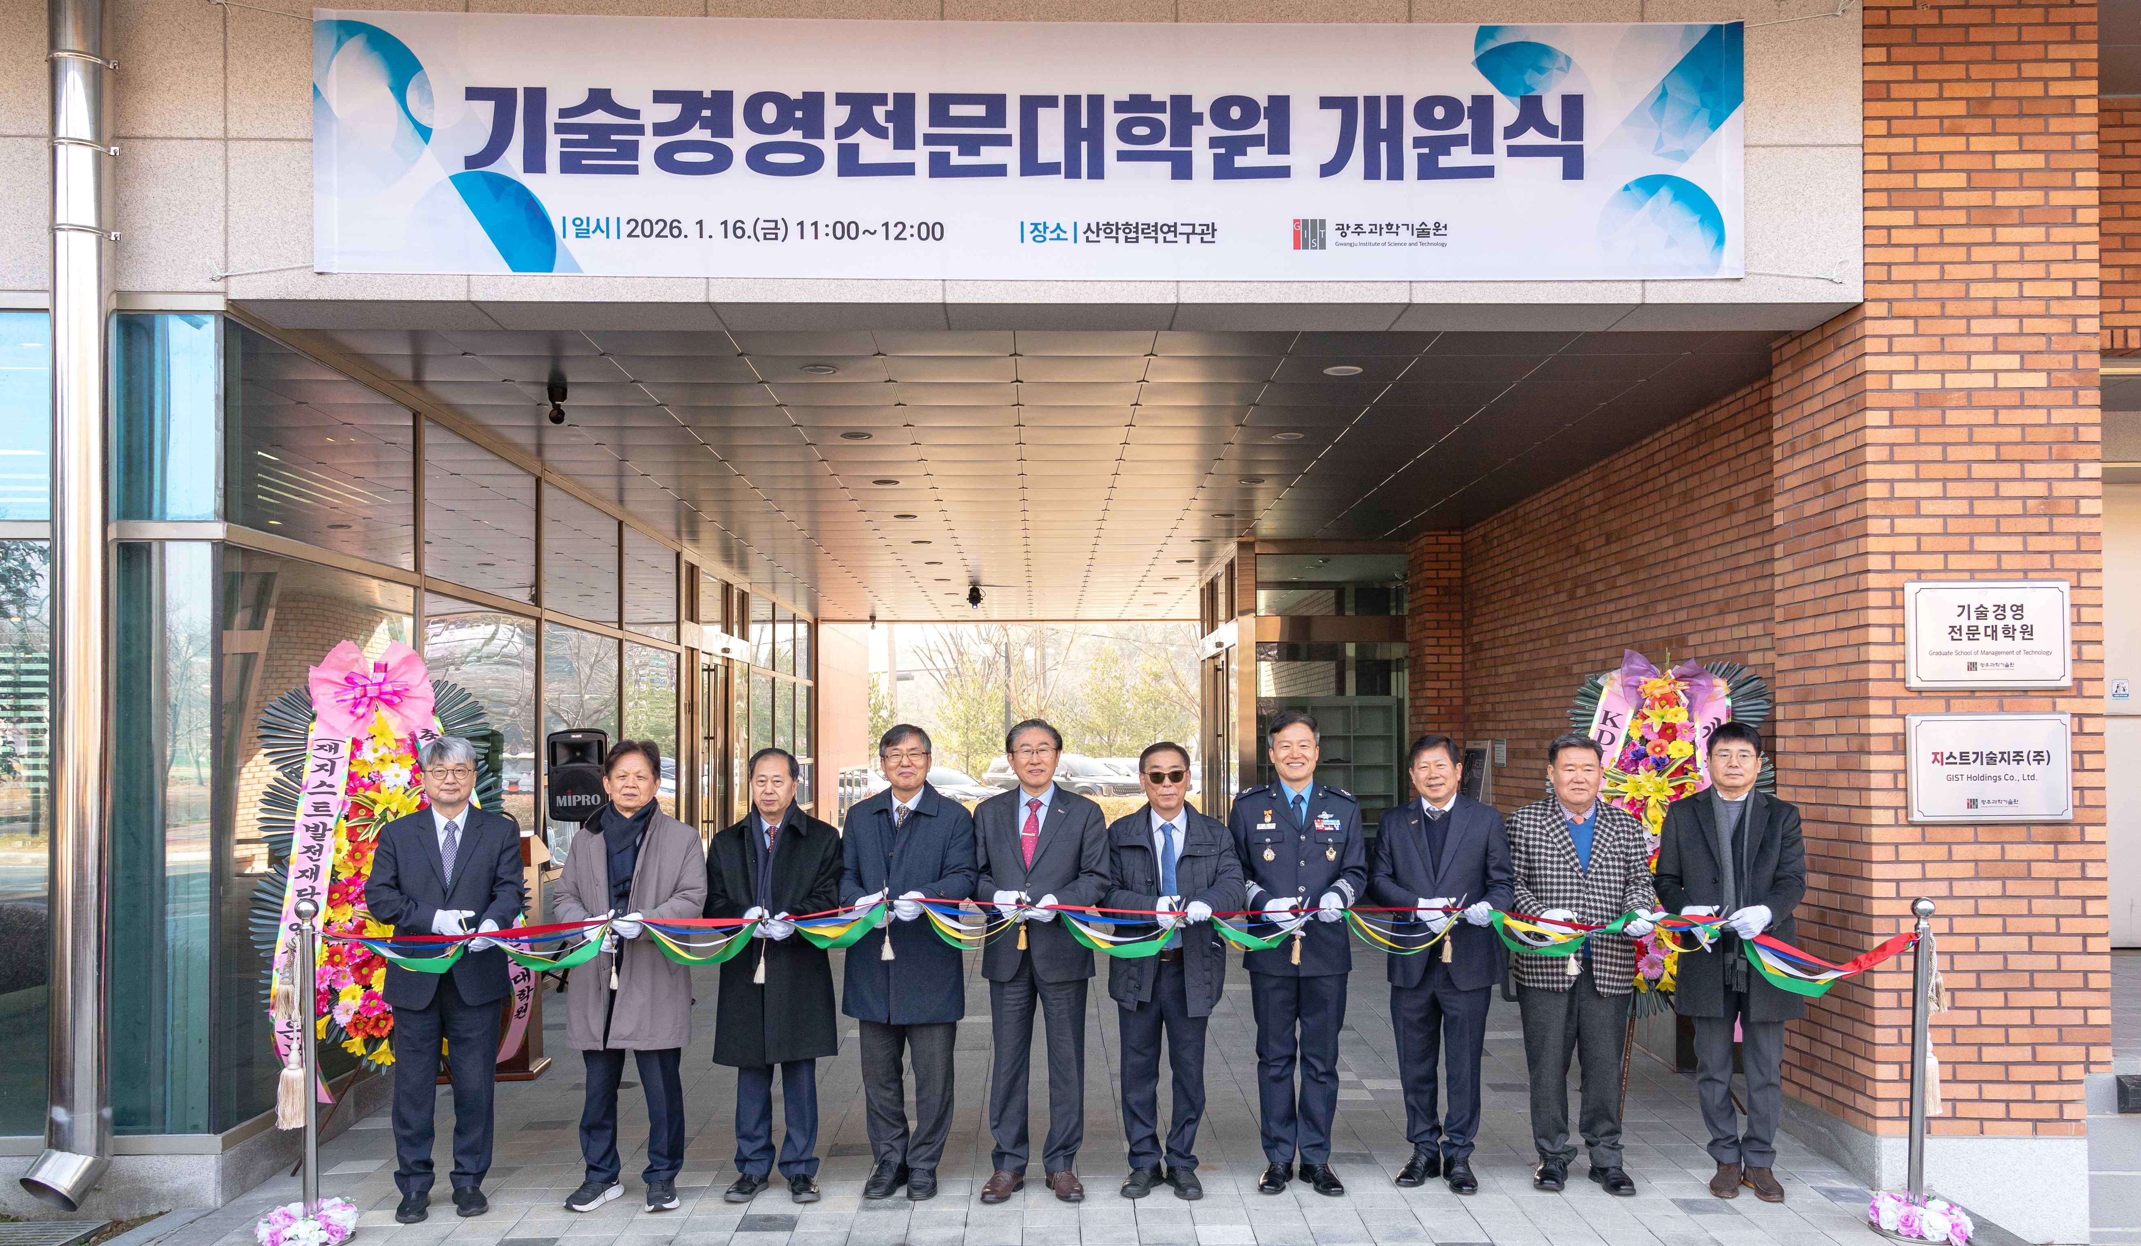

▲ GIST President Kichul Lim and key guests celebrate the opening of the GIST Graduate School of Management of Technology (MOT) with ribbon cutting ceremony.

The Gwangju Institute of Science and Technology (GIST, President Kichul Lim) announced that it held the opening ceremony for the Graduate School of Management of Technology (MOT, Dean Sangho Kim) at the GIST Industry-Academia Cooperation Research Center on Friday, January 16.

The opening ceremony was attended by President Kichul Lim, Director Shengyao Tang of the Food and Agriculture Organization of the United Nations (FAO) Korea Liaison Office, President Young-seok Shin of the Korea Institute for Health and Social Affairs, President Joon-kyung Kim of the KDI School of Public Policy and Management, Chairman Eun-mo Choi of the GIST Development Foundation, Director Joong-soo Kim of the 1st Fighter Wing of the Air Force, President Jeong-soon Park of the GIST Technology Management Academy (GTMBA) Alumni Association, and Director Eung-jin Bang of the Technology Commercialization Center at the Korea Institute for Advancement of Technology. These figures, along with others from industry, academia, research, and the public sector, celebrated the launch of GIST MOT.

GIST MOT is a specialized graduate school established with the goal of fostering a regional industrial ecosystem and fostering global AI-based management professionals who will lead the era of artificial intelligence (AI). It officially launched after approximately one year of preparation following its selection for the Ministry of Trade, Industry and Energy's (MOTIE) Professional Training Program in March 2025.

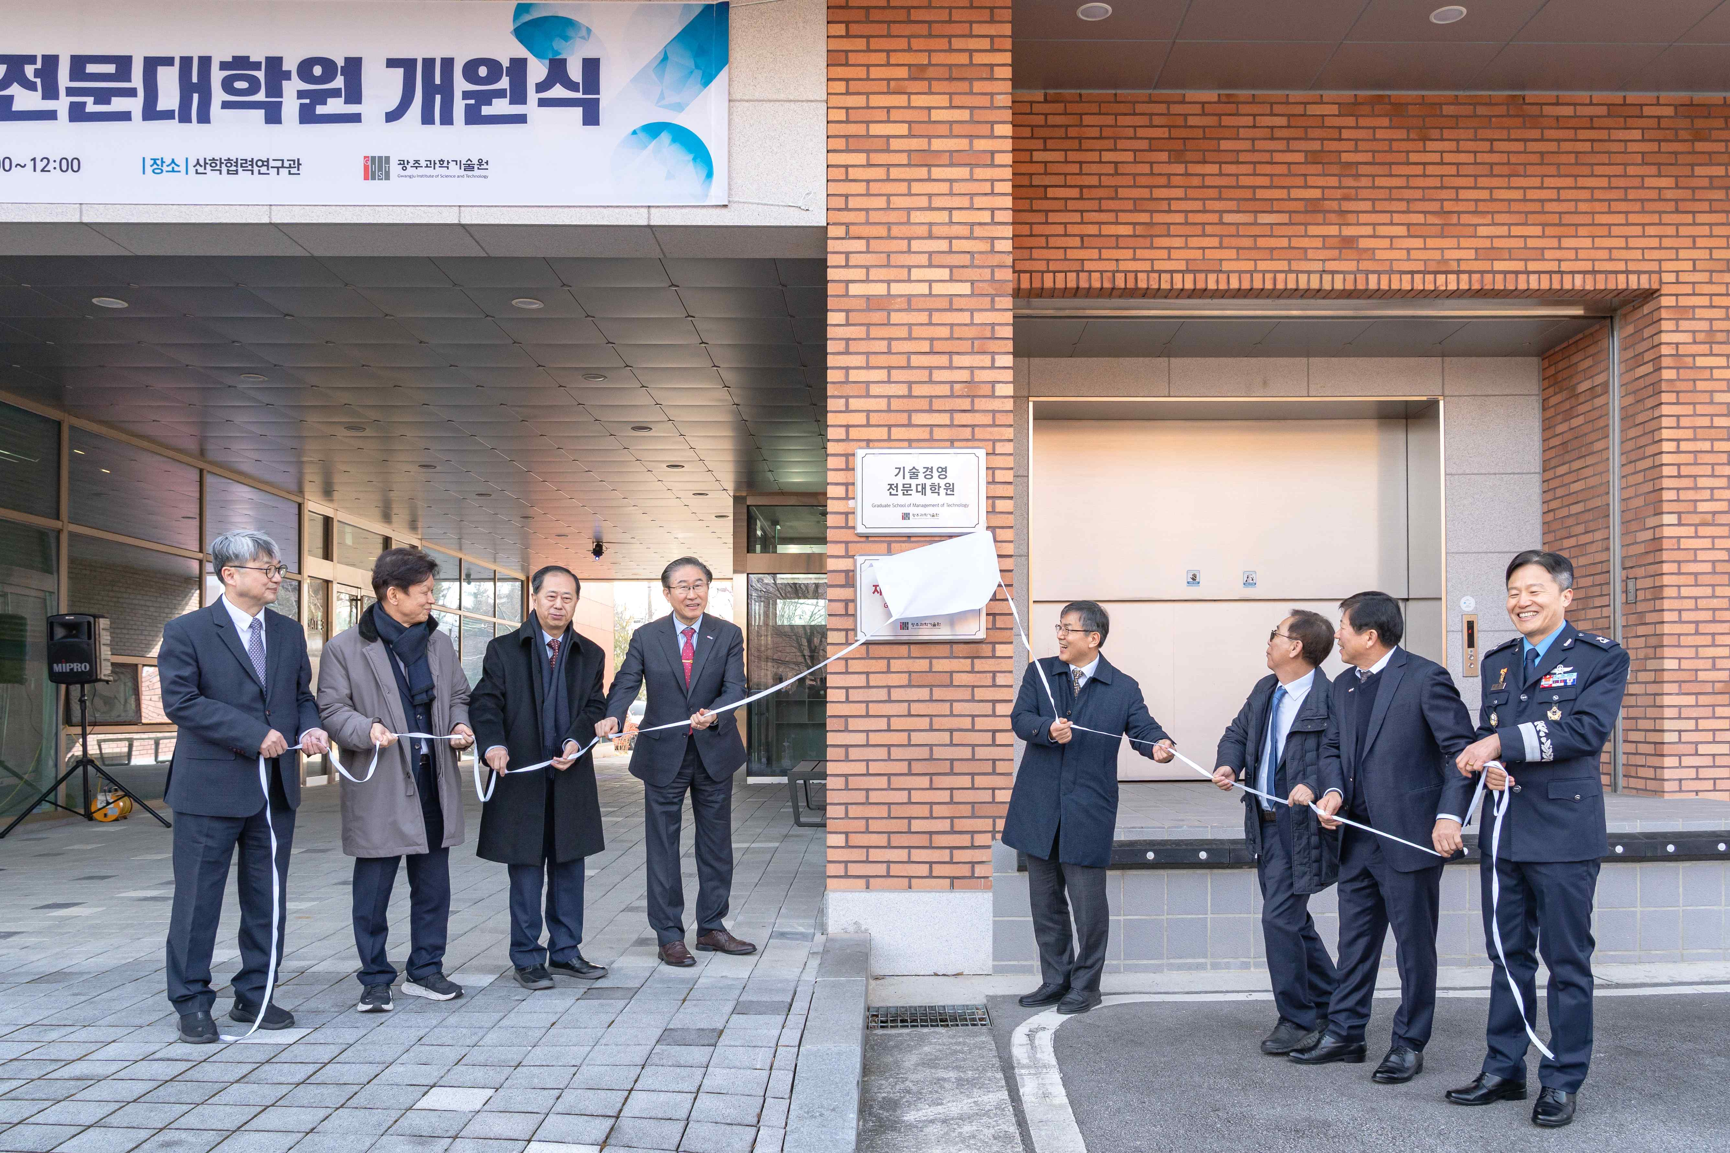

▲ GIST President Kichul Lim and key guests unveil a plaque commemorating the opening of the GIST Management of Technology (MOT).

GIST MOT focuses on business performance-focused convergence education, problem-solving project-based learning (PBL), and demand-based curriculum design. Consultative classes and industry-academic collaboration projects span the entire planning, R&D, and commercialization cycle, providing implementation-oriented education that connects research outcomes to industry and policy.

Notably, the program offers diverse, hands-on educational programs, including industry-academic-research PBL, global PBL, domestic and international internships, and MOT special lectures, creating an educational structure that naturally leads to entrepreneurship and employment. Through these programs, the program aims to systematically cultivate talent with master's and doctoral degrees in technology management.

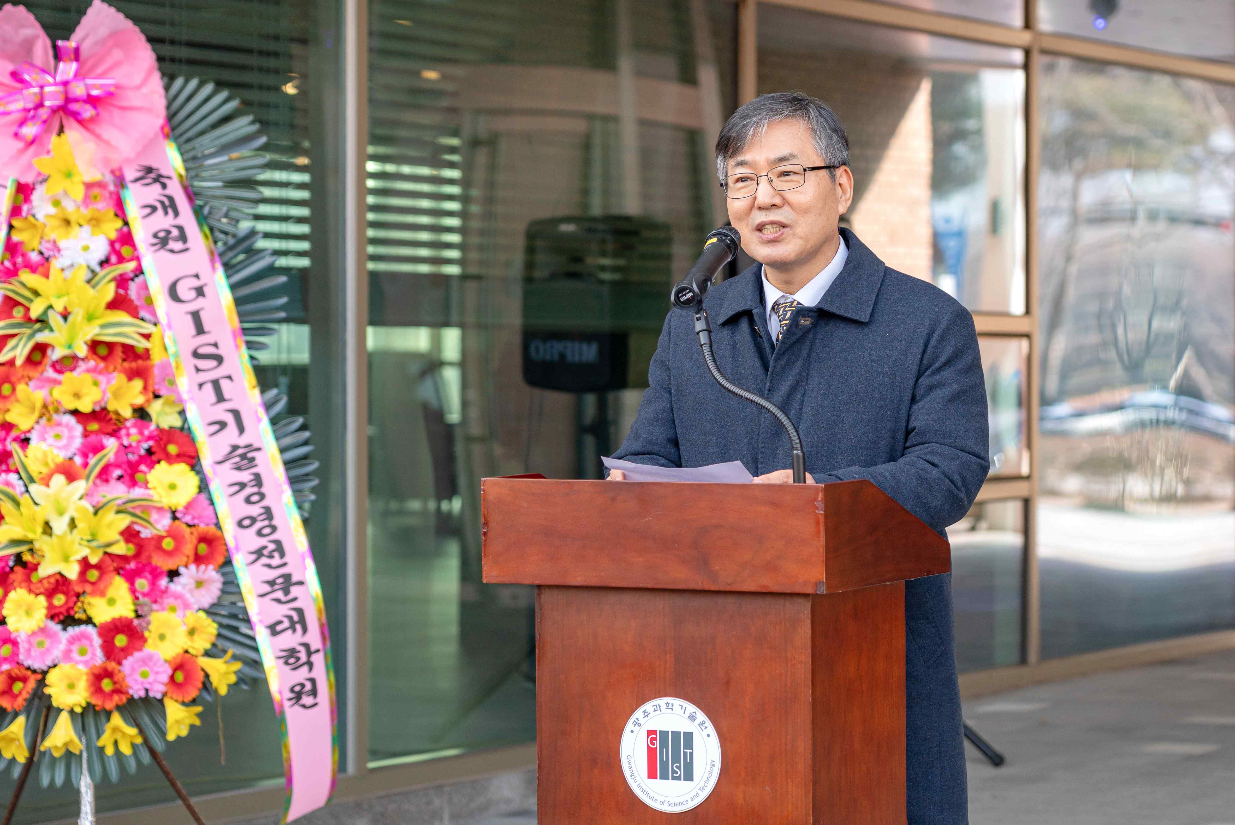

▲ Dean Sangho Kim delivers a welcoming address at the opening ceremony of the GIST Management of Technology (MOT), held at the GIST Industry-Academic Cooperation Research Center.

GIST MOT recruits current business owners and successors based in the Honam region who are either running or preparing to run businesses as "General Scholarship Students." It also selects "KIST Scholarship Students" from students with a clear business vision and who wish to pursue full-time graduate school after graduation. General Scholarship Students receive support from their affiliated companies for their studies, while KIST Scholarship Students receive a full scholarship from GIST.

GIST MOT will begin recruiting 15 new master's students for the spring semester of 2026 and plans to gradually expand its graduate program.

President Kichul Lim stated, "The opening of GIST MOT lays a new foundation for cultivating management professionals in the Honam region. We will develop it into a platform that will lead the regional industrial ecosystem by connecting cutting-edge and traditional, global and local technologies."

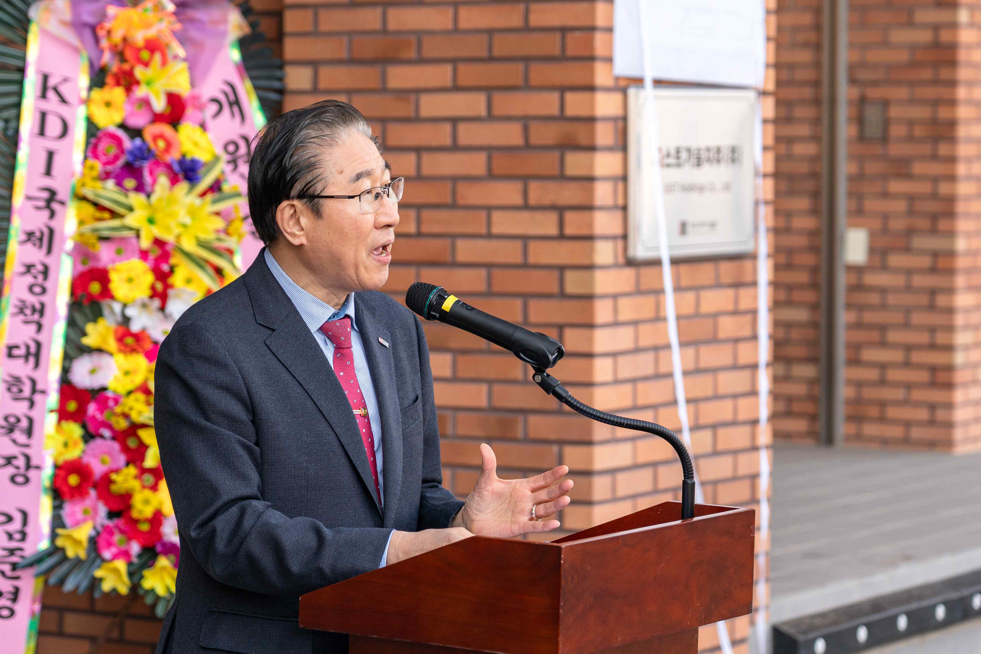

▲ GIST President Kichul Lim delivers a congratulatory address at the opening ceremony of the Graduate School of Management of Technology (MOT), held at the GIST Industry-Academic Cooperation Research Center.

KDI School Director Jun-kyung Kim, who attended the opening ceremony, said, "The opening of the GIST MOT is a crucial opportunity to enhance both regional and national industrial competitiveness. I hope this agreement will foster a collaborative model that organically links research, policy, and education."



