GIST and the Korea Institute for Health and Social Affairs collaboration will integrate technology and policy in the health and welfare sectors

- On Friday, the 16th, an MOU was signed in the GIST administration building to strengthen research and policy collaboration, laying the foundation for collaboration between AI and biomedical research and health and welfare policy research... Joint research and policy collaboration in the health and welfare sectors will begin in earnest

- The establishment of a cooperation task force will establish a phased cooperation system... This will expand human exchanges between researchers and policy experts

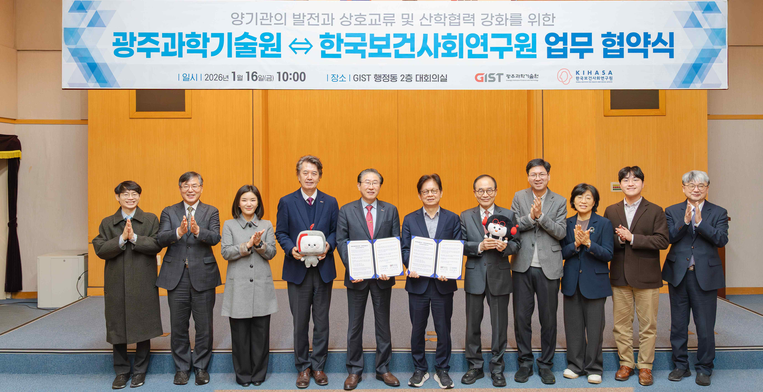

▲ GIST and the Korea Institute for Health and Social Affairs signed a Memorandum of Understanding (MOU) to strengthen mutual exchange and industry-academia cooperation in the fields of health and welfare. Participants pose for a commemorative photo.

The Gwangju Institute of Science and Technology (GIST, President Kichul Lim) announced on January 16 (Friday) that it signed a Memorandum of Understanding (MOU) with the Korea Institute for Health and Social Affairs (KIHASA) in the conference room on the second floor of the GIST Administration Building to strengthen mutual exchange and industry-academia cooperation in the fields of health and welfare.

This agreement is noteworthy in that it combines GIST's research capabilities in artificial intelligence (AI) and biomedical science with the KIHASA's expertise in health and welfare policy research, establishing a foundation for collaboration that will connect science and technology-based research outcomes with tangible policies and industrial outcomes.

The signing ceremony was attended by GIST President Kichul Lim, Vice President for Public Affairs Yonghwa Chung, Graduate School of Management of Technology Dean Sangho Kim, Department of Biomedical Science and Engineering Dean Euiheon Chung, and Professor Kibae Kim of the AI ​​Policy and Strategy Graduate School, as well as President Young-seok Shin and Director of the Health and Medical Policy Office Hyun-woong Shin of the Korea Institute for Health and Social Affairs. Also present were KDI School of Public Policy and Management (KDI School) Dean Jun-kyung Kim and Director of Planning Jin-soo Lee to expand cooperation on health and welfare policies and talent development.

The key terms of the agreement include: ▴ conducting joint research in the health and welfare field; ▴ promoting the commercialization of joint research outcomes; and ▴ hosting academic and joint events related to the joint research.

To systematically promote this agreement, the two institutions will establish a collaboration task force co-led by Dean Sangho Kim of GIST's Graduate School of Management of Technology and the Director of the Health and Medical Policy Research Division at the Korea Institute for Health and Social Affairs. This task force will establish a step-by-step collaborative framework, encompassing everything from joint research planning and coordination to dissemination. This is expected to foster the discovery of future joint research projects and foster deeper personal exchanges between researchers and policy experts.

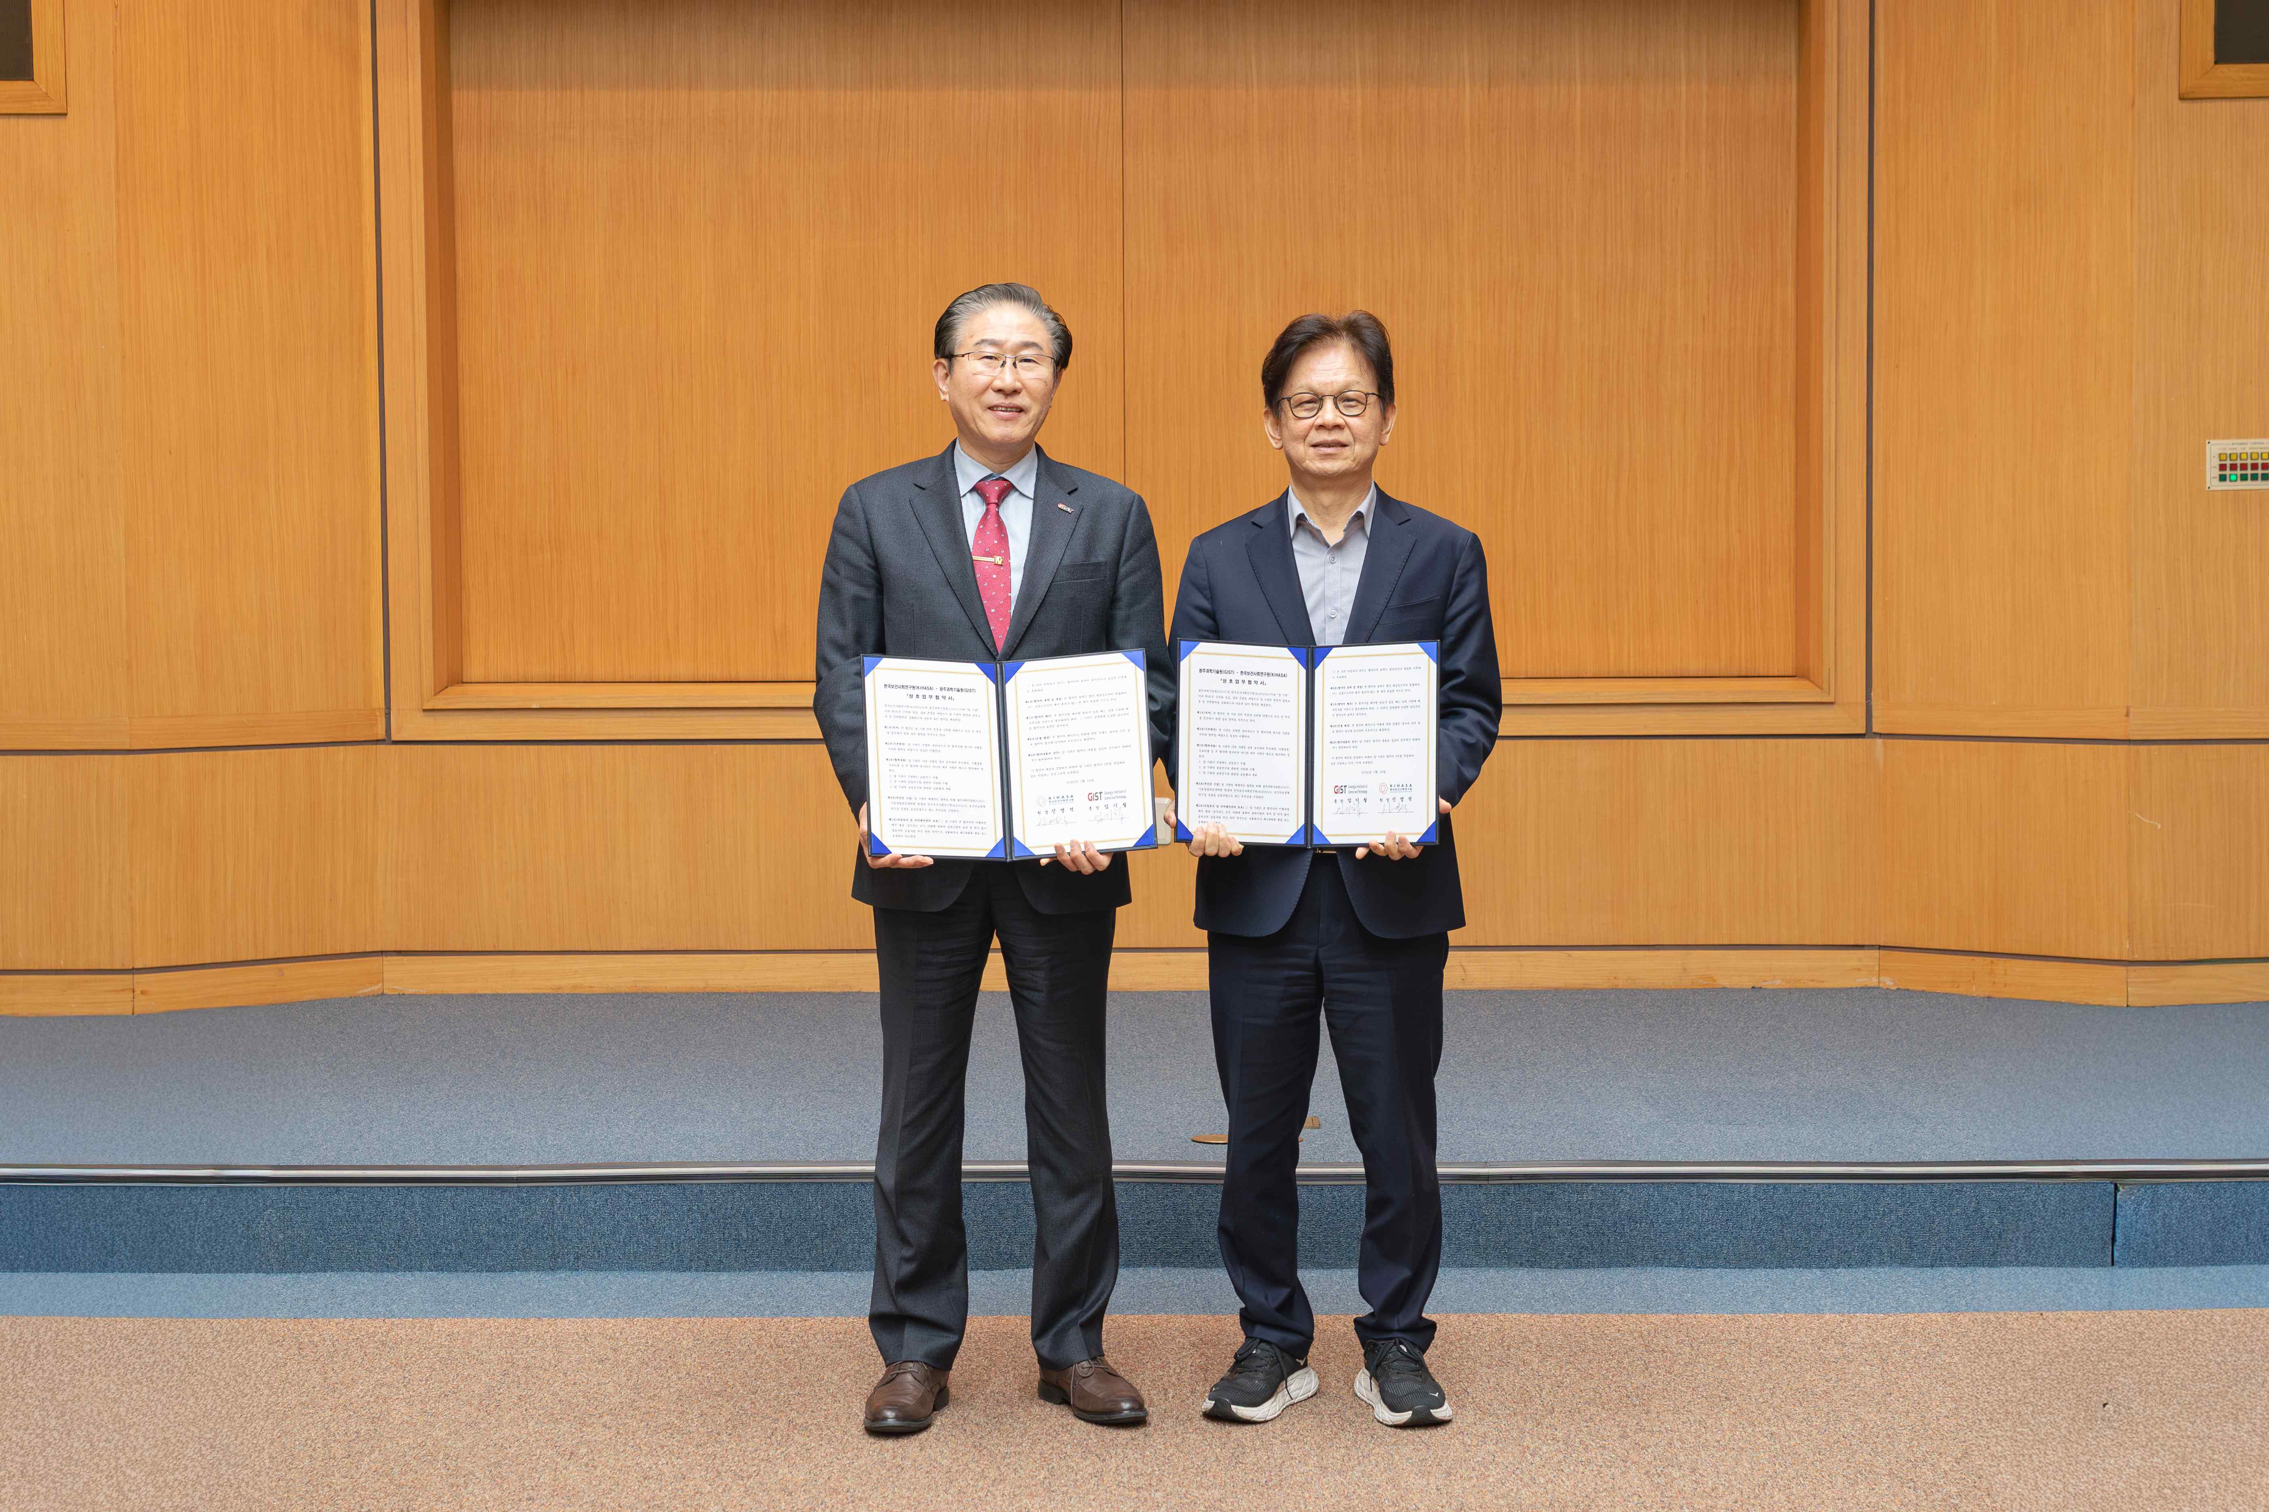

▲ (From left) GIST President Kichul Lim and Korea Institute for Health and Social Affairs President Young-seok Shin pose for a commemorative photo after signing a Memorandum of Understanding (MOU) to strengthen mutual exchanges and industry-academia cooperation in the health and welfare sectors.

GIST President Kichul Lim stated, "Through this agreement, we hope to create a research and policy collaboration model that can substantially contribute to improving the quality of life for the public by combining GIST's accumulated AI and biomedical research capabilities with our policy research expertise."

GIST Graduate School of Management of Technology Dean Sangho Kim stated, "This agreement is an opportunity to expand the direction of technology management education, which connects research results with industry and policy, to the health and welfare sectors. We will cultivate convergent talent and achieve tangible results through collaboration."

Korea Institute for Health and Social Affairs President Young-seok Shin stated, "This agreement is a meaningful starting point for connecting science and technology-based research results with policy in the health and welfare sectors. We will strengthen our cooperation so that joint research reflecting real-world issues can lead to policy outcomes."

Meanwhile, a joint workshop between GIST and Korea Institute for Health and Social Affairs was held that afternoon in conjunction with the MOU signing. Hyun-woong Shin, Director of the Health and Medical Policy Research Division at Korea Institute for Health and Social Affairs, presented on "Directions for Improving Health and Medical Policy in the AI ​​Era," followed by a panel discussion.



