GIST semiconductor engineering students learn at CES 2026 with their department head

- 18 students from the second class of the Department of Semiconductor Engineering (class of 2025) and Department Head Sung-Min Hong officially attended CES 2026, along with other students... All students enrolled in the Department of Semiconductor Engineering who have completed two semesters will be given the opportunity to attend CES, fostering global, practical talent

- "This opportunity to directly witness the development of the global ICT industry will broaden our understanding of our major and shape our career paths."

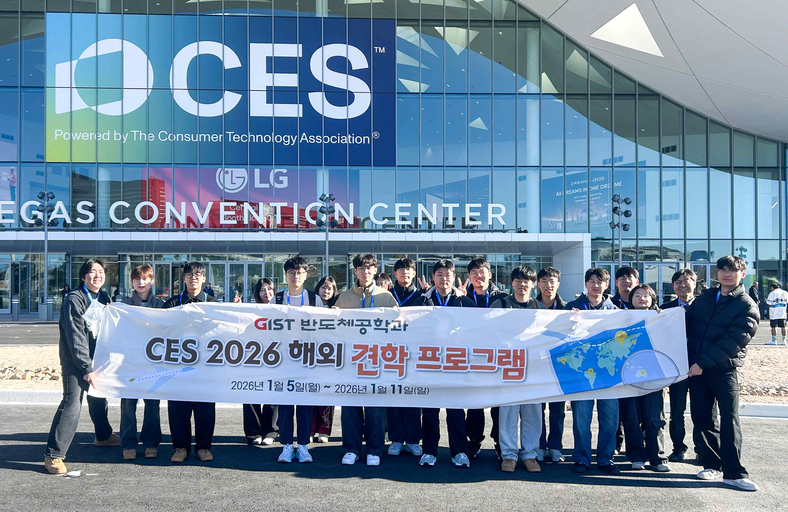

▲ GIST's second-year students from the Department of Semiconductor Engineering pose for a commemorative photo in front of the CES 2026 exhibition hall in Las Vegas, USA.

The Gwangju Institute of Science and Technology (GIST, President Kichul Lim) announced that its Semiconductor Engineering students visited CES 2026, the world's largest consumer electronics and information technology (IT) exhibition, held in Las Vegas, Nevada, USA from January 6 to 9 (local time). They had an educational opportunity to experience the latest technologies and market trends in the global semiconductor and information and communications technology (ICT) industries firsthand.

This CES visit was attended by 18 second-year students from the Department of Semiconductor Engineering, who entered in 2025, along with Department Head Sung-Min Hong and Professor Dongseok Kwon. This was the second official field trip, following the 22-person visit from the first-year students last year.

Throughout the exhibition hall, students witnessed cutting-edge technologies, such as artificial intelligence (AI) semiconductors, next-generation displays, autonomous driving, and smart manufacturing, showcased by global semiconductor companies and innovative startups, moving beyond the R&D stage and into actual products and services. This experience provided a three-dimensional understanding of the overall semiconductor industry trends and the direction of technological development.

In particular, experiencing semiconductors as a core infrastructure for diverse industries, including AI, mobility, healthcare, and energy, provided a vivid opportunity to experience firsthand how knowledge gained through theory and experimentation translates into tangible industrial and economic value.

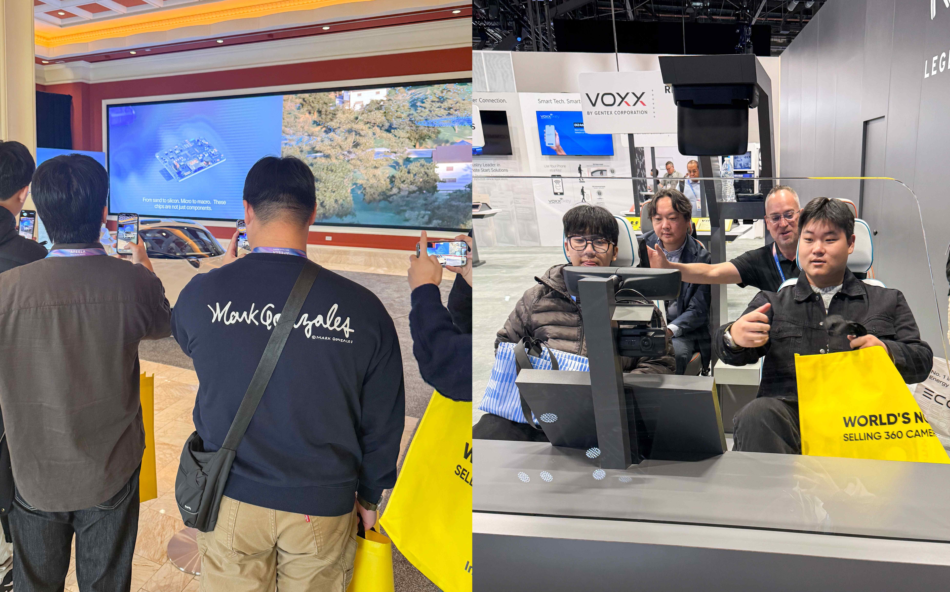

▲ GIST's second-year students from the Department of Semiconductor Engineering visited the CES 2026 exhibition hall in Las Vegas, USA. (Left) They observed a Pagani hypercar and (Right) experienced camera technology that captures the driver and passenger seats of a self-driving car at the VOXX booth.

As part of its field-oriented education program, designed to foster industry understanding and problem-solving skills as future semiconductor engineers, the Department of Semiconductor Engineering at GIST offers a CES field trip to all undergraduate students who have completed two semesters.

Students who are unable to attend due to leave of absence or personal reasons are guaranteed one visit before graduation, ensuring that all students have access to global technology experiences.

Seong-hyeon Maeng, a student who participated in the field trip, said, "Through the exhibitions of global companies and innovative startups, I was able to see at a glance how next-generation technologies are applied to real-world industries and products." He added, "Being able to directly compare and analyze the direction of the global ICT industry broadened my understanding of my major and provided an opportunity to concretely map out my career path."

Sung-Min Hong, Dean of the Department of Semiconductor Engineering, stated, "Witnessing firsthand how cutting-edge technologies, previously only accessible through textbooks and academic papers, are used in industrial settings to solve problems and translate into business opportunities will be a valuable asset for students. The shock and excitement experienced in the field will serve as a strong motivation for learning, laying the foundation for their growth into global semiconductor engineers who will lead future markets."

Established in 2024, the GIST Department of Semiconductor Engineering is a contracted department linked to Samsung Electronics recruitment. It will select 30 students annually through 2028, for a total of 150 students in the integrated bachelor's and master's program. Through close collaboration with Samsung Electronics, GIST is accelerating the development of next-generation semiconductor talent equipped with both practical skills and research competitiveness.



