GIST and the Korea Fabless Industries Association (KFIA) signed an MOU to build a full-cycle ecosystem for AI semiconductors: The office of Representative Hyung-bae Min and the Gwangju-Jeonnam Integrated Semiconductor Forum Preparatory Committee co-hosted the "Gwangju-Jeonnam Semiconductor Industry Ecosystem Establishment Strategy Forum," which was attended by experts from industry, academia, and research, including Arm Korea CEO Seon-wook Hwang

- GIST-KFIA collaboration to build a full-cycle AI semiconductor ecosystem encompassing design, packaging, and proof-of-concept (PoC)… Promoting joint R&D and customized talent development reflecting the needs of the fabless industry

- Jointly building an advanced process verification infrastructure… Laying the foundation for Gwangju and South Jeolla Province to become key hubs for AI semiconductors and post-processing in the southern region

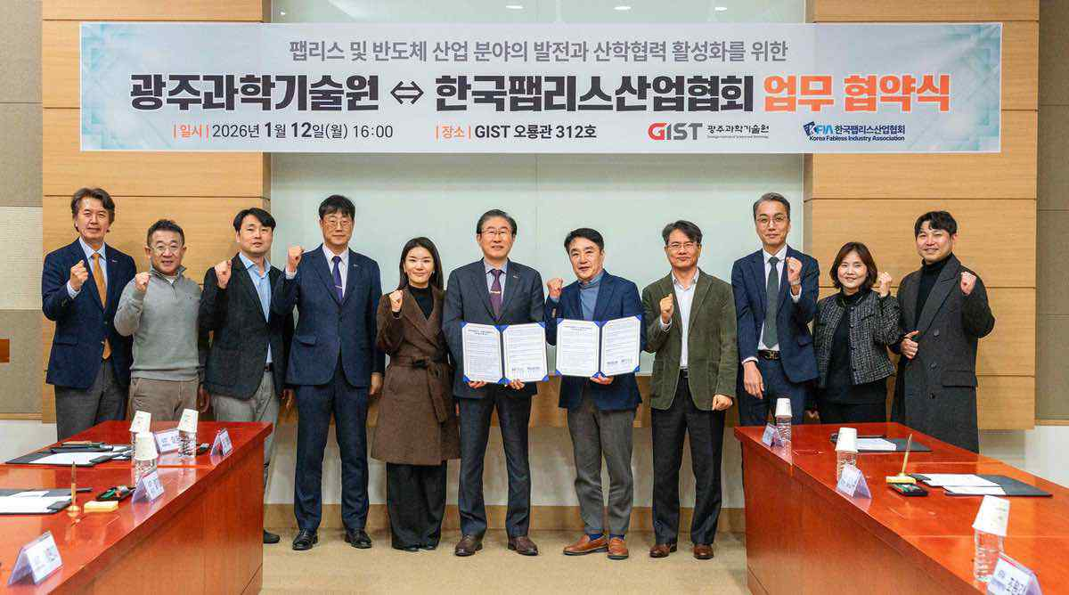

▲ Key officials from GIST and the Korea Fabless Industry Association (KFIA) pose for a commemorative photo after signing an agreement to strengthen the competitiveness of the AI ​​semiconductor industry at a business agreement signing ceremony held at GIST's Oryong Hall on Monday, January 12th.

The Gwangju Institute of Science and Technology (GIST, President Kichul Lim) and the Korea Fabless Industry Association (KFIA, Chairman Kyung-soo Kim) announced on Monday, January 12th, that they signed a Memorandum of Understanding (MOU) at GIST's Oryong Hall to strengthen the global competitiveness of the domestic AI semiconductor industry and foster a semiconductor ecosystem in the southern region.

This agreement aims to build a full-cycle AI semiconductor ecosystem encompassing design, manufacturing, packaging, and the proof-of-concept (PoC) stage to verify the actual operation of the technology.

This is expected to be a significant turning point for the domestic AI semiconductor industry, enabling it to move beyond a design-centric structure and secure full-cycle integrated competitiveness by connecting university research findings with actual technologies and products in industrial settings.

KFIA, a domestic industry organization representing fabless companies that specialize in design rather than manufacturing semiconductors, will play a key role in this agreement, including ▲ providing field-focused data, ▲ establishing education and research directions based on industry needs, and ▲ participating in joint R&D and government projects.

Specifically, to address the lack of advanced process validation and technology verification infrastructure common to fabless companies, GIST will jointly establish a validation environment with GIST to effectively support complex semiconductor R&D that individual companies would struggle to accomplish on their own.

Through this agreement, GIST plans to leap forward as a research-oriented university with integrated research capabilities spanning the entire cycle, from AI semiconductor design through post-processing and packaging, to real-world validation in areas like energy, mobility, and smart manufacturing, all the way to the AI ​​Transformation (AX), where AI technology is deployed across industries.

In particular, GIST is currently building an "AI Semiconductor Advanced Process Fab" with government support, encompassing the pre- and post-process stages, from the manufacturing of basic semiconductor materials (wafers), to the development of next-generation semiconductors, including AI semiconductors. This facility will serve as the validation and research foundation for this agreement.

Through this, the Gwangju-Jeonnam region is expected to establish a regional cooperative system centered around GIST, linking universities, research institutes, and industry. By completing a full-cycle ecosystem linking AI semiconductor design, packaging, and verification, it will simultaneously promote balanced regional development and foster national strategic industries.

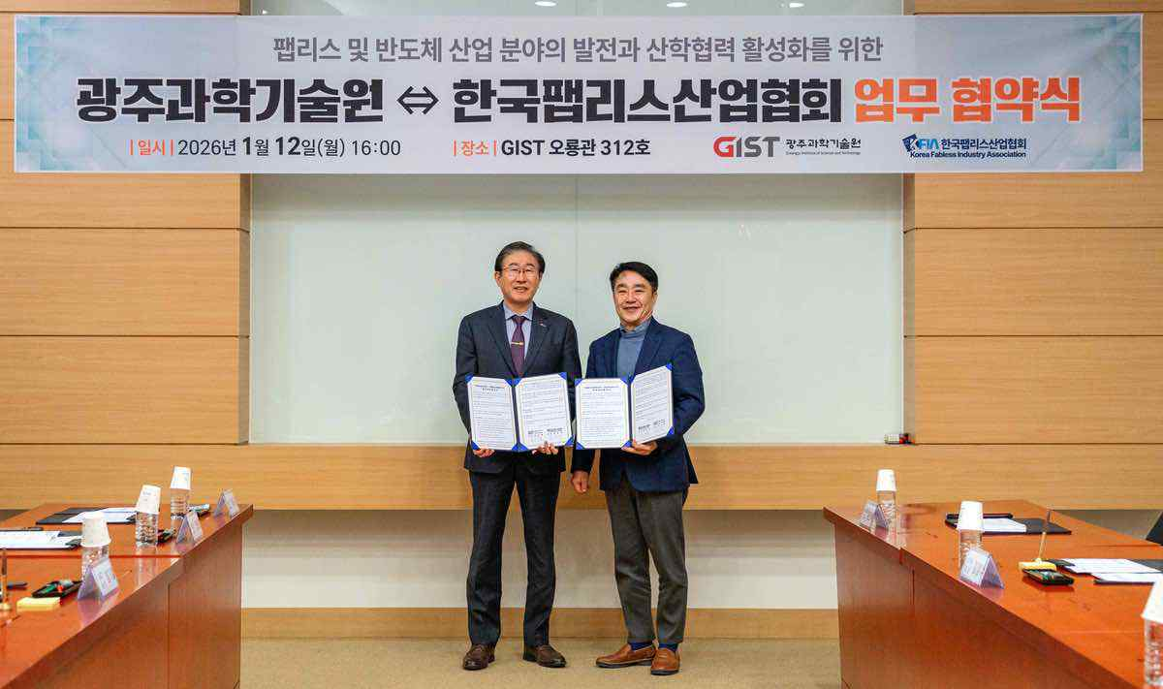

▲ (From left) GIST President Kichul Lim and Korea Fabless Industry Association Chairman Kyung-soo Kim pose for a commemorative photo after signing an agreement on Monday, January 12th to strengthen the competitiveness of the AI ​​semiconductor industry.

GIST President Kichuk Lim said, “GIST is a research-oriented university representing the Honam region, and is the optimal anchor institution to implement the ‘Vortex University’ model in the southern region, where talent, companies, and capital gather, like Stanford University and UC Berkeley in Silicon Valley.” He added, “Through close cooperation with the Korea Fabless Industry Association, we will do our best to enhance the global competitiveness of the domestic AI semiconductor industry and help the southern region grow into a true semiconductor cluster.”

Kyung-soo Kim, Chairman of the Korea Fabless Industry Association, stated, "One of the biggest challenges fabless companies face is the lack of advanced process verification and validation infrastructure." He emphasized, "Through this MOU, we will combine the outstanding research capabilities of both organizations with on-site industrial expertise to accelerate the acquisition of core technologies in the AI ​​semiconductor field and the cultivation of talent tailored to industry needs."

He added, "Through this, we will revitalize the domestic fabless ecosystem and take the lead in enhancing the national competitiveness of Korea's AI industry."

Based on this agreement, the two organizations plan to gradually pursue joint R&D projects, develop customized training programs based on industry needs, and jointly participate in government and local government projects.

In particular, they aim to accelerate the establishment of a technology-verification-focused packaging and back-end verification infrastructure and a regional AX verification platform, with the goal of generating tangible results starting in the second half of 2026.

Meanwhile, prior to the signing, the "Gwangju-Jeonnam Semiconductor Industry Ecosystem Establishment Strategy Forum" was held in the GIST Oryong Hall Multipurpose Hall, co-hosted by Democratic Party of Korea Representative Hyung-bae Min and the Gwangju-Jeonnam Integrated Semiconductor Forum Preparatory Committee.

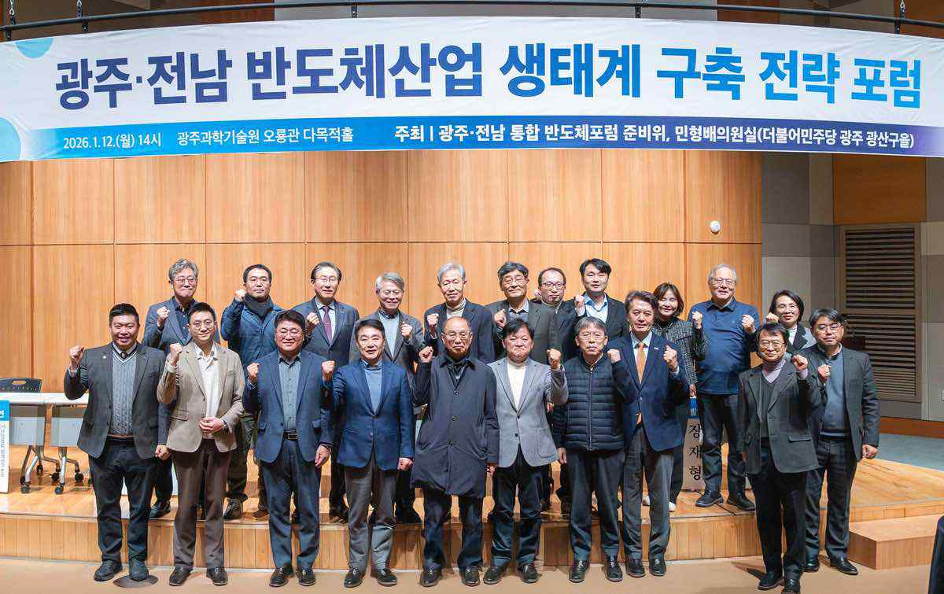

▲ Attendees pose for a commemorative photo at the "Gwangju-Jeonnam Semiconductor Industry Ecosystem Establishment Strategy Forum," held in the GIST Oryong Hall Multipurpose Hall on Monday, January 12th.

This event was planned to develop specific implementation strategies to elevate Gwangju-Jeonnam as a key hub for system semiconductors and back-end processing (packaging) in line with the government's K-Semiconductor Vision for the AI ​​Era.

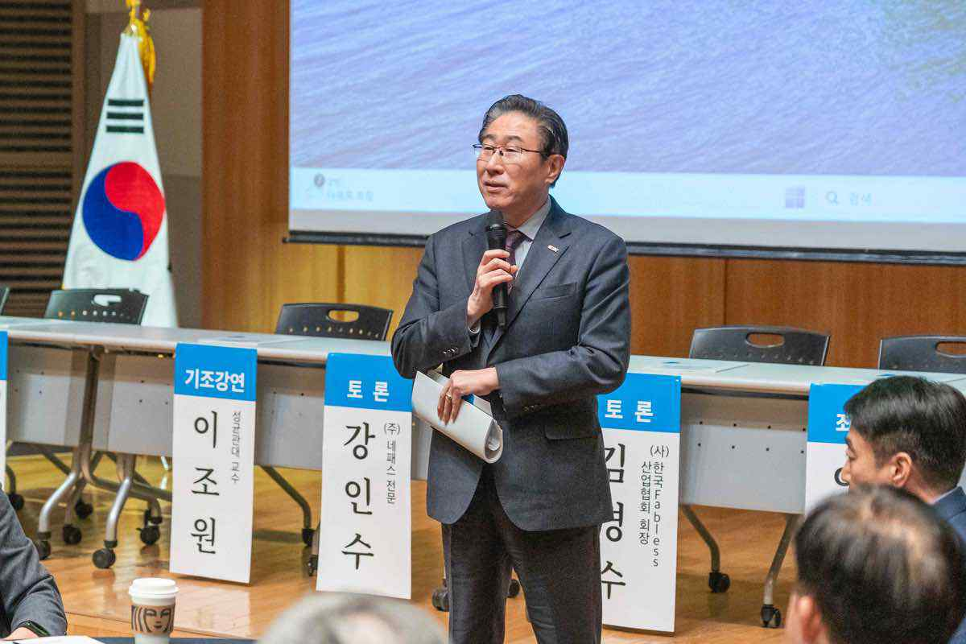

▲ GIST President Kichul Lim delivers a welcoming address at the "Gwangju-Jeonnam Semiconductor Industry Ecosystem Establishment Strategy Forum."

The forum featured keynote speeches by ▴ Secretary General Ki-hyun Ahn of the Korea Semiconductor Industry Association, ▴ KFIA Policy Research Director Kyu-min Han, and Professor Jo-won Lee of Sungkyunkwan University. Presentations were also given by ▴ Professor Duk-Jo Kong of the GIST AI Policy Strategy Graduate School, ▴ Professor Jong-seon Maeng of the Chonnam National University Semiconductor Research Institute, and ▴ Dean Jae-hyung Jang of the Korea Institute of Energy Engineering (KENTECH). A comprehensive discussion was held with experts from industry, academia, and research, including Sun-wook Hwang, CEO of Arm Korea, to discuss in-depth measures to foster the semiconductor industry in Gwangju and Jeonnam.



