GIST's Animal Experiment Ethics Committee selected as an "Excellent Institution" for 2025

- Recognized for excellent operational performance in an evaluation conducted by the Animal and Plant Quarantine Agency for institutions with established animal experimentation ethics committees under the Animal Protection Act… Positive evaluation for prioritizing a balance between science and ethics beyond meeting legal standards

- GIST Laboratory Animal Resource Center, Korea's largest rodent research facility, systematically manages animal experiments… Promoting bioethical values ​​through community-linked activities such as ethics education and youth life science camps



▲ Officials from the GIST Laboratory Animal Resource Center's Animal Ethics Committee pose for a commemorative photo after being selected as an excellent institution in the "2025 Guidance and Supervision of Institutions Establishing Animal Experimentation Ethics Committees." (From left) GIST Laboratory Animal Resource Center Director Dae-Ho Park, veterinarians Jeong-hyeon Lim, Chang-hwan Jeon, Jin-joo Choi, Eun-joo Kim, and Dong-oh Kang

The Gwangju Institute of Science and Technology (GIST, President Kichul Lim) announced that it was selected as an "Excellent Institution (President of the Animal and Plant Quarantine Agency Award)" in the "2025 Guidance and Supervision of Institutions Establishing Animal Experimentation Ethics Committees" evaluation hosted by the Animal and Plant Quarantine Agency (APQA), in recognition of its outstanding performance in animal experimentation ethics and overall committee operation.

A total of three institutions were selected as excellent institutions for the 2025 Animal Experimentation Ethics Committees: Gachon University's Gil-Ya Cancer and Diabetes Research Institute (top institution), Korea BMI Co., Ltd., and GIST (both excellent institutions). The selection results were notified to each institution via official notice on Wednesday, the 24th.

This selection is the result of an evaluation conducted on institutions that have established an Animal Experiment Ethics Committee nationwide in accordance with Article 58 of the Animal Protection Act. The Animal Experiment Ethics Committee operated by the GIST Laboratory Animal Resource Center (Director Dae-Ho Park) received high marks for enhancing the ethics of animal experiments and the efficiency of committee operation.

This demonstrates that the organization's approach, which prioritizes a balance between science and ethics, goes beyond simply meeting legal standards and has been positively evaluated.

* Institutional Animal Care and Use Committee (IACUC): This is a mandatory organization established within an institution to ensure the protection and ethical handling of laboratory animals, pursuant to Article 51 of the Animal Protection Act and Article 7 of the Laboratory Animals Act. Its role is to review, guide, and supervise the ethical and scientific validity of animal experimentation plans.

The foundation of these achievements lies in the nation's best-in-class laboratory animal research infrastructure and the professional operational system supporting it.

Opened in May 2017, the GIST Laboratory Animal Resource Center is the largest rodent research facility in Korea, built with a total project cost of 18.2 billion won. It features state-of-the-art infrastructure, including clean breeding rooms, an infection laboratory (BL-2), histology and clinical pathology, and quarantine and health monitoring laboratories.

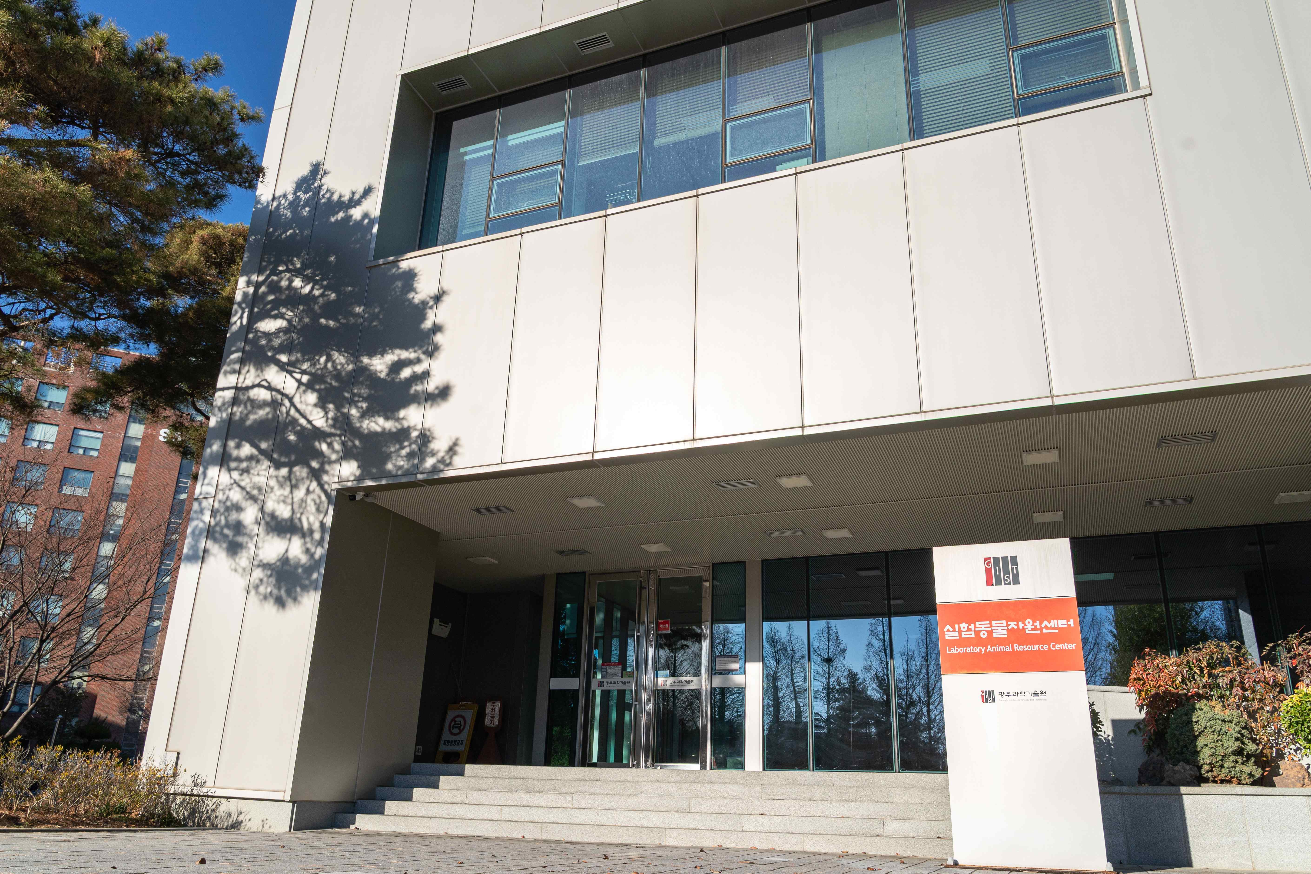

▲ Panoramic view of the GIST Laboratory Animal Resource Center

All breeding rooms feature individually ventilated cages (IVCs) to minimize cross-contamination. Designs that consider both energy efficiency and animal welfare ensure a safe and stable research environment.

Building on this infrastructure, the Center has established a laboratory animal management system that considers both ethics and research reliability, based on the "3R Principle*" of animal testing. By providing customized technical support tailored to research needs, including genetically modified mouse production, decontamination support, and tissue and clinical pathology analysis, the Center serves as a key infrastructure that enhances both research efficiency and reliability.

* The 3R Principle of Animal Testing: This stands for Replacement, Reduction, and Refinement. It is a priority consideration when planning animal testing and is stipulated in the Animal Protection Act.

Furthermore, the GIST Laboratory Animal Resource Center systematically supports the operation of the Animal Experiment Ethics Committee, ensuring that researchers can fully adhere to legal and ethical standards and focus on their research.

Through rigorous prior review of animal experiment protocols, continuous monitoring of animal use and management, and ongoing ethics education and life-respecting campaigns, the center strives to ensure ethical awareness is naturally embedded in research settings.

In particular, the Center has enhanced its Post-Action Monitoring (PAM)* system, which monitors the progress of approved animal experiments as planned. This minimizes animal suffering while enhancing the objectivity and reproducibility of research results.

Furthermore, the Center regularly operates a "Life Science Camp" for youth, continuing its efforts to spread bioethical values ​​in partnership with the local community.

* Post-Approval Monitoring (PAM): This system verifies and confirms that animal experiments approved by the Animal Experiment Ethics Committee are being conducted appropriately according to the approved terms. Through monitoring, guidance, and advice throughout the experimental process, it continuously manages animal welfare and compliance with research ethics.

This systematic management and transparent operational performance not only meets the ethical standards required for domestic and international research collaborations, but also serves as a crucial foundation for enhancing the external credibility of GIST's life science research.

Dae-Ho Park, Director of the GIST Laboratory Animal Resource Center (Professor of Life Sciences and Chair of the Animal Experiment Ethics Committee), stated, "This award is official recognition of GIST's efforts to operate the committee professionally and transparently, emphasizing ethical responsibility in animal experiments as a core value." He added, "We will continue to faithfully implement the 3R principles of animal experimentation and continuously strengthen our advanced post-management system to create a world-class research environment that enhances both animal welfare and research reliability."



