GIST ranks one tier higher in overall integrity
Improvements achieved through institutional reforms… In the public university sector, the integrity effort index rose two tiers from Grade 3 to Grade 2

- The Anti-Corruption and Civil Rights Commission announced the "2025 Comprehensive Integrity Evaluation of Public Institutions"... Among the "Integrity Efforts" indicators, the "Interest and Effort of the Institutional Leader" category significantly exceeded the national and public university average (+8.4 points)

- Establishing a systematic anti-corruption and integrity promotion foundation through the operation of an integrity control tower was recognized as a best practice

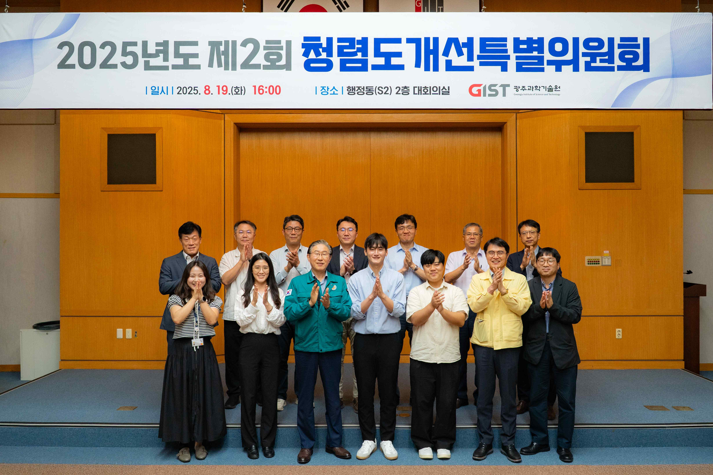

▲ GIST holds special committee to improve integrity

The Gwangju Institute of Science and Technology (GIST, President Kichul Lim) announced that it achieved a Grade 3 overall integrity rating in the national and public university category in the "2025 Comprehensive Integrity Evaluation of Public Institutions" conducted by the Anti-Corruption and Civil Rights Commission, rising one level from the 2023 evaluation.

GIST received a Grade 2 in the "Integrity Efforts" index, which evaluates anti-corruption efforts and institutional improvements, achieving a two-level improvement compared to the previous evaluation. This demonstrates that university-level integrity policy implementation has led to improvements in the evaluation indicators.

GIST's most significant achievement in this evaluation was the significant improvement in the Integrity Efforts index, which led to an increase in its overall integrity rating.

In the "Institutional Leader's Interest and Efforts" sub-category of the Integrity Efforts sub-category, GIST scored 8.4 points higher than the national and public university average. This demonstrates that integrity policies spearheaded by key executives have been steadily established throughout the organization.

Since GIST received a 4th grade in comprehensive integrity in the 2023 evaluation, the president has personally reviewed integrity issues and comprehensively reorganized policies and implementation systems. These changes have led to an increase in the overall rating in this evaluation.

To date, GIST has consistently implemented various measures, focusing on areas vulnerable to corruption. These include: ▴ reviewing integrity initiatives led by the president; ▴ restructuring the integrity and anti-corruption promotion system; ▴ expanding customized and targeted integrity education for all members; ▴ operating participatory integrity campaigns and an Integrity Intensive Week; and ▴ preventing corruption through system and procedure improvements.

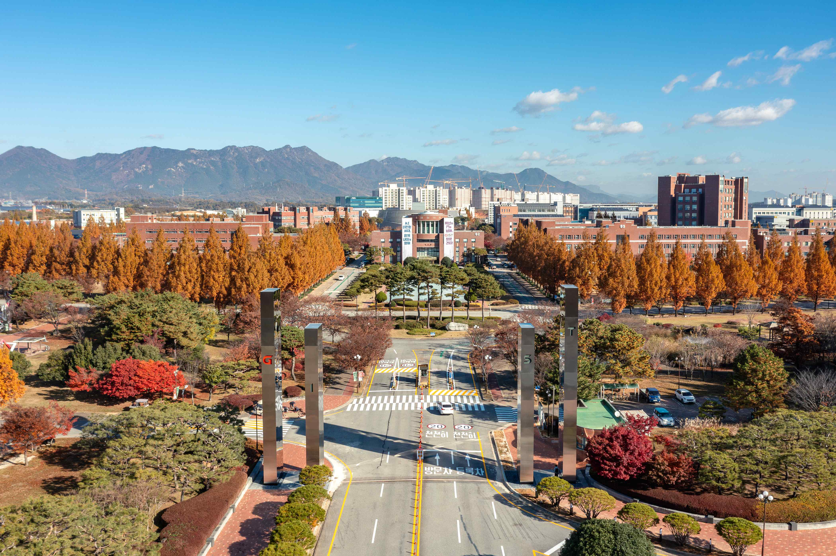

▲ Panoramic view of the GIST campus

As a result of these efforts, GIST has been recognized as a model for excellence in the field of anti-corruption and integrity promotion systems. The Anti-Corruption and Civil Rights Commission praised GIST for its systematic establishment and operation of an anti-corruption and integrity promotion system. This system includes the "GIST Integrity Improvement Special Committee," chaired by the president, operating an Integrity Improvement Working Council and an Integrity Promotion Team, and forming an Integrity Advisory Group comprised of faculty, researchers, staff, and student representatives.

President Kichul Lim stated, "In this first comprehensive integrity assessment since my inauguration, the two-level improvement in the integrity effort index compared to the previous assessment is a result of the collaborative efforts of all members." He added, "It is significant that our consistent efforts to prioritize integrity as a core value and to implement systemic improvements and on-site inspections have been recognized in this evaluation."

He continued, "We will continuously review all systems and operations to ensure that more members can experience a culture of integrity in their daily lives. We will strive to establish ourselves as a university where integrity is a daily part of everyday life and one trusted by society."



