"The Future of Energy, Growing in the City of Light" GIST launches next-generation solar energy and AI energy materials research centers

- Opening of the 'Solar and Photovoltaic Energy Systems Research Center (Director Hee Joo Kim)' and the 'AI Energy Materials and Analysis Center (Director Soo-young Jang)'…Securing leadership in next-generation solar power technology and promoting innovation in the energy materials supply chain

- Supporting carbon neutrality and energy security strategies through AI-integrated core technology research…Enhancing regional and national strategic technology competitiveness in Gwangju and Jeonnam through verification of research results and strengthening industry collaboration

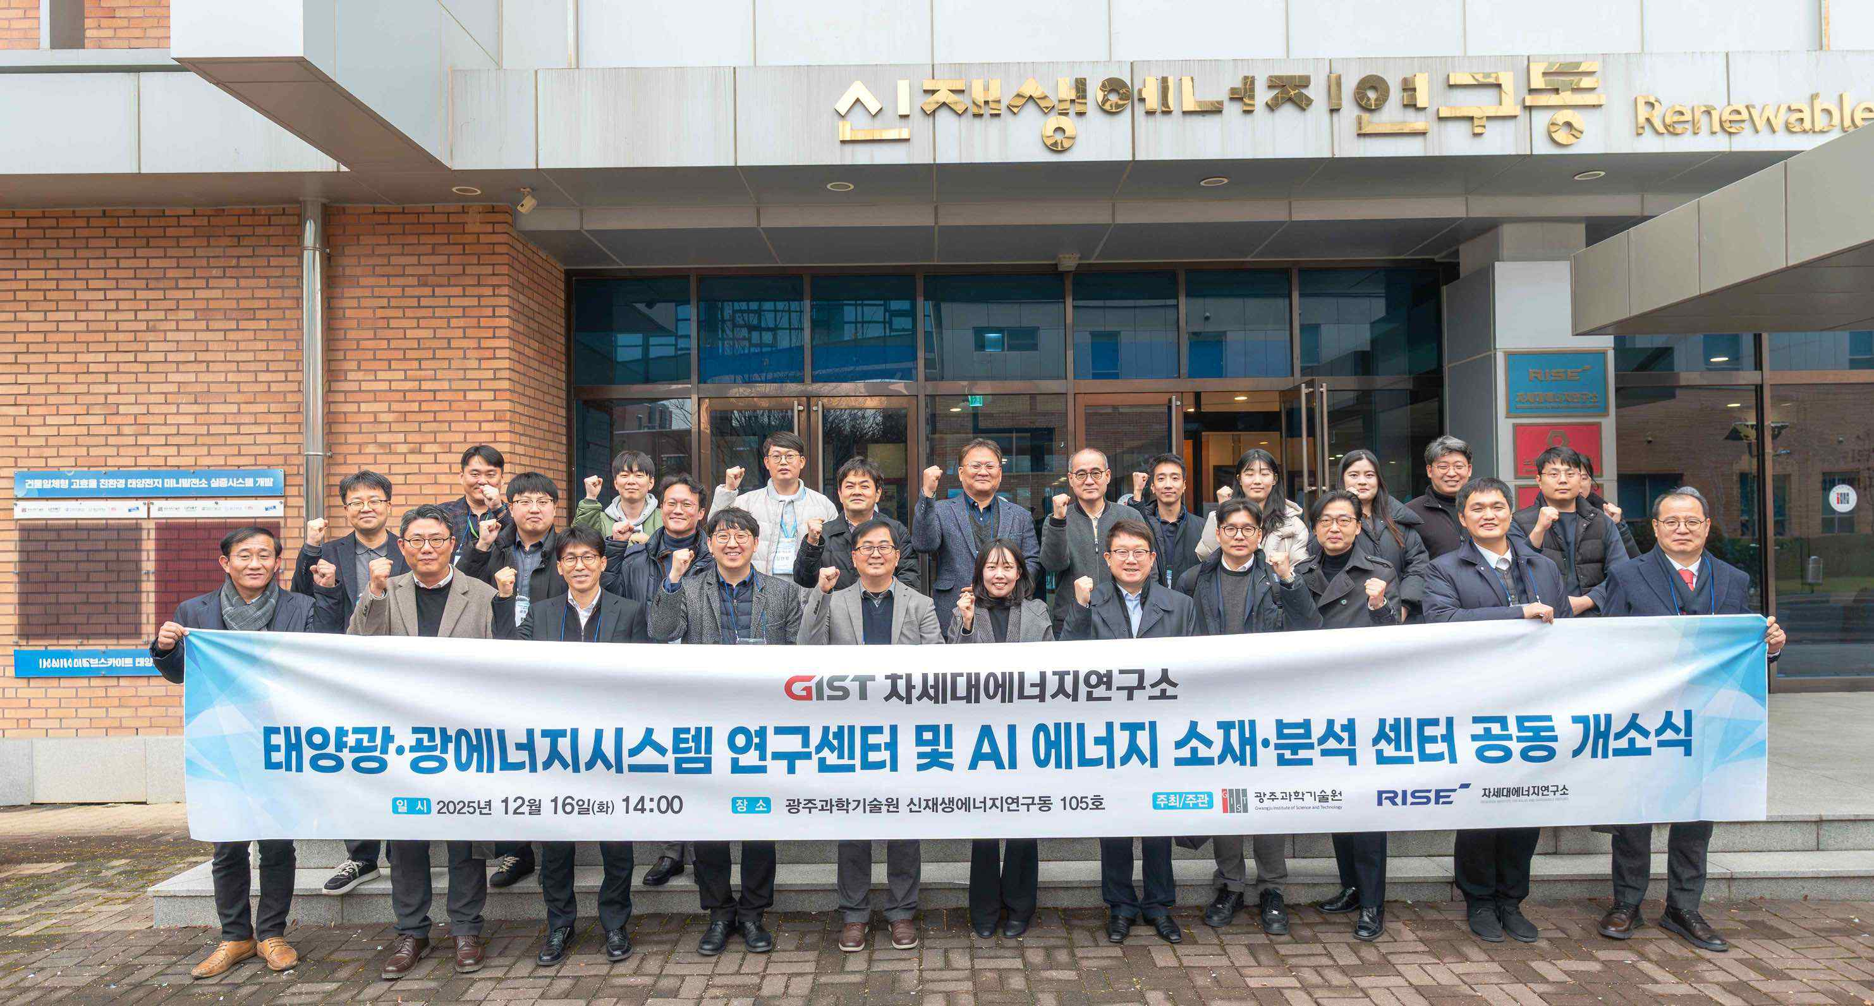

▲ Attendees pose for a commemorative photo at the joint opening ceremony of the GIST Solar and Photovoltaic Energy Systems Research Center and the AI Energy Materials and Analysis Center.

The Gwangju Institute of Science and Technology (GIST, President Kichul Lim) announced the opening of the "Photovoltaic and Photonic Energy Systems Research Center" (Director: Professor Hee Joo Kim, Department of Chemistry) and the "AI Energy Materials and Analysis Center" (Director: Research Professor Soo-young Jang, Research Institute for Solar and Sustainable Energies) in response to the competition for leadership in next-generation solar power technology and the trend of innovation in the energy materials supply chain based on artificial intelligence (AI).

The opening of these two research centers is significant in that, amidst the accelerating global competition for next-generation solar power technology and the restructuring of the energy materials supply chain, they consolidate GIST's research capabilities to establish a research foundation encompassing everything from securing core technologies to verification and industrial linkages. They are particularly noteworthy for establishing a research base that proactively responds to national carbon neutrality policies and energy security strategies by combining next-generation solar power and energy materials with AI technology.

The opening ceremony was held on Tuesday, December 16th at the GIST Research Institute for Solar and Sustainable Energies. Approximately 50 people* attended, including GIST faculty, local government officials, industry representatives, and research institutes.

* participating organizations: Gwangju Metropolitan City, Korea Energy Agency, Korea Institute of Industrial Technology, Korea Electronics Technology Institute, Korea Photonics Technology Institute, Gwangju Research Institute, and the AI ​​Industry Convergence Business Group, including approximately 15 organizations.

The event began with a welcoming address by Kang Hong-gyu, Vice Director of the GIST Research Institute for Solar and Sustainable Energies. Congratulatory remarks followed from GIST Vice President for R&DB Yong-Chul Kim, Korea Energy Agency Gwangju-Jeonnam Regional Headquarters Director Seung-chan Jang, and Gwangju Metropolitan City Energy Industry Division Director Jun-sik Park. Center Directors Hee Joo Kim and Soo-young Jang, respectively, presented the center's founding principles, research vision, and future plans.

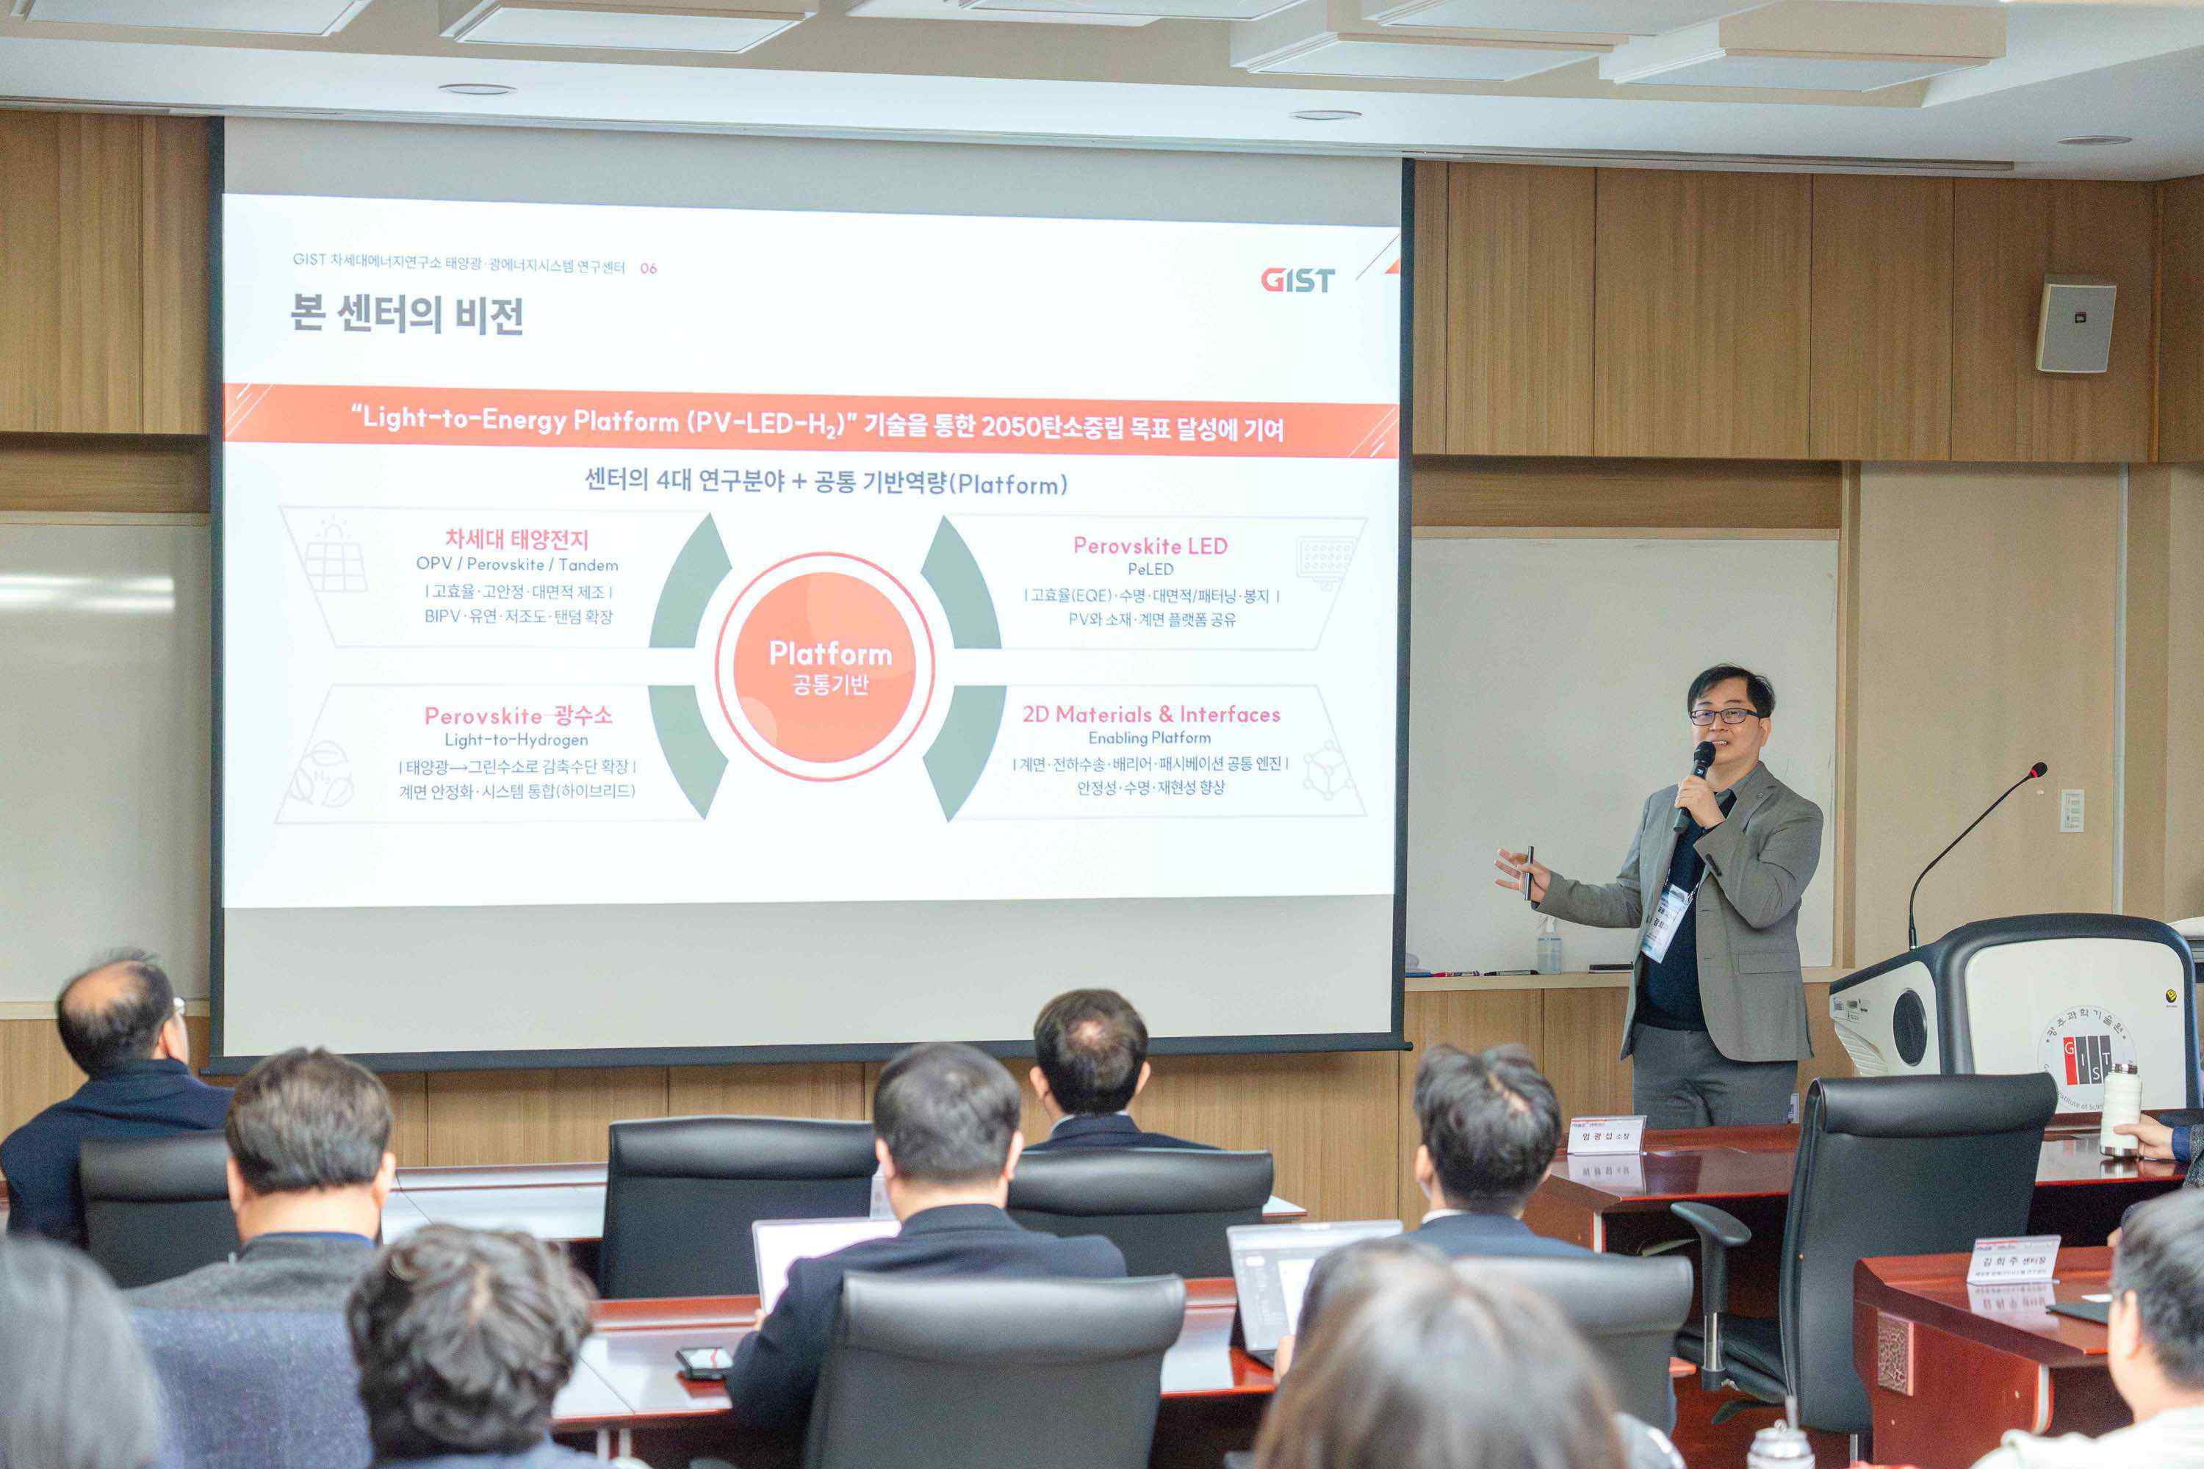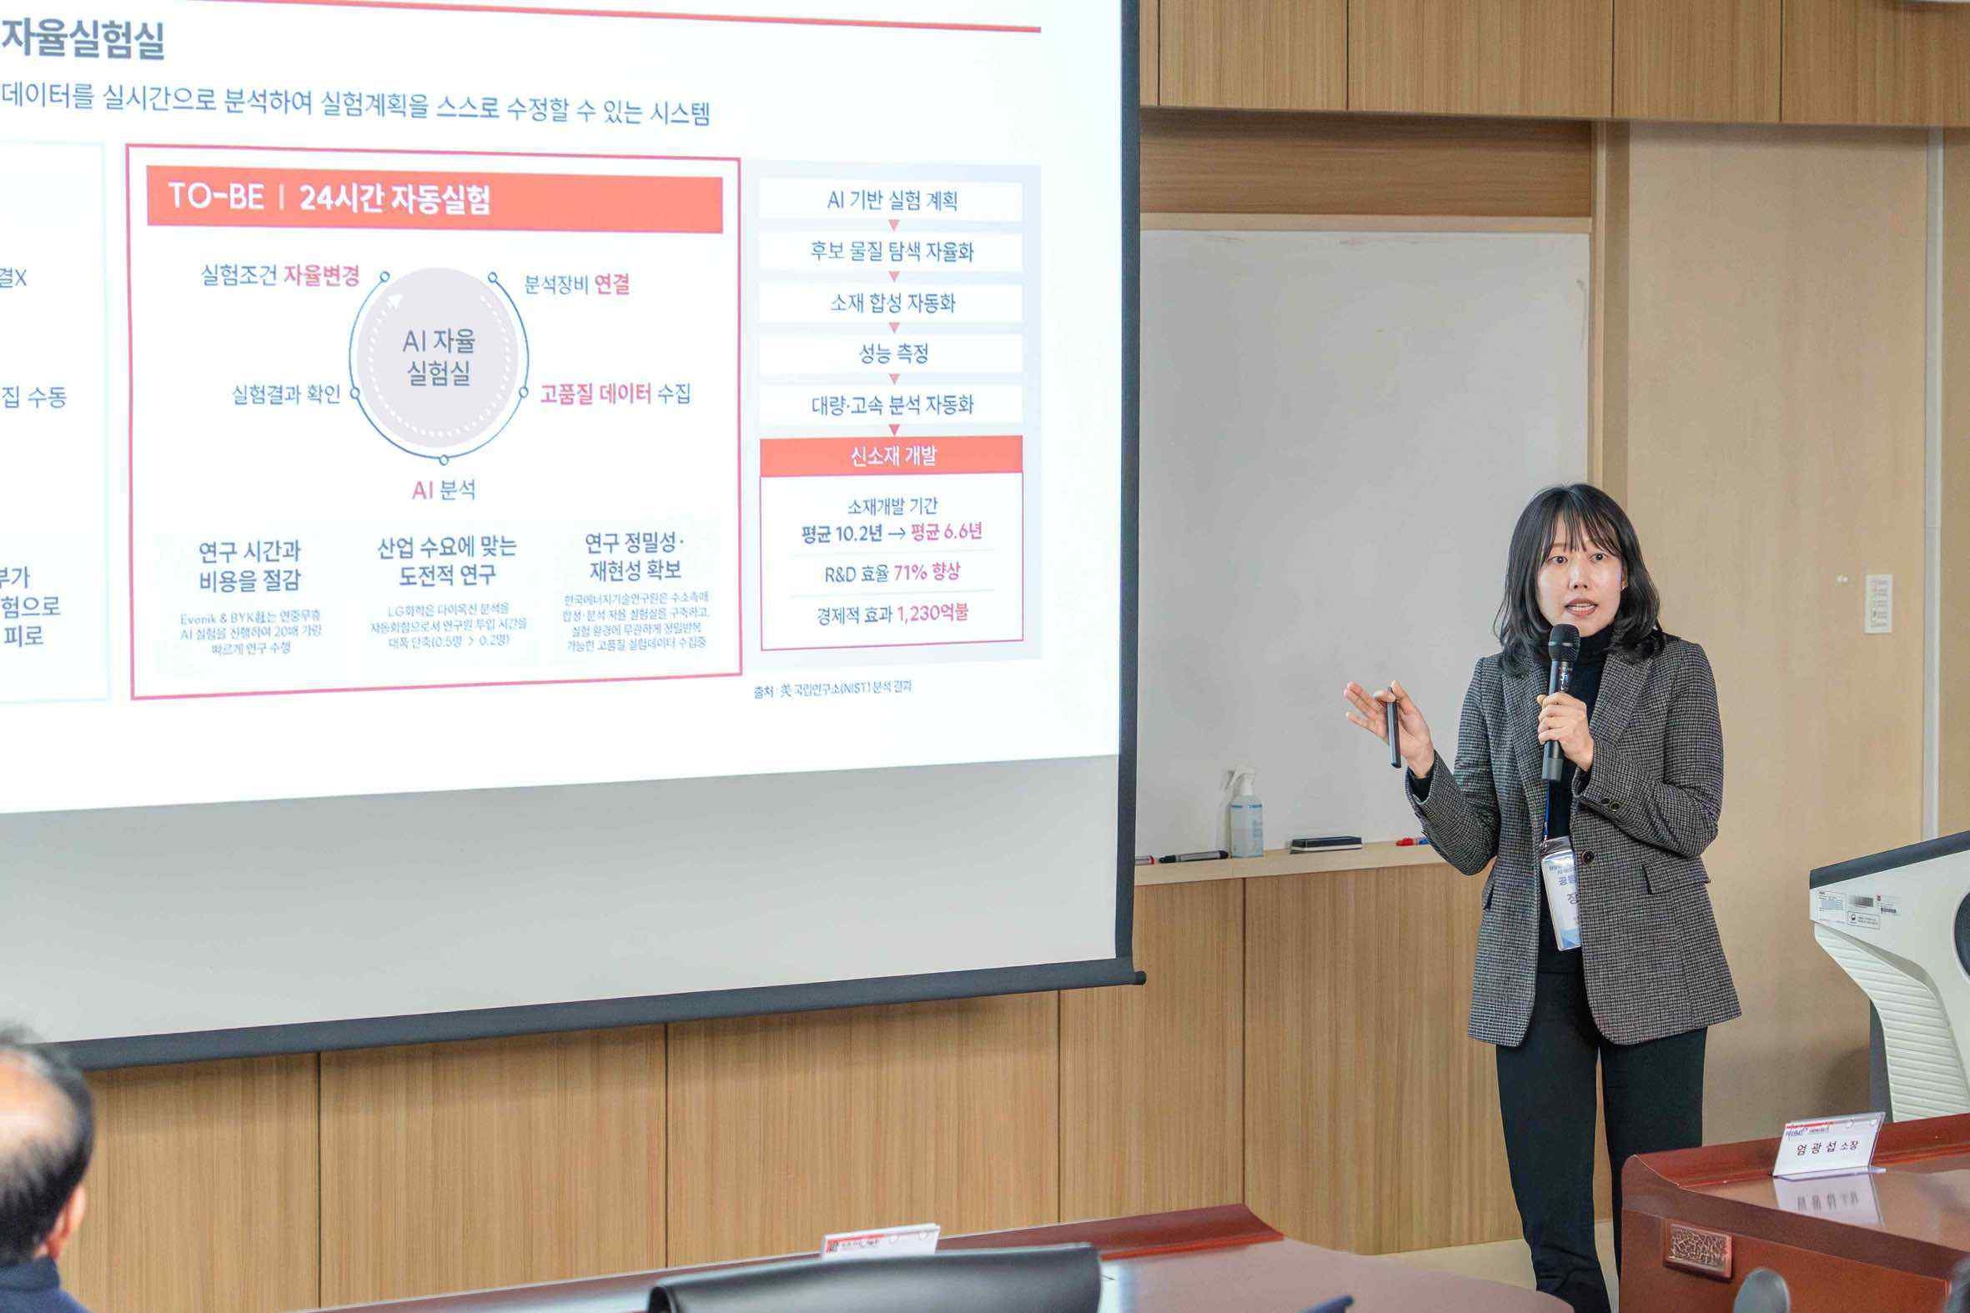

▲ Hee Joo Kim, Director of the Solar and Photovoltaic Energy Systems Research Center (left), and Soo-young Jang, Director of the AI Energy Materials and Analysis Center (right), present the center's founding principles, research vision, and future plans to attendees at the opening ceremony.

The two research centers plan to pursue core source technology research focused on securing leadership in next-generation solar energy technology and innovating the energy materials supply chain, focusing on ▴ next-generation solar energy (perovskite and organic solar cells), ▴ photovoltaic energy systems, ▴ photoelectrochemical-based energy conversion, ▴ organic-inorganic hybrid electronic materials, and ▴ AI-based autonomous experiments on energy materials.

Furthermore, in line with the national carbon neutrality policy, we plan to expand the potential for next-generation solar technology demonstrations. In the energy materials sector, we will also conduct commercialization research with an eye toward improving the supply chain structure encompassing hydrogen, batteries, and solar power.

Hee Joo Kim, Director of the Solar and Photovoltaic Energy Systems Research Center, stated, "Next-generation solar technology is a key energy transition tool in the carbon-neutral era, and securing technological leadership is paramount. Building on GIST's accumulated research capabilities in perovskite, organic solar cells, and photovoltaic systems, we will contribute to securing global leadership in next-generation solar technology."

Director Kim served as a postdoctoral researcher in the laboratory of Professor Alan J. Heeger (University of California, Santa Barbara, USA), winner of the 2010 Nobel Prize in Chemistry. He has expanded the link between academia, industry, and policy through joint research on solar cells between Korea and the US and academic activities.

Soo-young Jang, Director of the AI Energy Materials and Analysis Center, said, “The energy materials field is at a point where a shift in research methods is required due to global supply chain instability and intensifying technological competition,” and added, “We will contribute to innovation in the energy materials supply chain encompassing hydrogen, batteries, and solar power through AI-based autonomous experiments and analysis.”

Director Jang served as a visiting researcher in Professor Martin Heeney's research group at Imperial College London. Based on his research in new material synthesis and organic electronic materials, he has collaborated with domestic and international researchers and industries to promote the industrial application and technological dissemination of his research findings.

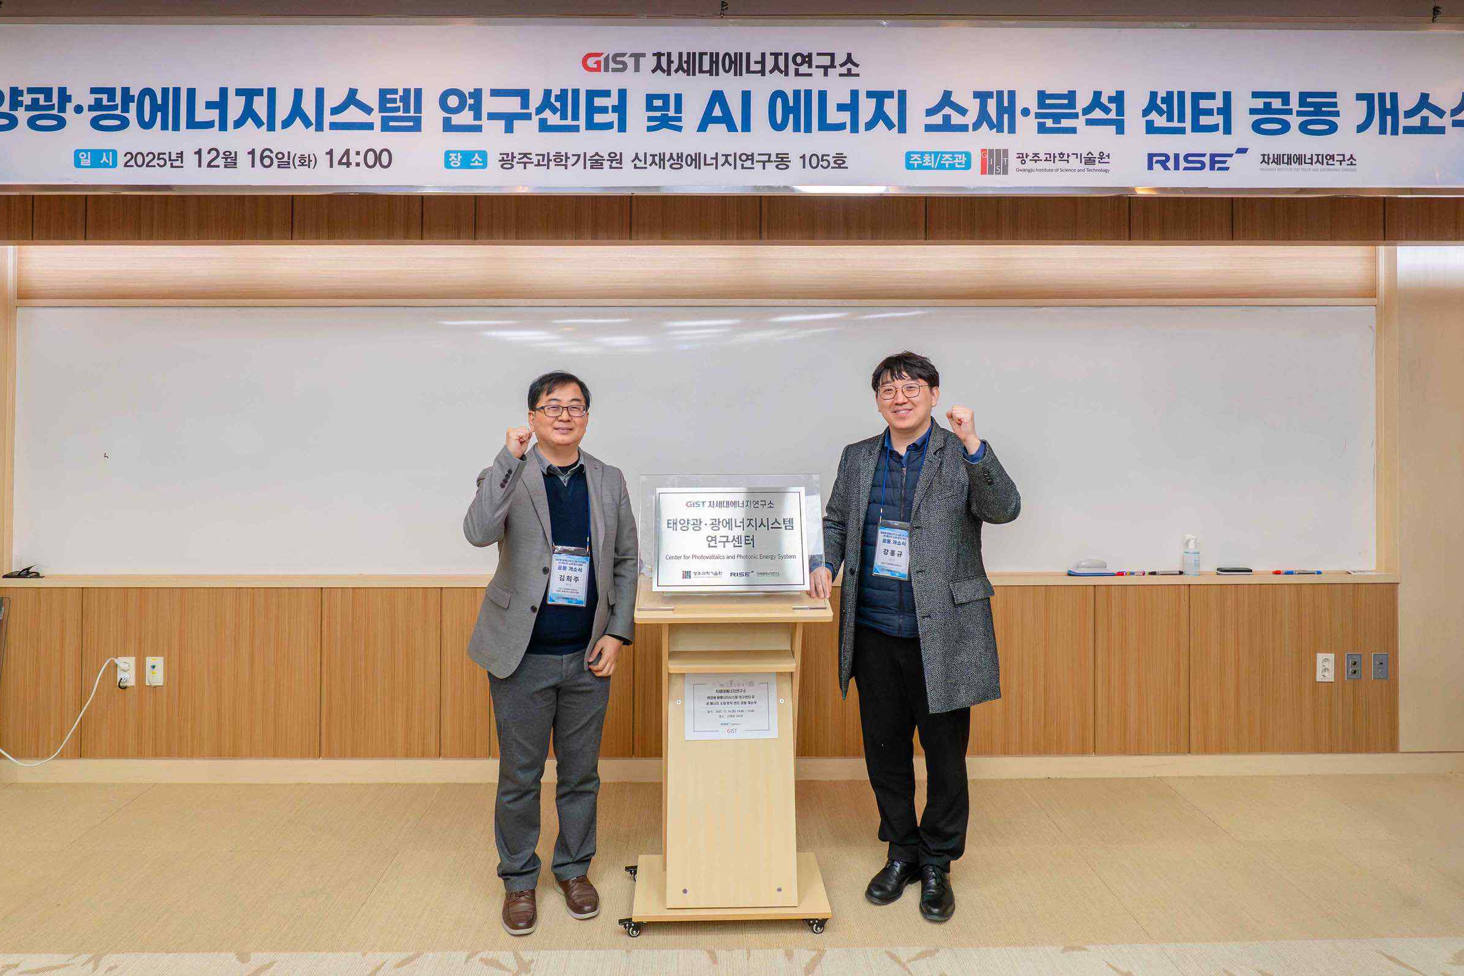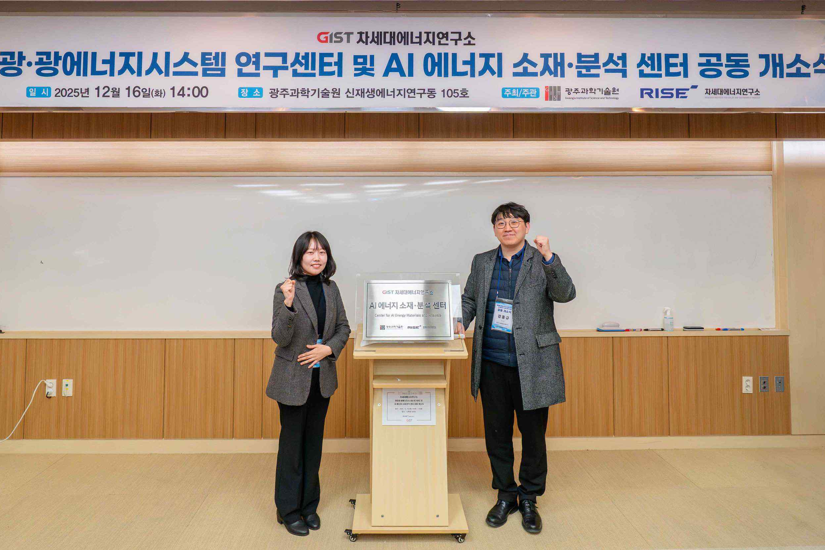

▲ Unveiling the plaque at the joint opening ceremony of the GIST Photovoltaic and Photonic Energy Systems Research Center and the AI ​​Energy Materials and Analysis Center. (Left) Hee Joo Kim, Director of the Solar and Photovoltaic Energy Systems Research Center, and Hongkyu Kang, Vice Director of the Research Institute for Solar and Sustainable Energies. (Right) Soo-young Jang, Director of the AI Energy Materials and Analysis Center, and Hongkyu Kang, Vice Director of the Research Institute for Solar and Sustainable Energies.

With the opening of these two research centers, GIST plans to simultaneously pursue leadership in next-generation photovoltaic technology and innovation in the energy materials supply chain, in line with the government's policies for commercializing next-generation photovoltaic technology and expanding renewable energy, as well as the AI ​​Great Transformation Innovation Strategy.

Through this, the plan is to gradually expand the verification of research results and industrial linkages centered on the Gwangju and Jeonnam regions, and to continuously strengthen its role as an energy research and verification hub that supports strengthening national strategic technology competitiveness and securing energy security.



