"Future Careers at GIST Labs" GIST holds "Biohealth Science Camp" for middle and high school students from Hwasun County

- As part of the Hwasun County Healthcare Industry Specialized Talent Development Project, approximately 130 students from Hwasun Dongbok Middle School, Hwasun High School, and Neungju High School participated... Bio-AI convergence lectures and hands-on programs tailored to the learning level of middle school through high school students were provided

- Lectures by biohealth researchers provided career exploration opportunities and hands-on experience at cutting-edge research facilities, including the Advanced Institute of Instrumental Analysis... This is an example of educational cooperation between local science and technology institutes contributing to the development of local talent

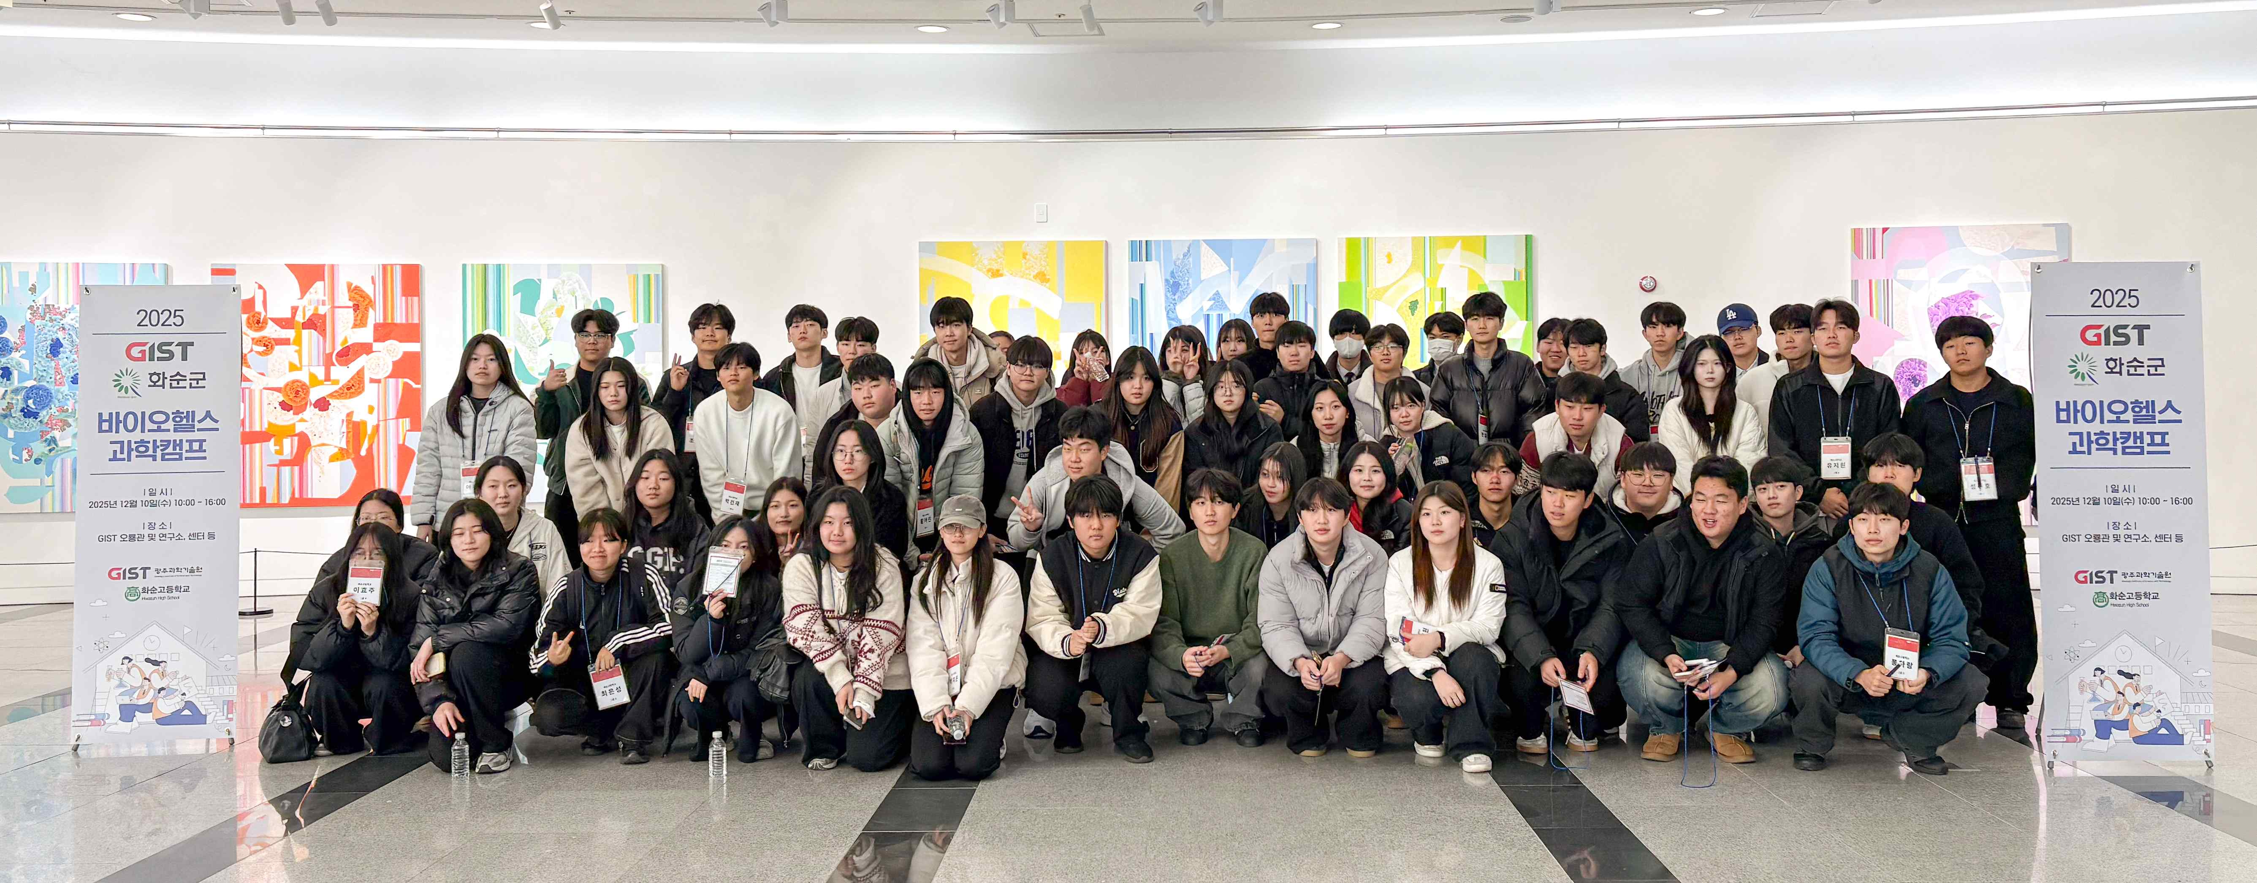

▲ Middle and high school students from the Hwasun area who participated in the "2025 GIST-Hwasun Biohealth Science Camp" pose for a commemorative photo.

The Gwangju Institute of Science and Technology (GIST, President Kichul Lim) announced the successful operation of the "GIST-Hwasun Biohealth Science Camp," a regional science education program in collaboration with Hwasun County, Jeollanam-do.

This science camp was implemented as part of Hwasun County's healthcare industry talent development project. Approximately 130 local middle and high school students from Hwasun Dongbok Middle School, Hwasun High School, and Neungju High School participated. GIST provided a foundation for nurturing talent who can learn and grow locally and advance to universities and industry through educational and experiential programs tailored to each student's learning level, from middle school to high school.

The Neungju High School camp was held for two days, December 15th (Monday) and 16th (Tuesday).

Lectures on bio-AI convergence topics followed, such as ▴ ‘Is Digital Medicine Actually Medicine?’ (Professor Jae Gwan Kim, Department of Biomedical Science and Engineering) ▴ ‘Can We Read Thoughts Through Brain Signals?’ (Professor Mansu Kim, Department of AI Convergence) ▴ ‘How Does the Space Environment Affect Cells?’ (Professor Steve K. Cho, Department of Life Sciences), offering a multidimensional perspective on the expanding direction of the future healthcare industry and the role of science and technology.

Prior to this, science camps were held on Tuesday, the 9th, and Wednesday, the 10th, for students from Hwasun Dongbok Middle School and Hwasun High School, respectively.

The Hwasun Dongbok Middle School camp, designed for middle school students, offered basic life science education and an introduction to the latest research trends, providing a starting point for students to become more familiar with science and explore future career paths.

The lectures, "Organoids: The Story of Mini Organs" (Professor Jin-Wook Choi, Department of Life Sciences) and "Learning Alzheimer's Disease with Animal Models" (Dr. Yumi Lee, Department of Biomedical Science and Engineering), stimulated students' scientific curiosity through real-world research cases and broadened their understanding of the biohealth field.

The Hwasun High School camp offered an in-depth course designed with major selection and career planning in mind, allowing students to directly engage with university-level research topics.

The lectures, "Research on Understanding Life Phenomena with Lasers and Light" (Professor Hyuk Sang Kwon, Department of Biomedical Engineering) and "The Undertaker in Our Body: The Life, Aging, Illness, and Death of Cells" (Professor Dae-Ho Park, Department of Life Sciences), introduced biohealth research topics addressed at universities and in the field, providing students with an opportunity to envision specific majors and career paths.

In addition to lectures, this Biohealth Science Camp included a hands-on program that included tours of GIST's core research facilities, including the Advanced Institute of Instrumental Analysis, Laboratory Animal Resource Center, Advanced Photonics Research Institute, and Supercomputing Center.

Students were able to observe cutting-edge research equipment and the experimental environments where actual research takes place, experiencing firsthand how scientific theories from textbooks are implemented in the field. This naturally deepened their understanding of the actual research process in science and technology and the role of researchers.

The Laboratory Animal Resource Center, in particular, provided pre-sessional training on research ethics and the importance of respect for life, along with on-site explanations, providing a meaningful opportunity to learn about the social responsibility and ethical values ​​inherent in biohealth research.

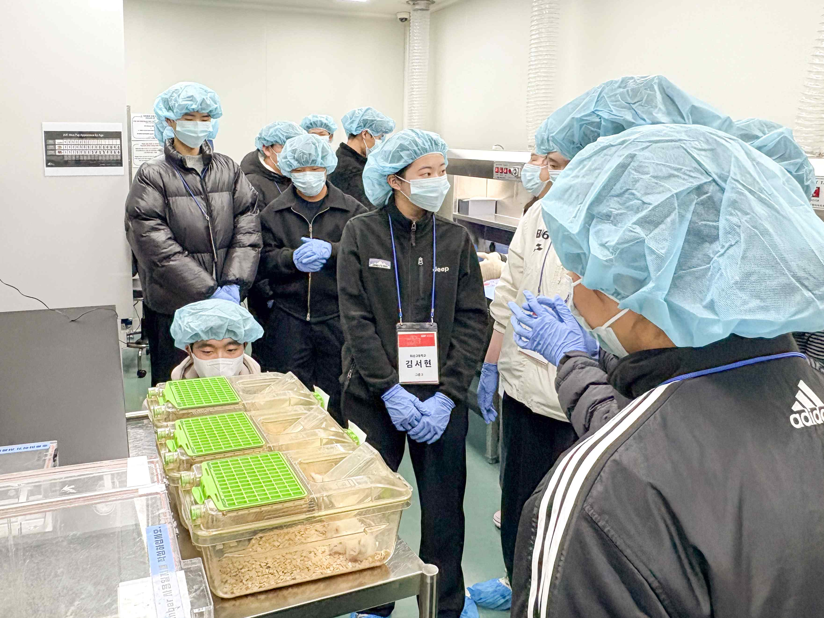

▲ Students participating in the 2025 GIST-Hwasun Biohealth Science Camp are receiving training on research ethics and respect for life at the Laboratory Animal Resource Center.

International and Public Affairs Dean Jae Gwan Kim, stated, "This Biohealth Science Camp is a program that allows local science and technology institutes to directly expose local students to research sites and provide an opportunity to consider careers in science and technology." He added, "By combining Hwasun County's healthcare industry strategy with GIST's research and education capabilities, we will continue to support local students so they can experience world-class science education without having to travel to the metropolitan area."

Meanwhile, this camp was funded by the 2025 Jeonnam Education Development Special Zone Pilot Project budget and is recognized as a representative model of regional, collaborative science education involving local governments, universities, and local schools.



