Connecting the present and future of AI and cultural technology, GIST successfully concludes the "Present and Future of AI & CT Convergence Research" forum

- Hosted by the Ministry of Culture, Sports and Tourism and co-hosted by GIST Korea Culture Technology Institute, the event discussed the future direction of AI and cultural technology convergence at Shilla Stay Seocho in Seoul on December 4th

- Approximately 70 participants from government, industry, academia, and research attended, broadly discussing the present and future of AI and cultural technology from the perspectives of industry, art, policy, law, and institutions

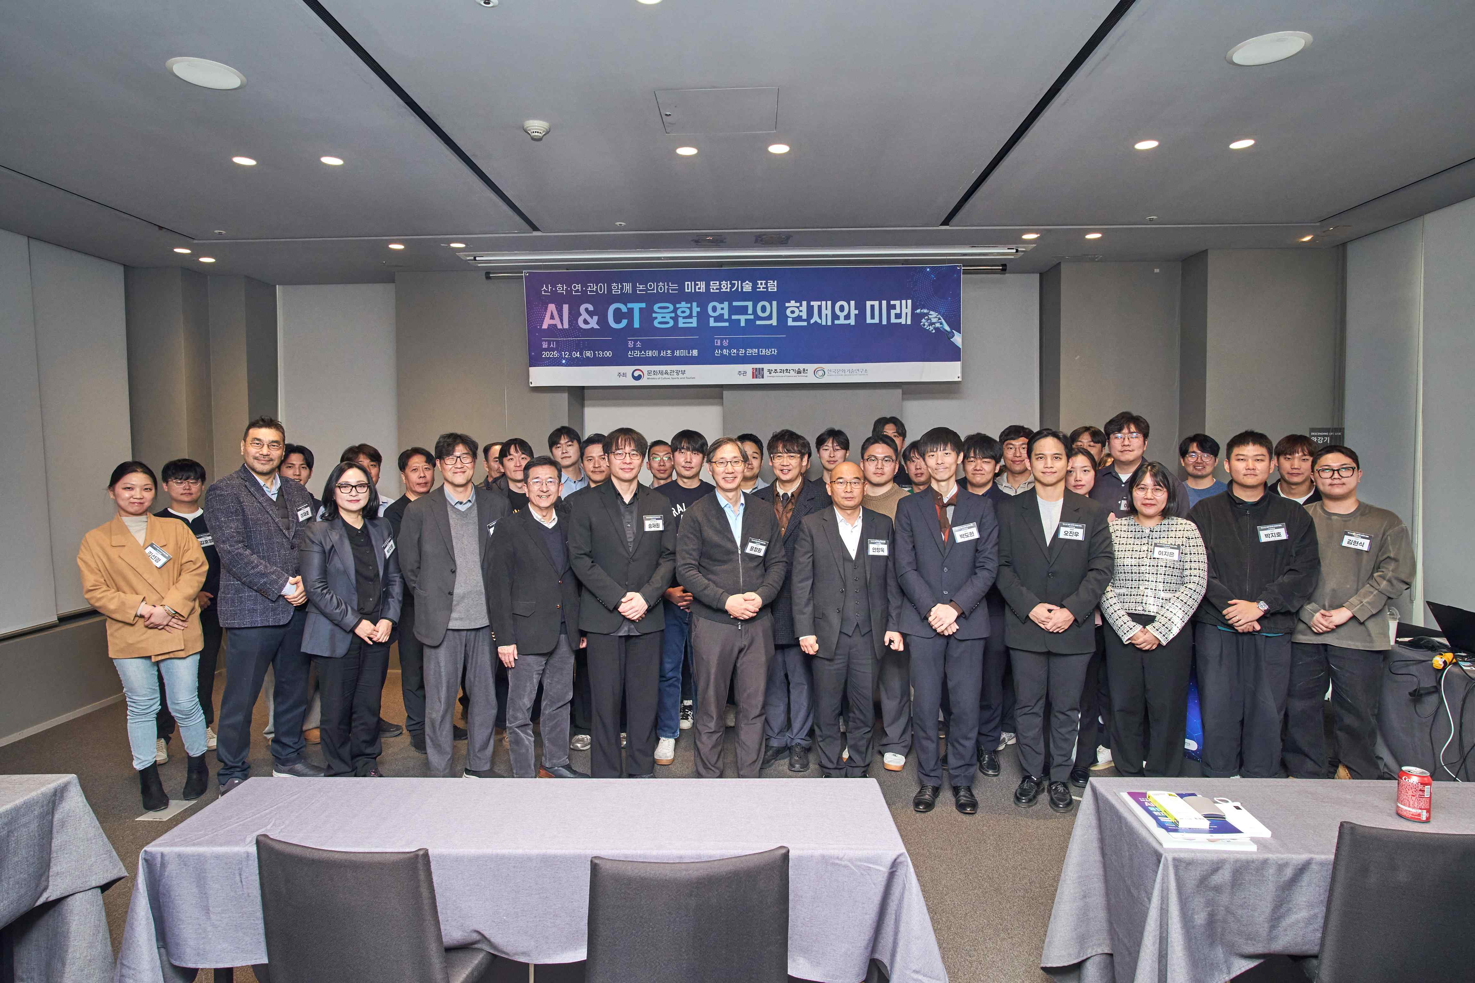

▲ Participants in the "Present and Future of AI & CT Convergence Research" forum, held at Shilla Stay Seocho in Seoul on Thursday, December 4, pose for a commemorative photo after the event.

The Gwangju Institute of Science and Technology (GIST, President Kichul Lim) announced that it held a forum titled "Present and Future of AI & CT Convergence Research" at Shilla Stay Seocho in Seoul on Thursday, December 4, to examine the changes the convergence of AI and CT (cultural technology) will bring to the cultural industry, the arts, and how we enjoy culture in our daily lives.

Hosted by the Ministry of Culture, Sports and Tourism and co-hosted by GIST Korea Culture Technology Institute (Director Jungwon Yoon), the forum brought together approximately 70 participants from government, industry, academia, and research to broadly discuss the present and future of AI and cultural technology from the perspectives of industry, art, policy, law, and institutions.

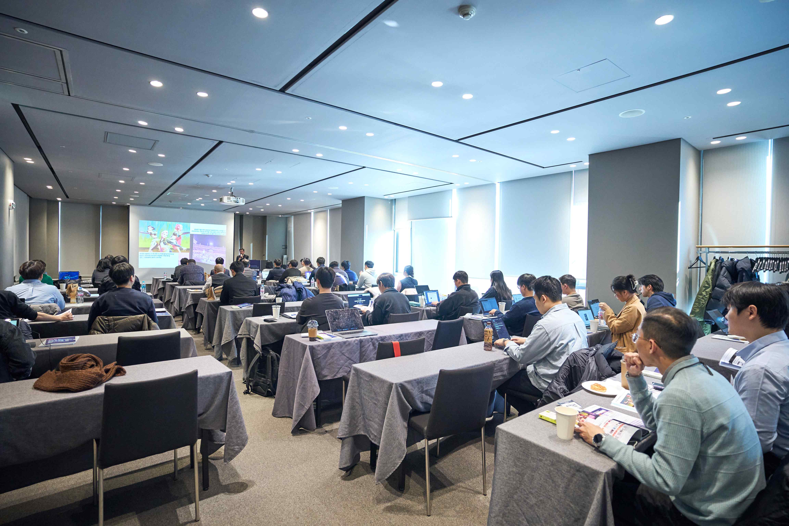

▲ Attendees listen to a presentation on the future of AI and cultural technology convergence at the "Present and Future of AI & CT Convergence Research" forum held at Shilla Stay Seocho in Seoul on December 4th.

In the first session, "The Future of AI & CT Convergence Research,"Don-jeong Kim, a producer at the Korea Creative Content Agency, presented on the topic of "K-Culture and AI Convergence Cultural Technology."

Producer Kim examined the global spread of K-Culture and diagnosed that the convergence of AI and cultural technology is emerging as a key factor in determining the competitiveness of the content industry. Specifically, he predicted that after 2026, cultural technology R&D will be reorganized around hyper-realistic content, personalized technology, and intelligent creative tools.

Following this, Ji-young Park, Director of the Emotional Digital Human Interface Division at the Electronics and Telecommunications Research Institute (ETRI), presented on the topic of "Emotion-Reading Technology: Personalized Experiences Created by AI," introducing how emotional recognition AI is becoming a key technology for providing personalized cultural experiences by analyzing user responses in real time.

Professor Do Hyun Park of the Department of AI Convergence at GIST presented "Key Legal Issues of Generative AI." He addressed legal and institutional challenges posed by the proliferation of generative AI, including copyright infringement, privacy protection, deepfakes, and fake news. He also explained the changing regulatory environment centered around the Framework Act on Artificial Intelligence, scheduled to take effect next year.

The second session, "AI & ART Convergence," highlighted the rapidly blurring boundaries between art and technology.

Professor Jin-joon Lee of KAIST presented "AI and Creativity in the Post-Digital Era," analyzing how AI is evolving beyond a tool for artistic creation to one that expands human imagination and modes of expression.

Jae-won Song, Director of Research at Dexter Studios, presented the rapidly changing VFX production environment driven by generative AI and examples of its use in media art. He explained that AI is becoming a key technology not only for streamlining production processes but also for rapidly producing high-quality video content.

Professor Chang Wook Ahn of GIST emphasized the emerging paradigm of AI-human collaboration in music creation through the case of Korea's first AI composer, "EvoM."

The third session, "Enjoying AI & CT Technology," showcased examples of AI technology being applied in real-world cultural settings.

Director Jungwon Yoon of the Korea Culture Technology Institute demonstrated how AI is effectively expanding cultural accessibility for the information-disadvantaged through examples of cultural services utilizing AI and CT technologies for the visually impaired.

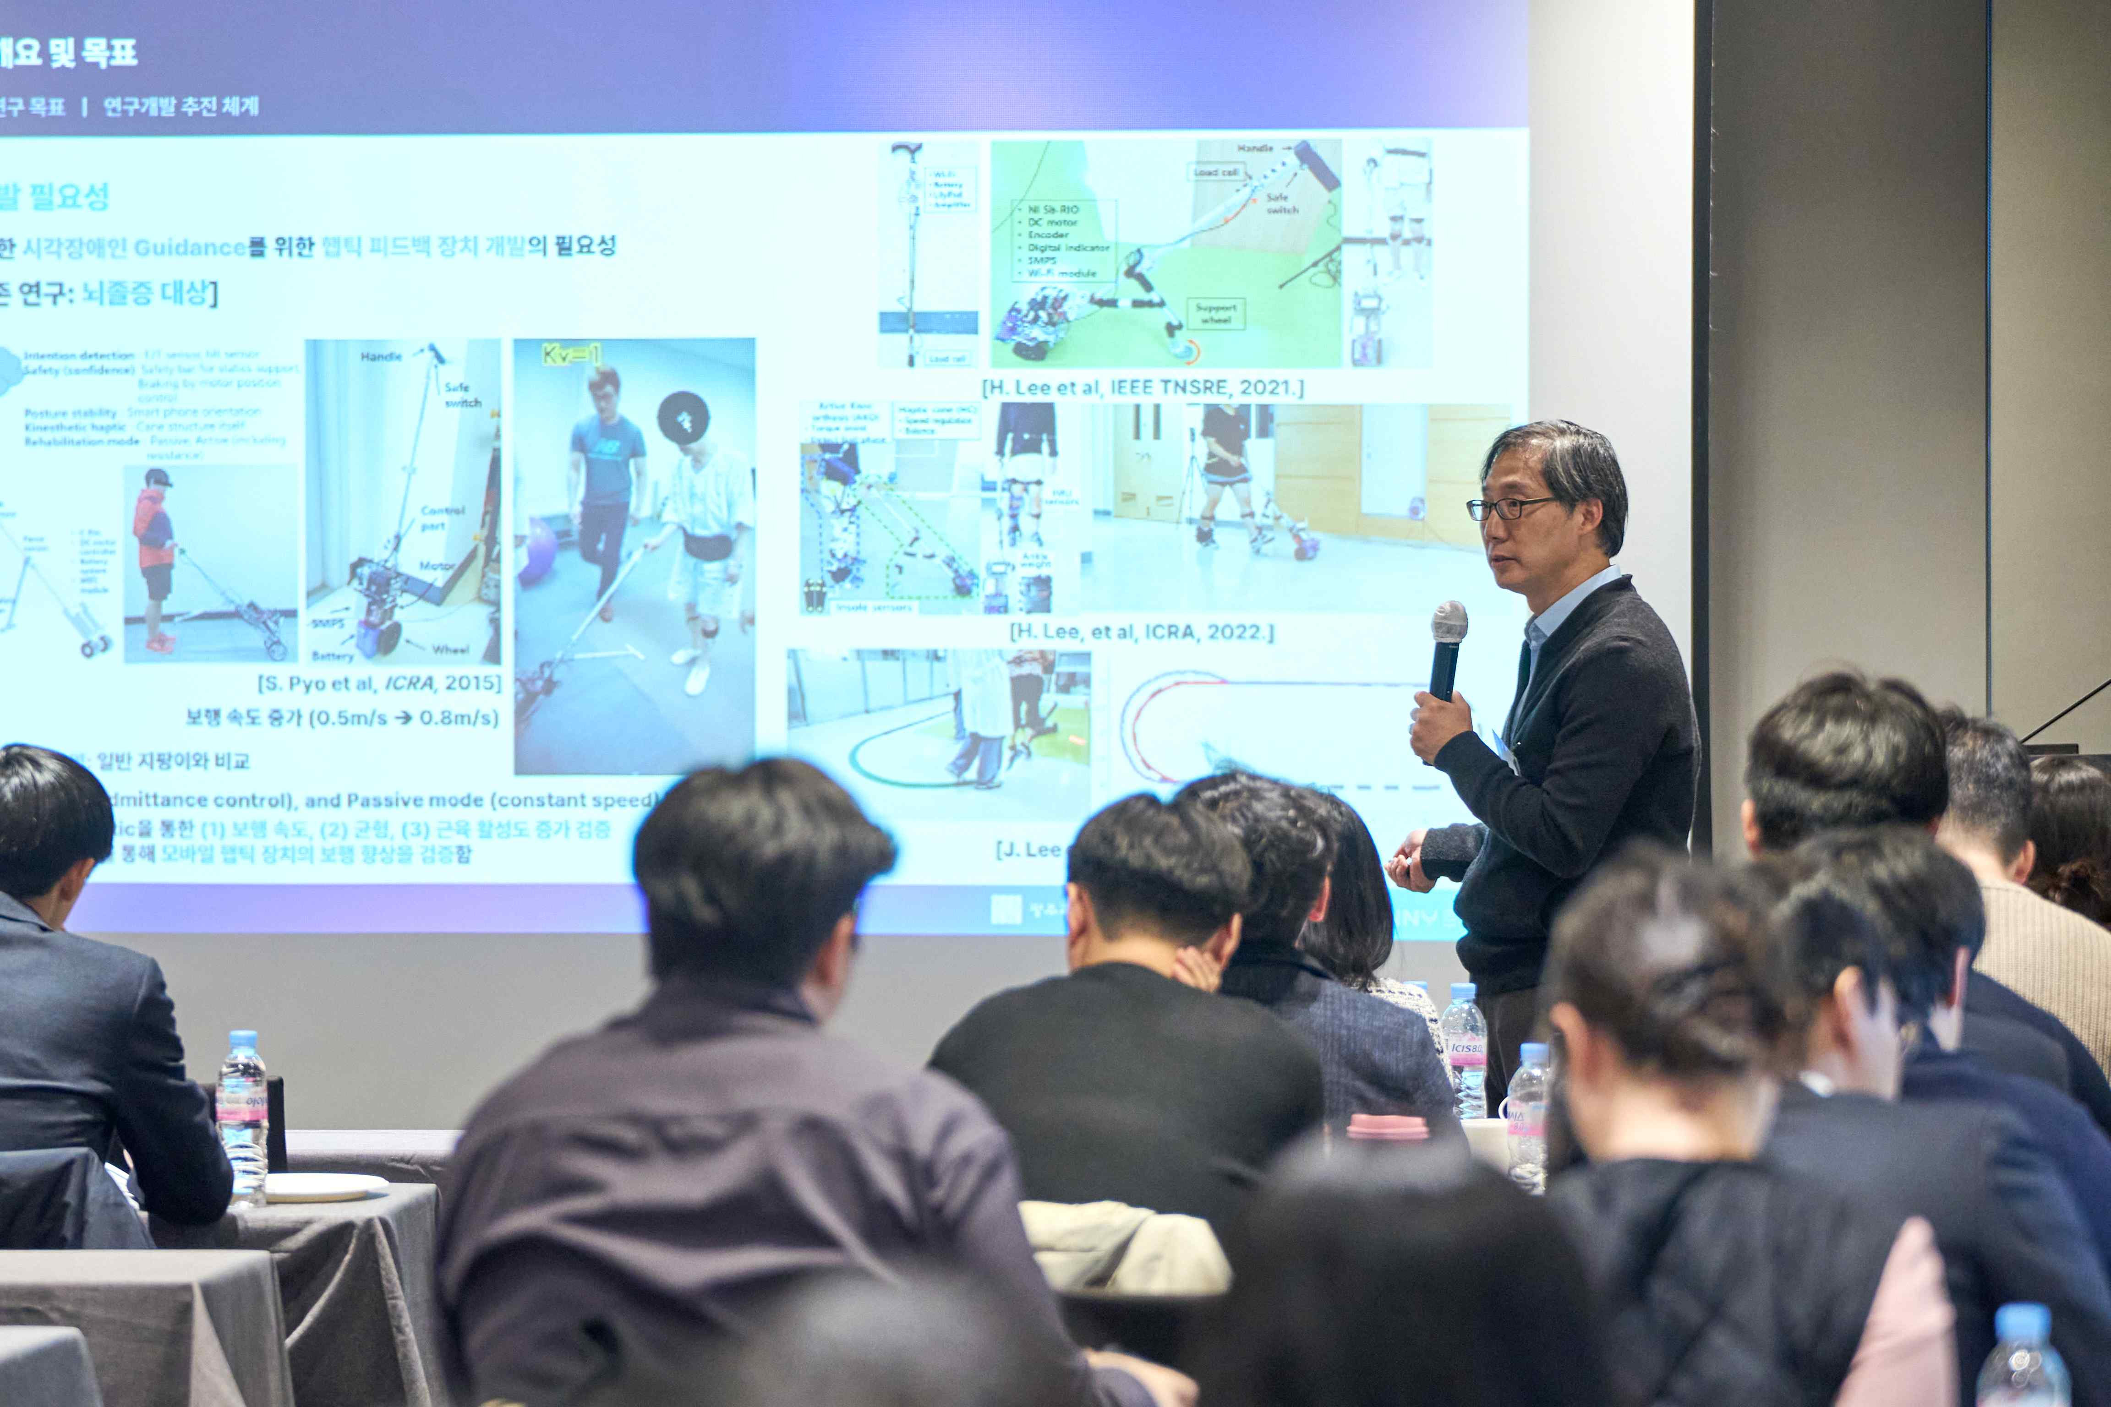

▲ At the forum titled ‘Present and Future of AI & CT Convergence Research,’ Director Jeongwon Yoon of the Korea Culture Technology Institute introduces examples of cultural services for the visually impaired utilizing AI and CT technologies.

Jae-ho Lee, a senior researcher at the Electronics and Telecommunications Research Institute (ETRI), introduced the "Intelligent Cultural Heritage Sharing Platform" research, conducted in collaboration with the National Museum of Korea, explaining that AI is opening up new possibilities for applications beyond the preservation of traditional cultural heritage.

Humelo Research Director Jin-woo Oh explained the evolution of AI voice technology based on emotional TTS and studio-quality audio technology, and presented the future of real-time interactive AI voices combined with digital humans and game NPCs.

Hyun-sik Kim, Director of the Korea Electronics Technology Research Institute (KETI), focused on generative AI-based content creation, explaining that text-to-video and automatic editing technologies are fundamentally transforming the production methods across the video, webtoon, and game industries.

Director Jungwon Yoon of the GIST Korea Culture Technology Institute, who hosted the forum, commented, "This forum confirmed that AI technology is driving innovation across the entire spectrum of content technology (CT)—from creation, production, and enjoyment." He added, "It was a meaningful forum where experts from industry, academia, research, and government gathered together to discuss the future direction of AI and CT convergence technologies and the legal and institutional issues at stake."

The Korea Culture Technology Institute reaffirmed its commitment to strengthening the AI-Cultural Technology research ecosystem through this forum and plans to continue expanding opportunities for exchange across industry, academia, and research through regular forums.

This forum demonstrates that AI and cultural technology are rapidly moving beyond the research stage and becoming core infrastructure for the content industry, artistic creation, and cultural enjoyment.



