"Blowing the Wind to Convey Your Heart" GIST hosts interactive digital exhibition <Metamorph>

- Nine interactive works created by graduate students participating in the Department of AI Convergence's "Digital Exhibition Content Project" class (advisor: Professor Eunsung Song) will be on display... A dual exhibition will be held at the GIST Central Library and Chonnam National University Hwasun Hospital until Friday the 19th

- Experience-oriented cultural and artistic experiences are provided through works that combine technology and senses, such as "Whirling Wishes," which visualizes the audience's memories and hopes... Attempting to expand public value through participatory media within the specialized medical environment

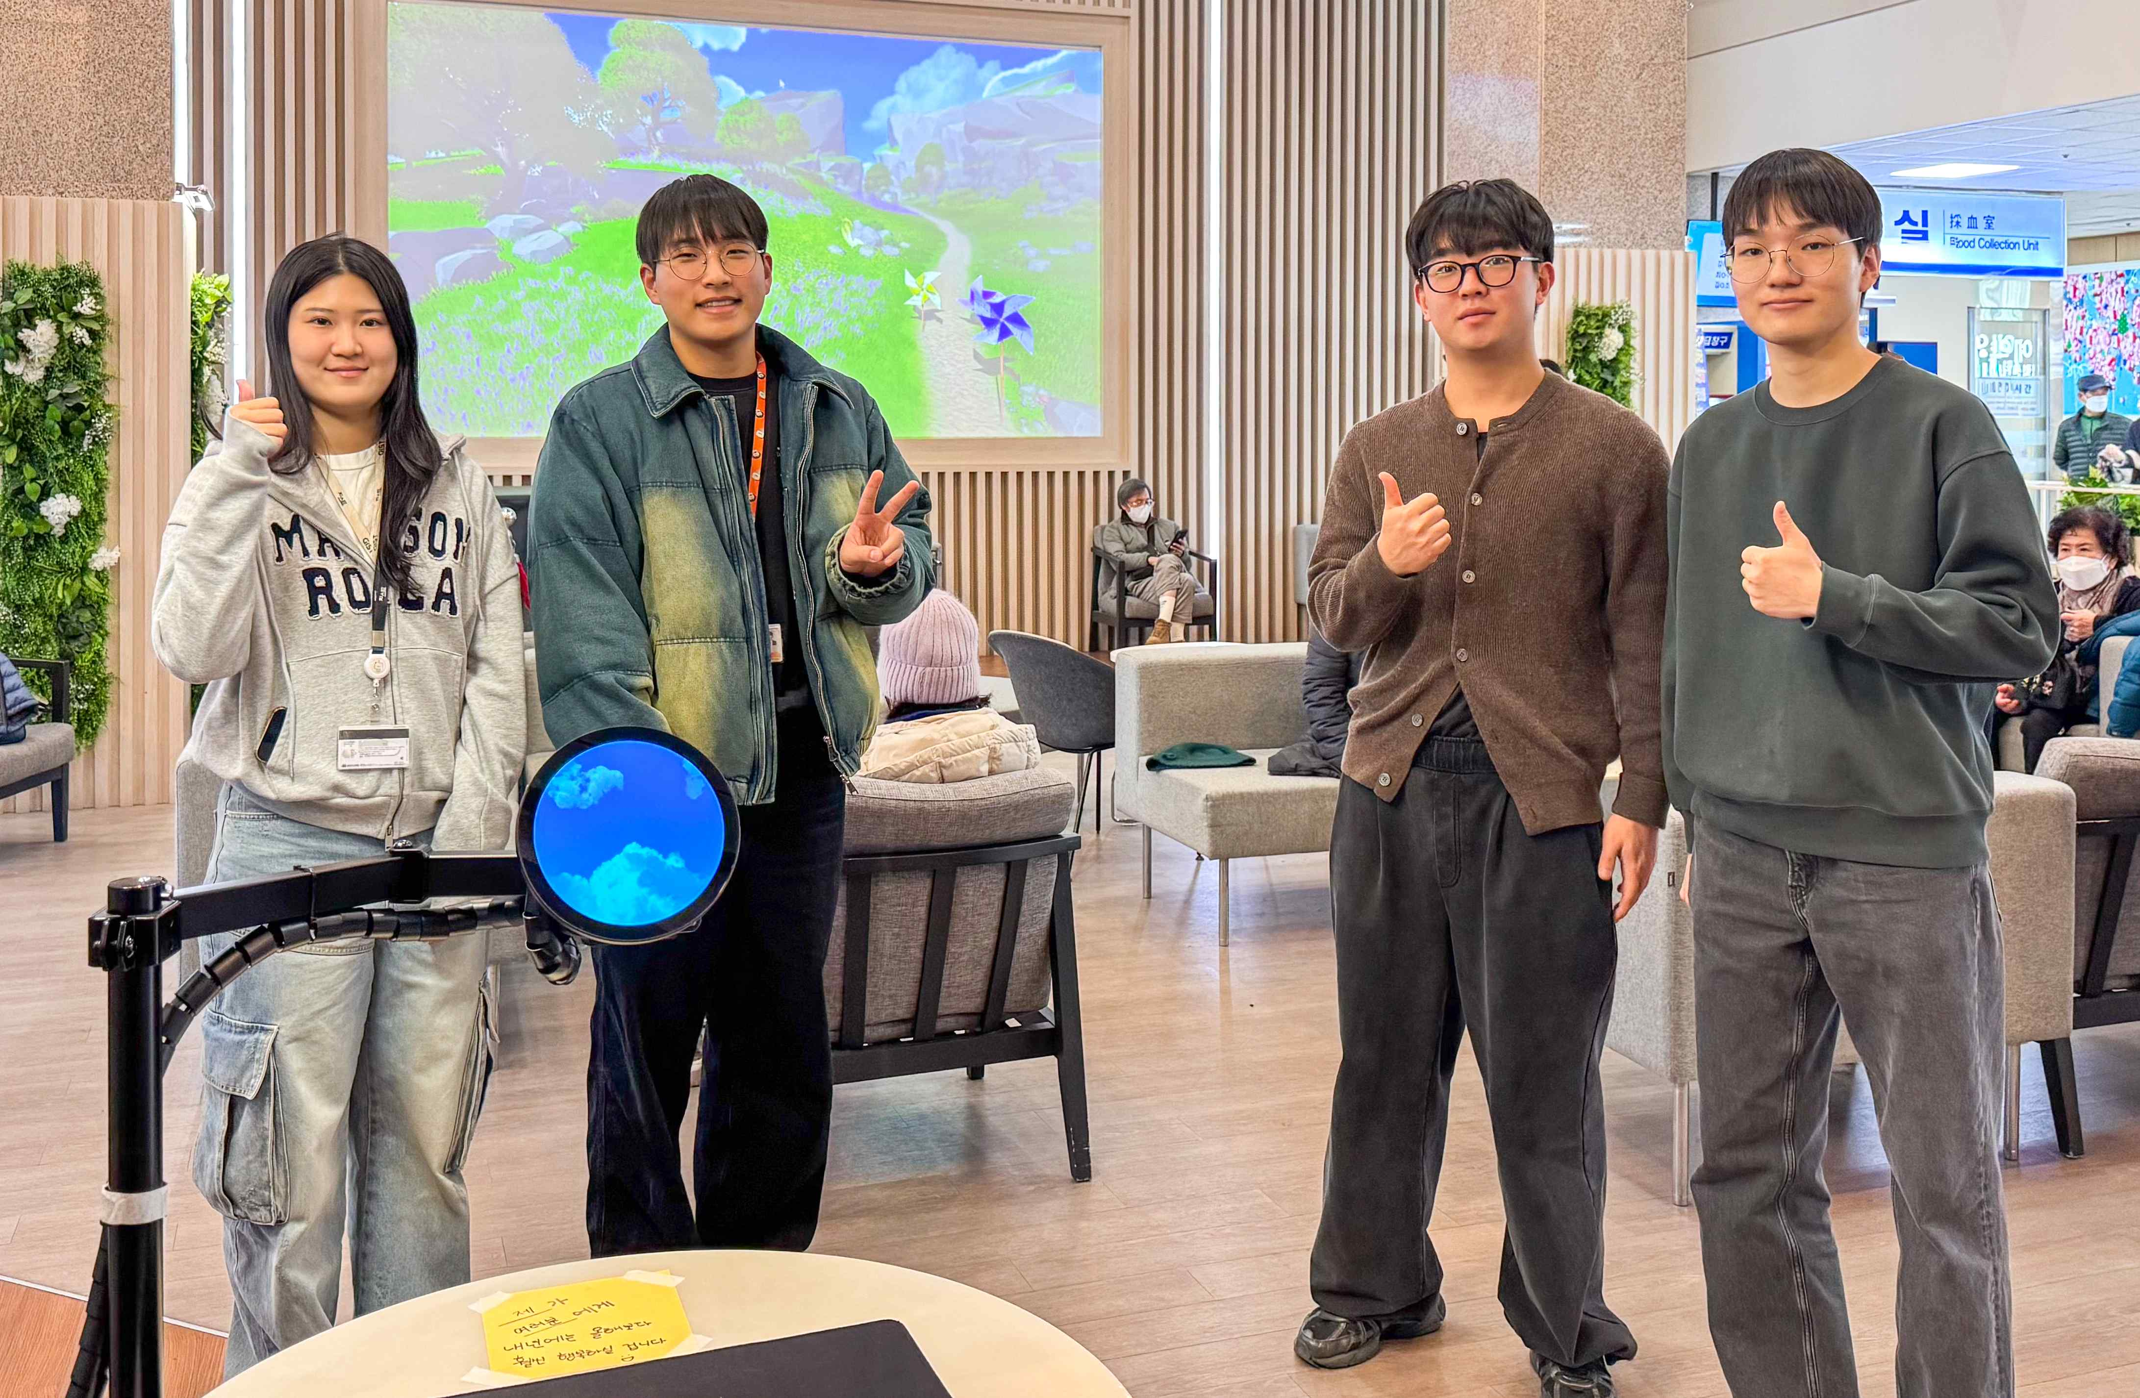

▲ (From left) GIST Department of AI Convergence students Eun-joo Kwon, Seong-hyun Kim, Yun-seong Lee, and Yu-cheon Park in front of the artwork "Whirling Wishes" installed in the first floor lobby of Chonnam National University Hwasun Hospital.

The Gwangju Institute of Science and Technology (GIST, President Kichul Lim) announced that the fifth digital exhibition project, "Metamorph," will be held simultaneously at GIST and Chonnam National University Hwasun Hospital. Graduate students participating in Professor Eunsung Song's "Digital Exhibition Content Project" class for the second semester of the 2025 academic year will showcase interactive works that combine technology and sensory perception.

The exhibition, which had previously been held exclusively at the first floor cafe of the GIST Central Library for four installments, will now be held in the first floor lobby of Chonnam National University Hwasun Hospital in Hwasun-eup, Hwasun County, Jeollanam-do. This year, the exhibition will also feature a special interactive installation for hospital visitors.

The "Digital Exhibition Content Project" is a project-based course for culture technology major of the Department of AI Convergence at GIST. Students plan and develop interactive media content that combines technology, art, and user experience. At the end of each semester, the students present their completed works in an exhibition.

This year's exhibition, themed "Where Sense and Systems Converge," features nine works exploring technology-based sensory interfaces and interactive media.

This project, in particular, attempts to combine perception, interaction, and systems thinking, and through its hospital exhibition, it also aims to experiment with works specifically tailored to the medical environment.

The exhibition title, "Metamorph," is inspired by the term "metamorphosis," symbolizing the process by which technological systems and human sensory experiences interact and create change.

This exhibition focuses on the moment when a system's structural patterns transform into a sensory, participatory experience, visually and spatially exploring the "point of transformation."

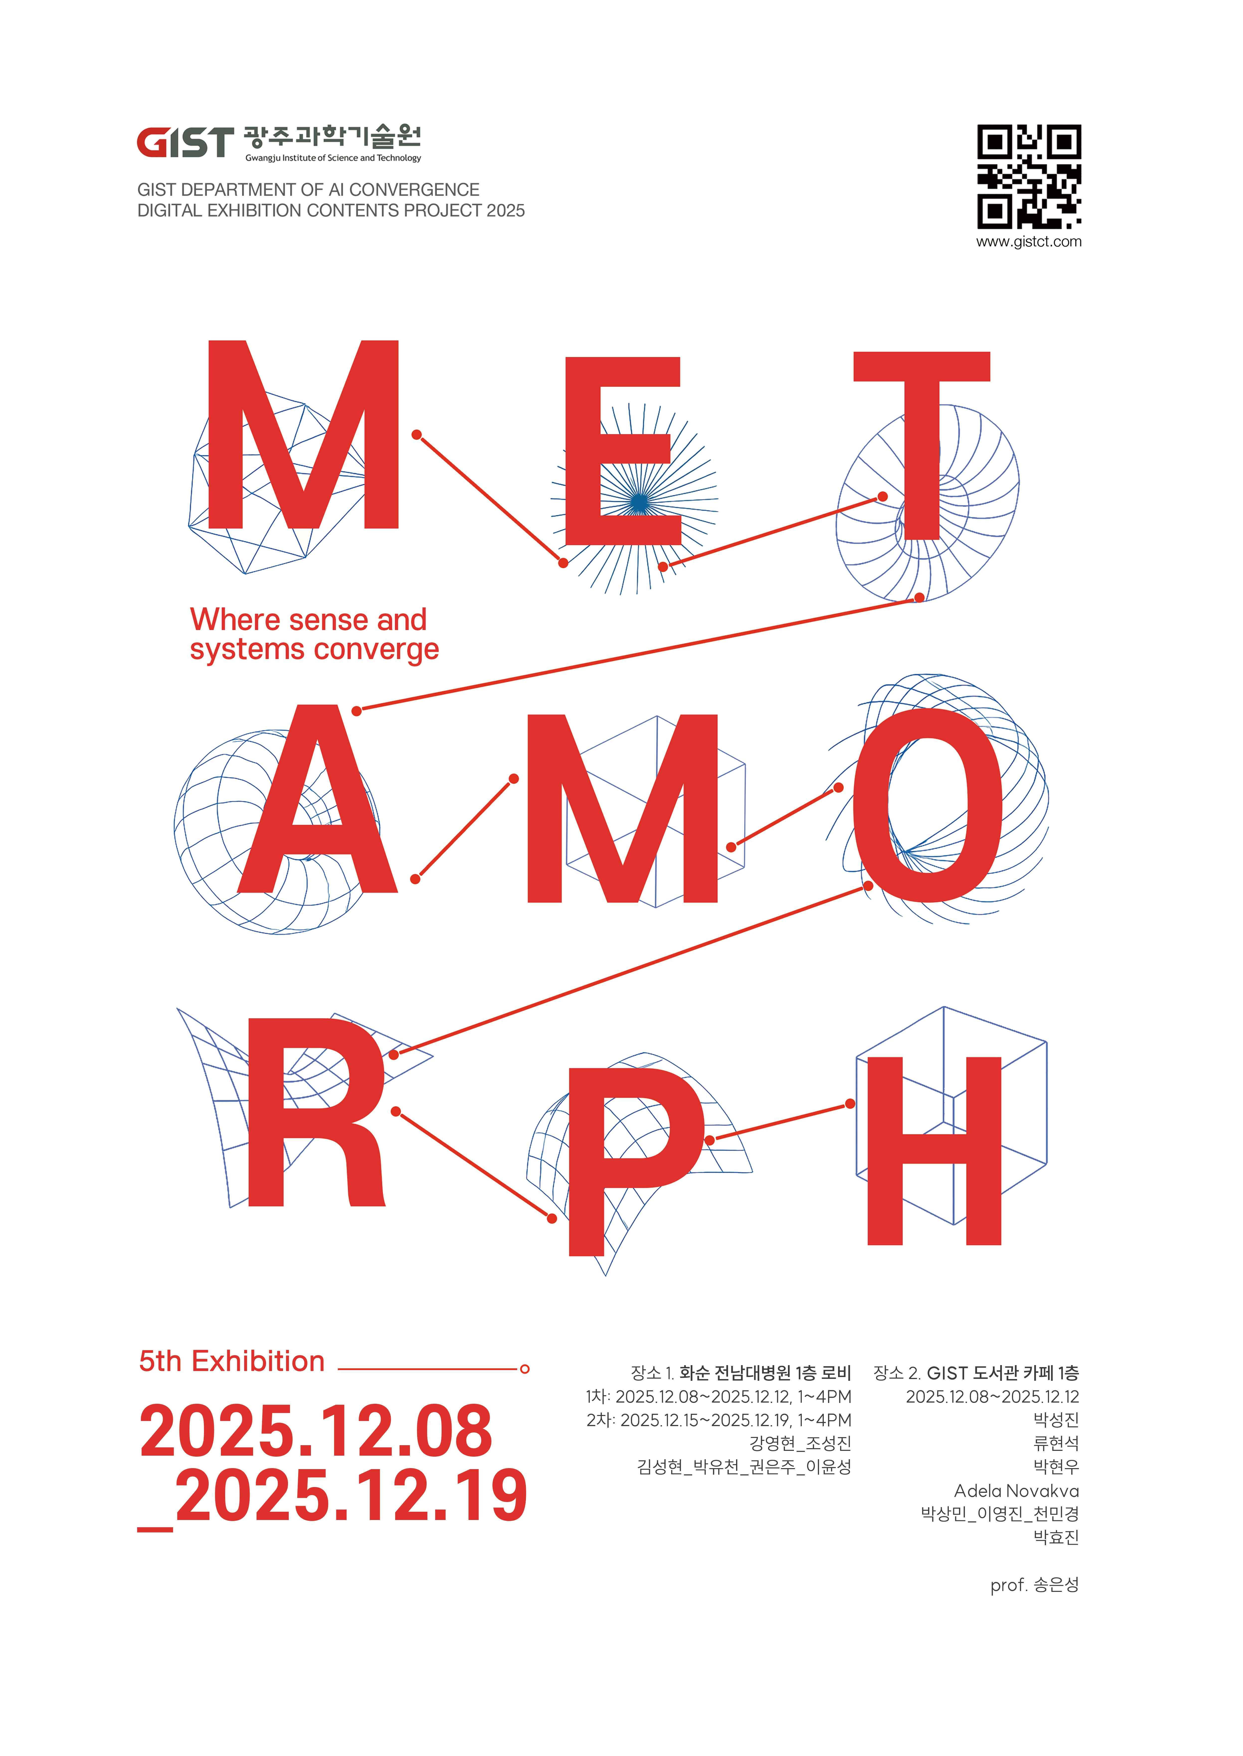

▲ Poster for the 5th Digital Exhibition Project, "Metamorph"

The hospital exhibition runs until Friday, the 19th, and features two interactive media works, offering comfort and new cultural and artistic experiences to patients, their caregivers, and medical staff.

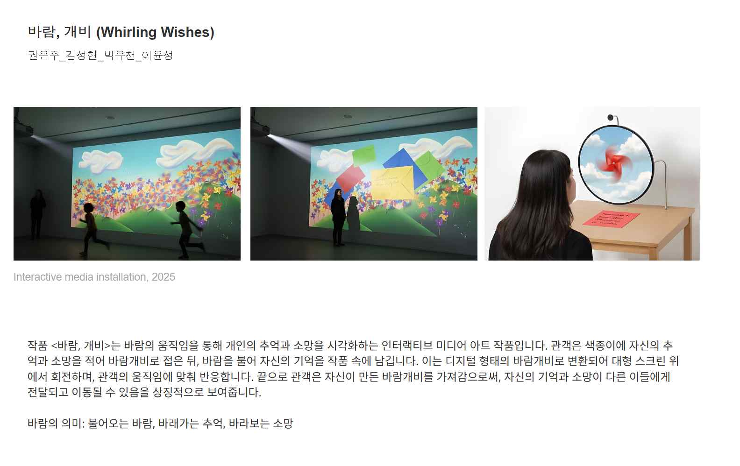▲ "Whirling Wishes," created by GIST Department of AI Convergence students (Eun-joo Kwon, Seong-hyun Kim, Yun-seong Lee, and Yu-cheon Park), is an interactive work that visualizes personal memories and wishes through wind. The pinwheels created by the audience are converted into digital images that respond to the audience's movements on a large screen.

"Whirling Wishes," one of the hospital exhibits, is an interactive media art piece that visualizes the audience's memories and wishes in the form of pinwheels. The wishes and memories written on colored paper are converted into digital pinwheels that rotate on the screen and respond to the audience's blowing movements. This interaction allows individuals to expand their thoughts and messages, sharing them with others, and provides an experience where small actions can lead to warm emotions.

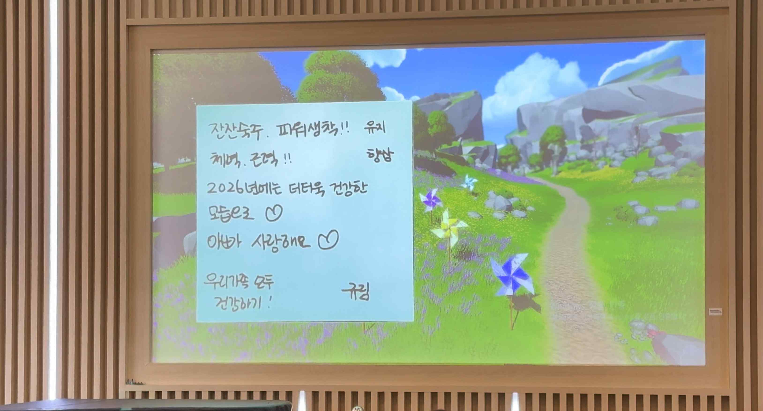

▲ "Whirling Wishes," a digital interactive work created by GIST Department of AI Convergence students, is on display in the first floor lobby of Chonnam National University Hwasun Hospital.

Professor Eunsung Song stated, "This exhibition is the result of students' own exploration and implementation of the intersection of technology and sensibility. Through experimentation in non-traditional spaces, we aimed to expand the social significance of the work."

Student Yu-cheon Park, who participated in "Whirling Wishes," said, "I hope this work will provide warm comfort and empathy to those visiting hospitals during the cold end of the year." He added, "We are also exploring additional exhibition options to ensure that more people can experience the work."



