GIST donates 235 science books to Suncheon and Gurye elementary schools in South Jeolla Province: Supporting science education for local children since 2003

- As part of its flagship community service project, the GIST Development Foundation and its student social contribution group, "Pium," donated a total of 235 books to Dongsan Elementary School in Suncheon, Suncheon Namsan Elementary School, and Guryebuk Elementary School in Gurye County

- Donating science books for use in libraries and classrooms contributes to expanding access to science learning and bridging the education gap for local children and youth... GIST plans to continue expanding its social contribution activities, including experiential programs and mentoring

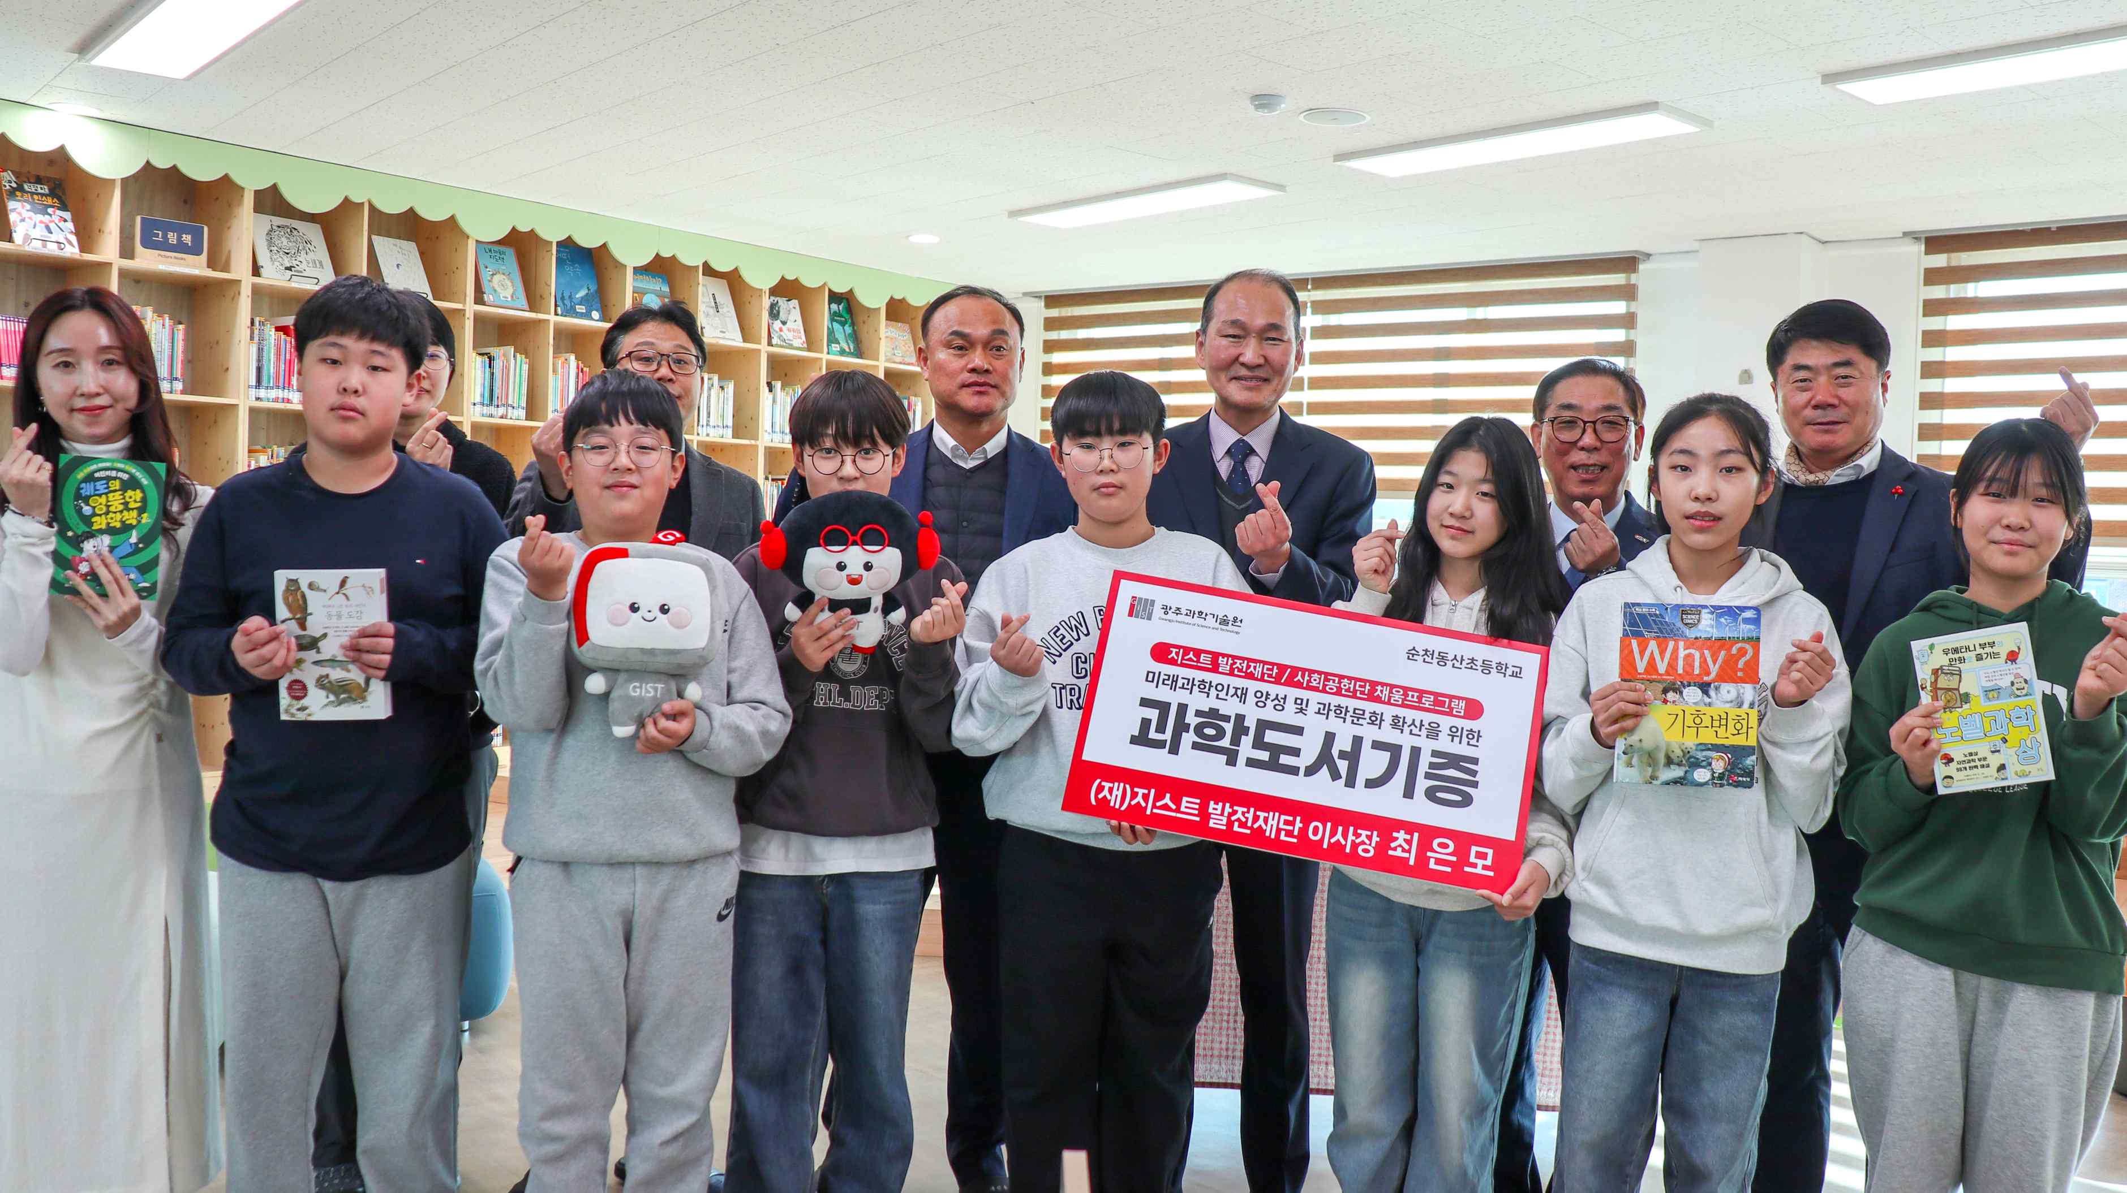

▲ Students pose for a commemorative photo at the "GIST Chaeum Program Book Donation Ceremony" held at Dongsan Elementary School in Suncheon on Monday, December 8th.

The Gwangju Institute of Science and Technology (GIST, President Kichul Lim) announced that the GIST Development Foundation and "Pium," a social contribution group comprised of GIST students, jointly donated approximately 5 million won worth of science books to elementary schools in South Jeolla Province. The "GIST Chaeum Program Book Donation Ceremony" was held at Dongsan Elementary School in Suncheon, South Jeolla Province, on Monday, December 8th.

The "GIST Chaeum Program," GIST's flagship community service program, was established to broaden the scope of science exposure and expand learning opportunities for local children and youth.

Since 2003, for the past 23 years, GIST has been supporting numerous elementary and middle schools in the Gwangju and Jeonnam regions with various science books, teaching aids, and experiment kits, contributing to narrowing regional educational gaps and improving children's educational well-being.

This year's book donations were made to three schools: Dongsan Elementary School in Suncheon City (146 books), Suncheon Namsan Elementary School (45 books), and Guryebuk Elementary School in Gurye County (44 books).

A total of 235 science books will be used not only in school libraries but also in various educational settings, including classroom instruction and reading activities.

The ceremony was attended by GIST Development Foundation Chairman Eun-mo Choi, Directors Won-man Kim and Geun-shin Lee, Suncheon Dongsan Elementary School Principal Gyeong-seok Gu, and members of the GIST International and Public Affairs Team and Development Fund teams.

Chairman Eun-mo Choi stated, "As a research-oriented university, GIST believes it is an important responsibility to share its accumulated scientific and technological knowledge and educational resources with the local community. We will continue to support the local community in various areas, including education, culture, and volunteer work, to foster mutual growth."

Principal Gyeong-seok Gu of Suncheon Dongsan Elementary School expressed his gratitude, saying, "Science books are invaluable learning materials that broaden students' imagination and creativity. We will actively utilize the books donated by GIST in our curriculum and reading activities to ensure students enjoy learning about science."

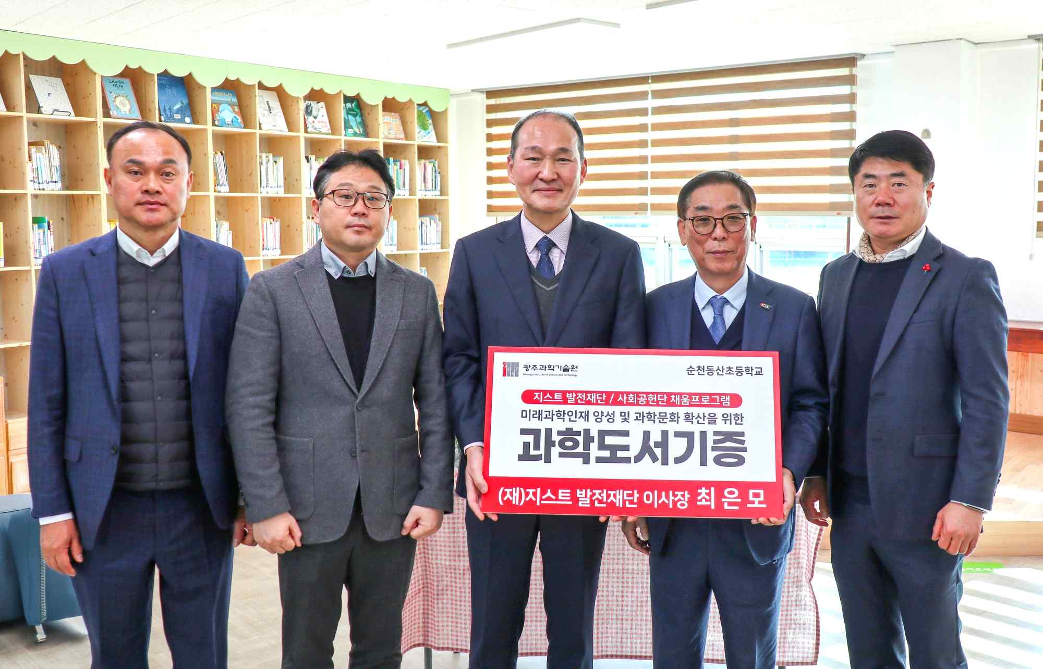

▲ Officials pose for a commemorative photo at the "GIST Chaeum Program Book Donation Ceremony" held at Dongsan Elementary School in Suncheon on Monday, the 8th. (From left) GIST Development Foundation Director Won-man Kim, Suncheon Dongsan Elementary School Vice Principal Gwang-seok Seo and Principal Gyeong-seok Gu, GIST Development Foundation Chairman Eun-mo Choi and Director Geun-shin Lee.

Meanwhile, in addition to this year's "Chaeum Program," GIST is working to strengthen the educational capacity of local communities through various social contribution programs, including operating science experience programs, providing science experiment kits, and joint educational activities with local children's centers.

The GIST Development Foundation and its social contribution group "Pium" plan to continue expanding their social contribution activities, including book donations, educational content development, and on-site educational support programs, to ensure that local children and youth have access to quality science education opportunities and broaden their future career paths.



