GIST and NASA establish Korea's first Soil Moisture Research Center in Hampyeong: GIST and Hampyeong County sign MOU to strengthen regional cooperative development and future innovation capabilities

- President Kichul Lim and Hampyeong County Mayor Sang-ik Lee attended the signing ceremony held at Hampyeong County Office on Wednesday, December 3rd, marking the beginning of a new regional research collaboration model... Focusing on climate response, talent development, and agricultural innovation

- High-density soil moisture and temperature observation equipment was installed in 25 200m x 200m pilot sites, enabling precise verification of NASA satellite data and the use of drought and extreme weather forecasts... Hampyeong County's high stability in its natural and agricultural infrastructure has secured its competitiveness as a global verification site

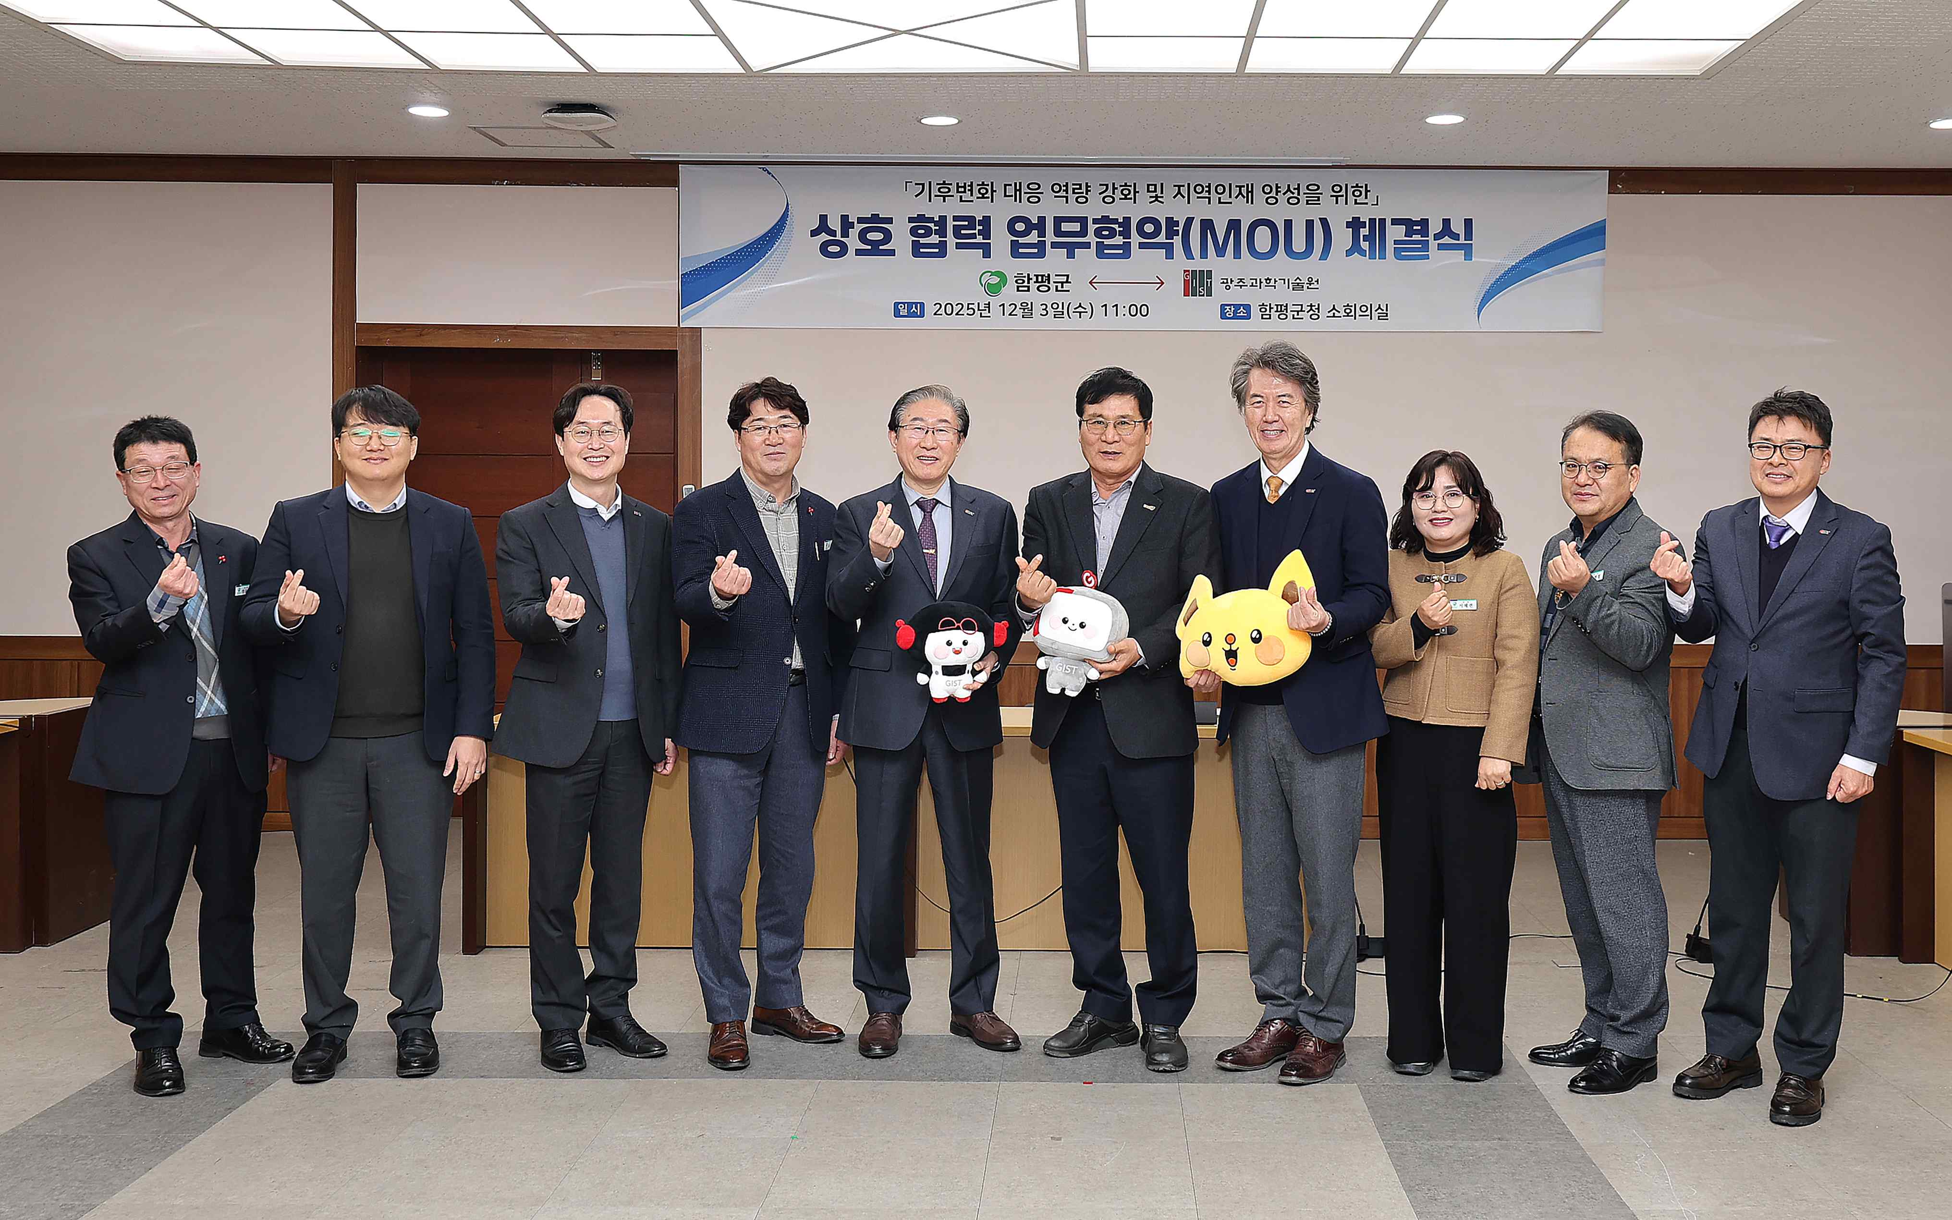

▲ GIST and Hampyeong County signed a Memorandum of Understanding (MOU) at the Hampyeong County Office on December 3rd to promote regional co-prosperity and strengthen future innovation capabilities. Participants pose for a commemorative photo.

The Gwangju Institute of Science and Technology (GIST, President Kichul Lim) announced on Wednesday, December 3rd that it signed a Memorandum of Understanding (MOU) with Hampyeong County, Jeollanam-do (Governor Lee Sang-ik) at the Hampyeong County Office to promote regional co-prosperity and strengthen future innovation capabilities.

This agreement is expected to serve as a catalyst for fostering a regional climate response and agricultural innovation ecosystem by linking GIST's global research capabilities with Hampyeong County's abundant natural and agricultural resources.

The signing ceremony was attended by GIST President Lim Ki-cheol, Vice President for External Affairs Jeong Yong-hwa, Director of the Office of External Cooperation Kim Jae-kwan, Professor Kim Hyeong-rok of the Department of Environmental and Energy Engineering, and Team Leader Kim Yong-ryeol of the External Cooperation Team. Fifteen representatives from Hampyeong County attended, including County Mayor Sang-ik Lee, Director of the Planning and Budget Office Jong-wook Choi, Director of the Agricultural Policy Office Byeong-cheol Noh, and Director of the Population and Economics Division Hye-ryeon Seo.

The key points of the agreement include: ▴ Strengthening Hampyeong County's climate change response and education capabilities; ▴ Fostering local talent and jointly utilizing research facilities; ▴ Identifying projects linking the Fourth Industrial Revolution with the agriculture, forestry, livestock, and fisheries industries; ▴ Establishing a GIST Techno Management Business Academy (GTMBA) curriculum and selecting scholarship recipients.

The most central topic of discussion in this agreement is the plan to establish Korea's first "Soil Moisture Verification Research Site" in Hampyeong County, a joint project between GIST and the National Aeronautics and Space Administration (NASA).

The research site will be comprised of 25 approximately 200m x 200m areas (with a maximum area of ​​1km x 1km). 120 soil moisture, soil temperature, and tree electrical conductivity measurement devices will be installed to verify NASA satellite observation data. The site will have minimal impact on agricultural activities. GIST has been collaborating with NASA to host annual seminars inviting American researchers and has already secured a long-term research funding, including funding from the National Research Foundation of Korea (NRF) for 2025-2031.

Hampyeong County is considered to have optimal conditions, competing with the approximately 30 verification sites currently operated by NASA worldwide, due to its high level of natural environmental conservation and stable agricultural infrastructure. Once the research site is fully operational, Hampyeong County is expected to emerge as a key hub for international climate and agricultural research and satellite data verification.

GIST President Kichul Lim emphasized, "If GIST's scientific and technological capabilities are combined with Hampyeong County's future regional development projects, we will be able to produce meaningful results." He added, "In particular, if the soil moisture verification research site jointly promoted by NASA and GIST is established in Hampyeong County, this will serve as an opportunity for GIST and Hampyeong County to collaborate even more closely."

Hampyeong County Mayor Sang-ik Lee emphasized, "Through this agreement, we anticipate that GIST's expertise, outstanding research capabilities, educational resources, and cutting-edge technology will be combined with Hampyeong County's administrative experience, local field data, and industrial infrastructure to create even greater synergy. I hope this will serve as a solid starting point for us to jointly address contemporary challenges such as climate change and regional extinction and pioneer an innovative future for Korea."

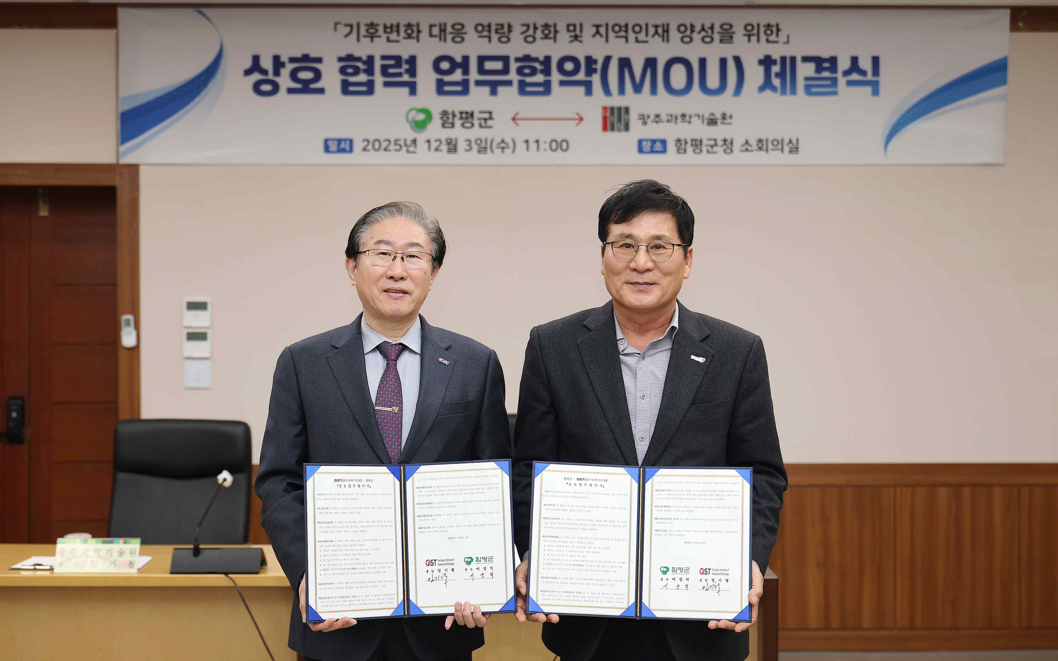

▲ At the GIST-Hampyeong County MOU signing ceremony held at the Hampyeong County Office on December 3, (from left) GIST President Kichul Lim and Hampyeong County Mayor Sang-ik Lee pose for a commemorative photo after signing the agreement.

Meanwhile, Professor Hyunglok Kim leads the "Hydro-Remote Sensing Artificial Intelligence Laboratory." He conducts research that integrates satellite remote sensing, AI, machine learning, and land surface modeling to estimate and analyze hydrological (water cycle) variables such as soil moisture, precipitation, evapotranspiration, surface water, and groundwater using satellite data.

GIST is the only university in Korea to have established a precision network capable of verifying observations from NASA's Soil Moisture Active Passive (SMAP) and NASA-ISRO Synthetic Aperture Radar (NISAR). Combining high-density soil moisture sensors, ground-based microwave radiometers, and drone-based high-resolution observation systems, GIST is conducting multi-layered soil moisture observations.

Related to this, GIST signed an MOU with NASA in November 2024 to understand the distribution of soil moisture in the East Asian region, and in October 2023, researchers from NASA's SMAP satellite program visited Hampyeong-gun in person to inspect the site and confirm the observation environment and construction feasibility.



