GIST holds R&D achievement meeting to address regional issues in assistive devices: Strengthening research and industrial cooperation in the Honam region to support independence for people with disabilities and the elderly

- The second year of the Ministry of Health and Welfare-supported "R&D on Independent Living Devices for the Disabled and the Elderly" project, which was jointly promoted by GIST, Gwangju Technopark, and Chonnam National University, will be shared in Yeosu on the 27th and 28th... This project will develop user-centered technologies

- Three projects will be presented: ▲ a back-pushing assistive device, ▲ a crutch-assisted device, and ▲ a face mouse... Technology trends will be shared, MOUs for cooperation between relevant organizations will be discussed, and a third-year research and industry revitalization plan will be established

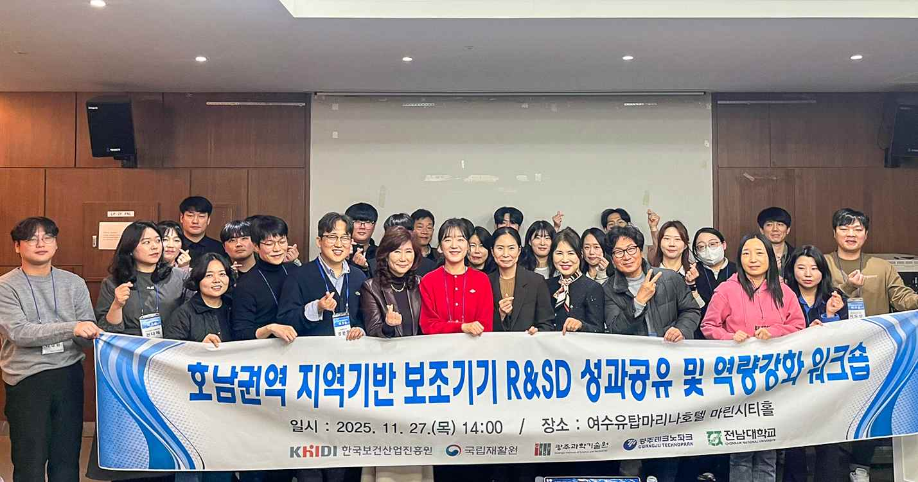

▲ Representatives from GIST and its partner organizations pose for a commemorative photo after attending the "Honam Region Regional Assistive Device R&SD Results Sharing Workshop," held at the Yeosu Yutap Marina Hotel on Thursday, November 27th.

The Gwangju Institute of Science and Technology (GIST, President Kichul Lim) announced that it held the "Research & Service·Development (R&SD) Results Sharing Workshop" at the Yeosu Yutap Marina Hotel on November 27th and 28th.

This event, part of the "Research and Development of Assistive Devices for Independent Living for the Disabled and the Elderly," a project supported by the Ministry of Health and Welfare, was organized to share research results from the second year, discuss plans for the third year, and strengthen regional cooperation networks.

This project, jointly promoted by GIST, Gwangju Technopark, and Chonnam National University, aims to support self-reliance and revitalize the assistive device industry by developing and distributing assistive devices based on local needs.

Approximately 40 people attended the event, including Professor Jiyeon Kang of GIST, Senior Researcher Seong-beom Park of Gwangju Technopark, Won-seok Choi, a specialist at the Korea Employment Agency for the Disabled, and Professor Wan-ho Jang of Jeonju University.

Participants shared the achievements of three assistive devices developed in the second year—the "Back Push Assist Device," the "Crutch Self-Standing Assist Device," and the "Face Mouse"—and discussed in-depth research and development directions and technological implementation plans to enhance user convenience.

They also solidified collaborative systems through the signing of MOUs with relevant organizations and companies, established research goals and strategies for the following year, and explored ways to revitalize the assistive device industry.

The workshop also featured expert lectures to strengthen the R&D capabilities and deepen the expertise of participating organizations.

▲ Professor Wan-ho Jang (Department of Occupational Therapy, Jeonju University) shared his field expertise on "Production of Customized Assistive Devices for the Disabled and the Elderly." ▲ Expert Committee Member Won-seok Choi (Korea Employment Agency for the Disabled) presented information on the project system and operations under the theme of "Understanding Assistive Technology Support Projects and Quality Control." ▲ Professor Jiyeon Kang (Department of AI Convergence, GIST) presented future technology trends to attendees under the theme of "Understanding Physical AI."

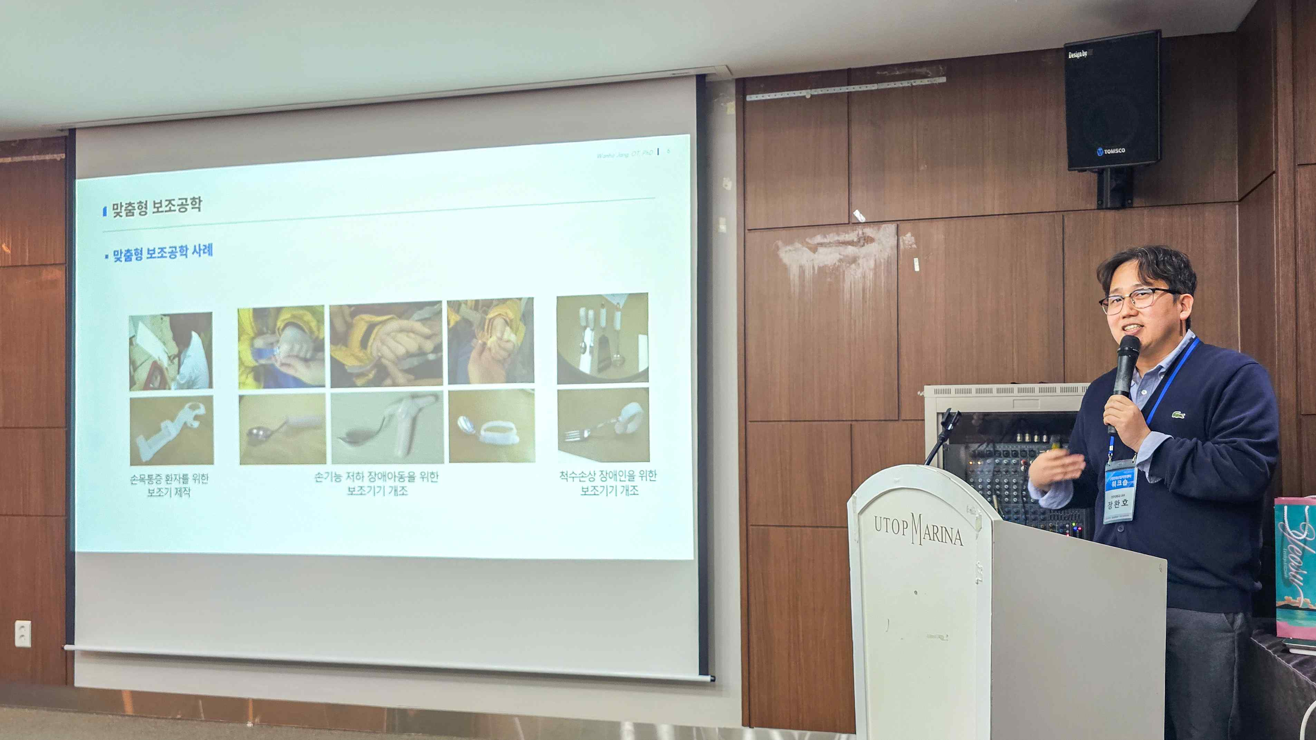

▲ Professor Wan-ho Jang (Department of Occupational Therapy, Jeonju University) gave a lecture on "Production of Customized Assistive Devices for the Disabled and the Elderly" to demonstrate practical application of assistive devices.

Professor Jiyeon Kang of GIST, who oversaw this project, stated, "This was a meaningful opportunity to bring together the research capabilities and field needs of the Honam region and drive practical growth in the assistive device industry." She added, "With this year-end gathering on a larger scale, we will strengthen the collaborative network among related organizations and actively pursue technological innovation through joint research."

GIST and its partner organizations plan to continue to support the convenient and independent living of people with disabilities and the elderly by developing assistive devices centered on local needs and actual users, and by revitalizing the industry.



