The 15th GIST Techno Management Business Academy (GTMBA) graduates donate 20 million won to the development fund

- 44 graduates from the 15th class graduated on Tuesday, November 25th… GTMBA has produced a total of 623 graduates since its inception in 2010

- GTMBA's 15th class donates 20 million won to the development fund…Han-sang Jang, CEO of Hyundai Conveyor Co., Ltd., stated, "As a GIST alumnus, I will contribute to the development of the school and the revitalization of the local economy"

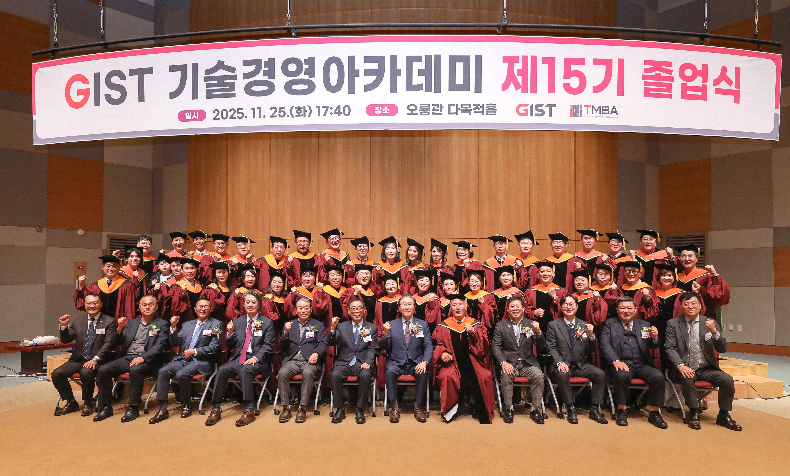

▲ The GIST Techno Management Business Academy held its 15th graduation ceremony at the Oryong Hall Multipurpose Hall on Tuesday, November 25th, and attendees pose for a commemorative photo.

The Gwangju Institute of Science and Technology (GIST, President Kichul Lim) announced that the Techno Management Business Academy (GTMBA, Director Jae Gwan Kim) held the 15th GTMBA graduation ceremony on Tuesday, November 25th, and also held a donation ceremony for the 20 million won development fund raised by the graduates.

The event was held at the Oryong Hall Multipurpose Hall, with approximately 60 people in attendance, including President Lim Ki-cheol, GIST officials and staff, and the 15th graduating class.

The 44 graduates of the 15th graduating class, who completed the 30-week GTMBA training course, received certificates of completion signed by the president. Han-sang Jang, CEO of Hyundai Conveyor Co., Ltd. (President of the 15th Alumni Association), received the Innovation Leader Award.

Chairman Han-sang Jang said, “We decided to donate to the development fund with the hope that GIST will continue to grow into a world-class science and engineering education and research institution.” He added, “I would like to express my sincere gratitude to the GIST Technology Management Academy officials for providing high-quality educational programs. As a GIST alumnus, I will contribute to the development of the school and the revitalization of the local economy.”

In his congratulatory remarks, President Kichul Lim urged, "Building on your GTMBA completion, I urge you to take pride in your work and actively utilize the insight and network you've built through the Executive Management Program to strengthen your business operations and local industries."

He added, "I look forward to continued cooperation and communication between industry and GIST."

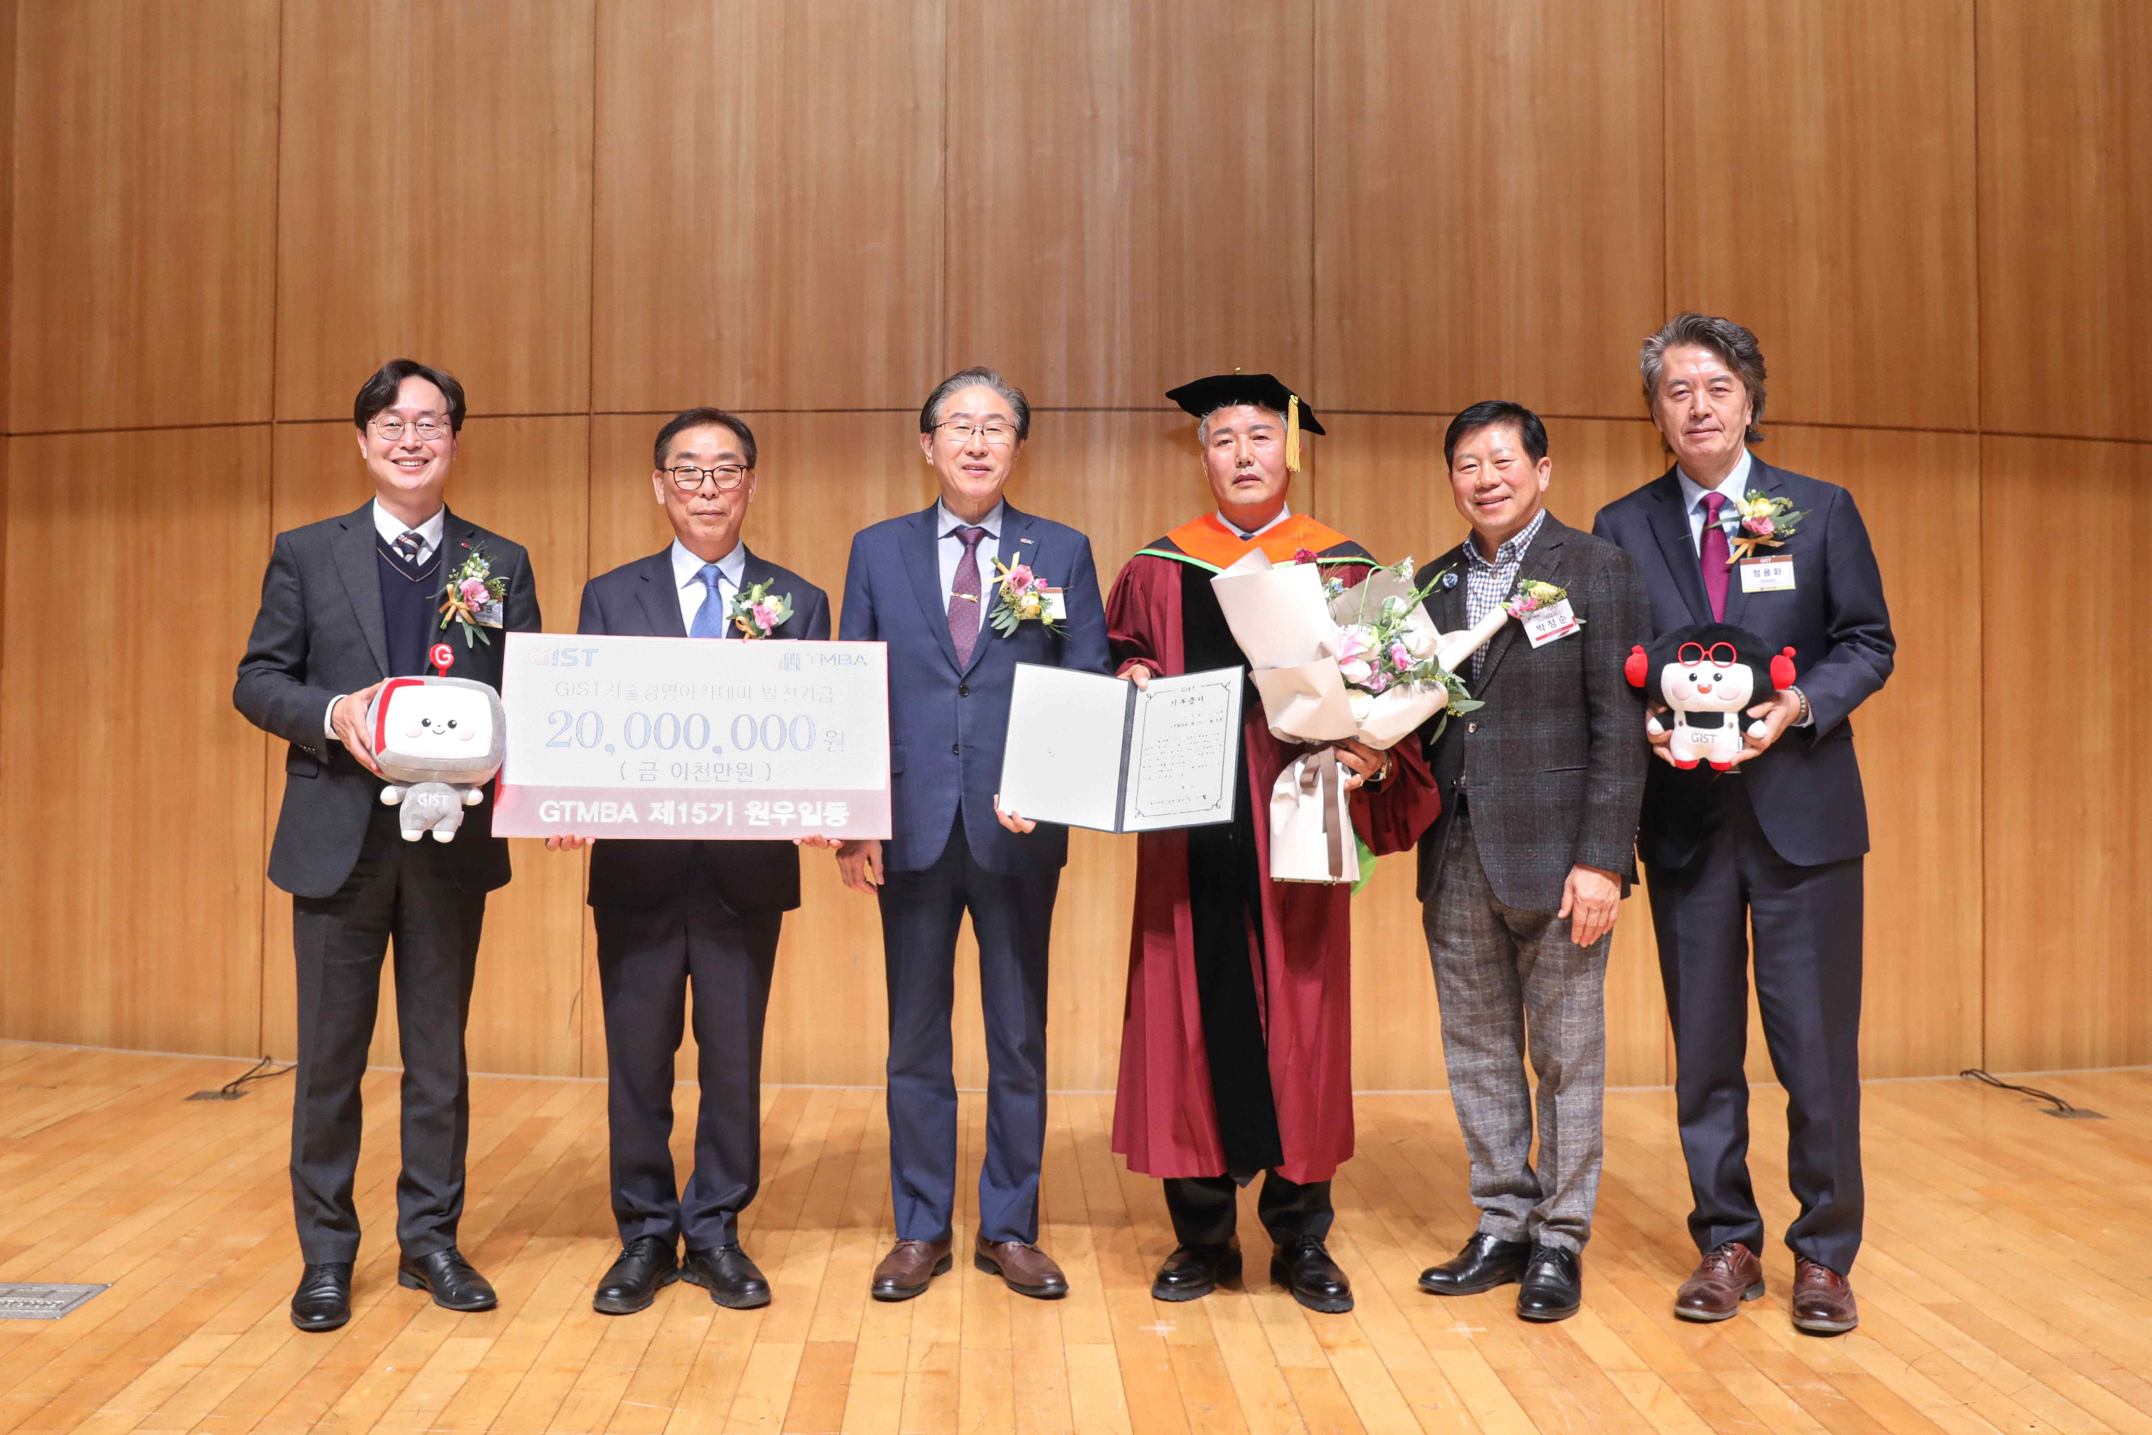

▲ The GIST Techno Management Business Academy held a 20 million won donation ceremony for the 15th Alumni Association Development Fund at the Oryong Hall Multipurpose Hall on Tuesday, November 25th, and took a commemorative photo. (From left) Jae Gwan Kim, Director of the GIST Academy; Eun-mo Choi, Chairman of the GIST Development Foundation; GIST President Kichul Lim; Han-sang Jang, CEO of Hyundai Conveyor Co., Ltd.; Jeong-soon Park, President of the GTMBA Alumni Association; and Yonghwa Chung, Vice President for Public Affairs at GIST.

GTMBA established its CEO program in 2010 to cultivate business leaders through systematic CEO education. To date, approximately 620 alumni are actively engaged in various fields of society.

The program is a 30-week program that begins in March and runs through December. Lectures are held every Tuesday at 7:00 PM in GIST's Oryong Hall. The program is currently recruiting new students for the 16th class of 2026.



