GIST and the Korea Postal Savings & Insurance Development Institute (PoSID) signed an agreement to foster talent in the convergence of finance and AI and to promote regional cooperation

- A signing ceremony was held at GIST on Monday, November 24th, attended by President Kichul Lim and President Dae-seop Shin... The agreement aims to combine GIST's cutting-edge research capabilities with PoSID's financial and digital expertise to foster talent in the convergence of finance and AI. Joint education and research programs will be promoted

- The agreement also aims to expand industry-academia exchanges, strengthen field-focused collaboration networks, and launch joint research to develop and validate AI-based financial innovation technologies... This is expected to foster a regional digital financial innovation ecosystem and drive future national innovation growth

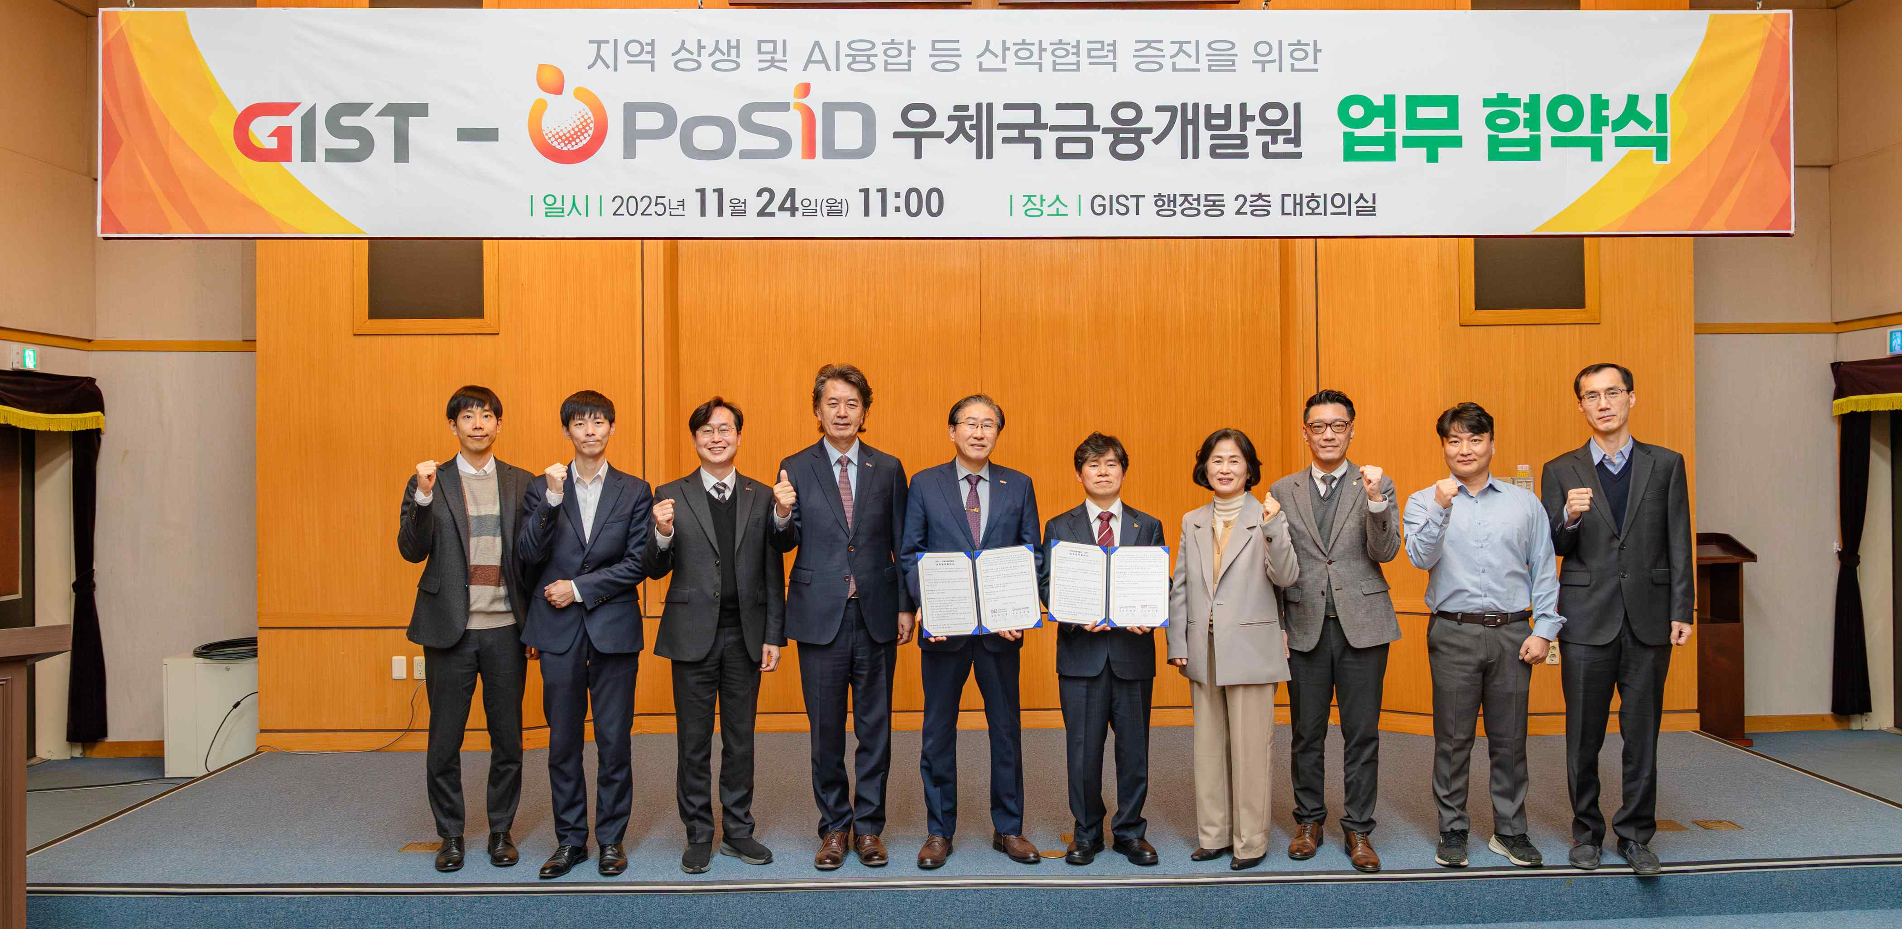

▲ Key officials from GIST and PoSID pose for a commemorative photo after signing a business agreement for financial and AI convergence cooperation at the business agreement signing ceremony held in the GIST Administration Building conference room on Monday, November 24th.

The Gwangju Institute of Science and Technology (GIST, President Kichul Lim) announced on Monday, November 24th, in the GIST Administration Building conference room that it signed a business agreement (MOU) with the Korea Postal Savings & Insurance Development Institute (PoSID, President Dae-seop Shin) to foster talent in the financial and AI convergence field and promote regional cooperation.

This agreement combines GIST's cutting-edge scientific and technological research capabilities with PoSID's financial and digital expertise to establish a new model of academic-research-government cooperation required in the era of financial and AI convergence. Furthermore, it is expected to serve as a foundation for driving digital transformation and future innovative growth in the regional industrial ecosystem.

The signing ceremony was attended by GIST President Kichul Lim, Vice President for Public Affairs Yonghwa Chung, Dean of Office of International and Public Affairs Jae Gwan Kim, and Professors Ue-Hwan Kim and Do Hyun Park of the Department of AI Convergence. Ten officials from PoSID attended, including President Dae-seop Shin, Director of the Digital Information Strategy Office Ok-kyung Kim, Director of the Future Finance Planning Office Man-yeong Baek, Digital Technology Team Leader Chil-nyeon Kim, and System Quality Team Leader Nam-hoon Heo.

GIST is leading regional and national innovative growth based on its research capabilities in cutting-edge science and technology fields such as AI, semiconductors, and advanced materials. PoSID has been promoting digital transformation in finance and discovering new technologies for future finance. With this agreement, the two institutions will begin full-scale cooperation focusing on three key areas.

First, they will plan and operate a joint education and research program to cultivate talent in the convergence of finance and AI, linking GIST's education and research capabilities with PoSID's practical experience in finance and digital technology. Through this, we plan to systematically cultivate future talent with expertise in finance and AI.

Second, they will expand practical industry-academia exchange activities, such as industrial site tours, recruitment briefings, technical seminars, and practitioner exchange programs, to strengthen the collaborative network among students, researchers, and practitioners.

Third, we will promote joint research based on the convergence of finance and AI to expand our technological development and verification capabilities in future financial innovation areas, such as advanced AI-based financial services, financial data analysis, financial security, and next-generation financial platforms.

In particular, in the area of ​​joint research, we will broadly review technologies with immediate application in the financial industry, such as digital transformation (DX), AI-based risk analysis, financial automation technology, and AI security technology. We will actively identify joint projects to generate R&D results.

Through this collaborative foundation, the two organizations plan to systematically cultivate future financial and AI convergence talent and consistently secure tangible results that enhance the innovative competitiveness of local communities and national industries.

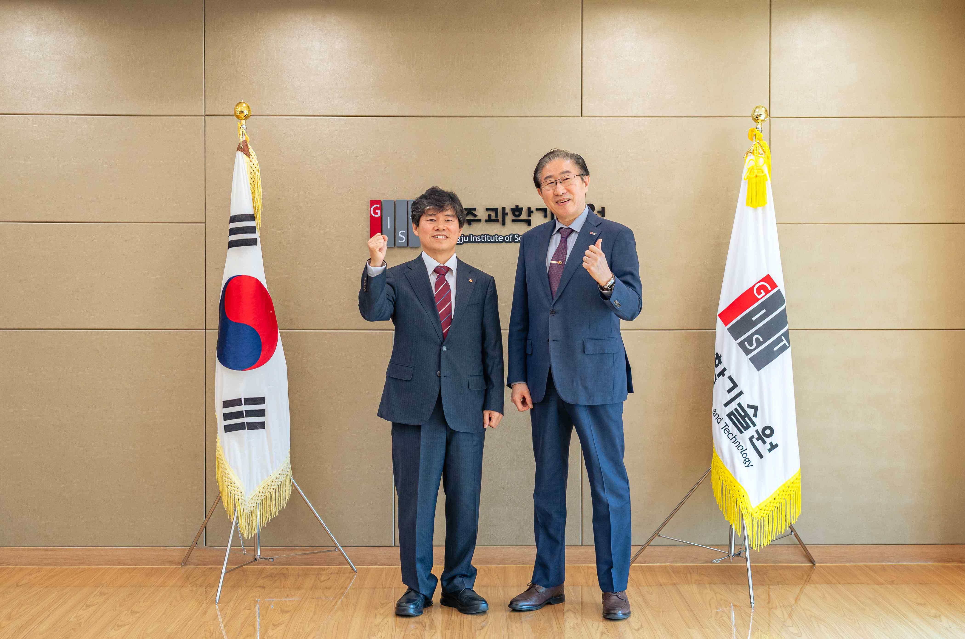

▲ (From right) GIST President Kichul Lim and PoSID Director Dae-seop Shin exchange pleasantries and take a commemorative photo in the GIST President's Office prior to the signing ceremony on November 24.

GIST President Kichul Lim stated, "In the era of AI transformation, the financial industry, as a leading service industry, is at the center of innovative changes, including advancements in fintech and the digitalization of blockchain-based financial services."

He continued, "GIST, with its financial technology and AI-based research capabilities, is exploring various collaborative opportunities that will contribute to talent development and revitalizing local industries." He added, "We hope that this agreement with PoSID will expand into practical collaborations, such as joint research, to meet the challenges and innovation demands of the digital transformation era."

PoSID Director Dae-seop Shin stated, "We expect that our institute's expertise in financial and digital strategic technologies and insurance, combined with GIST's cutting-edge research capabilities, will contribute to the advancement of the Postal Service's AI services. We will actively support students to gain practical experience and develop their capabilities, leading to employment."



