GIST launches Industry-Academia-Research Council for Graduate School of Management of Technology... also hosting Future Mobility Conference: Co-hosted by Gwangju Metropolitan City and the Ministry of Trade, Industry and Energy, and co-hosted by GIST and the Korea Future Mobility Cognitive Sensor Society

- On Thursday, November 20th, the GIST Graduate School of Management of Technology (MOT) held an inaugural ceremony for the Industry-Academia-Research Council... As a regional hub for industry-academia collaboration, the council will serve as a convergence collaboration platform supporting the AI+X transformation of key local industries

- The "2025 Korea Future Mobility Cognitive Sensor Society Fall Conference" will also be held on the 20th and 21st... Sharing the latest research findings, including vehicle component failure prediction technology (PHM) and image sensor and LiDAR sensor contamination response technology

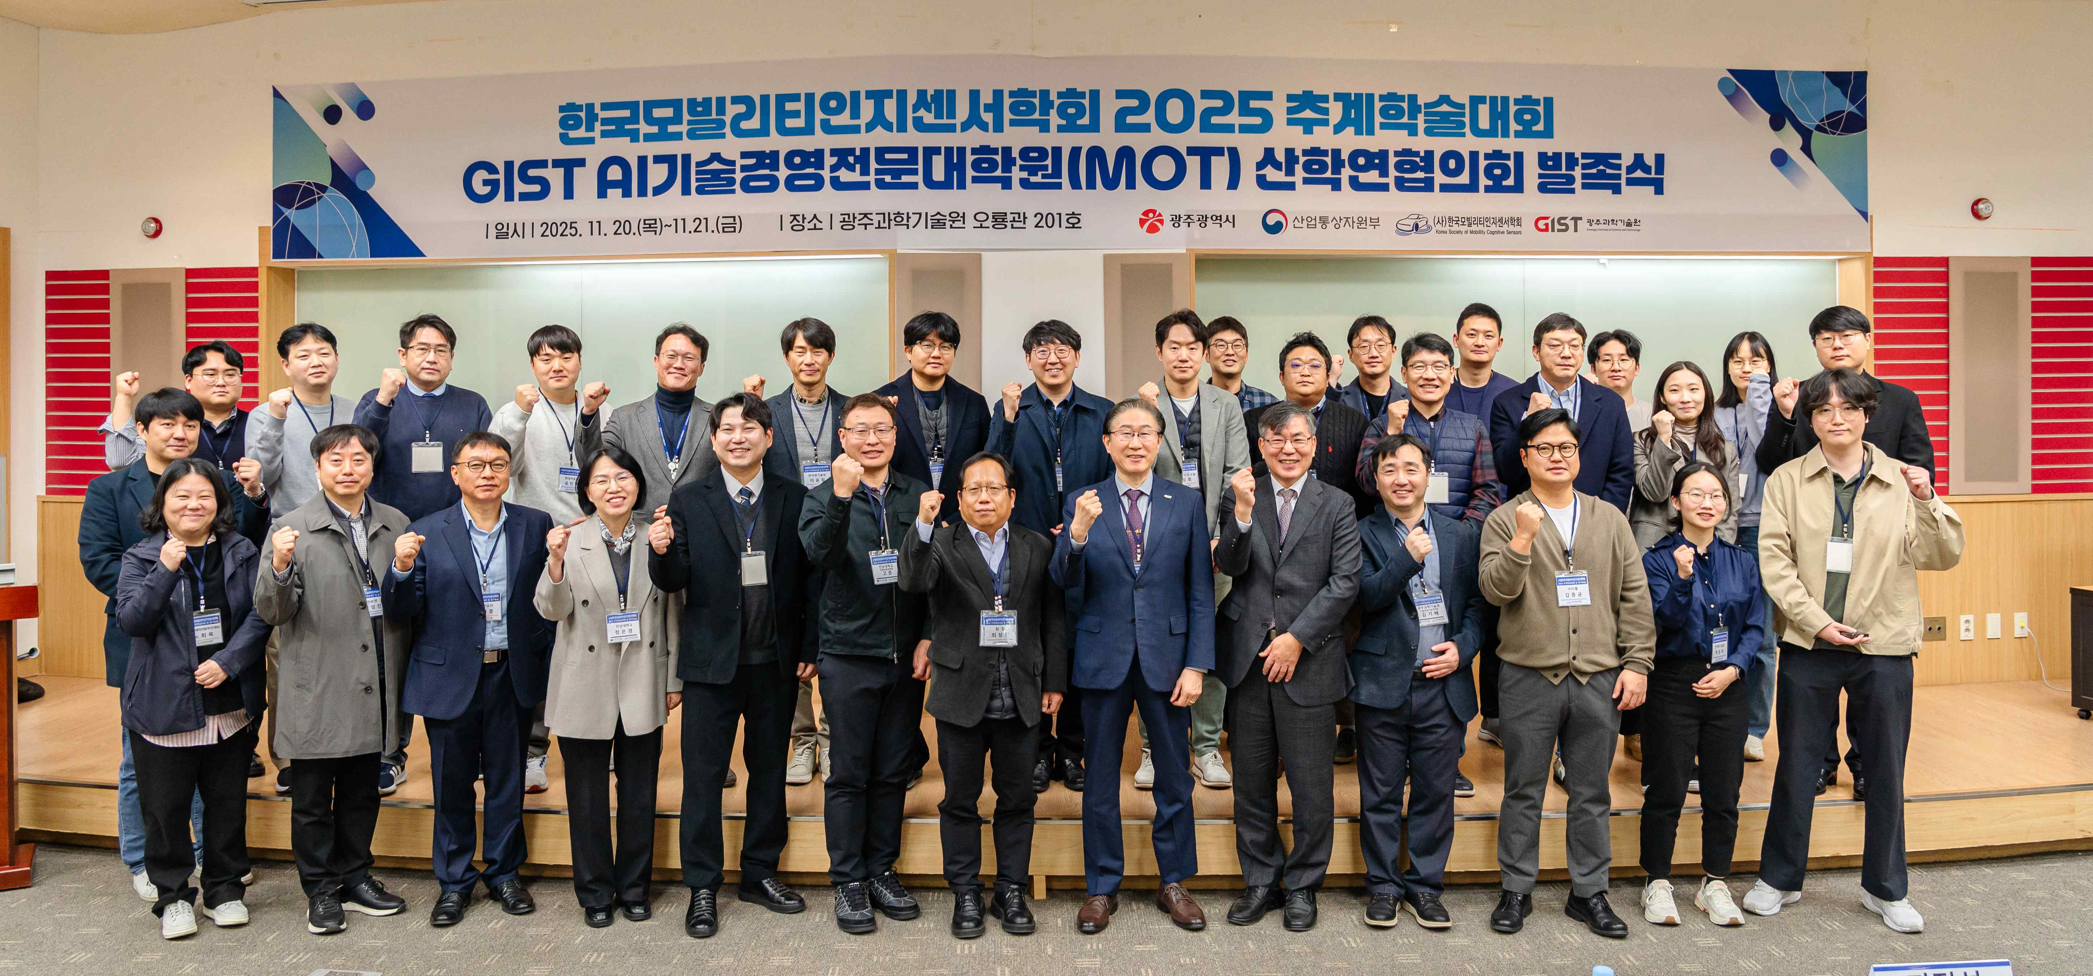

▲ Attendees of the "Graduate School of Management of Technology (MOT) Industry-Academia-Research Council Launch Ceremony" and the "2025 Korea Future Mobility Cognitive Sensor Society Fall Conference" pose for a commemorative photo at GIST's Oryong Hall.

The Gwangju Institute of Science and Technology (GIST, President Kichul Lim) announced that it held the "Graduate School of Management of Technology (MOT) Industry-Academia-Research Council Launch Ceremony" at GIST's Oryong Hall on Thursday, November 20th, followed by the "2025 Korea Future Mobility Cognitive Sensor Society Fall Conference" on Thursday, November 20th and Friday, November 21st.

The event was co-hosted by the Gwangju Metropolitan City and the Ministry of Trade, Industry and Energy, and co-organized by GIST and the Korea Future Mobility Cognitive Sensor Society.

The GIST Graduate School of Management of Technology Industry-Academia-Research Council, officially launched today, is a collaborative platform based on industry-academia-research convergence, bringing together local companies, research institutes, and universities.

The council will serve as a key hub connecting the GIST Graduate School of Management of Technology, which will open in March next year, with the local industry and plans to operate practical and field-oriented programs such as ▴ joint R&D between industry, academia, and research institutes ▴ training of technology management and artificial intelligence (AI) experts ▴ problem-based learning (PBL) projects targeting electric and mobility companies ▴ global cooperation programs.

Through this, students will be able to develop into practical talents encompassing technology and management. The council is expected to serve as a strategic platform that fosters the so-called "AI+X transition," a shift in regional industries that creates new value by applying AI technology to various fields, and leads practical research and educational cooperation.

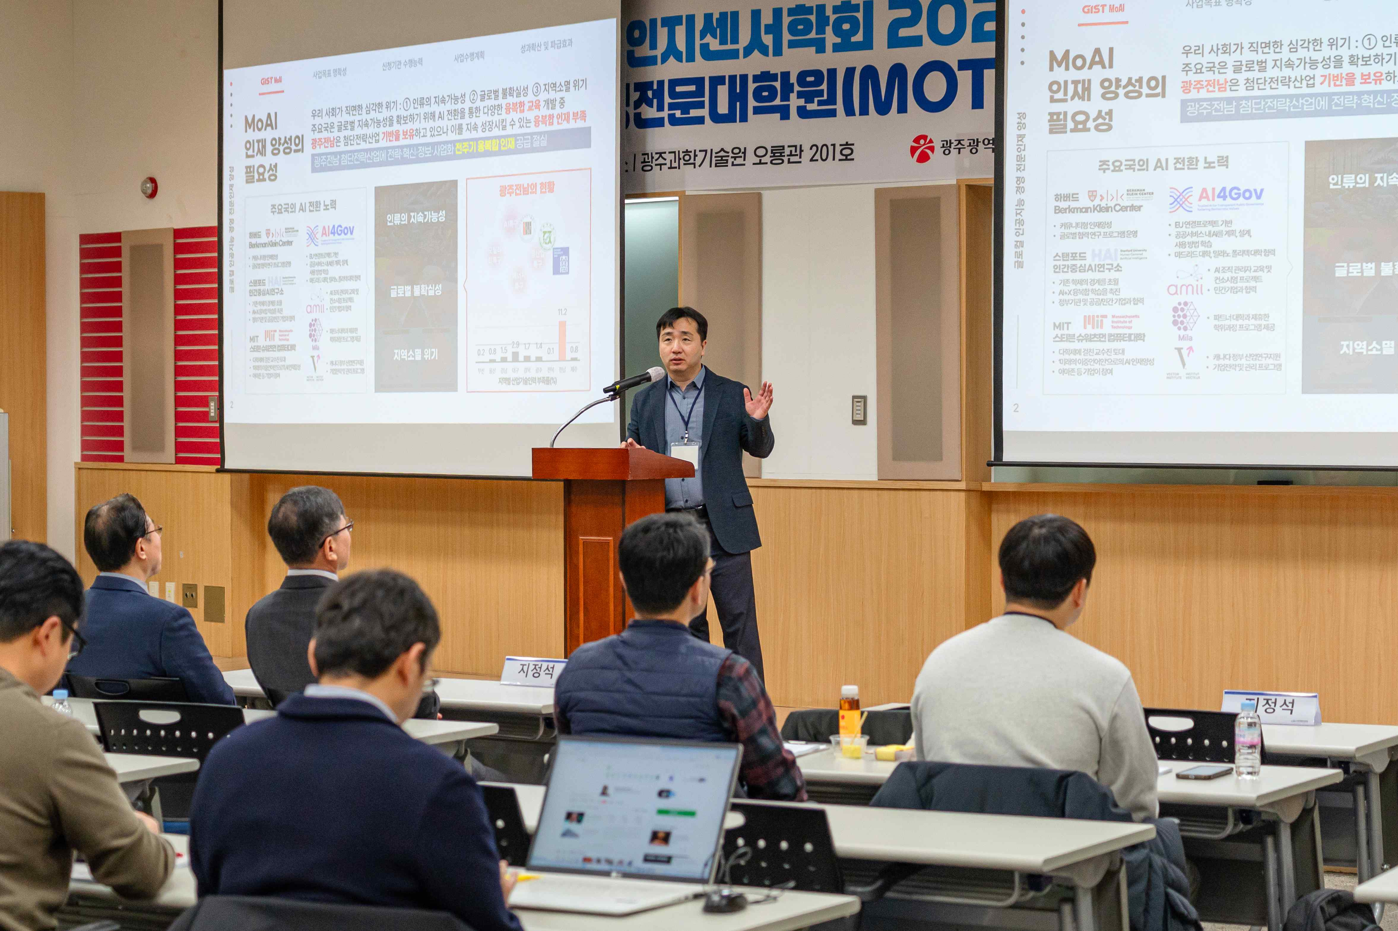

▲ Professor Kibae Kim of the Graduate School of Al Policy and Strategy emcees the event at the GIST Graduate School of Management of Technology (MOT) Industry-Academia-Research Council launch ceremony.

Gwangju Mayor Ki-jung Kang delivered a congratulatory video address, emphasizing, "Gwangju is leading the transformation of Korea's industrial landscape based on the future vehicle national industrial complex and the AI ​​industry." He added, "This academic conference and the launch of the Industry-Academia-Research Council are important milestones for Gwangju's leap forward as a testbed for global future mobility innovation."

He added, "I anticipate that the GIST Graduate School of Management of Technology will grow into a key partner connecting regional industries, research institutes, and companies. Gwangju City will actively support industry-academia-research cooperation to lead to tangible industrial outcomes."

GIST President Kichul Lim stated, "GIST's Graduate School of Management of Technology aims to strengthen the competitiveness of local industries and lead global innovation with 'AI+X Technology Management' as its core vision." He added, "The high level of interest and participation from industry and research communities witnessed at this event is evidence of Gwangju's growing technological innovation capacity."

He added, "With the newly launched Industry-Academia-Research Council at the center, we will pursue on-site demand-driven research, customized training for companies, and industrial intelligence projects to solidify Gwangju's position as a central hub for technological innovation in the southern region."

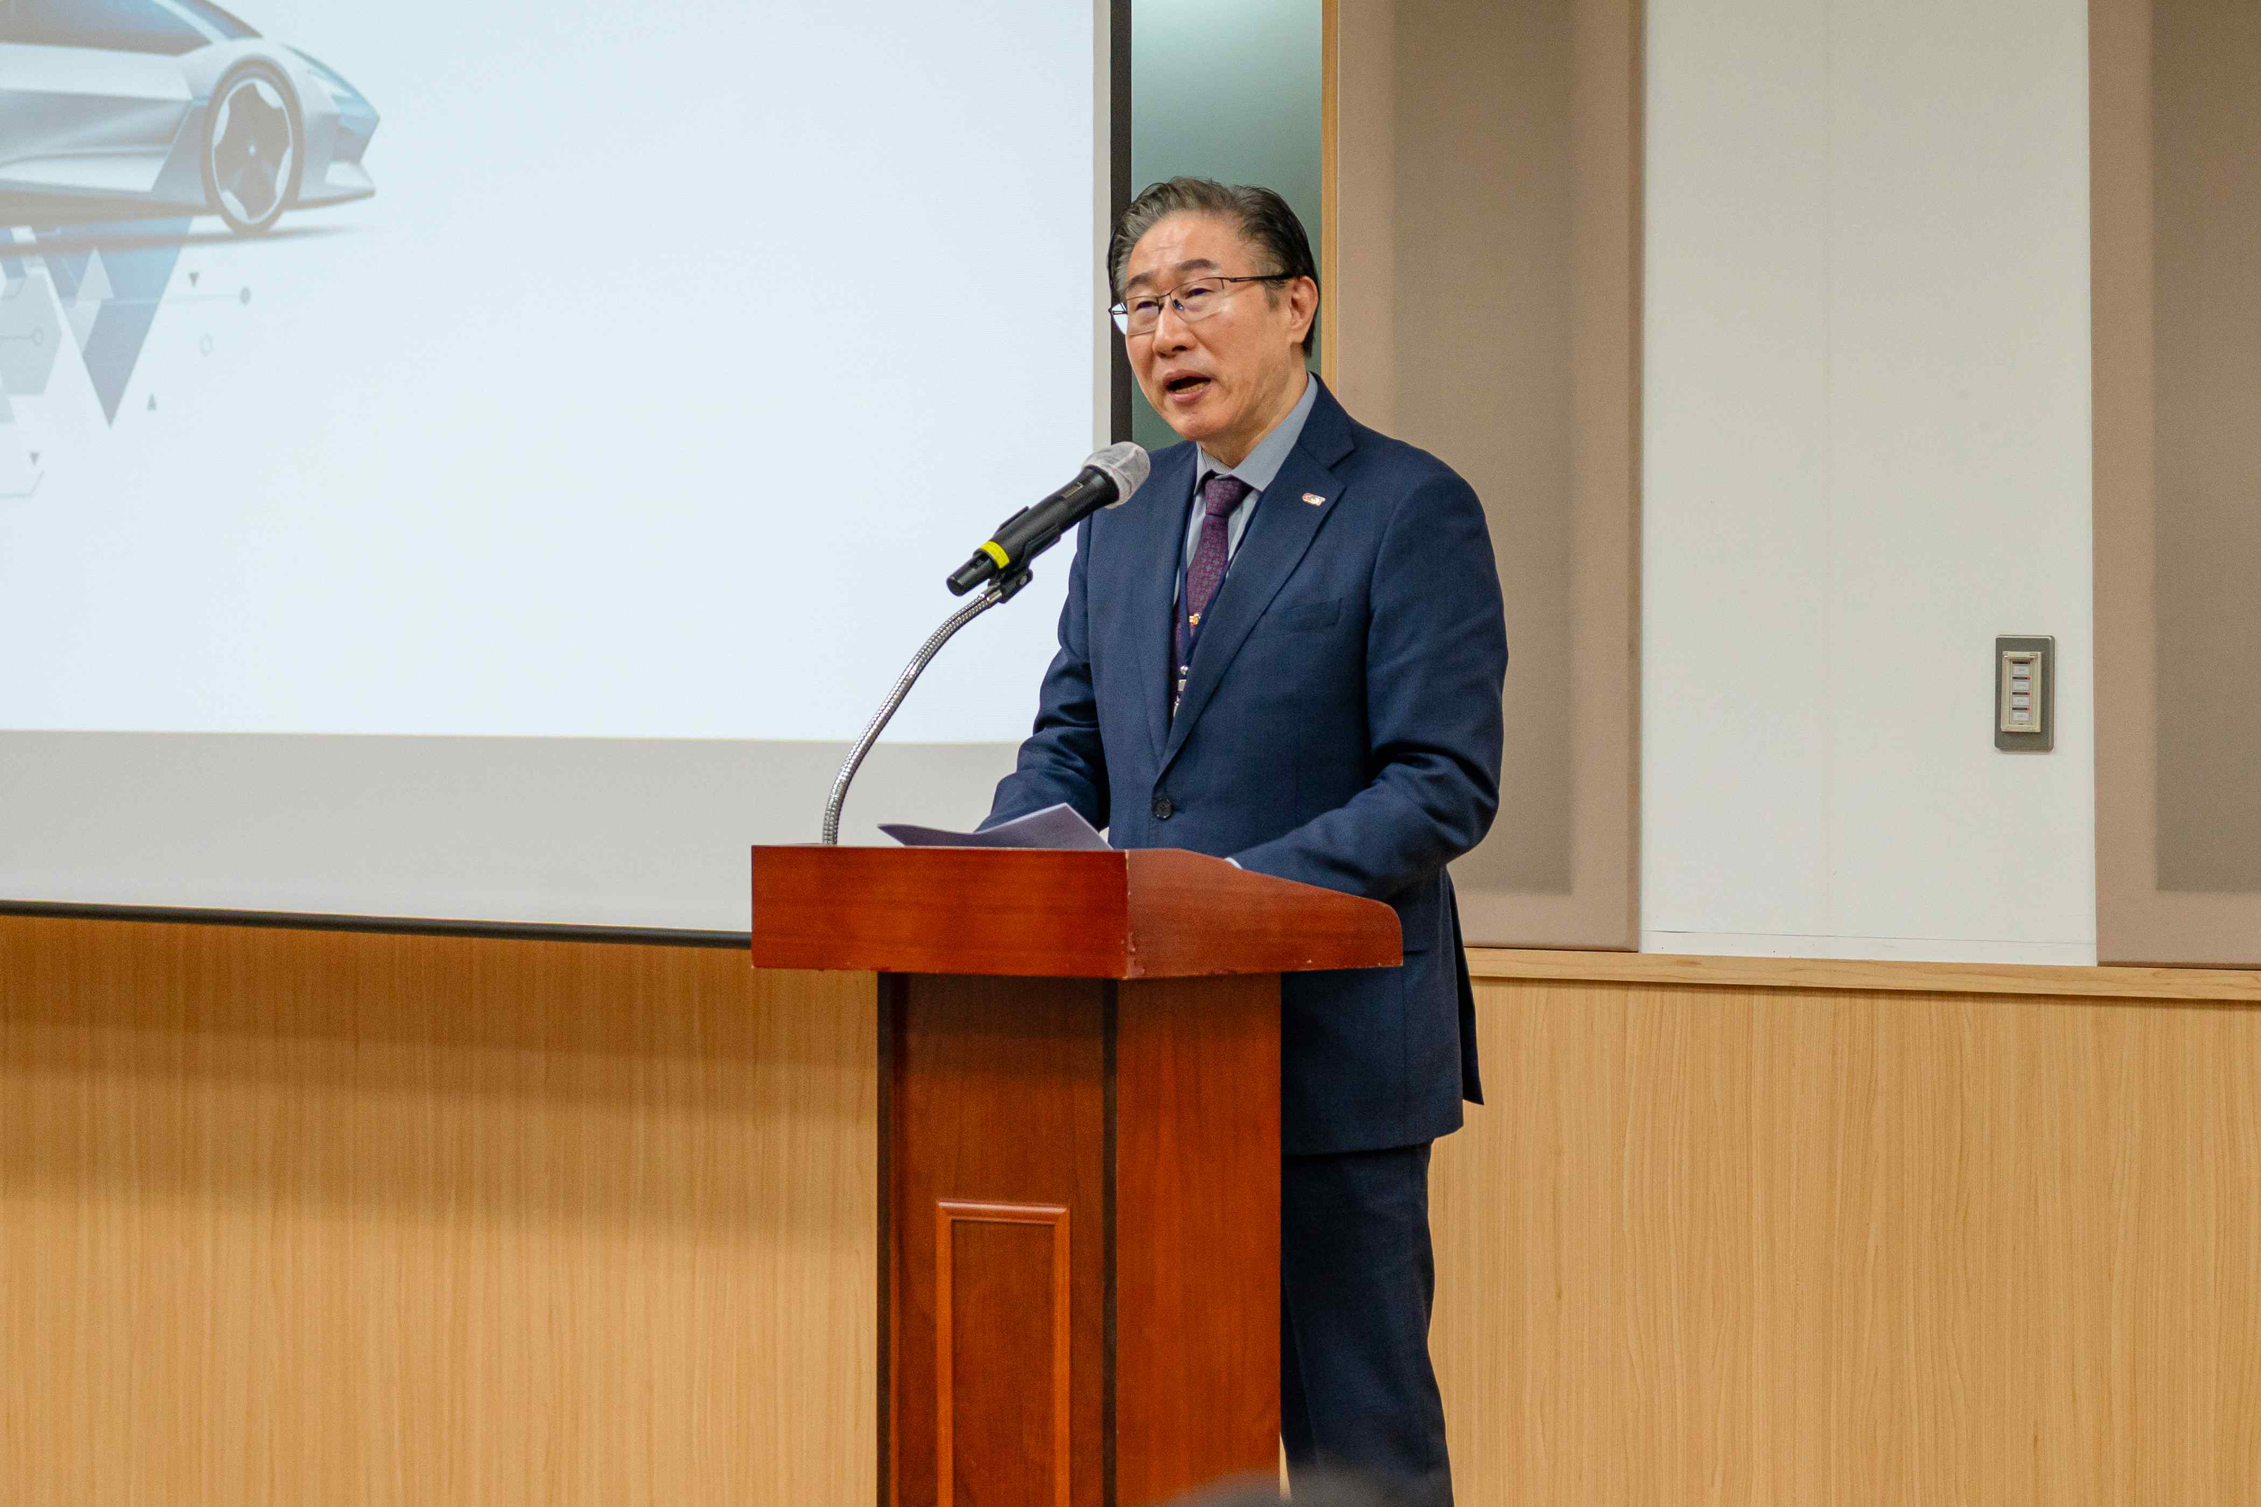

▲ President Kichul Lim delivers a congratulatory address at the inaugural ceremony of the GIST Graduate School of Management of Technology (MOT) Industry-Academia-Research Council.

The two-day conference brought together leading domestic mobility and sensor companies and research institutes, including Hyundai Motor Company, Intelligent Automotive Parts Promotion Agency, Korea Automotive Research Institute, HL Mando, and SOSLAB. The participants shared the latest research findings in key areas of future mobility, including AI-based sensor integration technology, autonomous vehicle safety and reliability assurance technology, vehicle component failure prediction technology (PHM), image sensor and LiDAR sensor contamination response technology, and aviation mobility technology.

Hyundai Motor Company and Intelligent Automotive Parts Promotion Agency presented keynote speeches on aeromobility composite materials and sensor convergence technology, and strategies for creating an AI-integrated automotive parts industry ecosystem, suggesting long-term directions for the industry.

The session, which brought together companies, universities, and research institutes, actively discussed reliability assessment technologies that reflect the needs of actual industrial sites and data-based safety assurance technologies.

GIST emphasized the significance of this event in that it shared the cutting-edge technologies and technology management-based innovation capabilities of the Gwangju region's industry, academia, and research institutes both domestically and internationally, and laid a practical foundation for the structural transformation of the local industry.

GIST Graduate School of Management of Technology Dean Sangho Kim stated, "This event solidifies Gwangju's status as a leading city in cutting-edge industries encompassing AI, future vehicles, and sensor industries. We will continue to enhance the competitiveness of local companies through the Industry-Academia-Research Council and build a sustainable cooperative system that connects with global technological innovation."

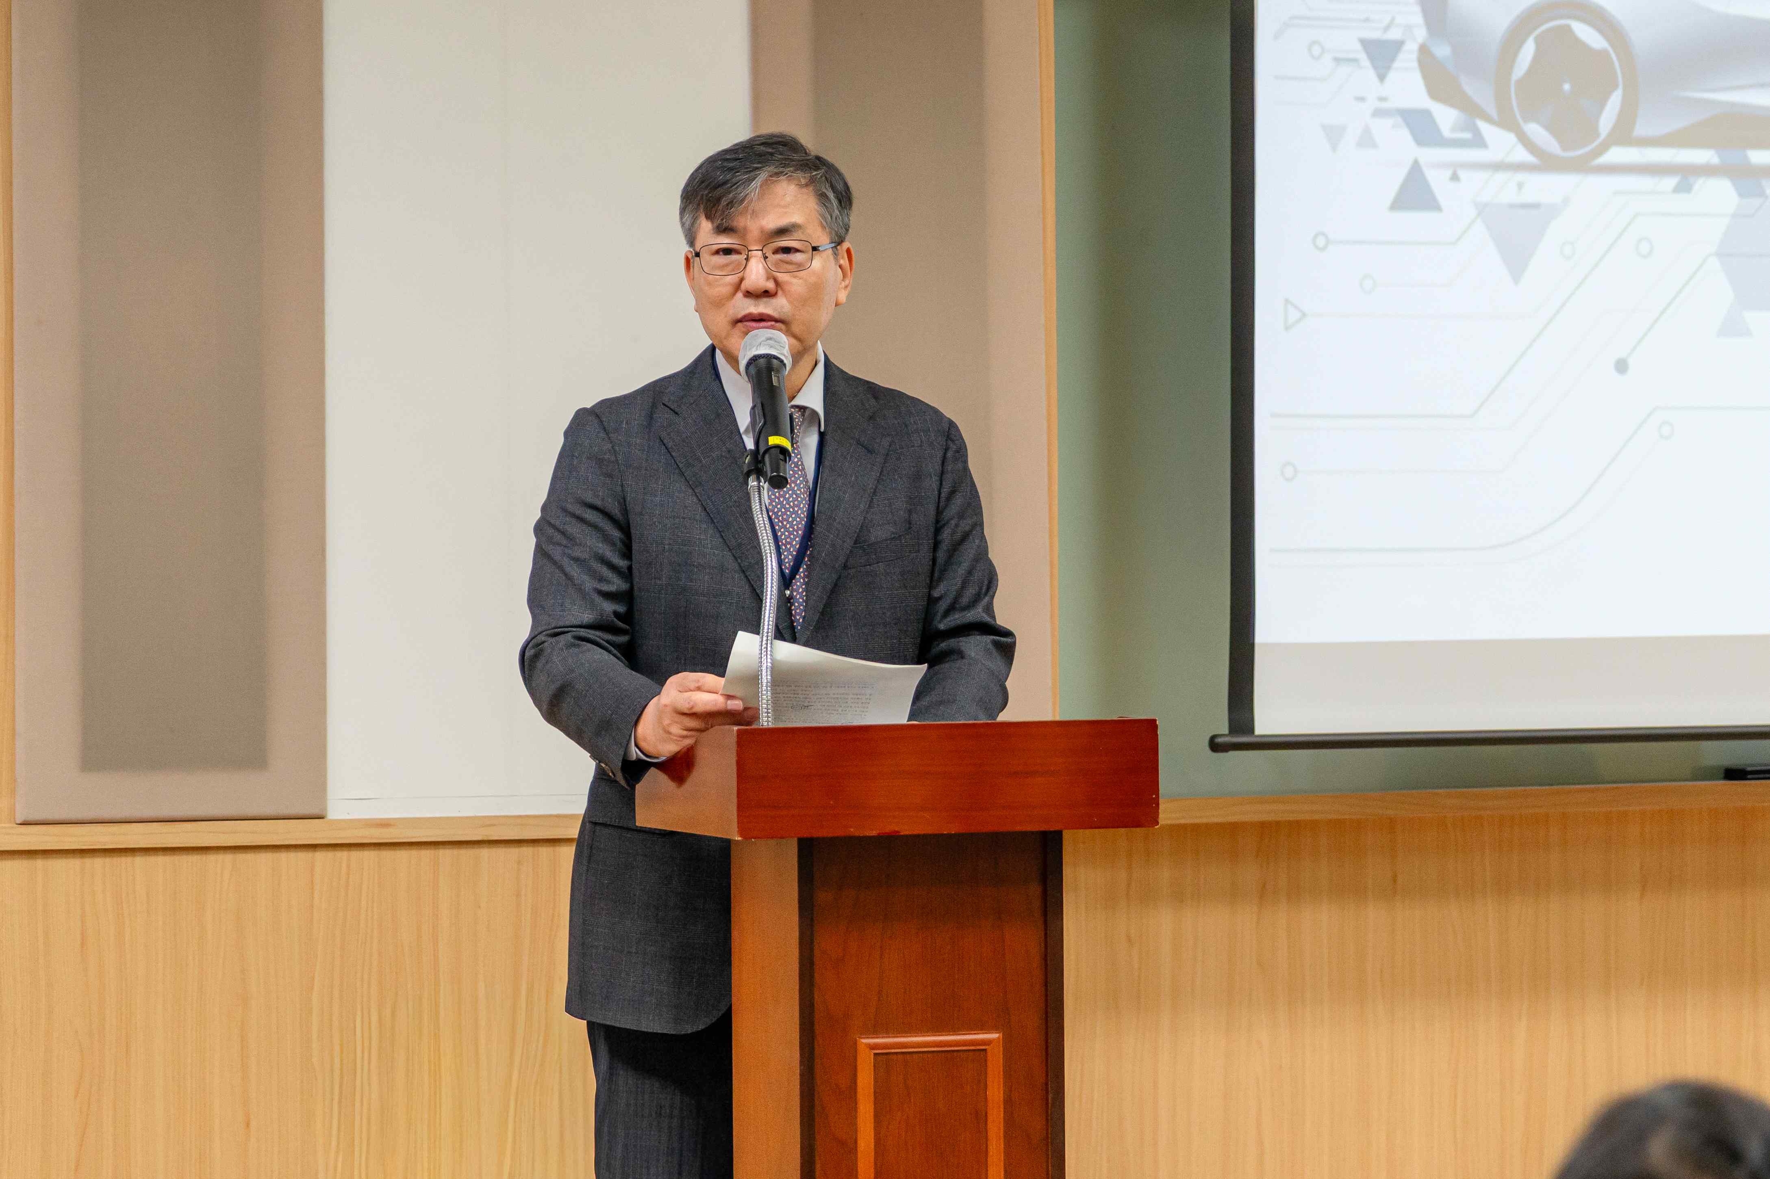

▲ Dean Sangho Kim delivers a welcoming address at the inauguration ceremony of the GIST Graduate School of Management of Technology (MOT) Industry-Academia-Research Council.

Meanwhile, the GIST Graduate School of Management of Technology (MOT), launched last October, is scheduled to open in March of next year. Its goal is to foster key talent who will strengthen the global competitiveness of AI-centric, cutting-edge strategic industries and drive technological innovation in local industries.



