"Students with different perspectives sat down together and surprisingly, they connected" GIST experiments with a democratic discussion culture through 'one-on-one in-depth conversations'

- GIST Newspaper, GIST School of Humanities and Social Sciences, and Party co-hosted the "2025 GIST Scientists' Dialogue." 30 current students participated in one-on-one conversations with students with widely differing backgrounds... Exploring a new debate culture through student-led dialogue experiments

- In-depth discussions on nine social issues, including AI accountability, the climate crisis, and inequality. Amidst the tight early voting results, participants emphasized the experience of hearing each other's context and background... "Providing a new model for public spheres"

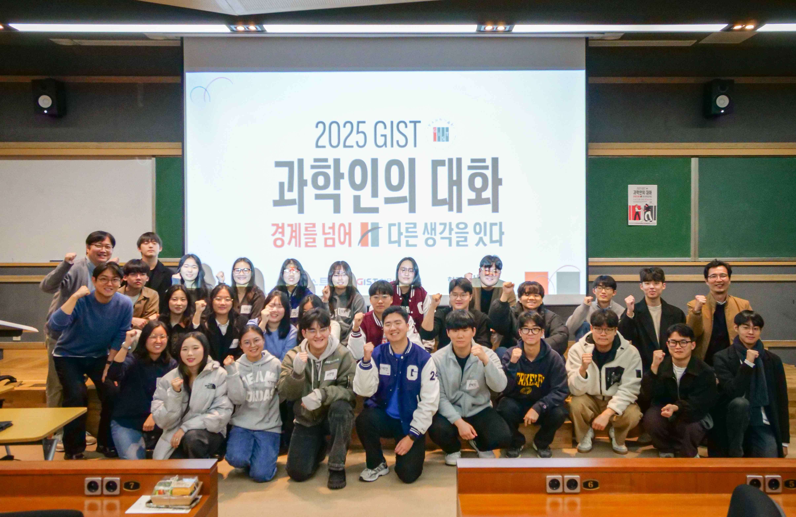

▲ Participants in the "2025 GIST Scientists' Dialogue" pose for a commemorative photo after the event.

The Gwangju Institute of Science and Technology (GIST, President Kichul Lim) announced that on Friday, November 14th, in College Building A, they conducted a "democratic debate experiment," where students engaged in one-on-one discussions with individuals with differing opinions.

GIST's student newspaper, GIST Newspaper, in collaboration with the GIST School of Humanities and Social Sciences and the social cooperative Party, hosted the "2025 GIST Scientists' Dialogue." Thirty students participated in the in-depth discussion program, which focused on nine social issues.

This program aimed to restore a healthy and safe debate culture within science and technology-specialized universities in an era where hate and ridicule are easily spread.

Participants used the "Galaxy Voting" and "Byeolbyeol Dialogue" platforms developed by Party to connect with individuals with different perspectives and engage in conversations that lasted approximately one hour. ‘Starry Conversation’ is a mobile app that matches two people with the most different opinions 1:1 and conducts a conversation based on pre-voting.

Since 2023, Party has been running "Korea Talks" in collaboration with the Hankyoreh and the Hankyoreh Economic and Social Research Institute, conducting experiments in social dialogue where citizens of diverse backgrounds meet and engage in dialogue to broaden their understanding.

This GIST program is particularly meaningful in that, building on this experience, the GIST student media directly planned and conducted a dialogue linking science, technology, and society.

Dean Gunoo Kim of the School of Humanities and Social Sciences encouraged the participants, saying, "Today is for the students." Party Director Yeon-soo Kim emphasized, "I hope this is not a debate where one person wins, but rather a time to listen to each other's backgrounds and contexts."

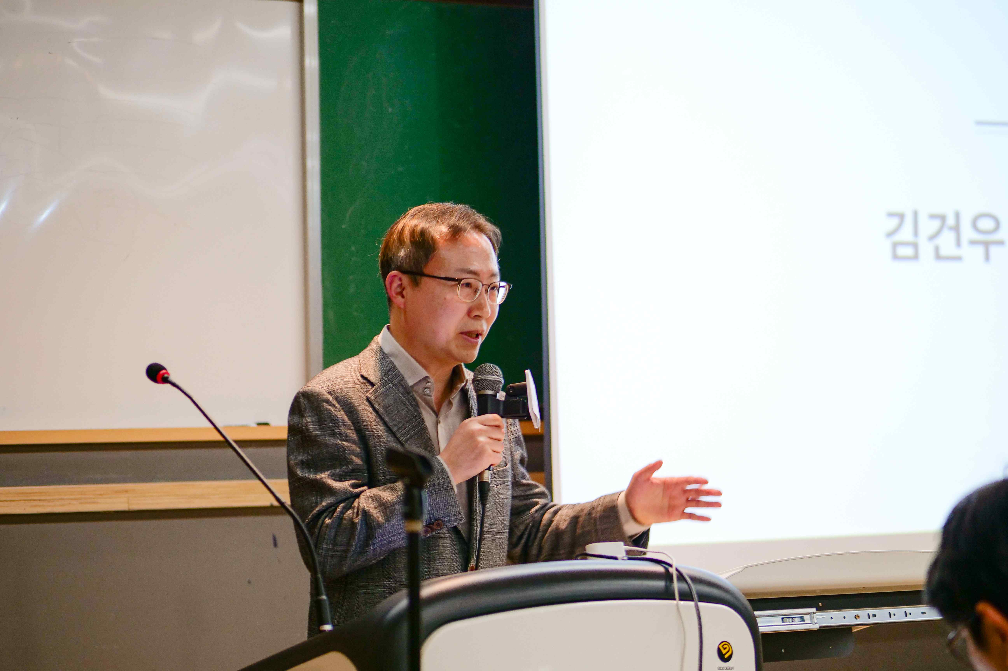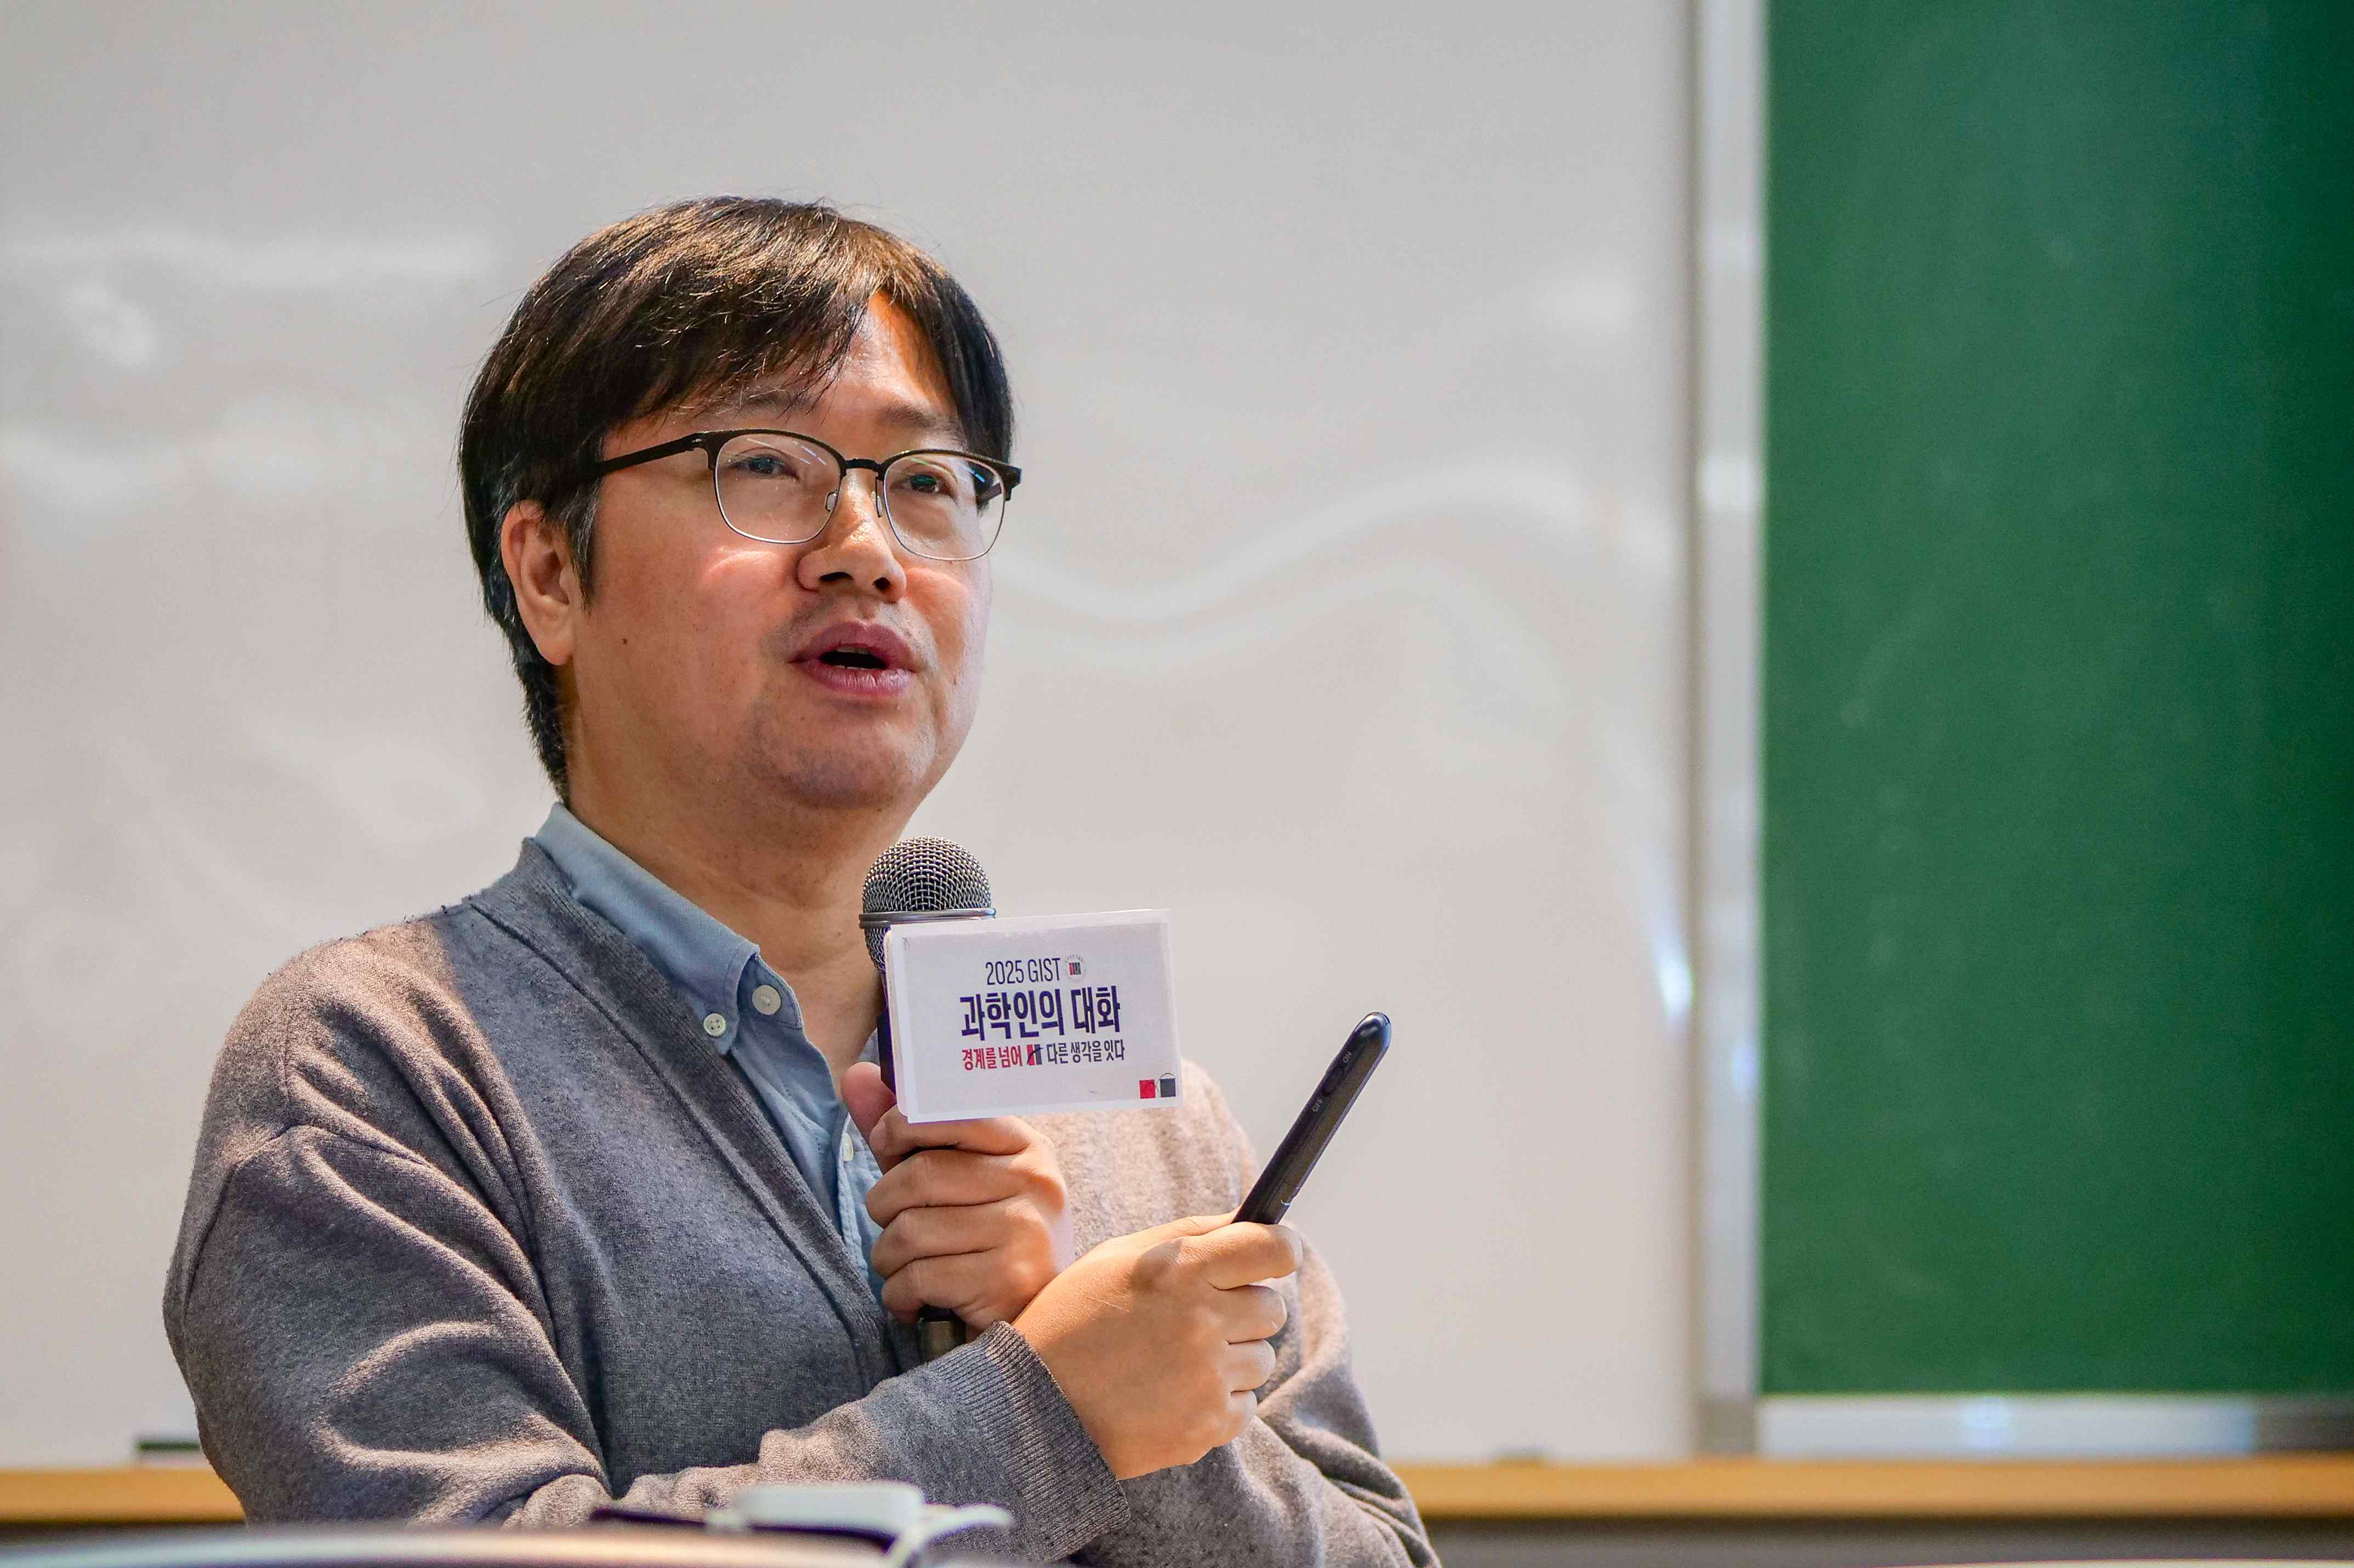

▲ GIST Dean Gunoo Kim of the School of Humanities and Social Sciences (left) and Party Director Yeon-soo Kim (right) explain the purpose of the event and encourage active discussion among students.

This program stemmed from the recognition that "more dialogue is needed about the responsibilities and roles of science and technology." As the impact of science and technology on society grows, fostering dialogue between scientists and citizens is crucial.

Participating students participated in a pre-vote on nine questions in four sections: ▴ Accountability in the AI ​​Era, ▴ Science and Inequality, ▴ Responsibility for the Climate Crisis, and ▴ The Social Role of Scientists. The questions presented were realistic and controversial, such as, "Is an experimental report written using AI really mine?" and "Can science and technology solve climate change?"

The pre-vote results showed a similar split for and against eight of the nine questions, demonstrating the diverse perspectives on current societal issues among GIST students. The full voting results and feedback will be released on the PARTY website.

At this event, students with the most differing opinions were matched one-on-one based on the pre-vote results and engaged in meaningful discussions. Despite meeting for the first time, they shared their backgrounds and perspectives, engaging in meaningful discussions.

Some students expressed their disappointment, saying, "The conversation was short," and expressed a desire to continue the conversation.

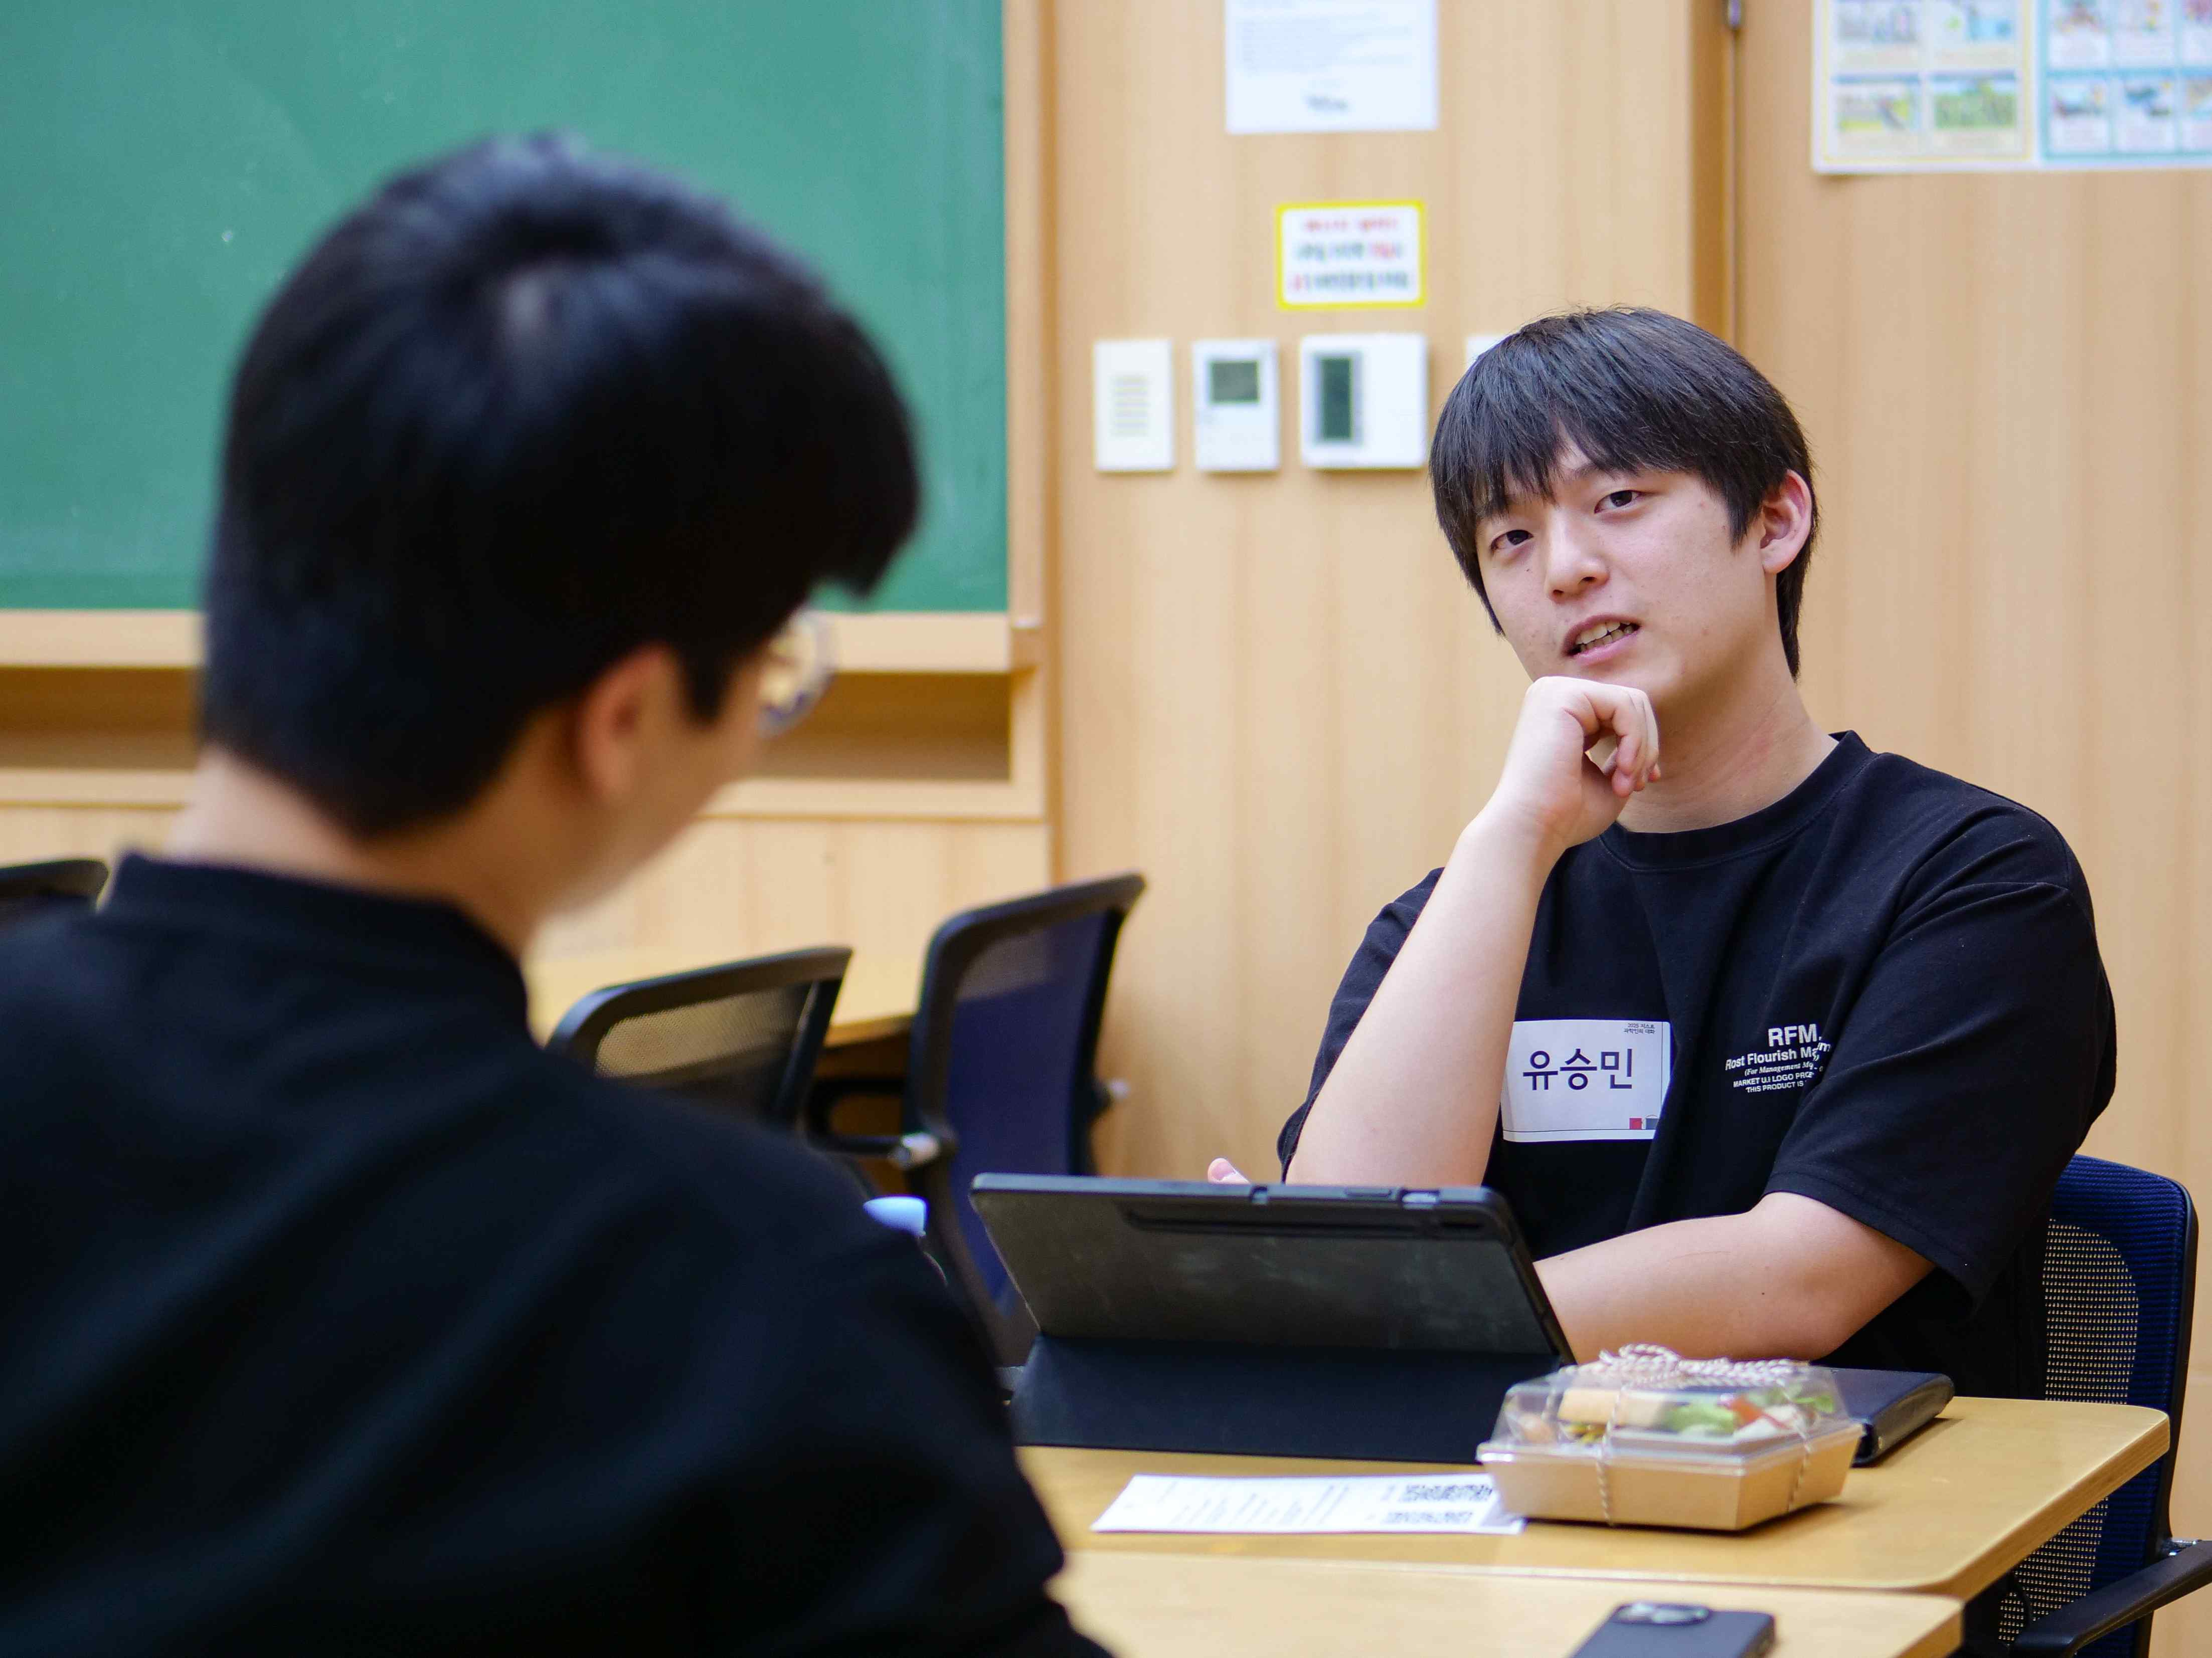

▲ Participants were matched one-on-one based on the results of the pre-voting and are engaged in a conversation, sharing their thoughts and opinions.

In the post-conversation sharing session, many students expressed their appreciation, saying, "It was meaningful because we were able to understand and empathize with each other, even with different opinions," and "It broadened my perspective on social issues."

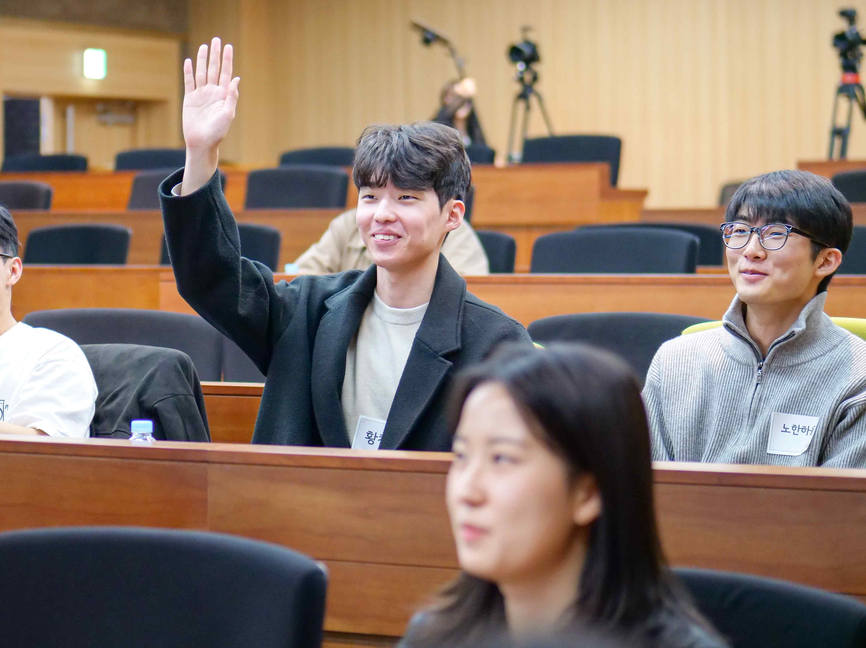

▲ Participants shared their thoughts and impressions after the conversation.

Si-hyeon Jo (4th year, chemistry) said, "Algorithms that tailor online content to individual preferences are increasingly fragmenting society, leaving few opportunities to engage with people with differing opinions. I hope this activity will be the first step toward discussing and resolving social issues together."

Yeon-woo Bae, a third-year student in the Department of Electrical Engineering and Computer Science and former deputy editor-in-chief of the GIST Newspaper, who organized the event, said, "As this was my first event, I had many concerns, but I am grateful that the participating students actively engaged in dialogue and recognized the need for a public forum."

Professor Dae-Cheong Ha of the GIST School of Humanities and Social Sciences commented, "Amidst growing social concerns about the crisis of democracy, this '2025 GIST Scientists' Dialogue' is significant in that it presents a new model for a public forum where young scientists and engineers can confront and reflect on their differences."

He added, "I hope that young GIST scientists and engineers will broaden their imaginations about their social roles by participating in public forums as citizens and developing digital technologies that strengthen democracy, such as Party's Galaxy Voting."



