GIST successfully held the '2025 GO! GO! GO! Fair'... Gwangju-style AI, mobility, and energy industry innovation models all in one place

- Co-hosted by Gwangju Metropolitan City, Gwangju Free Economic Zone Authority, GIST, and Korea Electric Power Corporation... The forum will be held on Monday, the 17th, at GIST's Oryong Hall to discuss practical cooperation for innovation in Gwangju's three key convergence industries and revitalize the local economy

- Approximately 100 participants, including representatives from AI, mobility, and energy companies, will participate... By exploring a Gwangju-style industrial innovation model where companies and institutions grow together, the forum will strengthen regional industrial competitiveness and lay the foundation for a leap forward as a future convergence industrial city

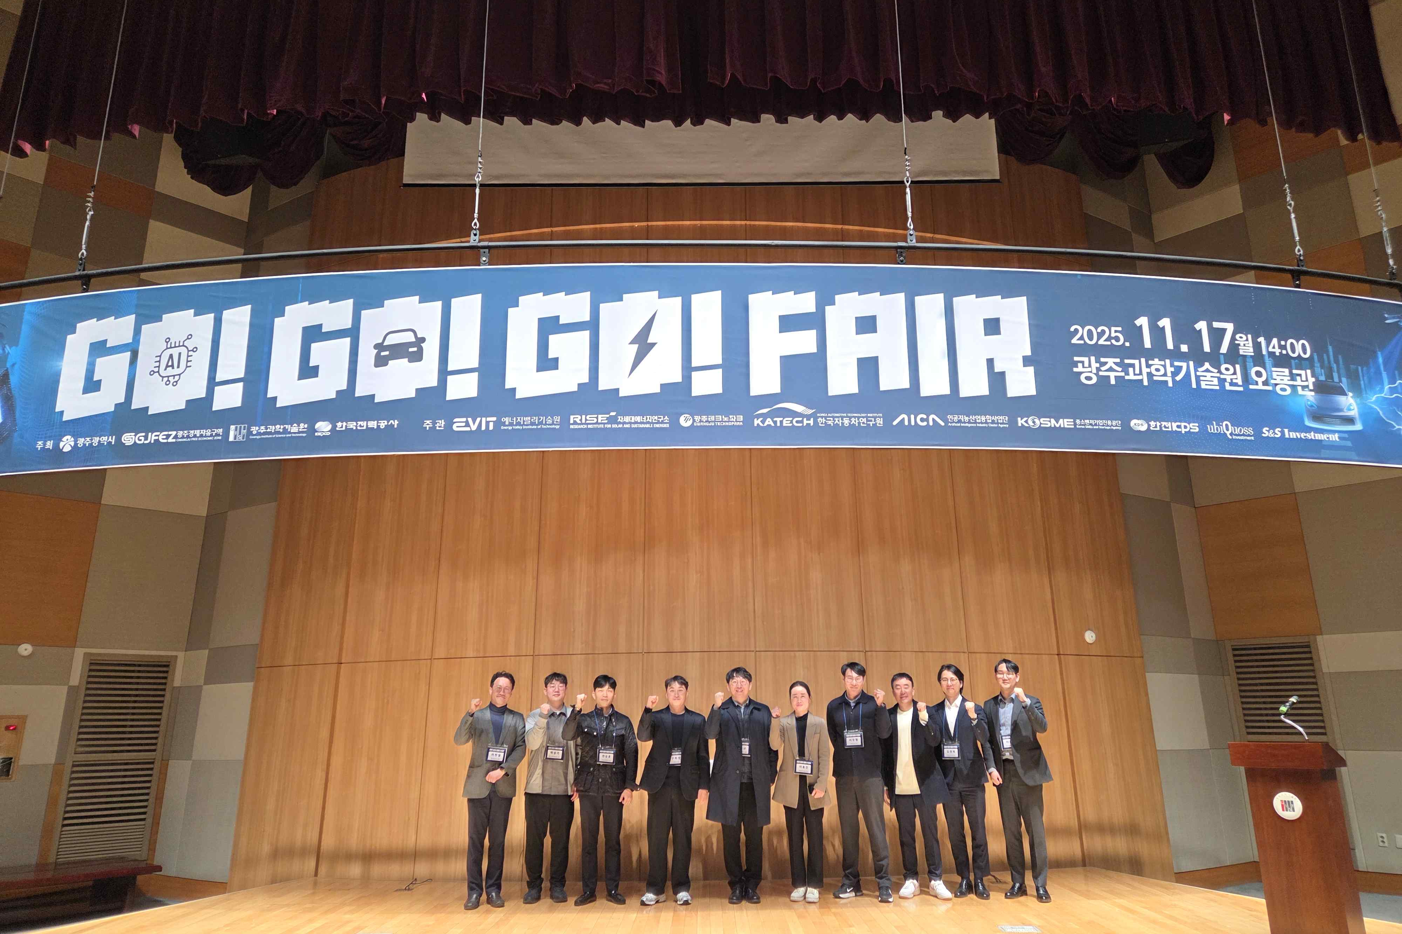

▲ Key speakers pose for a commemorative photo at the "2025 GO! GO! GO! Fair" held at GIST Oryong Hall on Monday, November 17th.

The Gwangju Institute of Science and Technology (GIST, President Kichul Lim) announced the successful hosting of the "2025 GO! GO! GO! Fair" at GIST Oryong Hall on Monday, November 17th.

Under the slogan "Save Companies (GO!), Save Gwangju (GO!), and Come Together (GO!)," the event was designed to promote convergence and innovation across the artificial intelligence (AI), energy, and mobility industries and to build an integrated support ecosystem encompassing technology, policy, and investment, with the participation of local governments, institutions, companies, and investors.

The event was co-hosted by the Gwangju Metropolitan City, the Gwangju Free Economic Zone Authority, GIST, and the Korea Electric Power Corporation (KEPCO), and co-hosted by the GIST Energy Valley Institute of Technology and the Research Institute for Solar and Sustainable Energies. Approximately 100 participants from industry, academia, research, and government, including AI, mobility, and energy companies, attended the event to discuss integrated support measures across all industries.

The first session, titled "Policies and Investments Support Corporate Growth!", brought together policy, technology, and investment organizations, including the Gwangju Free Economic Zone Authority, the Korea SMEs and Startups Agency, KEPCO KPS, S&S Investment, and Ubiquoss Investment. They shared strategies to support the entire corporate growth cycle, including location support, regulatory exemptions, policy funding, technology transfer, and open innovation funds.

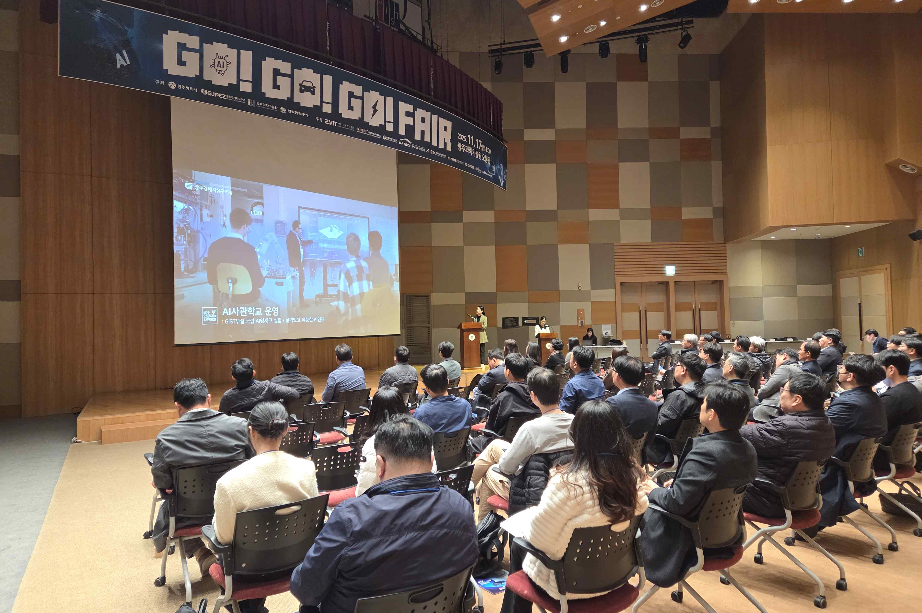

▲ The "2025 GO! GO! GO! Fair" was held at GIST Oryong Hall on Monday, November 17th.

Following this, the session, "We Support Research, Certification, and Infrastructure, from Corporate Technology Development to Commercialization!" featured participation from organizations such as Gwangju Technopark, the Korea Automotive Research Institute, and the Artificial Intelligence Industry Convergence Business Group. The session introduced a field-focused technical support system that supports companies throughout the entire process of technology development and commercialization, including R&D planning, (prototype) product testing and evaluation, patents, and provision of demonstration equipment.

Through this event, attendees shared the understanding that corporate support is shifting from "field-specific projects" to a "converged, integrated support system." They also agreed that collaboration among policy, technology, and investment stakeholders is crucial to creating viable innovation models at the industrial complex level.

GIST Energy Valley Institute of Technology Director Kwanghee Lee said, “I hope this fair will be the starting point for the Gwangju-style industrial innovation model where companies and institutions grow together,” and added, “We will continue to take the lead in building an integrated support ecosystem based on cooperation between industry, academia, research, and government, and in developing an industrial transformation implementation model.”

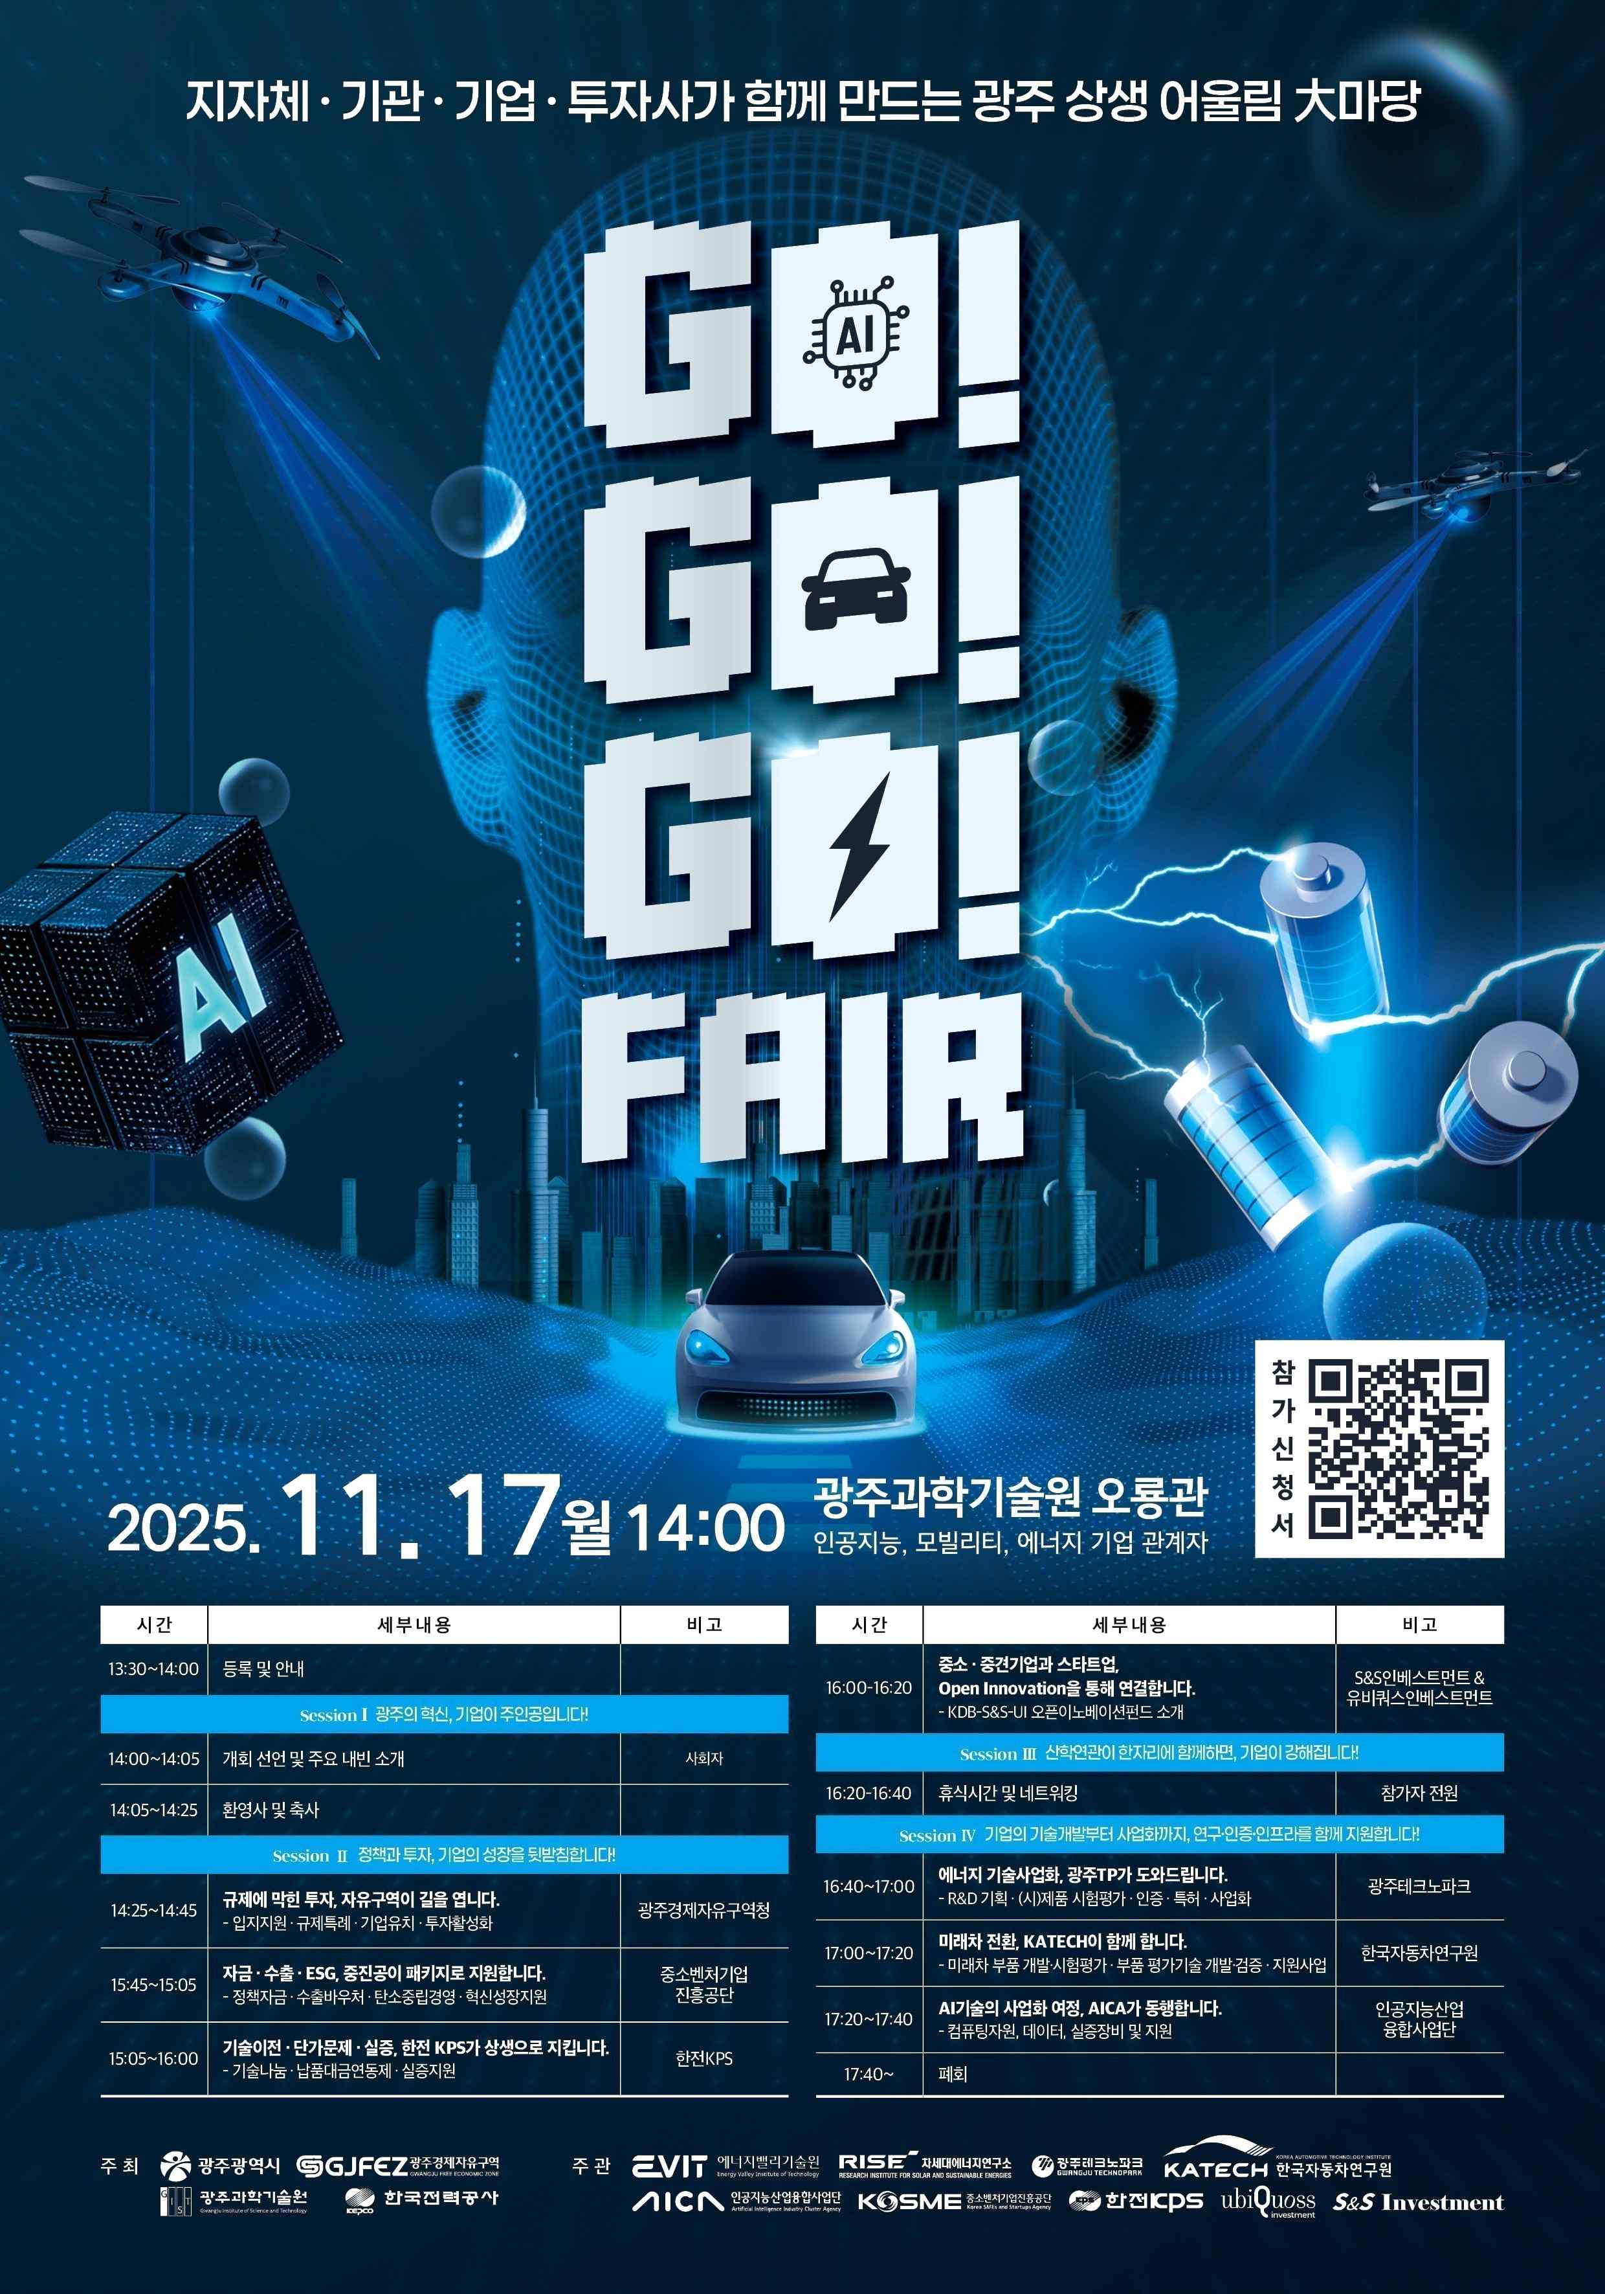

▲ Promotional poster for the "2025 GO! GO! GO! Fair." It includes information on the event schedule and key programs.

The "2025 GO! GO! GO! Fair" brought together Gwangju's three core industries—AI, mobility, and energy—to discover new growth engines and explore practical cooperation. This event served as a crucial opportunity to strengthen the region's industrial competitiveness and catalyze Gwangju's leap forward as a future convergence industrial city.



