GIST celebrates its 32nd anniversary with a new main gate and a leap forward

- GIST held a ceremony to commemorate its 32nd anniversary and the completion of its new main gate, reflecting on its achievements over the past 32 years and its vision for the future... The new main gate visualizes its brand identity and future vision, embodying its philosophy of openness, communication, and innovation

- "The essence of innovation at GIST is to connect researchers, students, the local community, and society, turning 'ideas that grow together' into reality"... A memorial plaque was also presented to the late Professor Kyoung-Woong Kim

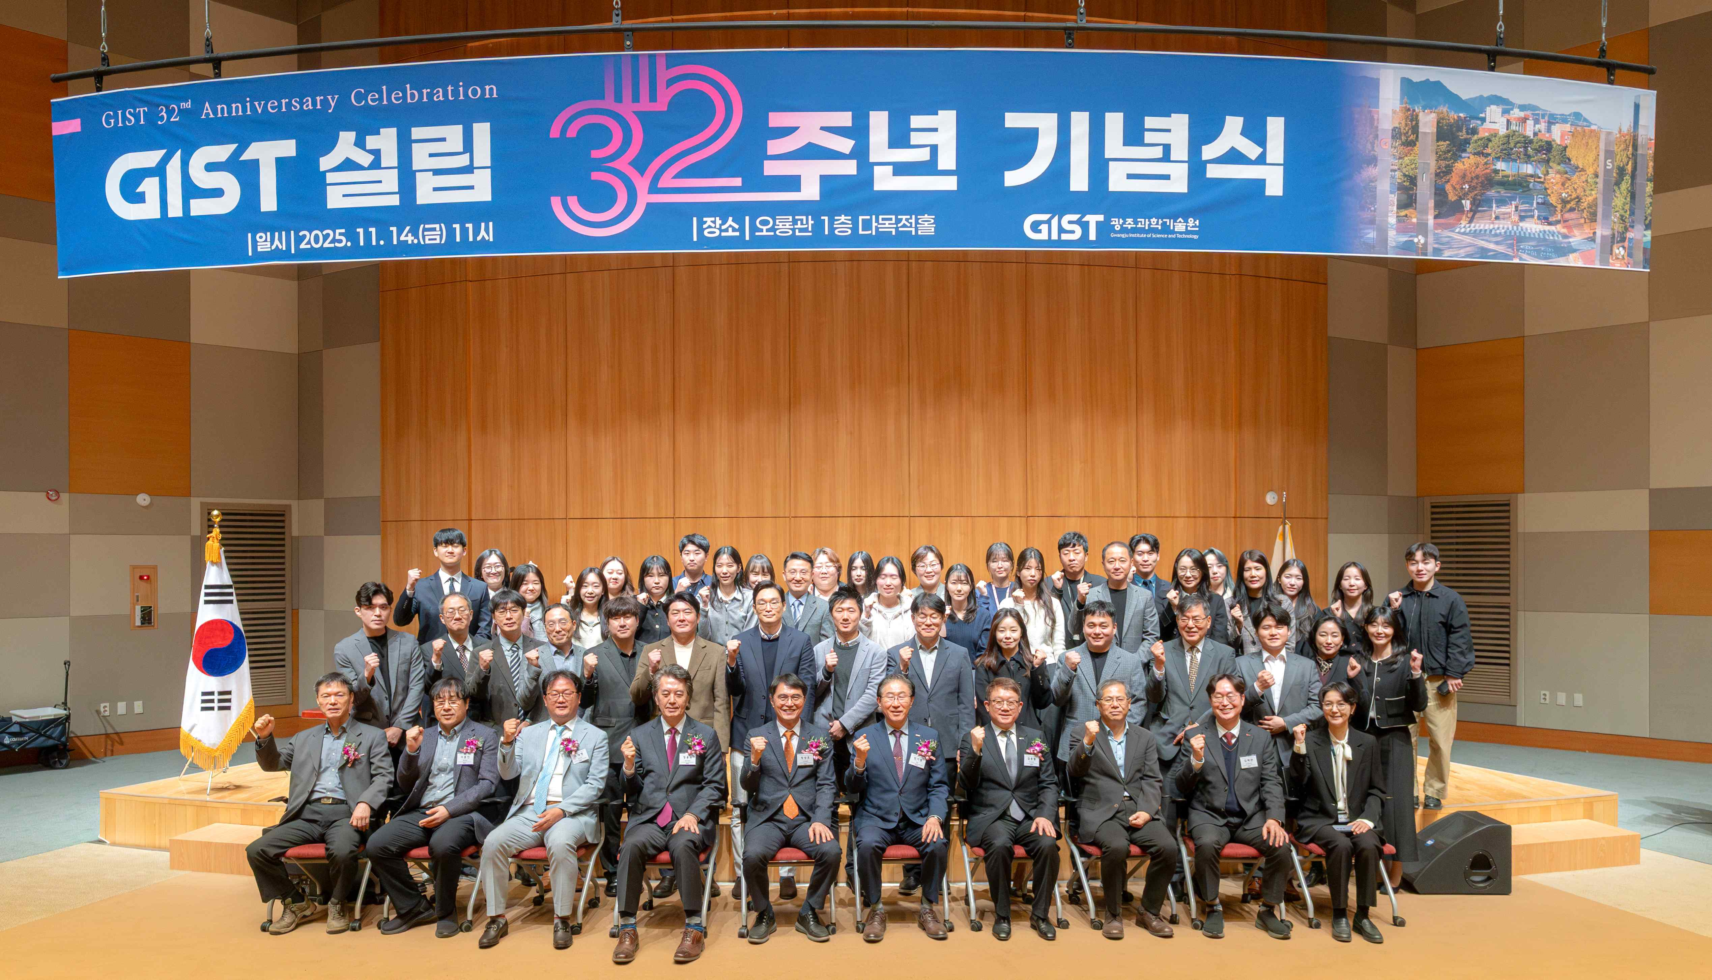

▲ Attendees pose for a commemorative photo at the GIST 32nd anniversary ceremony held in the multipurpose hall on the first floor of Oryong Hall on November 14th.

The Gwangju Institute of Science and Technology (GIST, President Kichul Lim) announced that it held a ceremony commemorating its 32nd anniversary on Friday, November 14th, at 11:00 AM in the multipurpose hall on the first floor of Oryong Hall. At 4:30 PM on the same day, a ceremony commemorating the completion of the main gate was held in the main gate event hall and Oryong Art Hall.

The ceremony reflected on GIST's achievements over the past 32 years in fostering scientific and technological talent, contributing to the development of national science and technology, local communities, and industry, and expanding international collaborative research. It also marked a new starting point for a leap forward in the future.

In particular, the new main gate, completed in celebration of its 32nd anniversary, serves as a landmark that visually demonstrates GIST's openness and innovation, demonstrating GIST's direction as a campus open to the local community, alumni, and donors.

At the 32nd anniversary ceremony, a commemorative plaque was presented to the late Professor Kyoung-Woong Kim of the Department of Environment and Energy Engineering, honoring his academic passion and dedication.

Professor Kim, a world-renowned authority in the field of soil and groundwater contamination remediation, has contributed significantly to the advancement of education, research, and international cooperation over the past 28 years since joining GIST in 1997. His achievements were recently highlighted by his inclusion in the "2025 Global Top 2% Researchers" list, jointly announced by Elsevier, a global academic information analytics company, and Stanford University, for the fifth consecutive year.

He implemented the "Ongdalsam Project," which supports water purification systems that operate without electricity in areas where people have no choice but to drink polluted water. He developed the "GIST Hope Water Purifier," a non-electric water treatment device and distributed it to over 20 countries, including Nepal, Indonesia, and the Philippines, demonstrating his commitment to the social responsibility of science and technology.

In his commemorative address, President Kichul Lim expressed his deep gratitude, saying, "I would like to express my deepest gratitude to all the members and the local community who have supported GIST over the past 32 years to bring it to where it is today." He added, "With the newly created campus space and these leap-forward projects, we will further accelerate innovation in education, research, and industry-academia cooperation."

He continued, "As Gwangju moves toward becoming an 'AI-centric city,' GIST must become a hub for industry-academia cooperation, connecting industry, talent, and innovation. We will work together to create a future industrial ecosystem by establishing an advanced AI semiconductor process FAB, expanding the IBS research group, and establishing a new AI school for gifted students."

President Lim also stated, "Innovation is not complete with outstanding ideas alone." He mentioned the School of Humanities and Social Sciences Professor Donghyuk Kim's recently translated book "Lonely Ideas," published by GIST Press, a university publishing company. He added, "Only when researchers, students, the local community, and society connect as a single ecosystem can 'ideas that grow together' become a reality. This is the essence of innovation that GIST strives for."

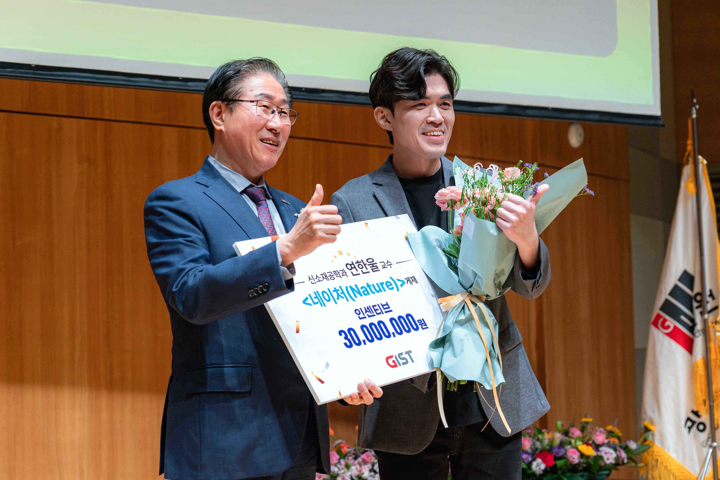

▲ President Kichul Lim poses for a commemorative photo with Professor Hanwool Yeon of the Department of Materials Science and Engineering, recipient of the Outstanding Journal Incentive, at the GIST 32nd Anniversary Ceremony.

In the afternoon, a ceremony commemorating the completion of the newly constructed GIST Main Gate was held.

The new Main Gate is more than just an entrance; it is a symbolic structure that embodies GIST's philosophy of openness, communication, and innovation. It intuitively conveys the brand identity and future vision from the first moment visitors encounter the campus.

The main gate was designed by G&M Architects Co., Ltd. based on a design selected through a competition, with technical support from POSCO, and constructed by NI Steel Co., Ltd. The futuristic design features four pillars symbolizing intellect, scholarship, passion, and youth, engraved with the letters G, I, S, and T in a "V" shape for victory. The stainless steel exterior reflects light and the surrounding landscape, symbolizing "GIST, constantly changing and growing."

The completion ceremony was attended by POSCO Group Chairman In-hwa Jang, Democratic Party National Assembly Member In-cheol Cho (Gwangju Seo-gu A), NI Steel Chairman Jong-min Bae, GIST President Kichul Lim and other key officials, GIST Foundation Chairman Eun-mo Choi, along with figures from the local economy and industry, alumni, donors, and student representatives, all celebrating GIST's new beginning.

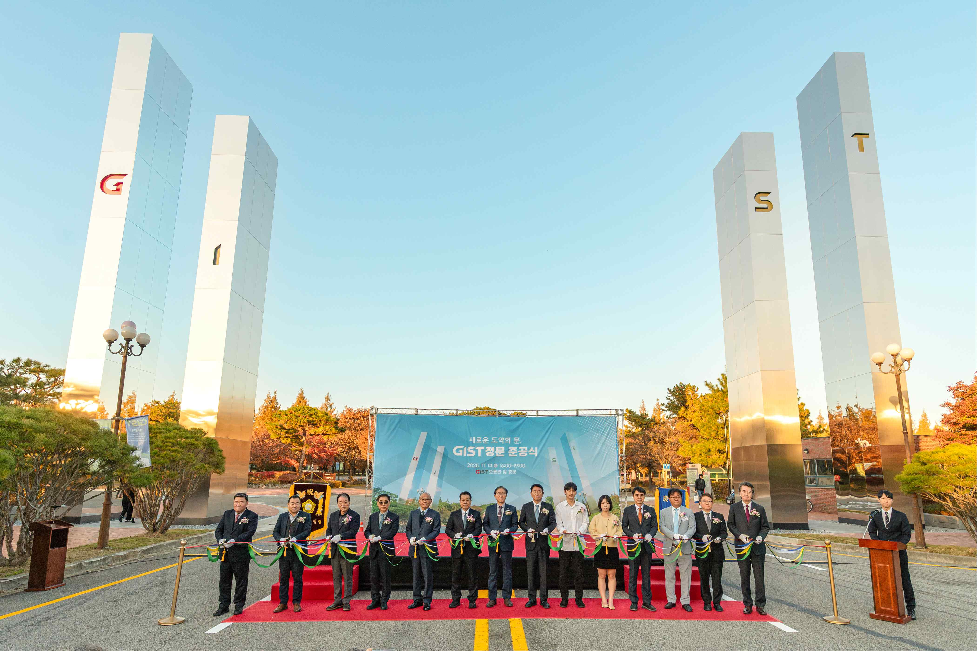

▲ On November 14th, at the GIST Main Gate Ceremony, a ribbon-cutting ceremony commemorating the completion of the main gate was held, attended by key figures including GIST President Kichul Lim, POSCO Group Chairman In-hwa Jang, and Democratic Party Representative In-cheol Cho. This is a panoramic view of GIST's new main gate, showcasing the grandeur of the harmonious blend of technology and art.

President Kichul Lim stated, "The new main gate is a magnificent structure that harmonizes technology and art, and will serve as a gateway for challenge and reflection for both students and researchers." He expressed his gratitude to POSCO Chairman In-hwa Jang, officials, donors, and the facility management team.

He also stated, "With the construction of the main gate, we will further expand communication with the local community and alumni, and expand the foundation for future donations and cooperation to jointly realize GIST's future vision."

In his congratulatory remarks, POSCO Group Chairman In-hwa Jang stated, "GIST has grown over the past 32 years by overcoming various challenges and challenges, and its unwavering conviction and determination will serve as the driving force for even greater advancements in the future."

"The new main gate symbolizes the unwavering spirit of GIST, like the POSCO stainless steel pillars, and will serve as a reminder of the challenges and determination of all its members," he said.

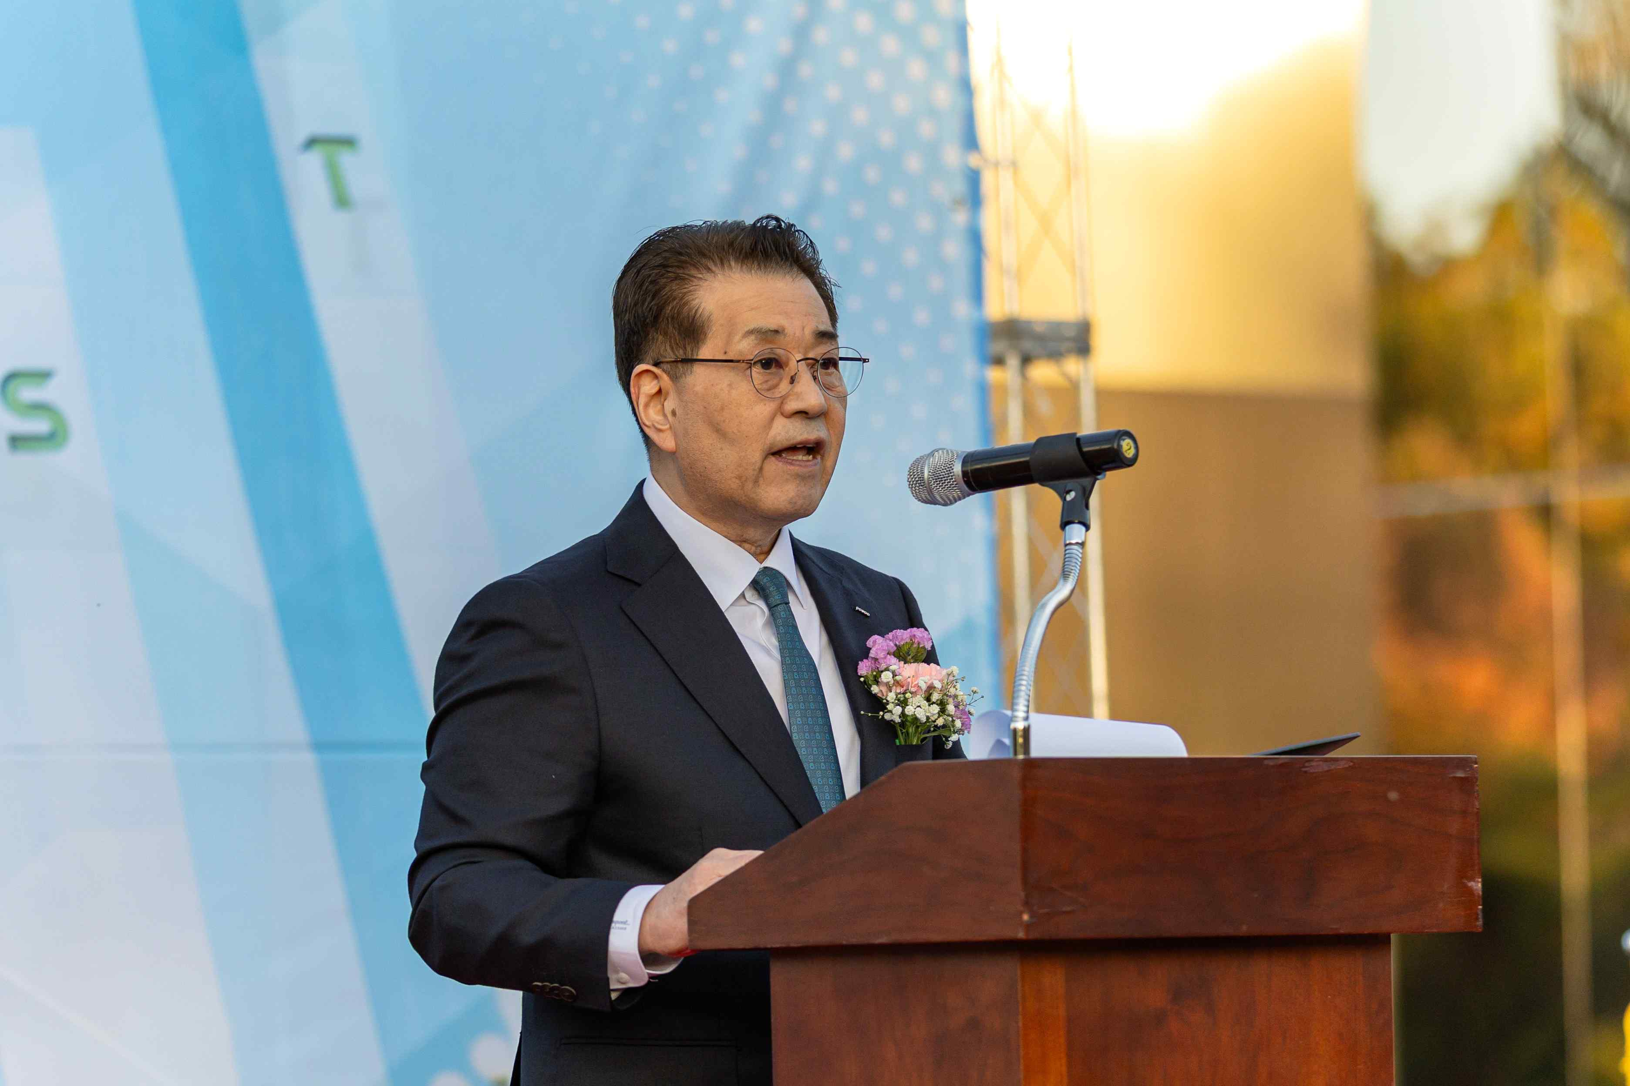

▲ POSCO Group Chairman In-hwa Jang delivers a congratulatory address, emphasizing GIST's challenges and growth and the significance of the construction of the main gate.

Founded in 1993 pursuant to the Gwangju Institute of Science and Technology Act, GIST has contributed to the nation's scientific and technological advancement by fostering cutting-edge scientific and technological talent and supporting industry-academia-research and international collaborations, technology transfer, and startup support.

Since its first graduating class in 1997, GIST has produced a total of 8,858 outstanding individuals (2,095 doctoral degrees, 5,271 master's degrees, and 1,492 bachelor's degrees). Through collaborations with leading universities and research institutes around the world, GIST continues to expand its global research and development (R&D) network.

In particular, in August of this year, it co-founded the ‘Human-Centered Physical AI Research Center’ with the Massachusetts Institute of Technology (MIT) in the United States, and is leading the development of cutting-edge technologies at a world-class level by actively conducting international joint research in the field of AI and robot convergence.



