NH Investment & Securities donates 20 million won to GIST's "Thousand Won Breakfast" project

- A donation ceremony was held at 2:00 PM on Friday, November 7th at the NH Financial Tower in Park One, Yeouido, Seoul… The "Thousand Won Breakfast" program contributes to the formation of healthy eating habits among students and the promotion of local agricultural product consumption

- NH Investment & Securities actively participated in the "Nongshim Cheonsim Breakfast Campaign" and donated funds for the "Thousand Won Breakfast" program for university students outside the Seoul metropolitan area... Taking the lead in promoting rice consumption and healthy eating habits

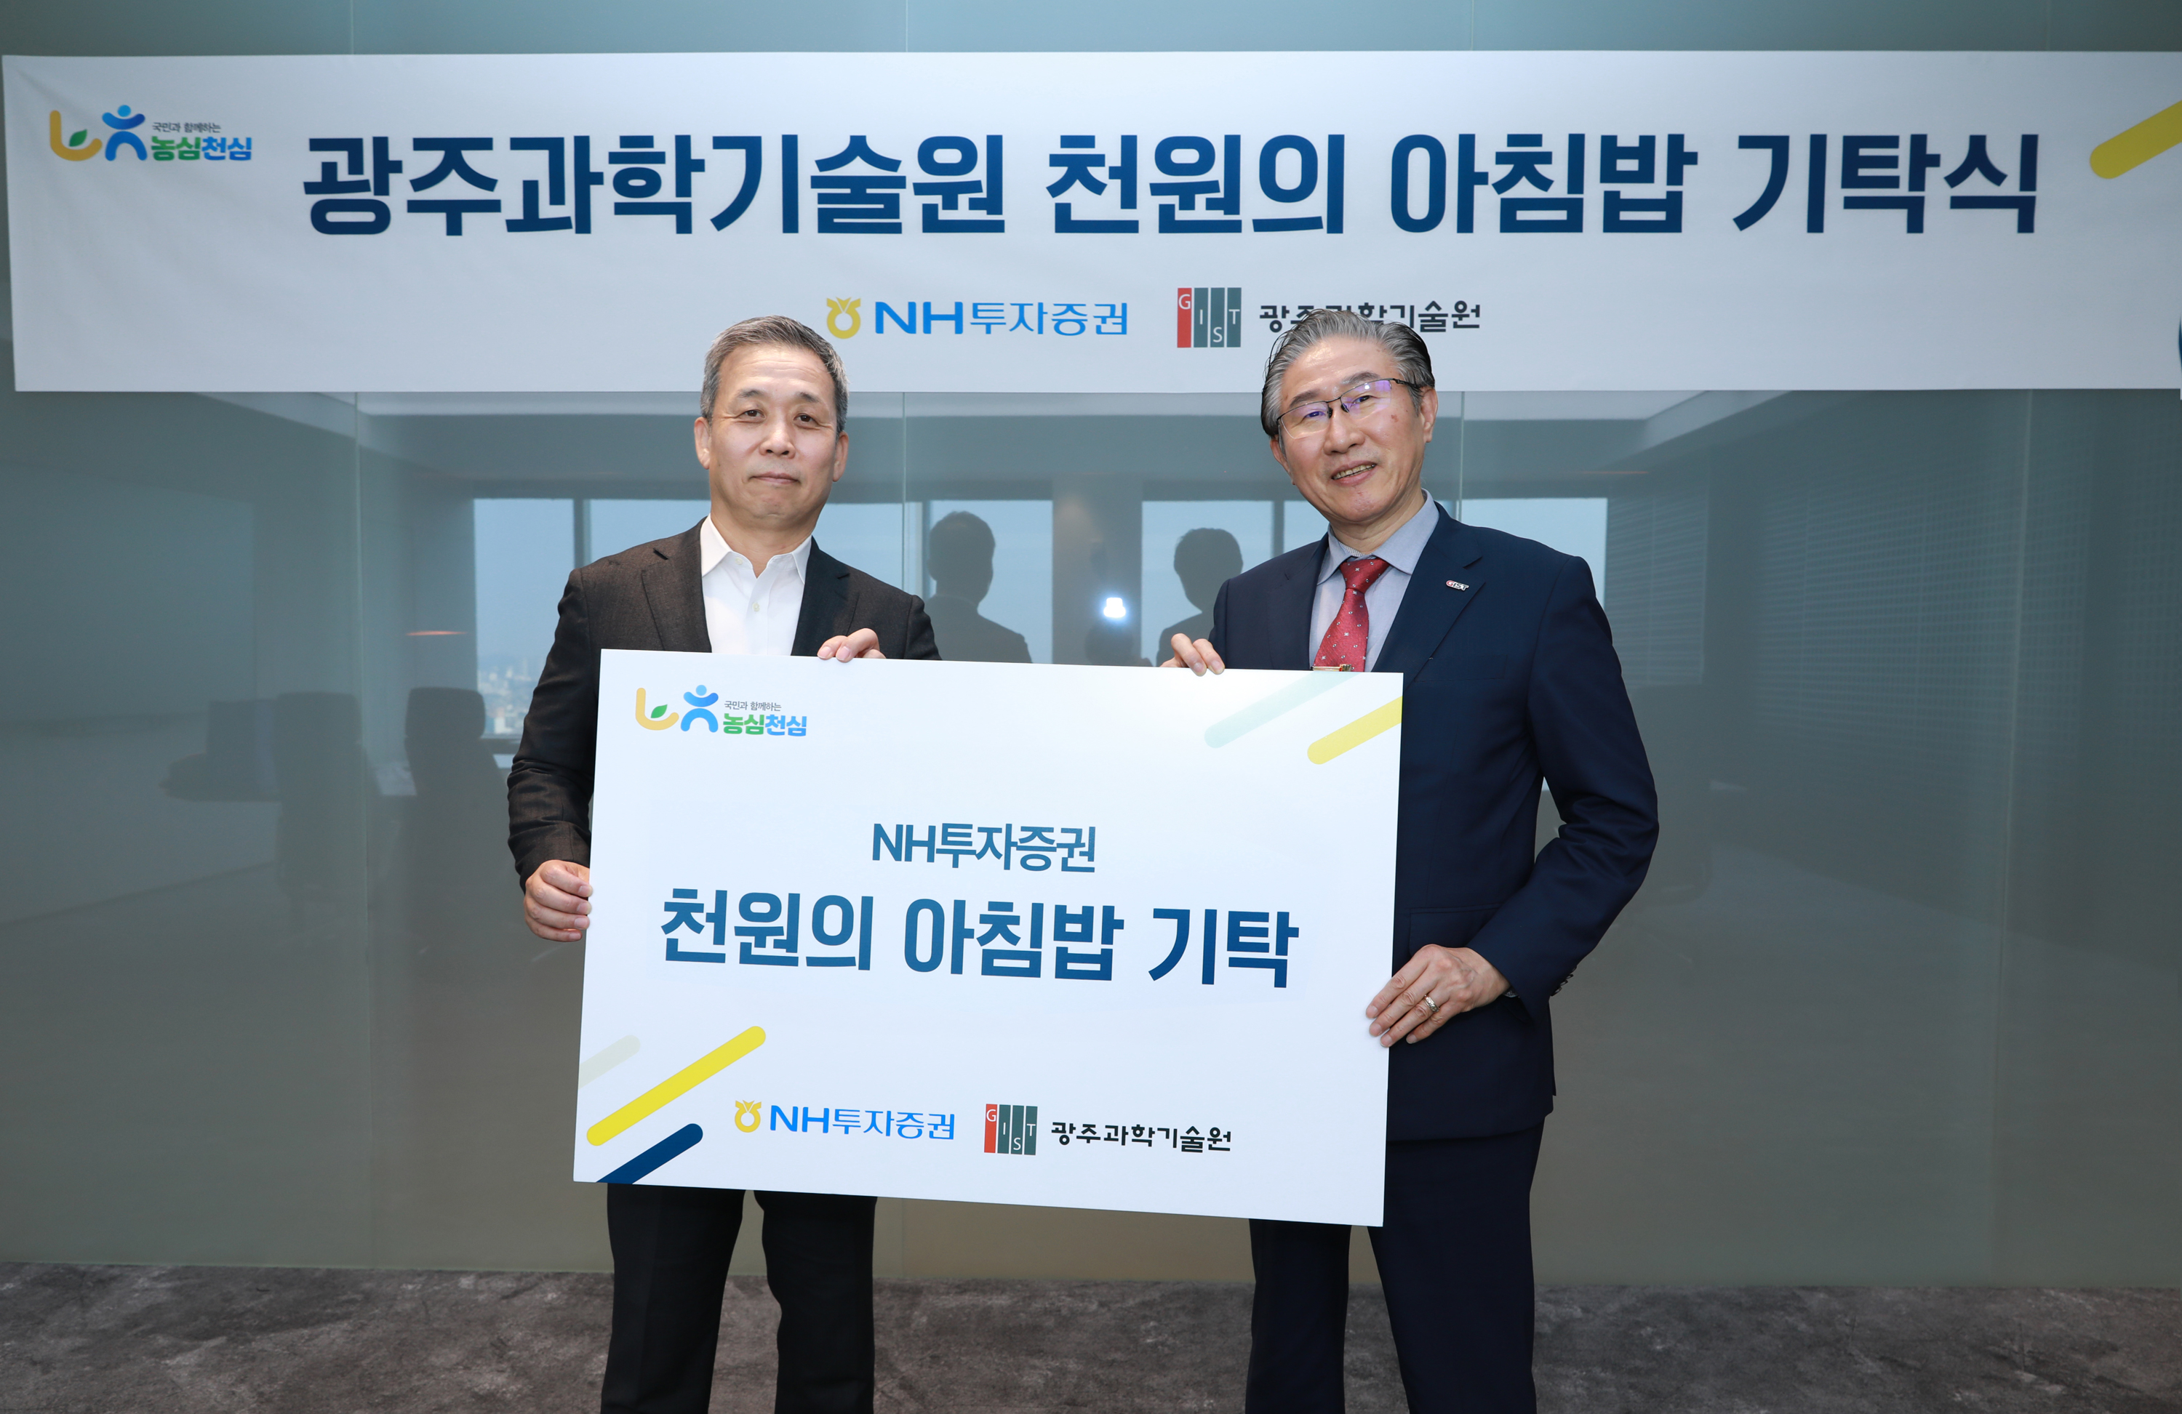

▲ On Friday, November 7, GIST President Kichul Lim (right) and NH Investment & Securities CEO Byung-woon Yoon (left) pose for a commemorative photo following the "Thousand Won Breakfast" donation ceremony at the NH Financial Tower in Park1, Yeouido, Seoul.

The Gwangju Institute of Science and Technology (GIST, President Kichul Lim) announced on Friday, November 7, at the NH Financial Tower in Park1, Yeouido, Seoul, that it received a KRW 20 million donation from NH Investment & Securities (CEO Byung-woon Yoon) to support the "Thousand Won Breakfast" project.

The "Thousand Won Breakfast" project provides students with a nutritious breakfast for just KRW 1,000, contributing to the formation of healthy eating habits and improved academic concentration. This program has consistently received enthusiastic responses from GIST students and is a representative student welfare program.

NH Investment & Securities is actively participating in the "Nongsim Cheonsim" (Farmers' Heart, Heavenly Heart) campaign, spearheading efforts to promote healthy eating habits and rice consumption.

To raise awareness of the importance of eating breakfast, NH Investment & Securities donated a total of KRW 530 million to 26 national and public universities outside the Seoul metropolitan area, as part of the "1,000 Won Breakfast Project Fund." This donation to GIST is part of this effort.

At the donation ceremony, GIST President Kichul Lim, Vice President for Public Affairs Yonghwa Chung, NH Investment & Securities CEO Yoon Byung-woon, and ESG Head Cheol-soon Lim, among other officials, attended and discussed mutual cooperation and improving student welfare.

President Kichul Lim personally visited the Seoul headquarters to express his gratitude for the donation and expressed his sincere gratitude to NH Investment & Securities for its support in the development of the university.

GIST President Kichul Lim stated, "I am deeply grateful to NH Investment & Securities for fulfilling its corporate social responsibility and contributing to the advancement of education. We will use your generous donation transparently and valuably to ensure that it provides practical benefits to students."

NH Investment & Securities CEO Byung-woon Yoon stated, "College students' breakfast habits are an investment in a healthy future. NH Investment & Securities will continue to work to promote youth welfare and increase consumption of local agricultural products through the 'Nongshim Cheonsim Breakfast Campaign.'"

An NH Investment & Securities official said, "GIST is Korea's leading science and technology university, leading the way in fostering key talent to lead future industries. With this donation, we will further strive to foster an educational ecosystem that thrives on the local community."

Meanwhile, GIST is strengthening its education, research, and welfare infrastructure, leveraging donations and support from businesses, alumni, and the local community, and is growing into a sustainable and innovative university.



