GIST launches "AI-ACE InnoCORE Research Group," an AI-based nanotechnology-based early diagnosis research group for brain diseases supported by the Ministry of Science and ICT

- Professor Eunji Lee of the Department of Materials Science and Engineering will lead the research team, developing core technologies for the early diagnosis of brain diseases by converging AI and nanotechnology... Collaborating with the four major science and technology institutes, Chonnam National University Hospital, KIST, Harvard University, and other Korean and international research institutions

- To address national challenges in the era of hyper-aging, 50 Innocore Fellows, experts in AI convergence across various fields, including artificial intelligence, nanotechnology, neuroscience, and advanced biotechnology, will be assembled, along with leading domestic and international mentors

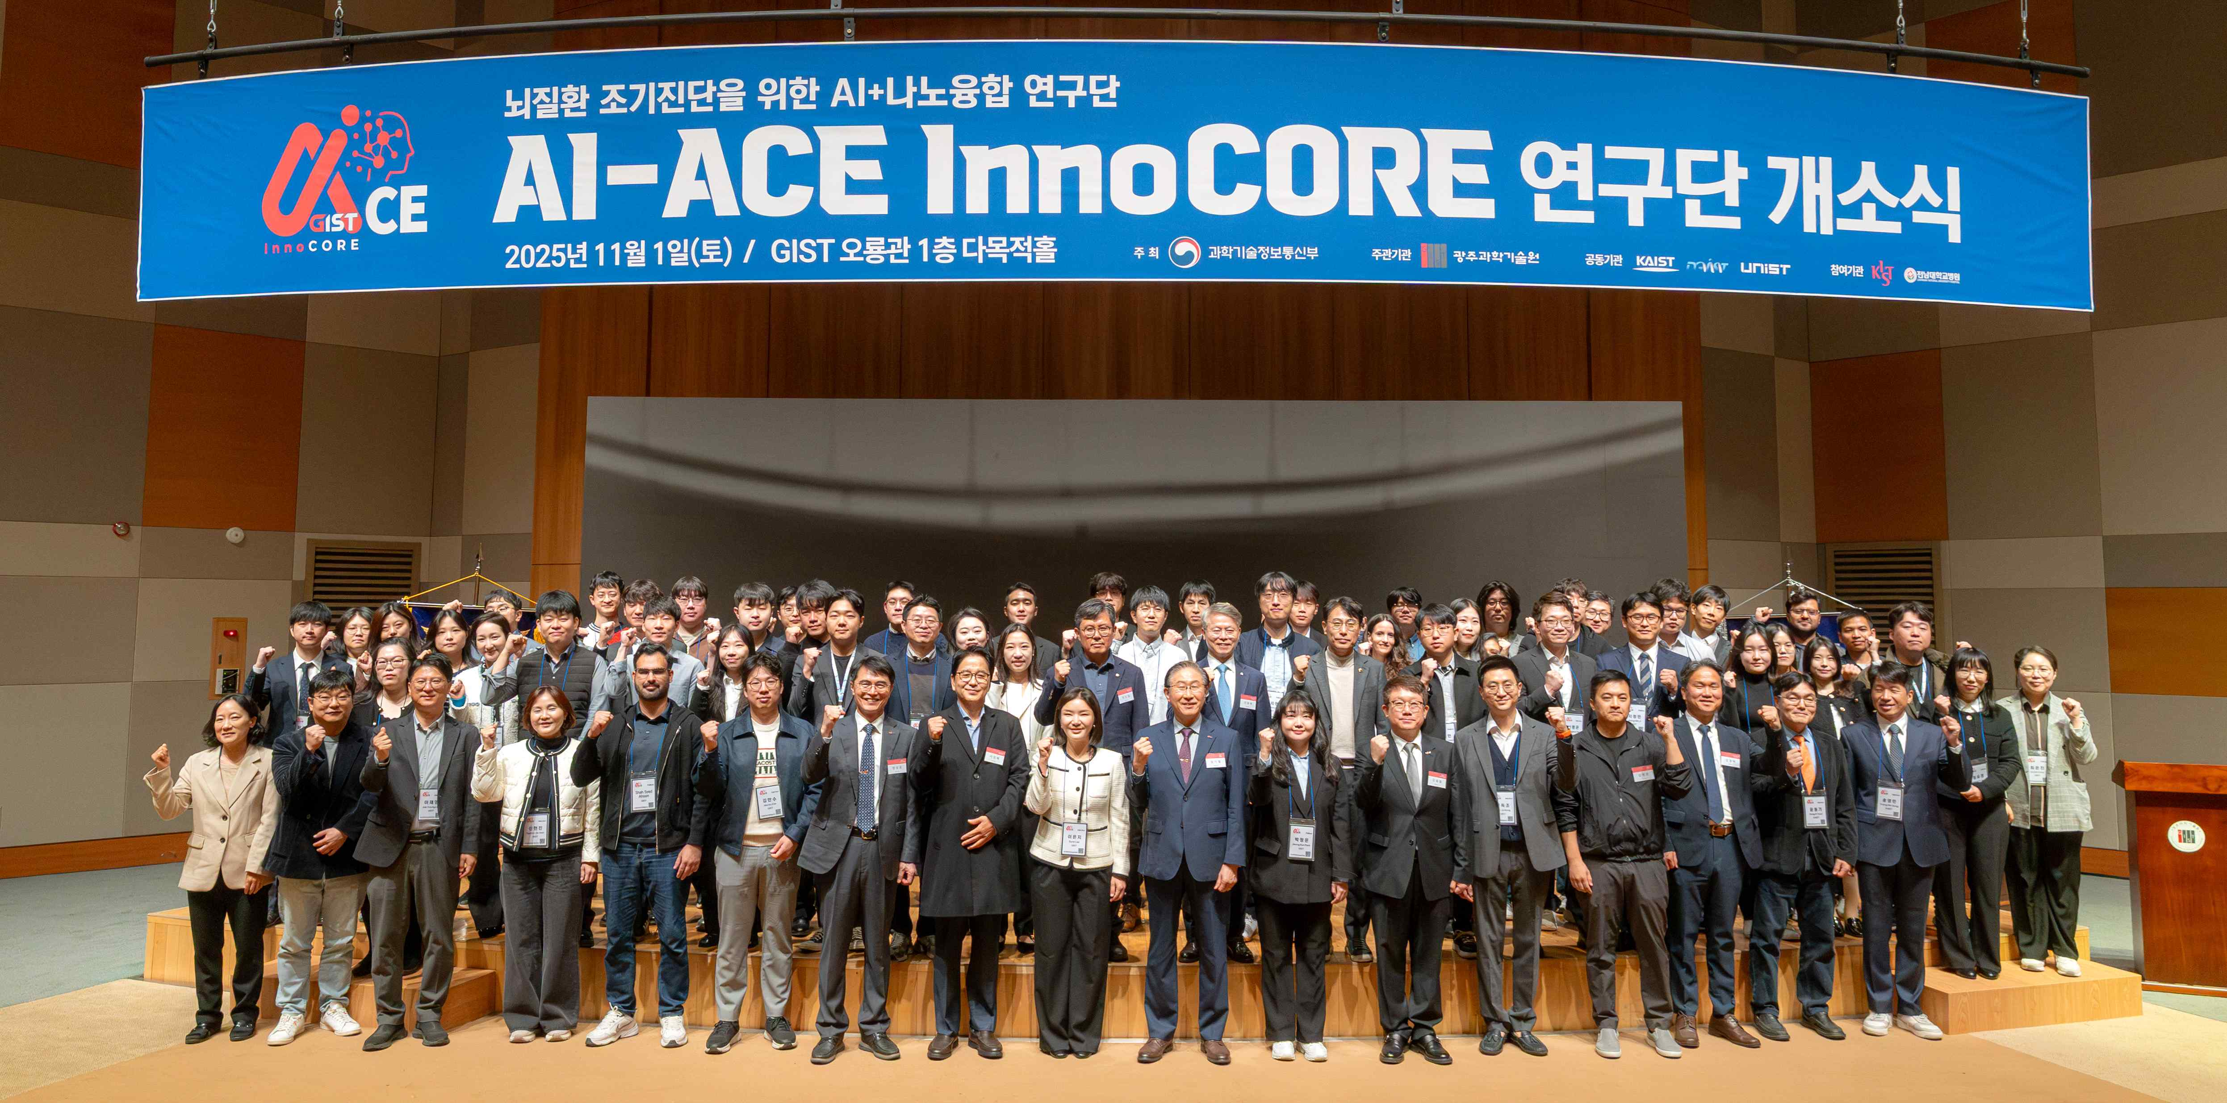

▲ Attendees pose for a commemorative photo at the opening ceremony of the GIST AI-ACE InnoCORE research group.

The Gwangju Institute of Science and Technology (GIST, President Kichul Lim) announced the launch of the "AI+Nano Convergence for Early Diagnosis of Brain Diseases (AI-ACE InnoCORE) Research Group," supported by the Ministry of Science and ICT, at 9:30 a.m. on Saturday, November 1, in the multipurpose hall on the first floor of Oryong Hall. The group announced the commencement of full-scale research activities.

Directed by Professor Eunji Lee of the Department of Materials Science and Engineering at GIST, the AI-ACE InnoCORE Research Group will be comprised of a core team of experienced and specialized postdoctoral researchers from Korea and abroad. The group will develop core technologies for the early diagnosis of brain diseases by integrating artificial intelligence (AI) and nanotechnology.

The opening ceremony was attended by prominent figures from various fields, including Representative Hyung-bae Min (Democratic Party of Korea, Gwangsan-eul, Gwangju), Representative Do-geol Ahn (Democratic Party of Korea, Dong-gu, Nam-gu, Gwangju), Director Kyung Taec Kim of the Center for Relativistic Laser Science at the Institute for Basic Science (IBS), Professor Seong-Bae Suh of the Department of Life Sciences at GIST (scheduled to take office as Director of the IBS Center for Microbiome-Body-Brain Physiology in December), and Director Byung-joon Kim of Amazon Web Services (AWS) Korea. Approximately 100 people attended, including President Kichul Lim, Vice President for Academic Affairs Sungho Jeong, Vice President for R&DB Yong-Chul Kim, and other key officials, faculty, staff, and students.

The opening ceremony began with a welcoming address by President Kichul Lim, followed by congratulatory remarks from Representatives Do-geol Ahn and Hyung-bae Min, and IBS Director Kyung Taec Kim. Director Eunji Lee then introduced the research group and unveiled a plaque.

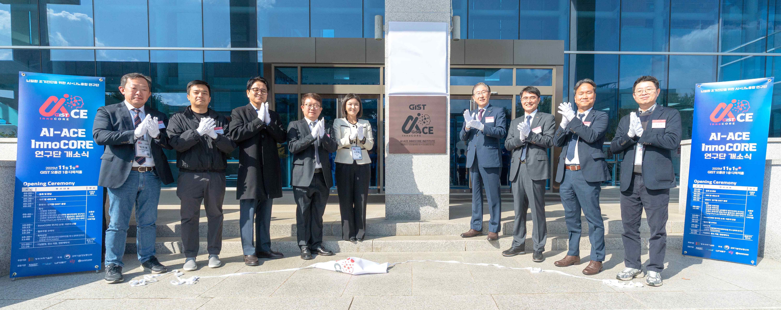

▲ Attendees celebrate the successful launch of the GIST AI-ACE InnoCORE Research Group by unveiling a plaque.

In his welcoming remarks, GIST President Kichul Lim stated, "I am confident that the 'AI-ACE InnoCORE Research Group' launched today will be a ray of hope toward conquering brain diseases, a critical challenge facing humanity in this era of rapid aging." He added, "I anticipate that the research group will combine the sharp analytical power of AI with the ultra-fine precision of nano-fusion technology to provide innovative solutions to the national challenge of early diagnosis of brain diseases."

He continued, "I believe that the research group will achieve powerful synergy through the collaboration of the four major science and technology institutes, Director Eunji Lee's outstanding leadership, and GIST's creative research environment. We will spare no effort in providing the best research environment and support so that the approximately 50 young InnoCORE Fellows can grow into leaders of innovation that will make humanity's hopes a reality."

The AI-ACE InnoCORE research group, which brings together the core capabilities of four major science and technology research institutes—Korea Advanced Institute of Science and Technology (KAIST), Daegu Gyeongbuk Institute of Science and Technology (DGIST), and Ulsan National Institute of Science and Technology (UNIST)—centered around GIST, the lead organization, is building a network of “open convergence research groups” with top Korean and international research institutions, including Chonnam National University Hospital (clinical), KIST (nano), and Harvard University (global collaboration). This is expected to accelerate the commercialization of early diagnosis technology for brain diseases and strengthen global competitiveness.

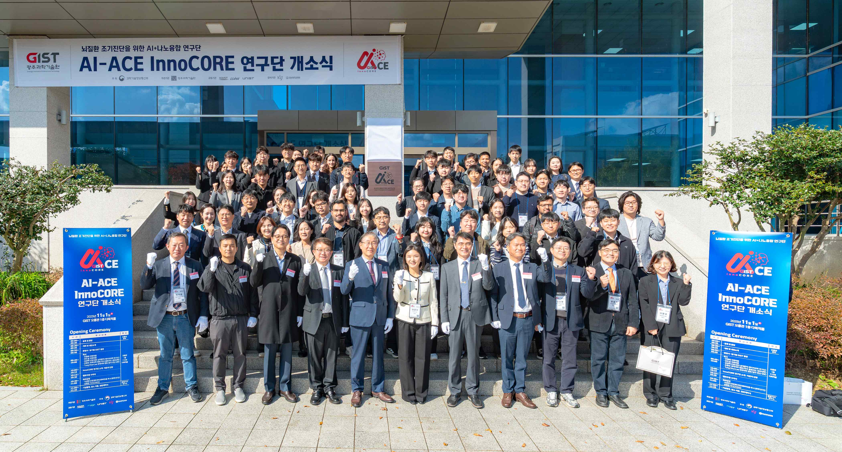

▲ Officials attending the opening ceremony of the GIST AI-ACE InnoCORE Research Group pose for a commemorative photo, wishing the group a successful launch.

Director Eunji Lee, who oversees the research group, is a globally recognized expert in the design of organic and polymer nanomaterials and advanced transmission electron microscopy analysis. Recently, she has presented a new research paradigm through the convergence of "real-time protein imaging + AI analysis" for the early diagnosis of degenerative brain diseases such as Alzheimer's disease.

Director Eunji Lee stated, "Our goal is to open new breakthroughs in the early diagnosis of brain diseases and precision medicine through the convergence of AI and nanotechnology. We will combine the capabilities and infrastructure of the four major science and technology institutes and collaborate closely with domestic and international partner organizations to contribute to the advancement of human health."

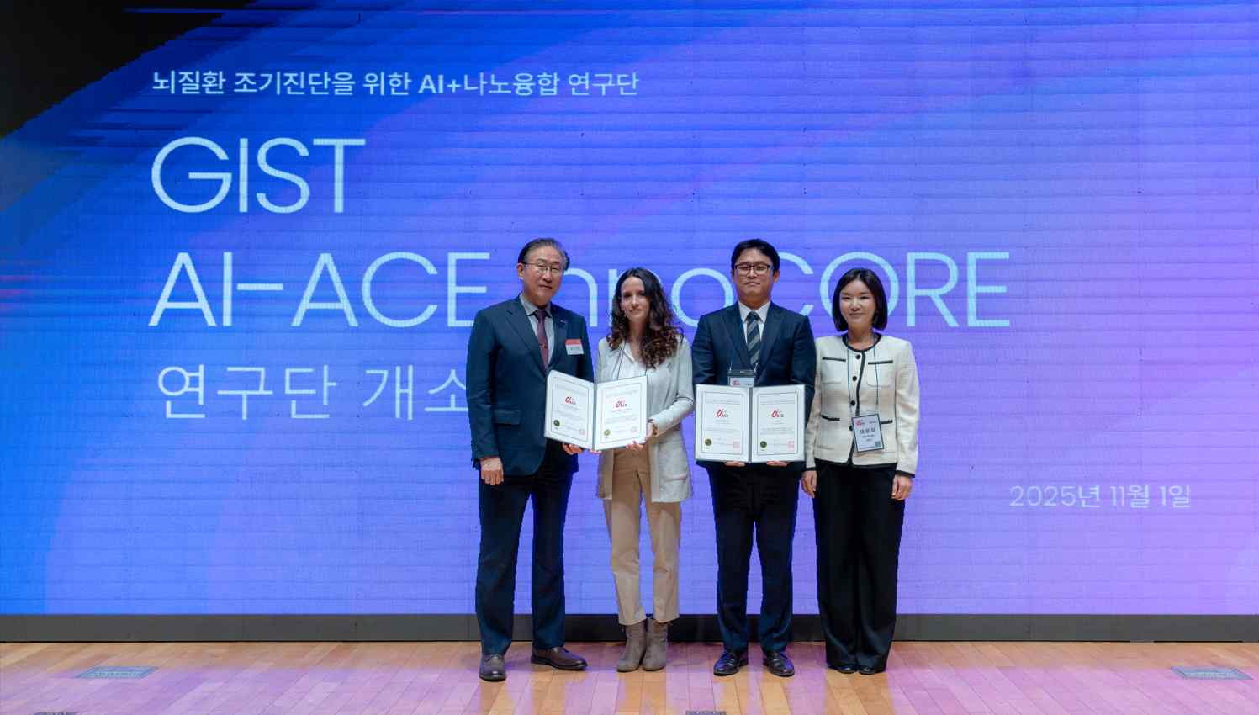

▲ A commemorative photo taken after presenting the InnoCORE Fellow certificate. (From left) President Kichul Lim, Fellow Cristina Risueño Segovia, Fellow Jeong-min Ji, and Director Eunji Lee

Meanwhile, the GIST AI-ACE InnoCORE Research Group, which officially launched today with an opening ceremony, will focus on the convergence of AI and nanotechnology for the early diagnosis of brain diseases. It will focus on developing high-sensitivity and high-resolution nano-optical devices and AI platform technologies capable of analyzing the multidimensional structure and changes of proteins that cause neurodegenerative diseases in real time.

With a vision of "transdisciplinary convergence and globally competitive postdoc-centered innovation," the research group aims to lead the future bio market based on real-time multidimensional protein structure analysis technology and foster an innovative ecosystem based on collaboration between industry, academia, and research.



