GIST and KIMS sign MOU for advanced convergence technology research cooperation, expected to strengthen the competitiveness of the materials industry and lay the foundation for future industrial innovation

- On Friday, October 31st, a business agreement was signed at GIST to strengthen mutual development and cooperation in advanced convergence technologies… Establishing a joint research and talent development system by combining basic and core technologies (GIST) with applied and commercialized technologies (KIMS)

- Expanding research focused on promising future industries such as energy, semiconductors, AI, and automobiles… Promoting the operation of industry-research cooperative degree programs and the cultivation of field-oriented master's and doctoral students. A dedicated task force team will be formed to support mid- to large-scale joint research, regional specialization, and global cooperation projects

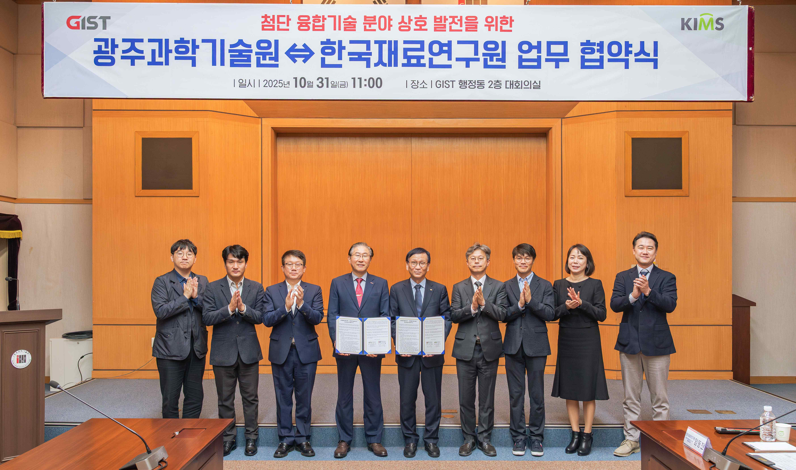

▲ GIST and KIMS signed a Memorandum of Understanding (MOU) on October 31st (Friday) in the conference room of the GIST Administration Building to promote mutual development in advanced convergence technologies. Participants pose for a commemorative photo.

The Gwangju Institute of Science and Technology (GIST, President Kichul Lim) announced that it signed a Memorandum of Understanding (MOU) with the Korea Institute of Materials Science (KIMS, President Cheol-jin Choi) on October 31st (Friday) in the conference room of the GIST Administration Building to promote mutual development and strengthen cooperation in advanced convergence technologies.

The signing ceremony was attended by GIST President Kichul Lim, Vice President for R&DB Yong-Chul Kim, and key officials and researchers, including Director KwangSup Eom and Vice Director Hongkyu Kang of the Research Institute for Solar and Sustainable Energies. Approximately ten KIMS officials were present, including Director Cheol-jin Choi, Vice President Chang-hoon Lee, Director Seung-mok Choi of the Energy and Environmental Materials Research Division, Director Hee-sook Yoon of the Bio and Health Materials Research Division, and Principal Researcher Dong-chan Lim.

Through this agreement, the two organizations will combine GIST's basic and core technology research capabilities with KIMS' applied and commercialization technology capabilities, thereby establishing a foundation for the development of advanced convergence technologies and human resource development through industry-academia-research collaboration.

Furthermore, they plan to collaborate on building an innovation ecosystem for future high-tech industries through national strategic technology research and development, regional industry collaboration, and global cooperation projects.

The agreement covers four key areas: ▴ research and technology development, ▴ mutual personnel exchange, ▴ joint research project planning, and ▴ task force team formation and operation.

In the research and development area, GIST plans to discover new technologies by integrating its core technologies with KIMS's commercialization technologies. They also plan to expand joint research focused on promising future industries such as energy, semiconductors, artificial intelligence (AI), automobiles, and displays.

In the area of ​​personnel exchange, the two organizations will jointly operate an industry-research cooperative research degree program and establish a practical, academic-research master's and doctoral program through participation in each institution's research projects, thereby establishing a system for fostering convergent talent.

The two institutions will form a dedicated task force to identify mid- to large-scale joint research projects, promote regionally specialized projects, and expand global collaboration. They will hold quarterly regular meetings and technology exchanges, as well as monthly working-level meetings. The working-level collaboration will be led by the GIST Next-Generation Energy Research Institute and the KIMS Energy and Environmental Materials Research Center.

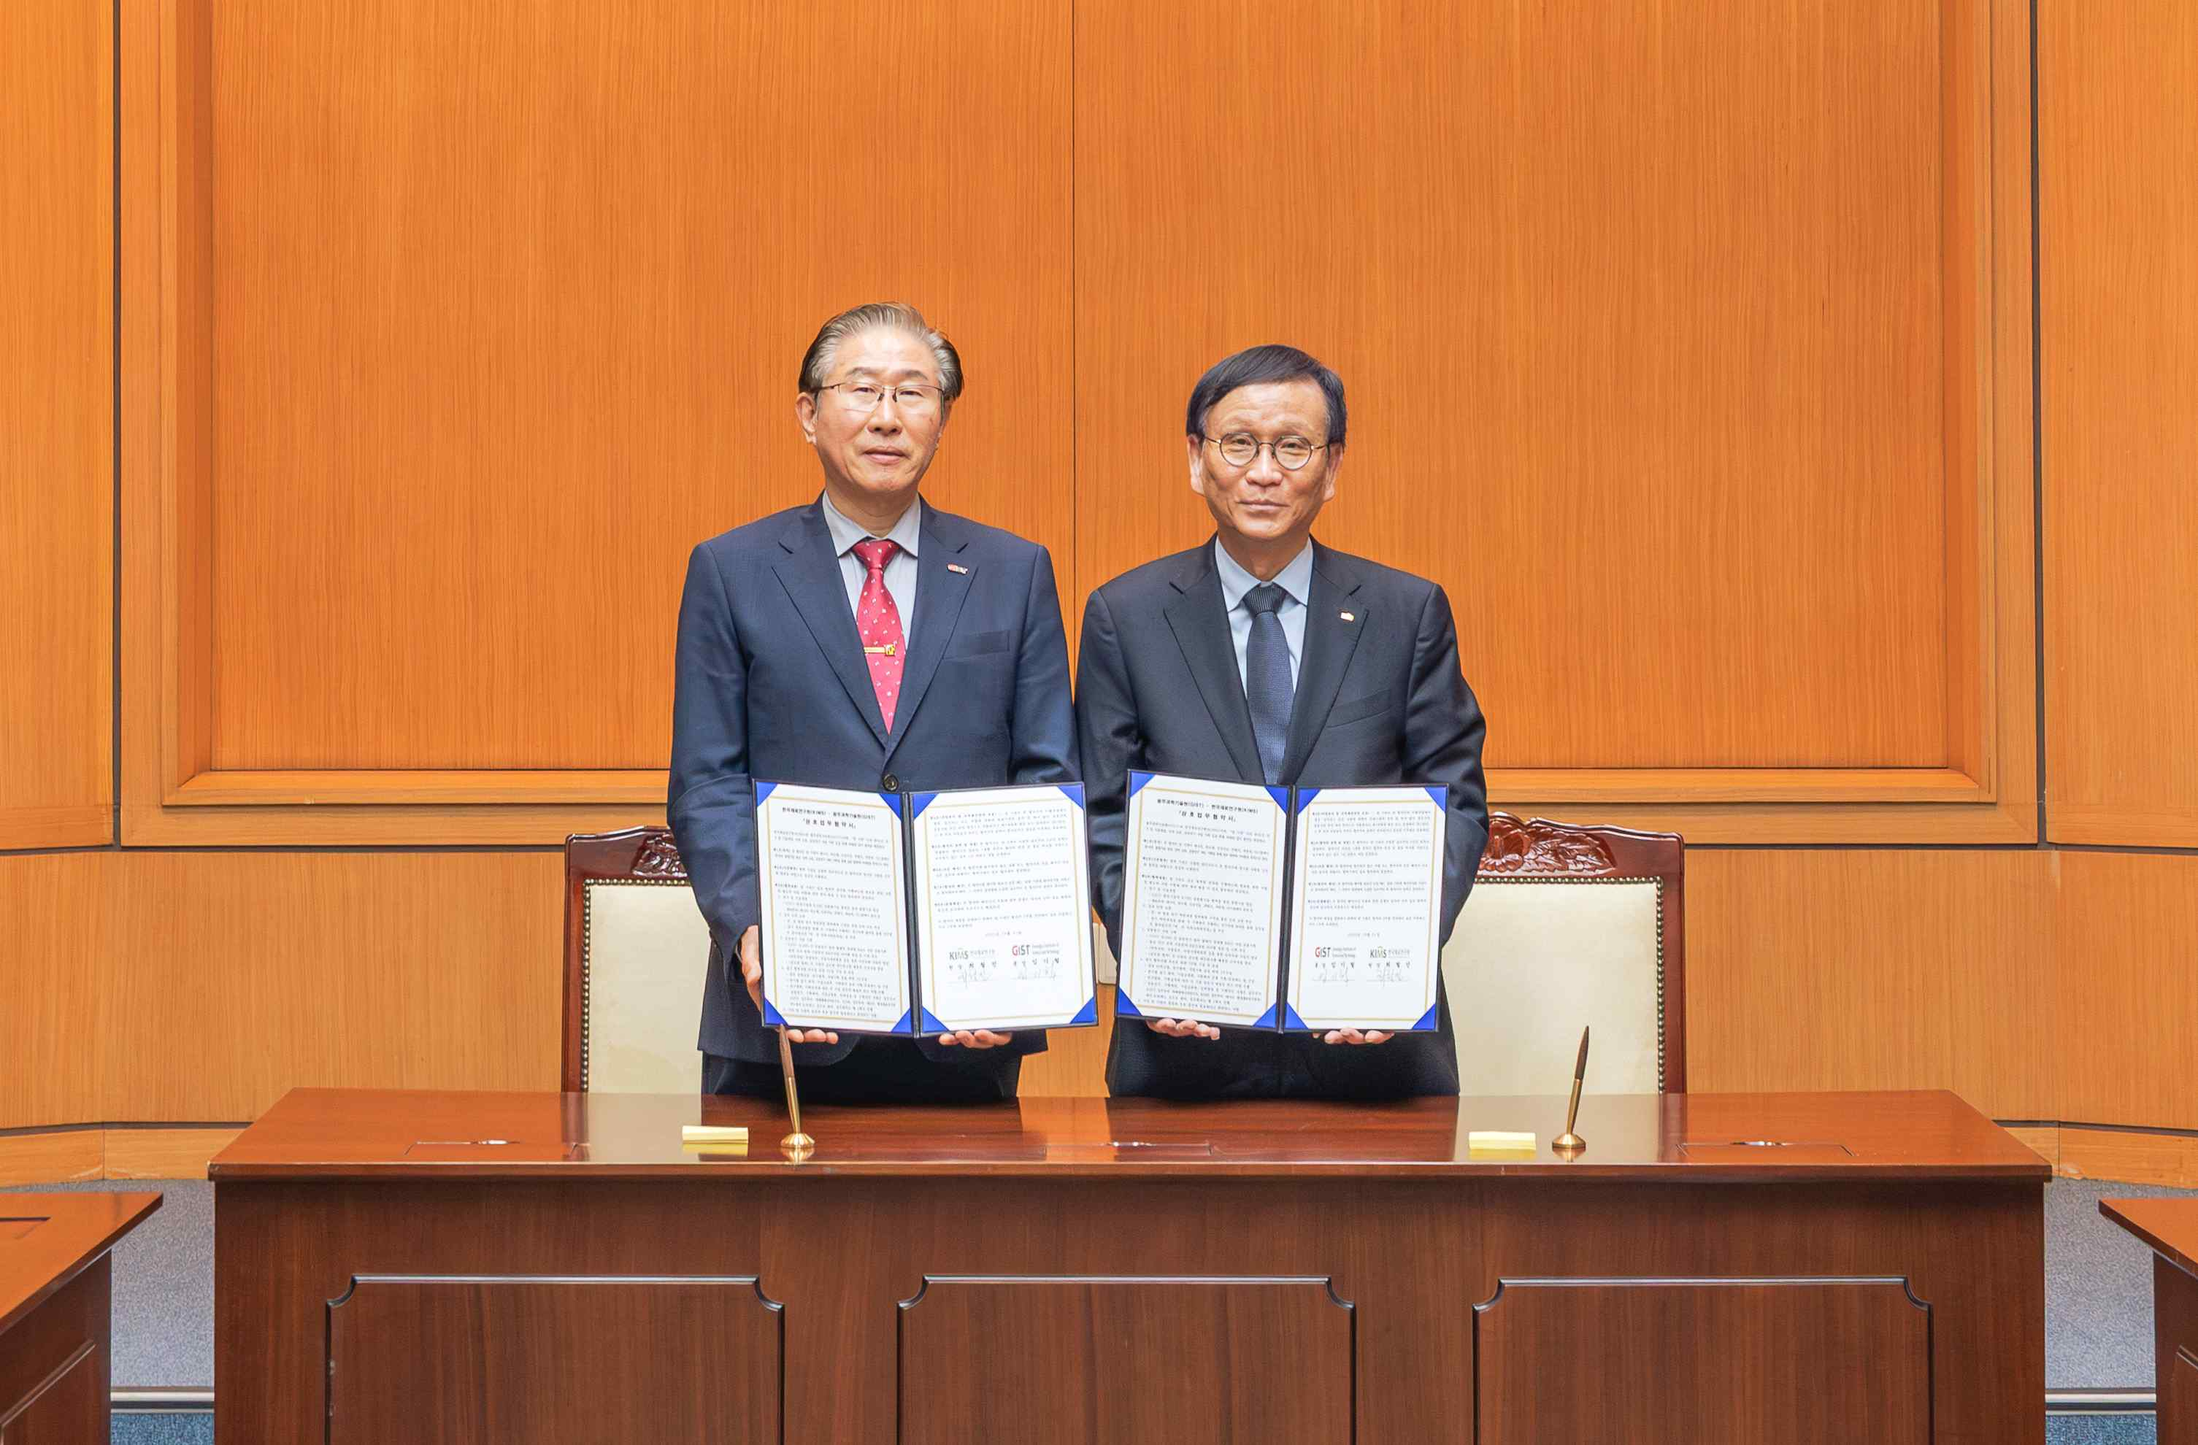

▲ (From left) GIST President Kichul Lim and KIMS Director Cheol-jin Choi pose for a commemorative photo after signing a Memorandum of Understanding (MOU) for the mutual advancement of advanced convergence technologies in the GIST administration building on Friday, October 31.

GIST President Kichul Lim stated, "The partnership between our two institutions today is a significant step forward that will further solidify the foundation of Korea's industrial competitiveness. With technology and materials emerging as key keywords in the era of AI-driven industrial transformation, the combination of KIMS's and GIST's fundamental knowledge and technologies will be a significant step forward for Korea's materials industry and the broader industry."

KIMS President Cheol-jin Choi said, “This agreement is very meaningful in that two institutions representing each field are joining hands to promote joint research, research cooperation, technology commercialization, and commercialization.” He added, “We promise to continue specific and practical cooperation in various fields, such as joint research, joint project planning, personnel exchange, mentoring for students and researchers, and improvement of the education system.”



