Sejong Construction Technology CEO Cheol-su Jeong donates 100 million won worth of waterproofing materials to GIST

- GIST Techno Management Business Academy (GTMBA) 13th Class Alumni Donate In Kind for School Development… Following JNT CEO Hee-kyung Han's Ceiling Material Donation, alumni's positive influence expands

- Advanced polyurea waterproofing material used to improve the safety of research and education spaces, including remodeling and maintaining aging buildings… President Kichul Lim: "A Model Example of Science and Technology Innovation in Partnership with the Field"

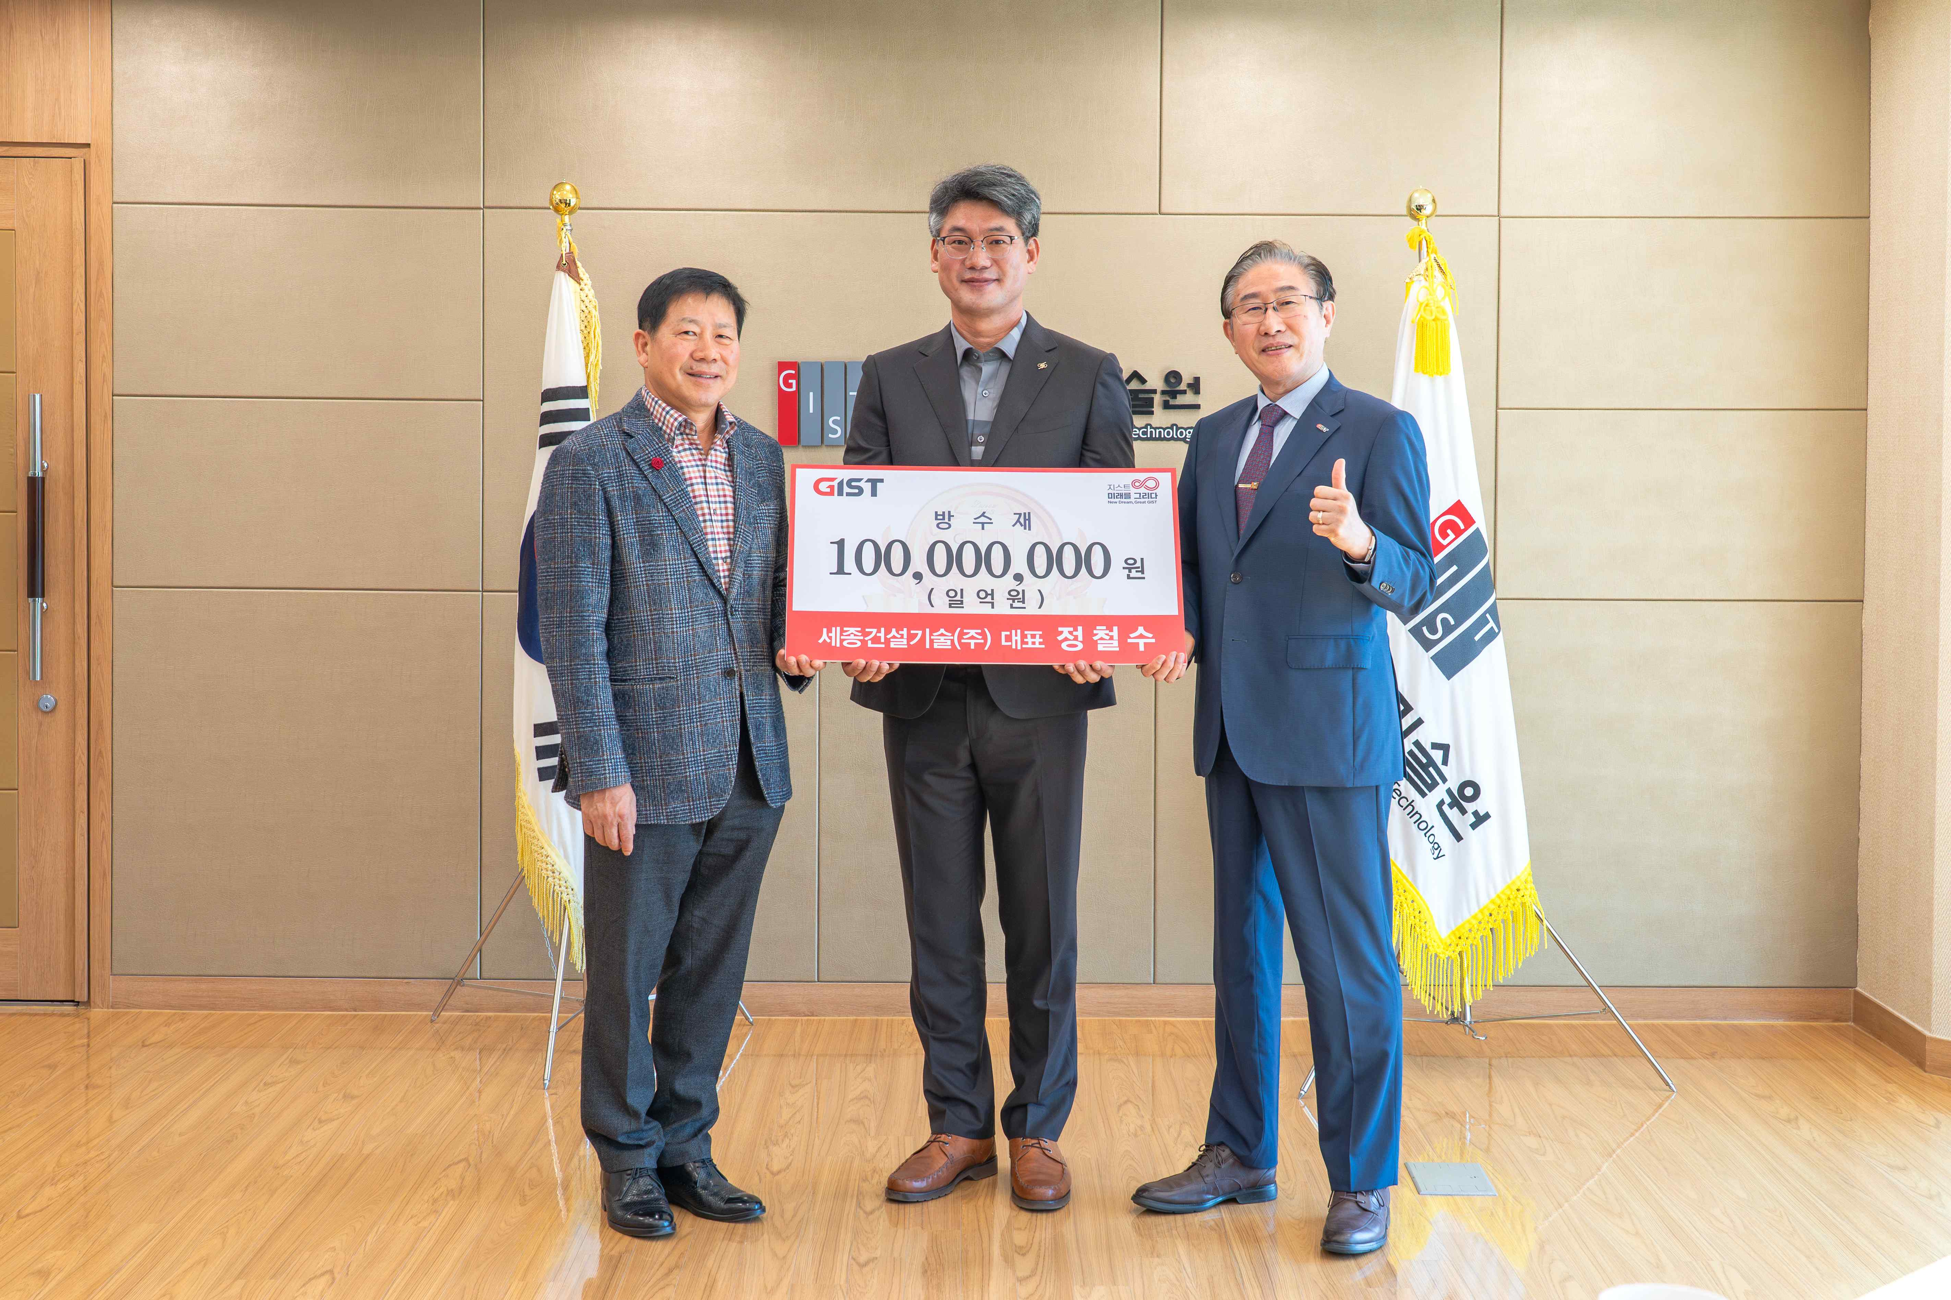

▲ On Monday, October 27th, CEO Cheol-su Jeong of Sejong Construction Technology Co., Ltd., a graduate of the 13th GTMBA class, donated approximately 100 million won worth of the company's products to GIST and posed for a commemorative photo. (From left) Jeong-soon Park, 8th President of the GTMBA Alumni Association (Chairman of Dongyang Metal Co., Ltd.), Cheol-su Jeong, CEO of Sejong Construction Technology Co., Ltd., and GIST President Kichul Lim

On Monday, October 27th, the Gwangju Institute of Science and Technology (GIST, President Kichul Lim) received a donation of 100 million won worth of its waterproofing materials from CEO Cheol-su Jeong of Sejong Construction Technology Co., Ltd. and expressed his gratitude.

CEO Cheol-su Jeong, a graduate of the 13th GIST Techno Management Business Academy (GTMBA), has maintained a close relationship with GIST, consistently demonstrating his interest in school development and contributing to the local community.

This donation stems from a long-standing relationship with JNT Co., Ltd. CEO Hee-kyung Han (GTMBA 8th class member), who recently donated ceiling materials to GIST. This donation was made with the intention of contributing to improving the educational and research environment at GIST.

The donated waterproofing materials will be used for the remodeling and maintenance of aging buildings on campus, and are expected to contribute substantially to enhancing the safety and functionality of these facilities.

Sejong Construction Technology Co., Ltd., headquartered in Mokpo, South Jeolla Province, is a construction materials company that develops and supplies advanced waterproofing materials and high-performance special protective coating systems based on polyurea resin, a high-tech polymer with exceptional durability and waterproofing properties.

The company holds public procurement service-registered products and eco-label certifications, contributing to the durability and safety of buildings in various locations, including public institutions, industrial facilities, and research complexes.

Under the management philosophy of "creating a safe building environment through technology," the company has grown into a trusted company through quality-focused management and customized technical support.

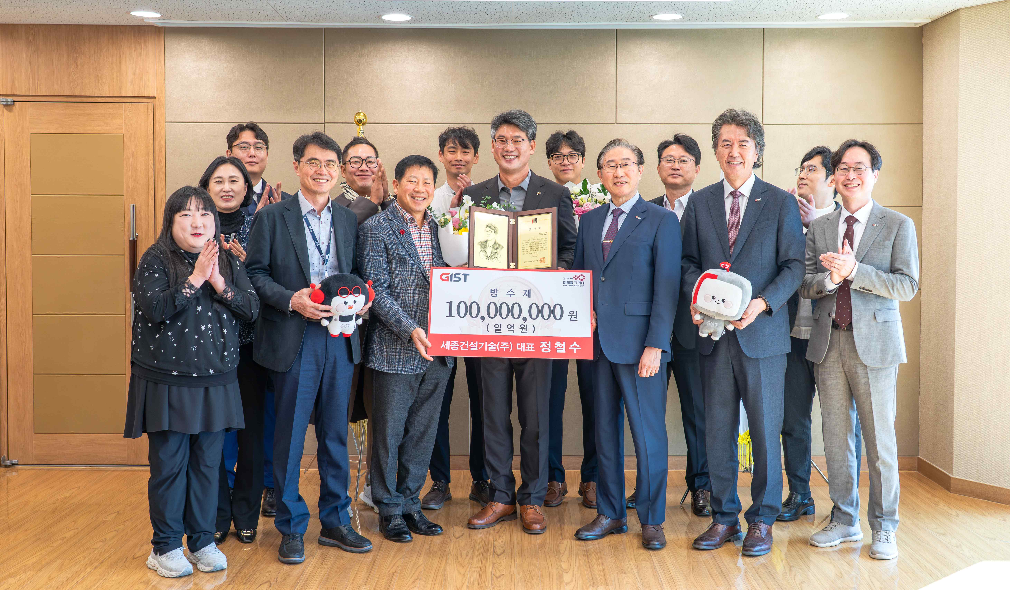

▲ Sejong Construction Technology CEO Cheol-su Jeong donates approximately 100 million won worth of the company's products to GIST and poses for a commemorative photo with GTMBA alumni present.

GIST President Kichul Lim stated, "This is a meaningful example of a company's technology and resources leading to the improvement of our university's research infrastructure." He added, "CEO Jeong's donation is an exemplary example of GIST's goal of 'science and technology innovation in collaboration with the field.'"

CEO Cheol-su Jeong stated, "The spirit of challenge and innovation I learned at GIST have been the driving force behind Sejong Construction Technology's growth today. I hope to contribute, even if only in a small way, to creating a safer and more pleasant educational and research environment at my alma mater, which led to this donation."



