GTMBA successfully held its 12th General Alumni Association President's Cup Friendship Sports Competition

- Donating 10 million won to the development fund and pledging to promote school development and coexistence with the local community

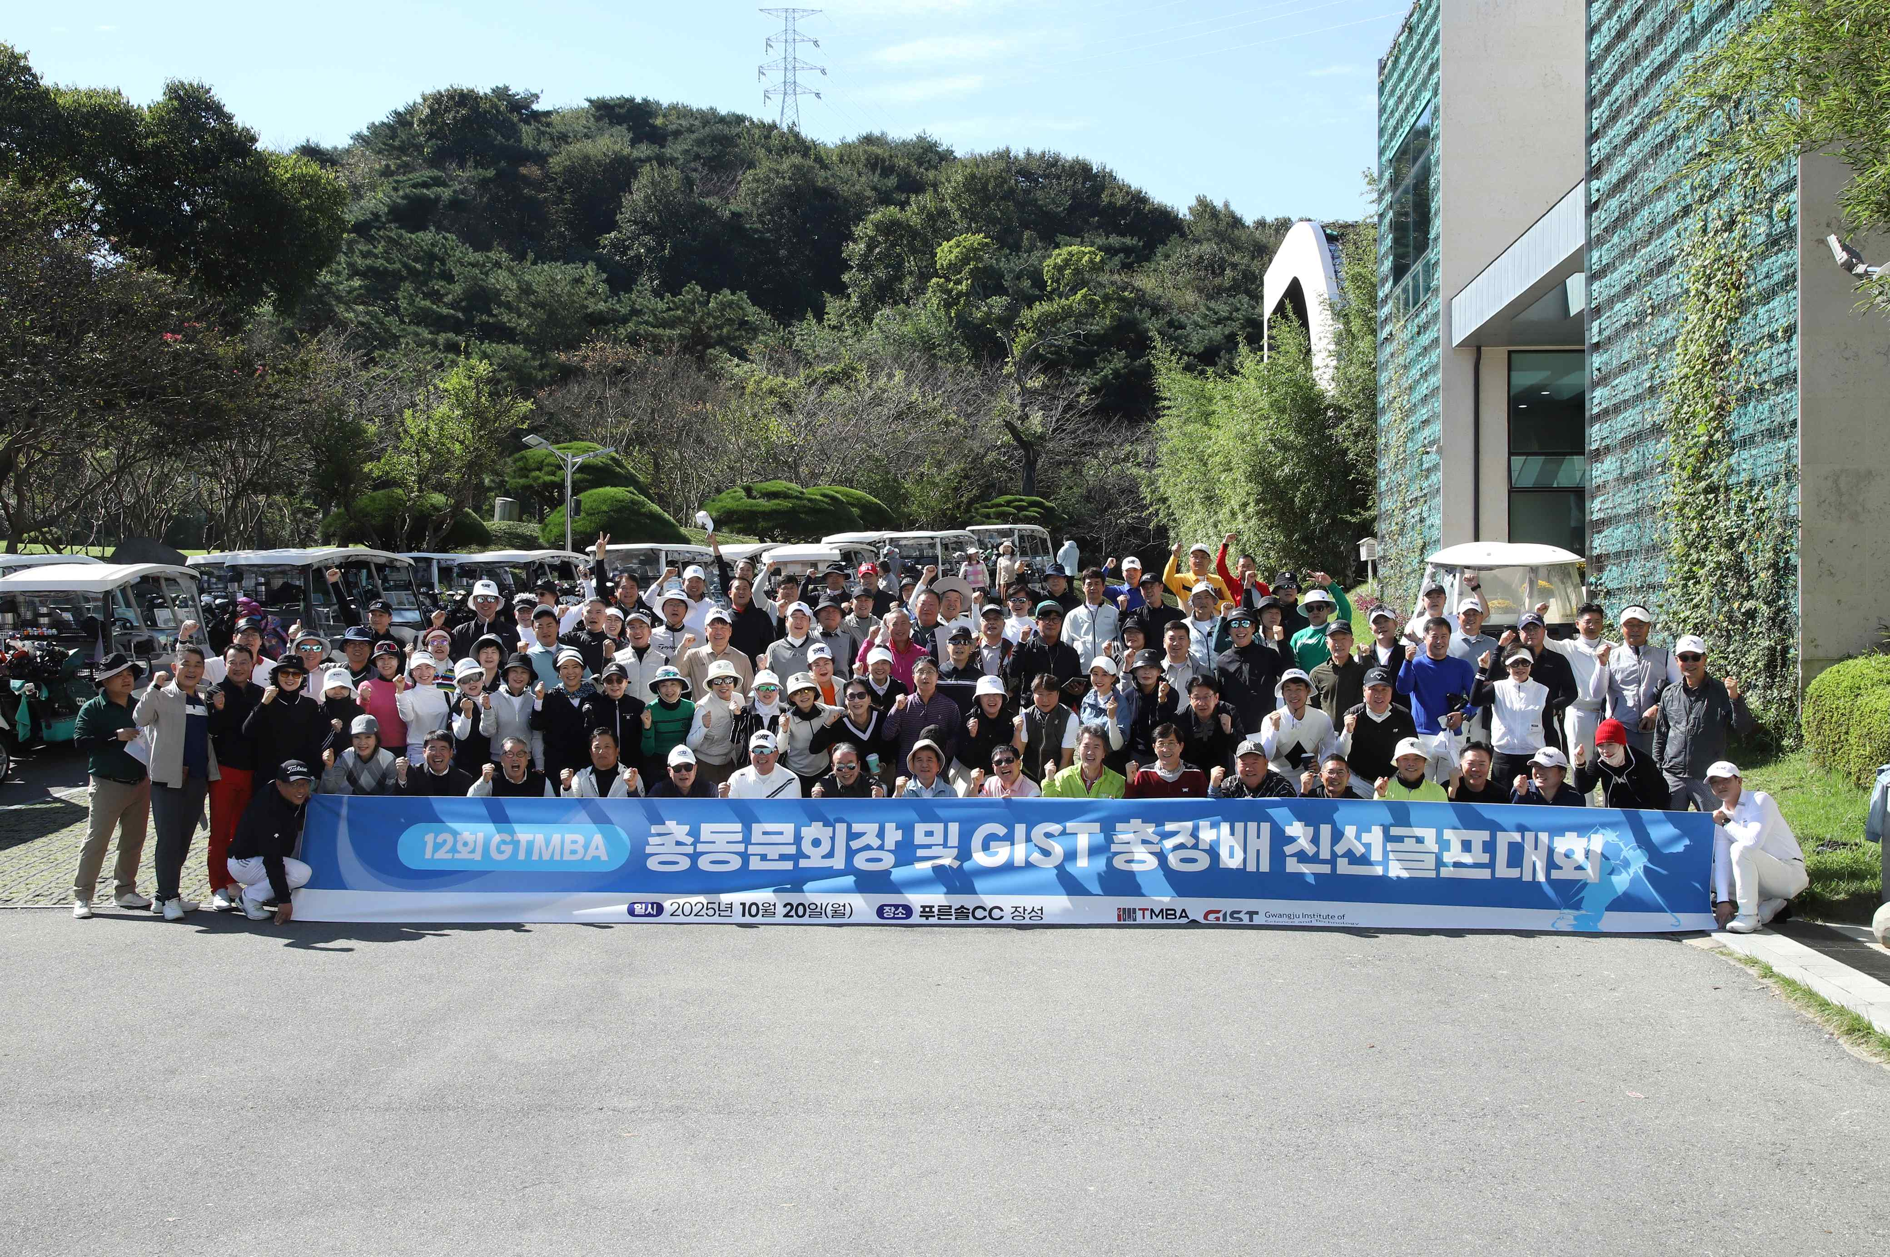

▲ The 8th GTMBA Alumni Association poses for a commemorative photo after the 12th GTMBA Alumni Association President's Cup Friendship Sports Competition held at Purunsol Golf Course in Jangseong on Sunday, October 20th.

The Gwangju Institute of Science and Technology (GIST, President Kichul Lim) announced that the GTMBA Alumni Association successfully held the 12th GTMBA Alumni Association President's Cup Friendship Sports Competition at Purunsol Golf Course in Jangseong on Monday, October 20th.

Approximately 300 alumni attended the event, which fostered meaningful friendship and unity. During the event, the GTMBA Alumni Association donated 10 million won to the development fund, expressing their unwavering support for GIST and its continued growth.

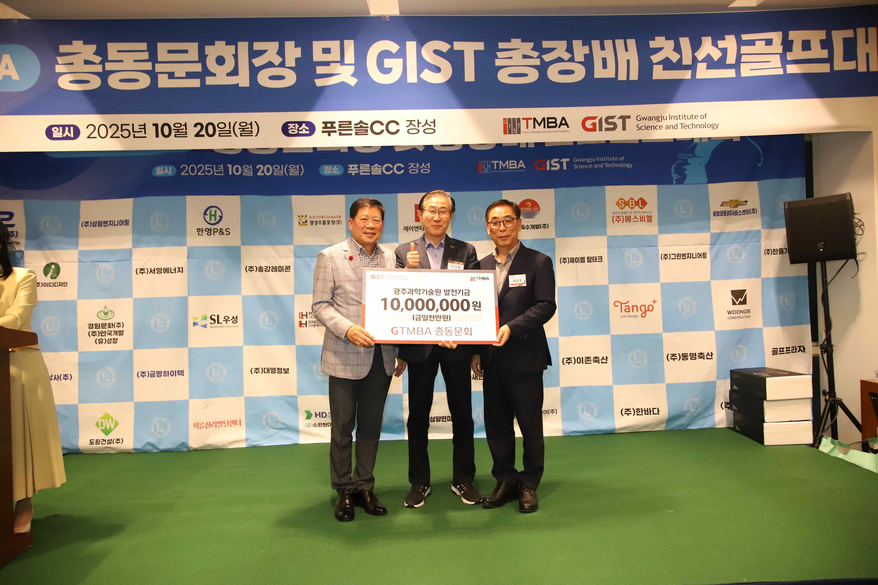

▲ On Monday, October 20, the GTMBA Alumni Association donated 10 million won to GIST for a development fund and took a commemorative photo. (From left) Jeong-sun Park, the 8th President of the GTMBA Alumni Association; GIST President Kichul Lim; and Eun-mo Choi, director of the GIST Development Foundation.

Also receiving the Merit Award that day, alumnus Wan-rae Seon (CEO of Art Design Co., Ltd.) donated a Samsung AirDresser worth 2 million won to the Korea Childhood Leukemia and Cancer Association, demonstrating his commitment to the community and supporting the cause.

Jeong-sun Park, President of the 8th GTMBA Alumni Association, stated, "This athletics competition was a meaningful occasion that strengthened the friendship and solidarity among alumni." He added, "GTMBA alumni will always be steadfast alumni of GIST and contribute to its development."

GIST President Kichul Lim expressed his gratitude, saying, "I would like to express my gratitude to the GTMBA Alumni Association for their warm hearts and deep affection. This event reaffirmed GIST's bright vision for the future. GIST will continue to strive for the development of the region and the nation, thanks to the strong support of our alumni."

Meanwhile, GIST Academy operates the Techno Management Business Academy (GTMBA), a non-degree program at GIST that opened in 2010. It is currently recruiting students for its 16th class, scheduled to begin in March 2026. (Inquiries: GIST Academy 062-715-2624)

GIST Academy provides managers in various fields with lectures from Korea's top experts, helping them gain a deeper understanding of the changing corporate environment and global management strategies. It also contributes to the formation of a broad network of professionals and the revitalization of the local economy and industry-academia cooperation.



