GIST hosted the 60th Academy Breakfast Forum, inviting international politics expert Professor Won-Gon Park

- International politics expert Won-Gon Park, Director of the Institute for Unification Studies at Ewha Womans University (Professor of North Korean Studies), will deliver a lecture titled "Trump Returns: Changing Diplomacy with Money and Power" at Oryong Hall on Monday, October 27th

- Analysis of Trump's second-term diplomatic strategy and the situation on the Korean Peninsula... The return of the Trump era, how should the international community respond?

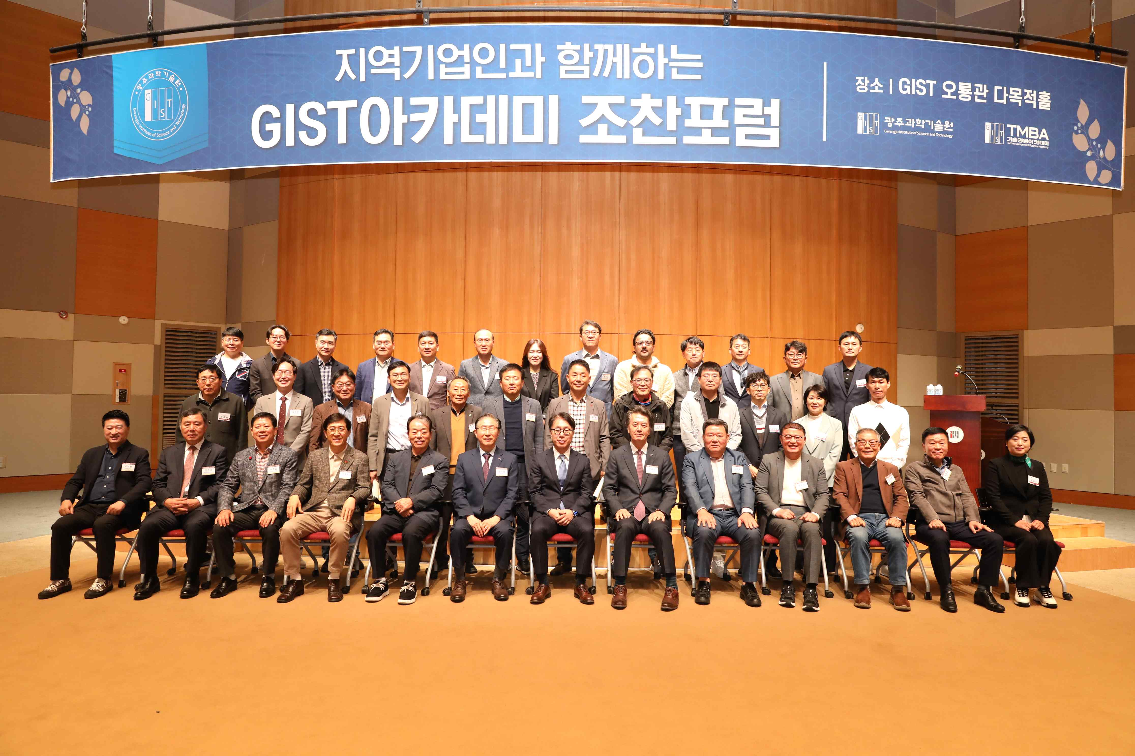

▲ GIST Academy hosted the October Breakfast Forum at Oryong Hall on Monday, October 27th, inviting Ewha Womans University's Won-Gon Park. Attendees pose for a commemorative photo.

The Gwangju Institute of Science and Technology (GIST, President Kichul Lim) announced that it held the 60th GIST Academy Breakfast Forum at Oryong Hall on Monday, October 27th.

Professor Won-Gon Park of the Department of North Korean Studies at Ewha Womans University was invited as a speaker and gave a lecture titled "Trump Returns: Changing Diplomacy with Money and Power."

Professor Won-Gon Park is an expert on North Korea and US foreign policy. He previously served as a professor of international and area studies at Handong Global University, director of the North Korea Center at the East Asia Institute, and vice president of the Korean Peninsula Peace Institute.

This lecture shared diverse perspectives on the impact of the Trump administration's policy changes on the Korean Peninsula and Northeast Asia, as well as the potential restructuring of the US-centric international order. The discussion was further enriched through a Q&A session with attendees.

Professor Park stated, "While there was considerable criticism during Trump's first term, with the advent of his second term, countries are focusing on developing practical countermeasures rather than criticism." He added, "Each country is working to minimize its own damage and find a breakthrough within the new international order."

He continued, "Trump's foreign policy is based on rejecting the United States' role as the world's sole superpower and maintaining an unacceptable attitude toward the changing world order." He added, "There's a clear tendency to selectively engage only in regions and issues directly related to American interests."

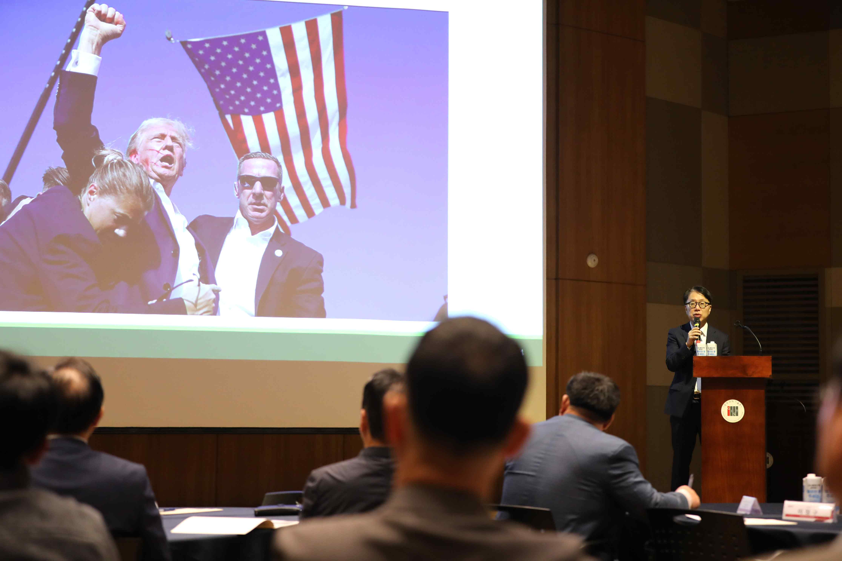

▲ Won-Gon Park, a visiting professor at Ewha Womans University, speaks at the GIST Academy's October breakfast forum on the topic, "Trump Returns: Changing Diplomacy with Money and Power."

Meanwhile, the GIST Academy, which oversees GIST's non-degree programs, operates the GTMBA (GIST Techno Management Business Academy) as its flagship program. The Academy regularly hosts breakfast forums for local businesspeople and alumni on the last Monday of each month in March, May, June, September, and October, inviting experts from various fields.

This 60th breakfast forum, the final one of the year, concluded successfully, providing participants with in-depth insights. The first breakfast forum next year is scheduled to be held in March 2026.



