GIST, the Korea Institute of Energy Research, and Gwangju National University of Education joined forces to open a "Battery Experience Classroom" for future generations

- On Saturday, the 25th, as part of the RISE project, hands-on, experiential science education for children and adolescents, including lithium-ion battery cell assembly and electrochemical experiments, was held... GIST graduate students, Gwangju National University of Education prospective teachers, and researchers from the Korea Institute of Energy Research participated

- Through hands-on experiments with energy storage principles and the value of sustainable energy, the GIST RISE project team aims to enhance energy literacy for future generations, working with the local community... The GIST RISE project team also plans to sequentially launch future educational programs, including those on hydrogen and power systems

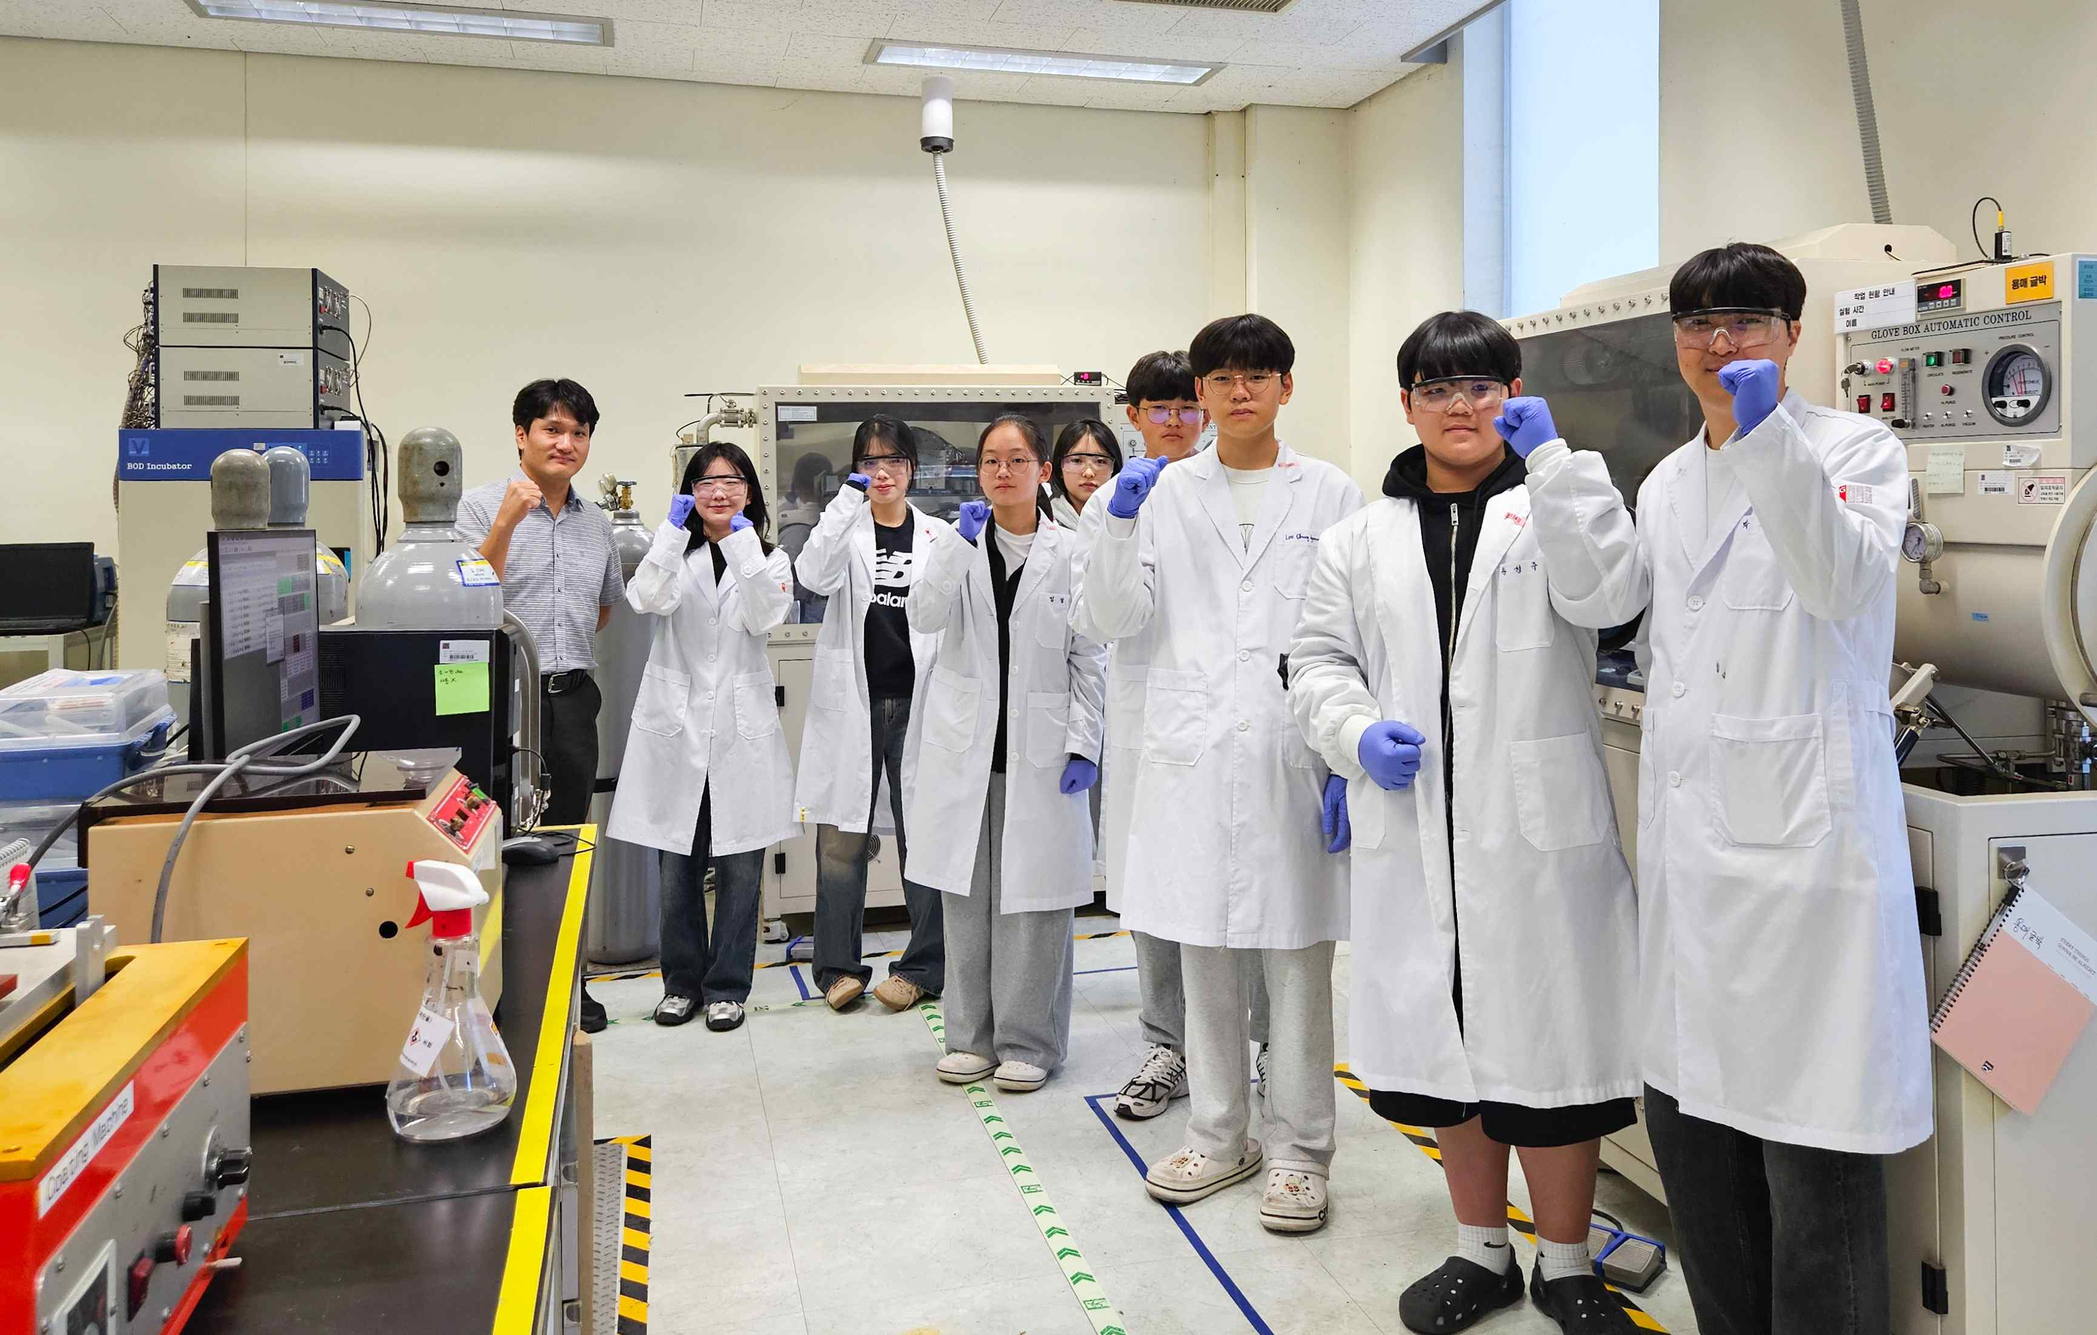

▲ The "Battery Energy Literacy & Makerthon" program held at the GIST Next Generation Energy Research Institute.

The Gwangju Institute of Science and Technology (GIST, President Lim Ki-cheol) announced that the GIST RISE Project Group (Director Inchan Kwon) held the "Battery Energy Literacy & Makerthon" program for children and adolescents at the Research Institute for Solar and Sustainable Energies on Saturday, October 25th.

This program, part of the Regional Innovation System & Education (RISE) project, hosted by the Ministry of Education and the National Research Foundation of Korea, was designed by GIST and the local community to enhance future generations' literacy in eco-friendly energy and foster a creative, science-based learning culture.

Following the enthusiastic response to the "Solar Energy Literacy & Makerthon" held on Saturday, October 11th, this educational program focused on "Principles and Applications of Battery Energy," with approximately 20 elementary and middle school students from Gwangju participating. It was divided into basic and advanced classes depending on the level of participation, and consisted of a fusion science experience combining theory, practice, and exploration.

The lecture was given by Joong-je Woo, Director of the Gwangju Eco-Friendly Energy Research Center at the Korea Institute of Energy Research, and provided an accessible explanation of specialized battery information.

The beginner class, aimed at upper elementary school students, involved assembling an electric vehicle kit, observing how it operates on battery power, and experiencing the principles of how electrical energy is converted into kinetic energy.

Pre-service teachers from Gwangju National University of Education assisted with the course, providing hands-on instruction tailored to the students' level and fostering a more engaging and energizing learning environment.

The advanced class, for middle and high school students, was led by Professor KwangSup Eom, Director of the GIST Ne Research Institute for Solar and Sustainable Energies (Department of Materials Science and Engineering). Students assembled lithium-ion battery cells, operated experimental equipment for electrochemical testing, and witnessed firsthand how battery performance and efficiency change.

They learned about battery structure and performance evaluation methods, observed actual research equipment, and learned the process of electrochemical analysis of batteries. GIST graduate student assistants assisted with the experiments, ensuring the students' safe learning and development.

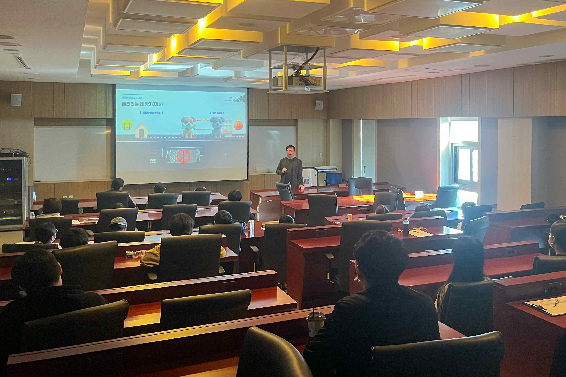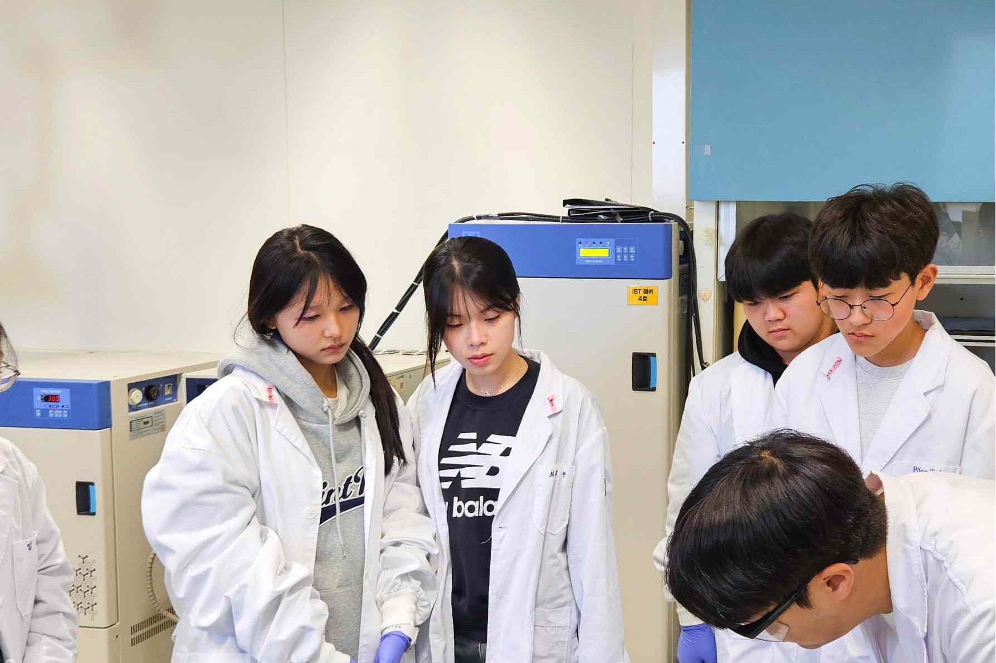

▲ Students learn battery principles in class and then experience hands-on training using research equipment in the battery lab.

One student who participated in this program, which was conducted as an experiential learning program that moved beyond lecture-based classes and focused on learning scientific principles through experiments, said, "The concept of urban mining, where raw materials are recovered from batteries, was the most impressive." During the subsequent hands-on training session, he said, "I felt the power of science when the electric car I built powered by a battery charge, and it was a fulfilling experience."

Hongkyu Kang, a senior researcher at the GIST Research Institute for Solar and Sustainable Energies, said, "I hope this training will increase interest and understanding not only of batteries but also of renewable energy in general." He added, "This experimental and hands-on science education will greatly contribute to enhancing children's energy literacy and creativity."

This program, an educational model operated by GIST in collaboration with the Korea Institute of Energy Research and Gwangju National University of Education, is recognized as a meaningful example of industry-academia-research collaboration among universities, research institutes, and the local community.

Meanwhile, the GIST RISE Project Team is recruiting additional participants for the "Hydrogen" (November 15th) and "Power Systems" (December 13th) programs. Further details can be found on the GIST website and through the information poster (QR code).

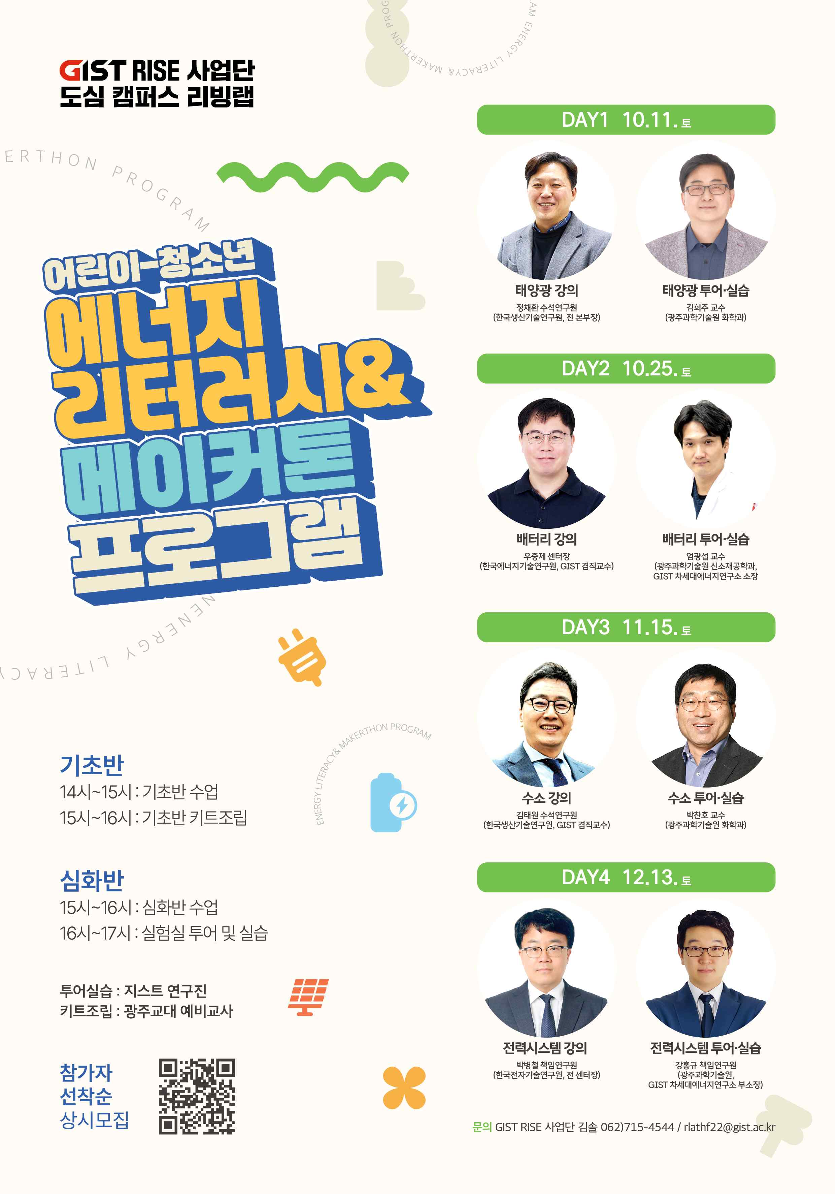

▲ A poster for the "Urban Campus Living Lab Energy Literacy Program" operated by the GIST RISE Project Team. It introduces the curriculum, which covers solar power, batteries, hydrogen, and power systems.

After all programs are completed, the integrated results of the entire series will be announced at a performance presentation in January 2026.



