"Gwangju's industrial complexes are moving toward zero carbon emissions with AI and renewable energy" GIST launches Gwangju RE100 Industrial Complex Planning Committee

- On Friday, the 24th, the first meeting of a collaborative platform was held at GIST's Oryong Hall, with 16 organizations from industry, academia, research, and government participating... In line with the government's carbon neutrality policy, the platform discussed implementation strategies for transitioning industrial complexes to 100% renewable energy

- GIST appointed Professor Yun-Su Kim (Director of the Power Grid Research Center) as chairperson and explored expanding renewable energy and corporate participation... GIST is working to strengthen research and technology support and establish a demonstration base

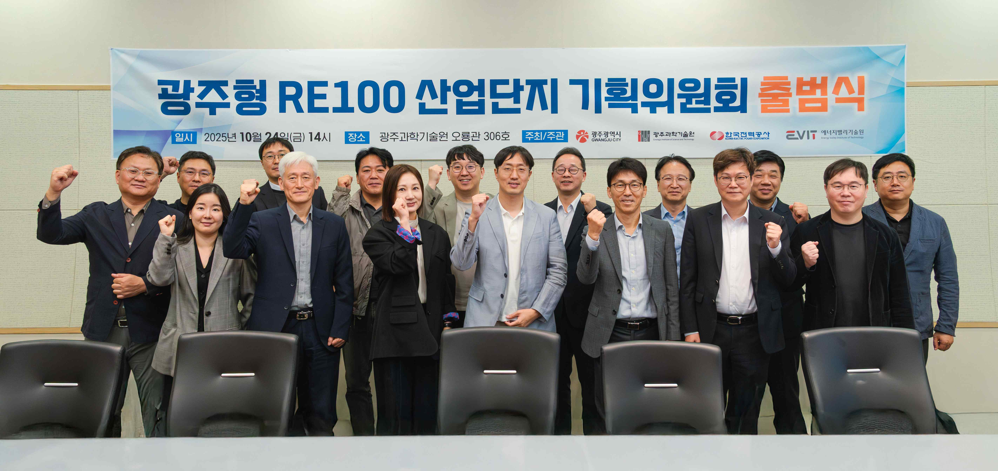

▲ Attendees pose for a commemorative photo at the "Gwangju RE100 Industrial Complex Planning Committee Launch Ceremony and First Meeting," held at GIST Oryong Hall on Friday, October 24th.

The Gwangju Institute of Science and Technology (GIST, President Kichul Lim) announced that, in line with the government's carbon neutrality policy, it held the "Gwangju RE100 Industrial Complex Planning Committee" Launch Ceremony and First Meeting at GIST Oryong Hall on Friday, October 24th.

This planning committee was formed to establish a cooperative system among policies, technologies, and industries in the Gwangju Industrial Complex and to concretize the energy transition strategy for the regional industrial complex. This will contribute to the realization of "RE100 (Renewable Electricity 100%)," an international campaign to transition companies to 100% renewable energy.

Key tasks include: ▴ assessing the current status and challenges of RE100 implementation in the Gwangju Industrial Complex, ▴ identifying feasible implementation plans, and ▴ developing strategies for linking with government projects. The council plans to develop a practical implementation strategy by integrating RE100-related policies, projects, and R&D.

The council is comprised of experts from 16 organizations across industry, academia, research, and government sectors: Gwangju Metropolitan City, Gwangju Free Economic Zone Authority, GIST, KEPCO KDN, Hanwha Shinhan Terawatt Hour, LS Electric, Gwangju Metropolitan City Corporation, Korea Renewable Energy Foundation, Korea Institute of Energy Research, Korea Institute of Industrial Technology, Korea Electronics Technology Institute, Korea Electrotechnology Research Institute, Korea Institute of Energy Technology (KENTECH), Chonnam National University, Gwangju Climate Energy Agency, and Gwangju Technopark. Yun-Su Kim, Director of the Power Grid Research Center at GIST and a professor in the Department of Electrical Engineering and Computer Science, was appointed as the committee chair.

The meeting, held to discuss specific implementation strategies for the Gwangju RE100 Industrial Complex project, which aims to make Gwangju a leading RE100 city, focused on short-term tasks such as promoting agricultural solar power projects and expanding renewable energy within the industrial complex, as well as mid- to long-term strategies such as expanding energy storage (ESS) infrastructure and expanding corporate participation.

Attendees agreed that the Gwangju RE100 Industrial Complex Planning Committee will serve as a starting point for the transition to a sustainable energy structure in the Gwangju Industrial Complex, and emphasized the need for regular meetings to develop policy proposals and promote pilot projects.

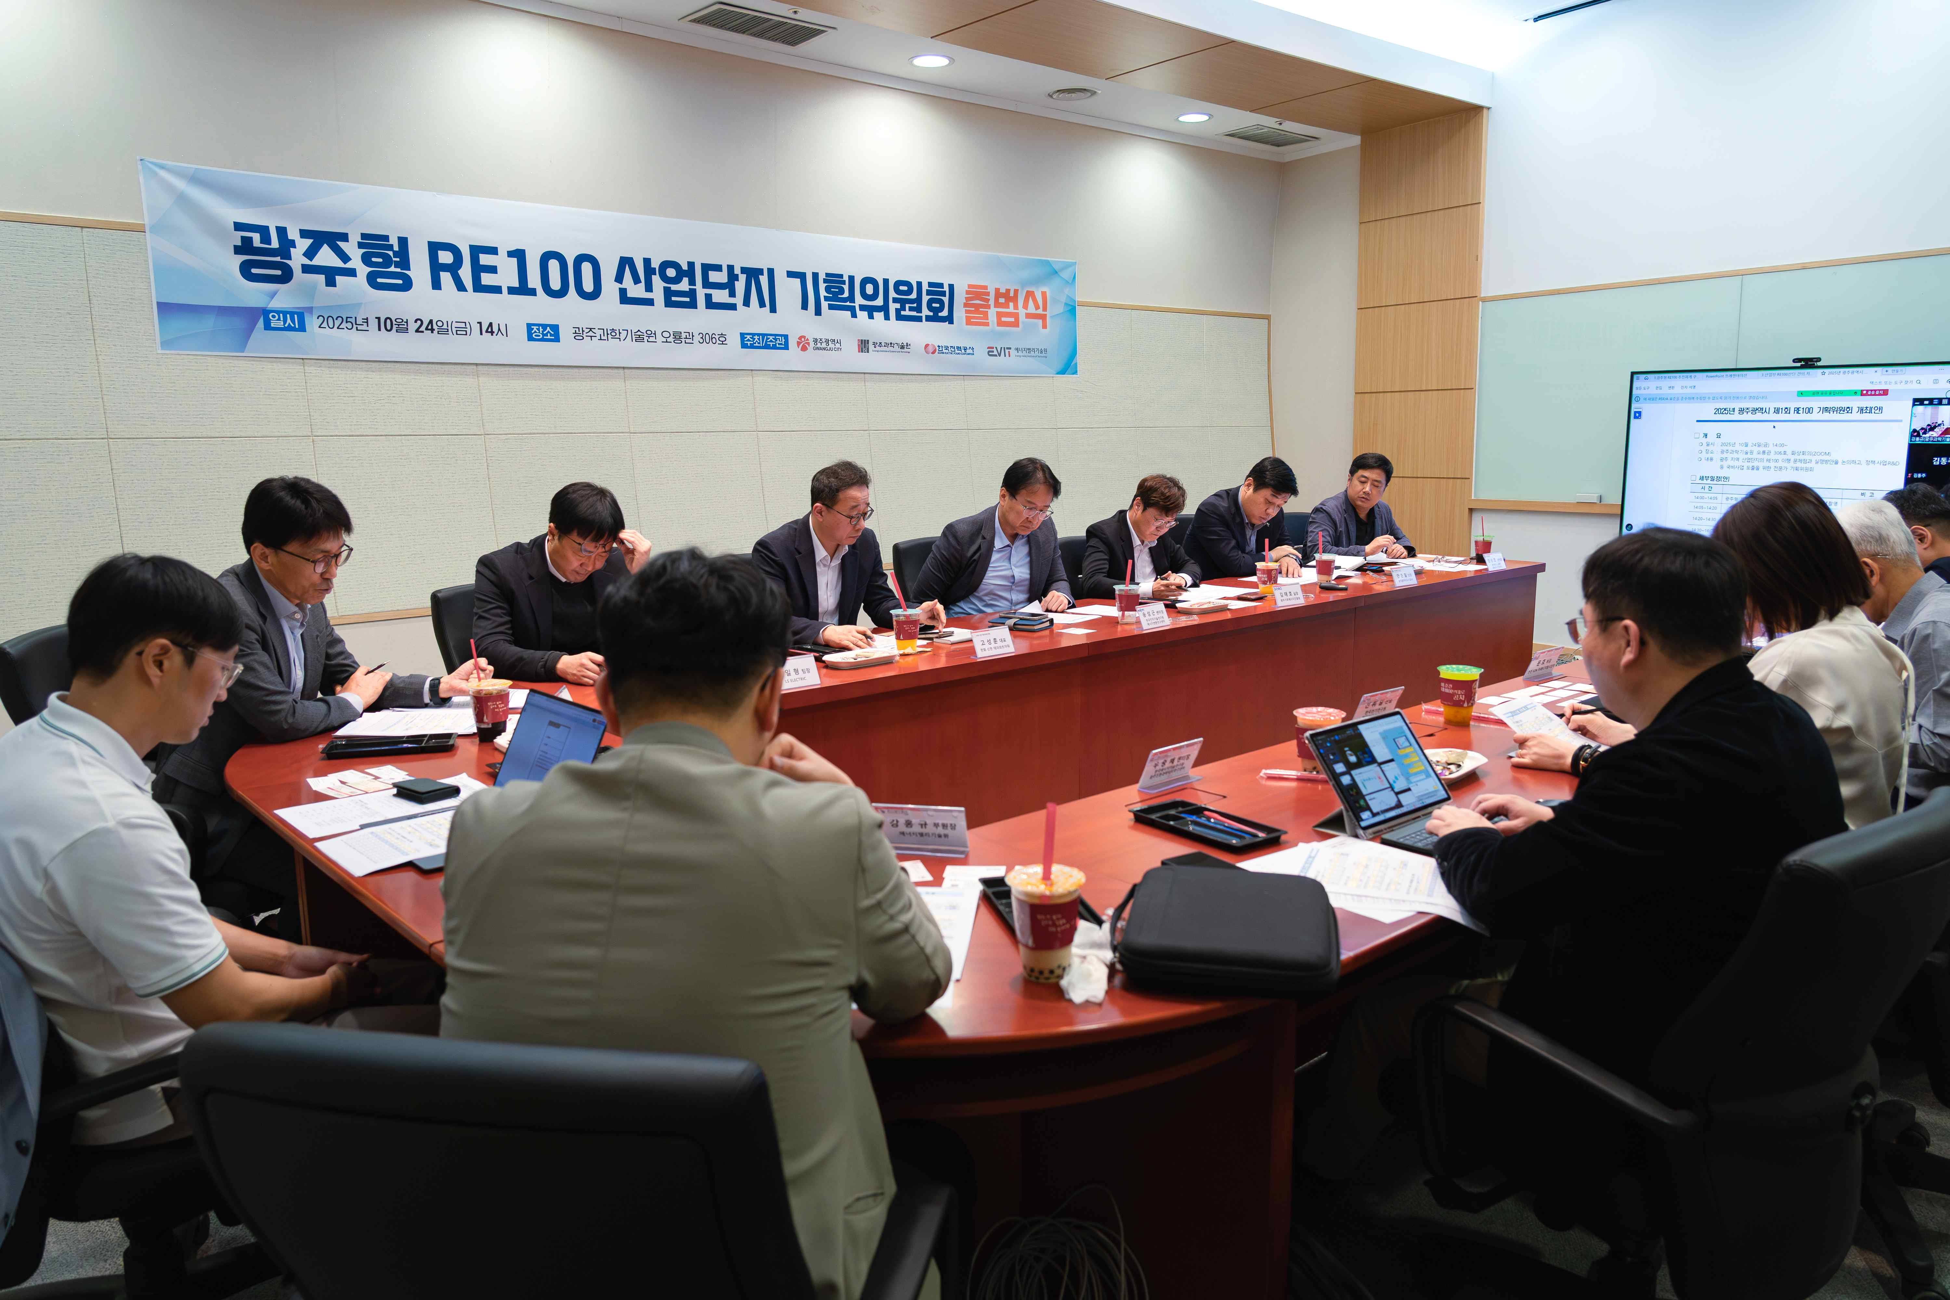

▲ Attendees discuss the implementation strategy for the Gwangju RE100 Industrial Complex at the "Gwangju RE100 Industrial Complex Planning Committee Launch Ceremony and First Meeting."

Chairman Yun-Su Kim (Director of the Power Grid Research Center at GIST) stated, "The Gwangju RE100 Industrial Complex Planning Committee will serve as a focal point for developing a feasible inland city-type RE100 model through collaboration between industry, academia, research, and government. We will continue discussions and cooperation to ensure Gwangju establishes itself as a leading city for RE100 industrial complexes in Korea."

Jun-sik Park, Director of the Energy Industry Division of Gwangju Metropolitan City, stated, "To help Gwangju leap forward as a leading RE100 city, we will establish a cooperative system centered around the committee where policy, technology, and industry can develop together."

Meanwhile, with the launch of the Planning Committee, GIST plans to strengthen research, technical support, and the establishment of a demonstration base for RE100 implementation in industrial complexes. Furthermore, it plans to gradually pursue follow-up research projects, including ▴ AI-based power grid optimization, ▴ decentralized energy management, and ▴ the development of regionally tailored RE100 models.

Additionally, GIST will host the "BIXPO 2025 Gwangju Energy Innovation Conference – RE100 Industrial Complex Activation" at the Kim Dae-jung Convention Center on Thursday, November 6th. Expert sessions will focus on RE100 industrial complex implementation strategies and regional corporate collaboration.

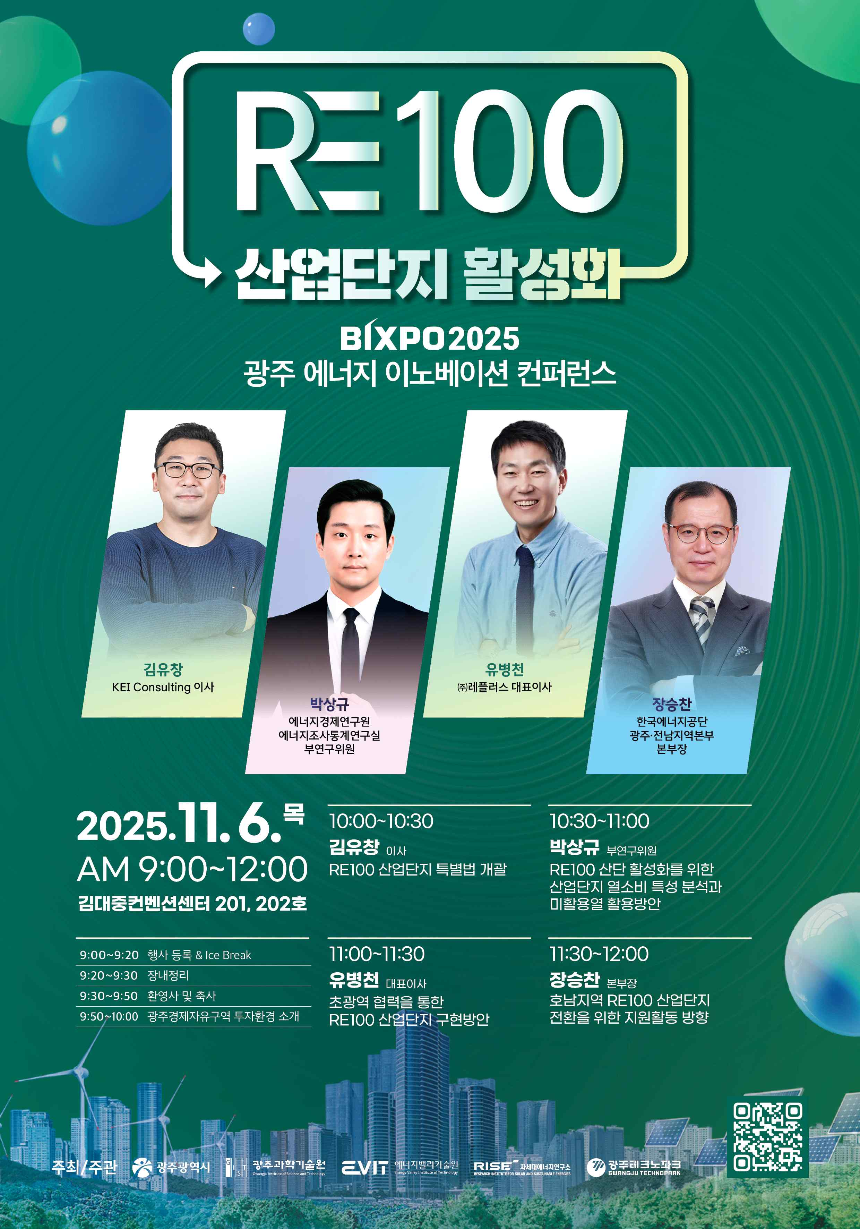

▲ The "BIXPO 2025 Gwangju Energy Innovation Conference – RE100 Industrial Complex Activation" will be held at the Kim Dae-jung Convention Center on Thursday, November 6th.



