A night where science and art meet: The GIST Opera Salon celebrates its 32nd anniversary

- "GIST Opera Salon: Where Science and Art Meet" will be held at 7:00 PM on Thursday, November 6th, at the Dasan Hall in GIST's Oryong Building... The Gwangju City Opera and the Camerata Jeonnam Orchestra will perform together

- An open autumn night cultural festival for alumni, donors, and citizens, showcasing opera masterpieces... GIST's vision as an "open university" that connects with the community through the harmony of science and art will be embodied

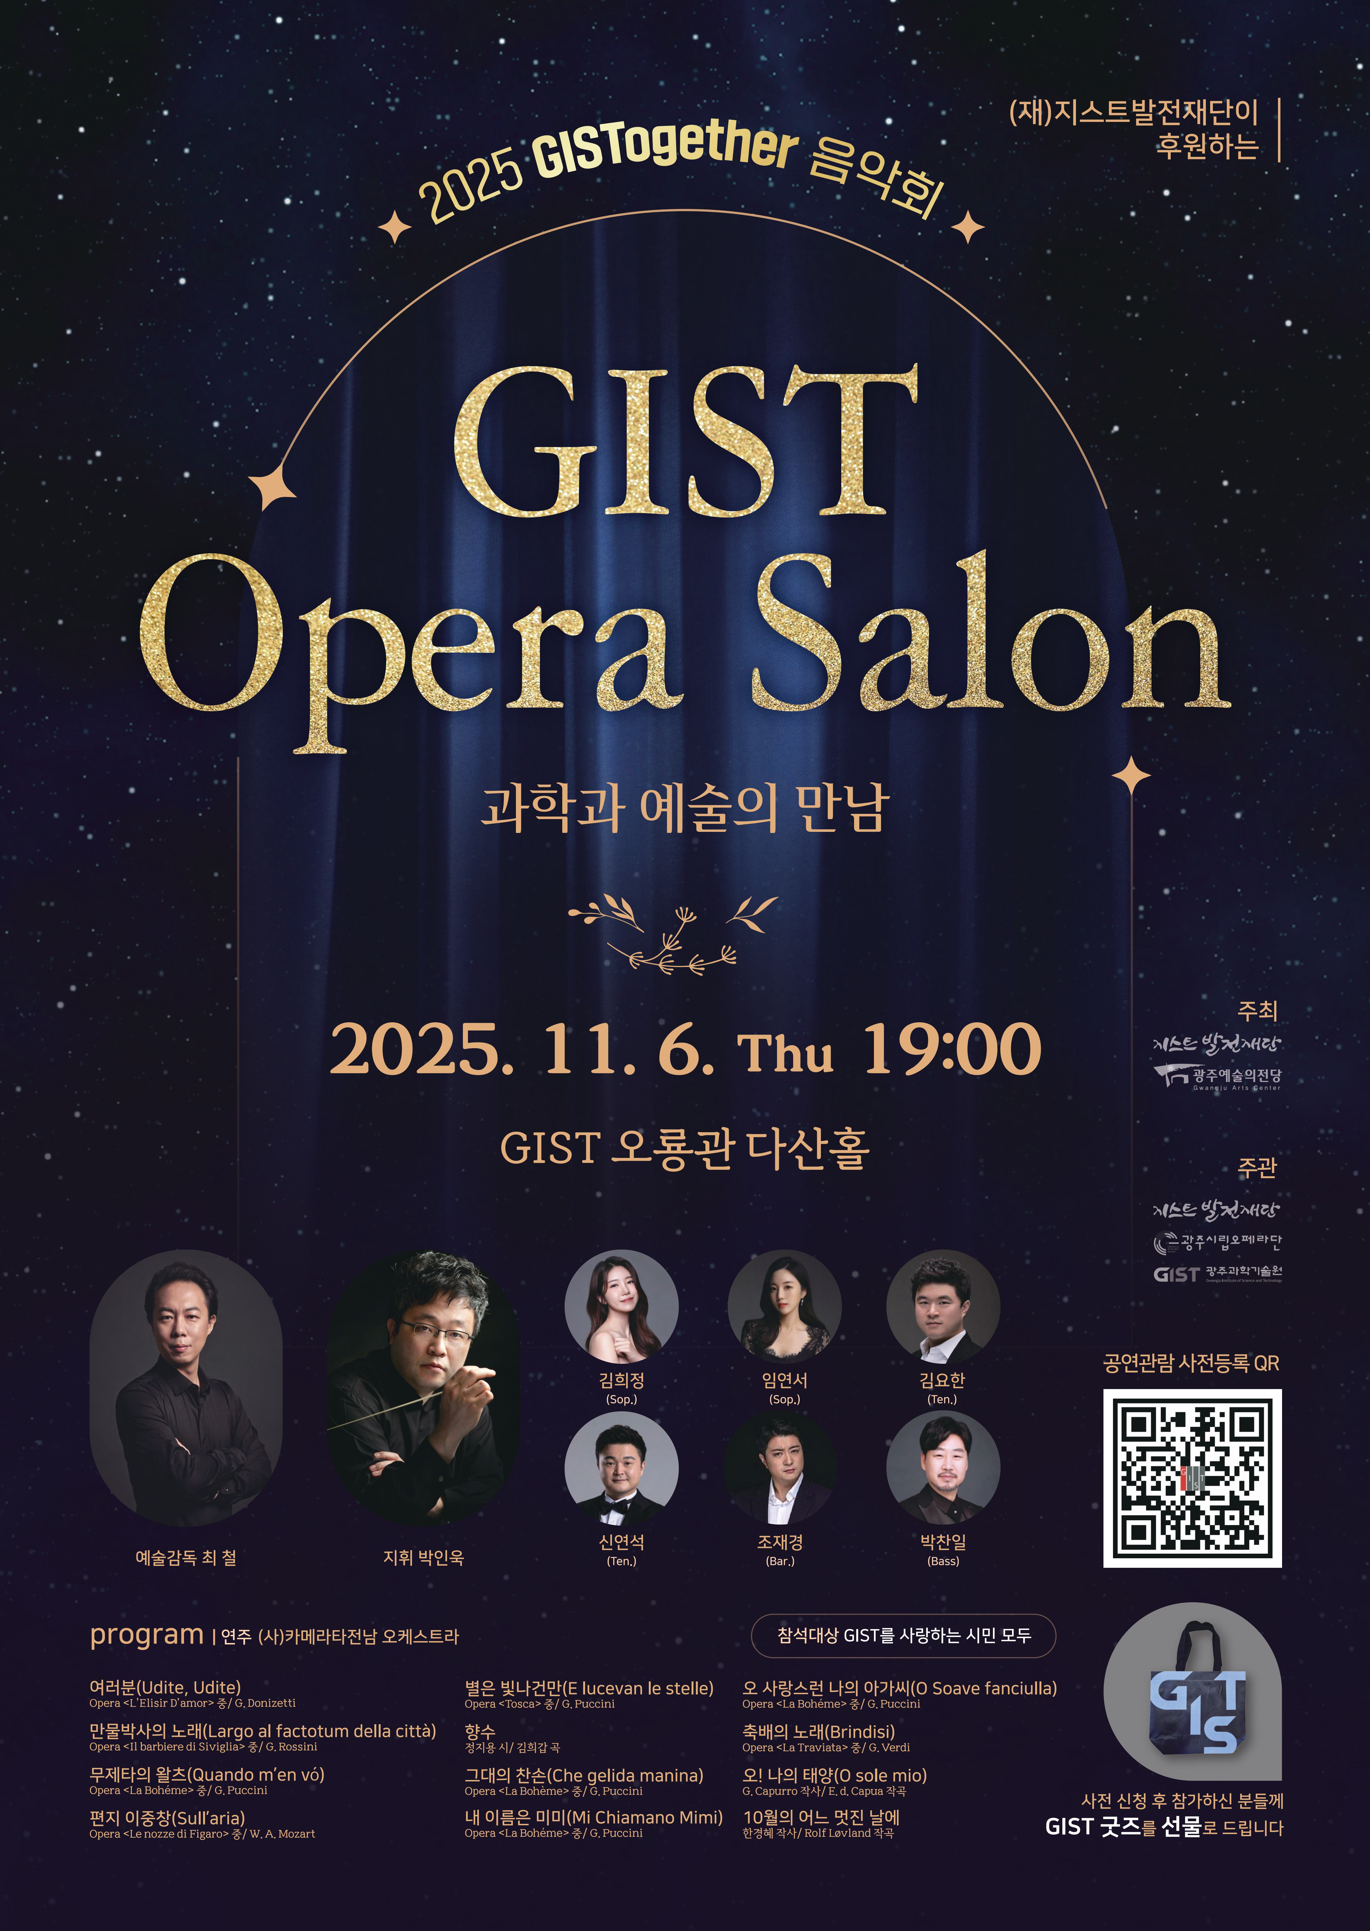

▲ Poster for the 2025 GIST Opera Salon: Science Meets Art

The Gwangju Institute of Science and Technology (GIST, President Kichul Lim) announced that it will host "GIST Opera Salon: Science Meets Art" at 7:00 PM on Thursday, November 6th, at Dasan Hall in GIST's Oryong Building, with support from the GIST Development Foundation (Chairman Hae-myung Kim).

This event commemorates GIST's 32nd anniversary and aims to promote the values ​​and vision of GIST as an "open university" through the harmony of science and art, while also fostering ongoing exchange and mutual growth with the local community.

The "GIST Opera Salon" is a cultural event open to alumni who have supported GIST's development, foundation executives, donors, GIST Technology Management Academy (GTMBA) alumni, and members of the public and community. It will showcase GIST's growth beyond a science and technology research institute, becoming a university that engages with the arts and connects with the community.

Pre-registration is available via the QR code provided on the event poster. Pre-registered attendees will receive commemorative GIST merchandise.

The performance will feature the Gwangju City Opera (Artistic Director Cheol Choi) and the Camerata Jeonnam Orchestra, conducted by Professor In-wook Park (Department of Music, Chonnam National University).

This "Special Opera Gala Concert*" will transcend the traditional stage format and allow the audience to naturally participate in the performance. Singers active on major stages both domestically and internationally will perform, including Hee-jungKim and Yeon-seo Lim (sopranos), Yo-han Kim and Yeon-seok Shin (tenors), Jae-kyung Jo (baritone), and Chan-il Park (bass).

This performance, featuring highlights from world-renowned operatic masterpieces by composers such as Puccini, Verdi, and Mozart, is designed to appeal to all ages. With splendid costumes and vibrant production, the concert promises to transcend the mere act of "spectatorship" and offer the thrill of "communal opera."

* gala concert: This performance format centers around famous scenes and famous songs from various operas. Rather than staging the entire opera, it is a festive concert where audiences can enjoy a variety of arias and ensembles in one place. Its distinctive feature is its relaxed and accessible atmosphere, allowing audiences to more easily experience the emotional impact of the art form.

President Kichul Lim stated, "GIST believes that while science has the power to change the world, art is the power to make that change beautiful." He added, "This Opera Salon will be a special stage where the resonance of science and the melodies of art will resonate with the public."

GIST Foundation Chairman Hae-myung Kim stated, "This concert is a meaningful opportunity to express our gratitude to the foundation's executives, major donors, and partner organizations who have supported GIST, and to share culture with the local community. We hope this will boost donor pride and further spread the culture of giving."



