GIST holds naming event to celebrate completion of the new main gate: Applications accepted until the 31st... Completion ceremony on November 14th

- "GIST Main Gate, Find My Name" naming event held. A public contest to name the main gate, reflecting GIST's identity and symbolism, is underway... QR code submissions will be accepted until October 31st, with the final announcement to be made on November 11th

- The new main gate, constructed with four metal pillars that reflect the sky and surrounding landscape, will become a new landmark symbolizing intellect, youth, communication, and truth... The completion ceremony is scheduled for November 14th

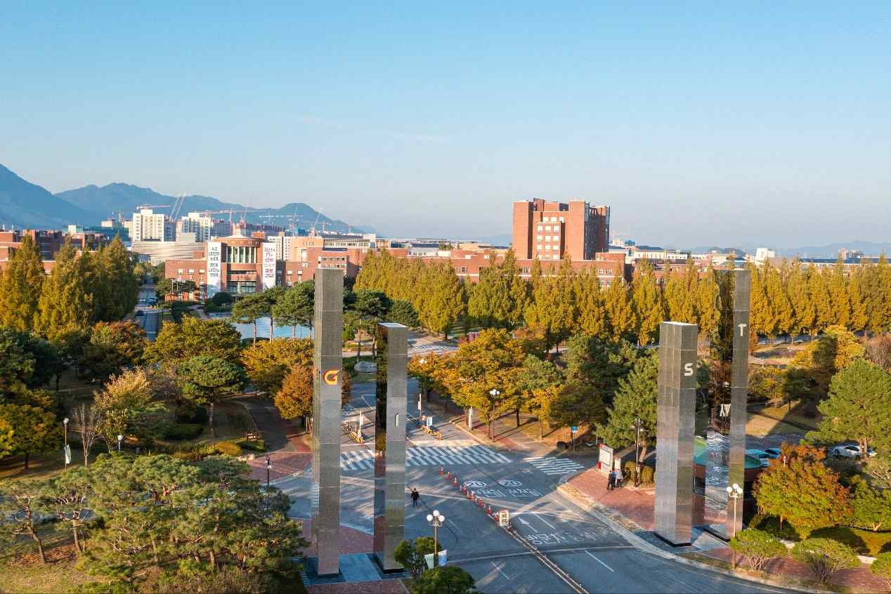
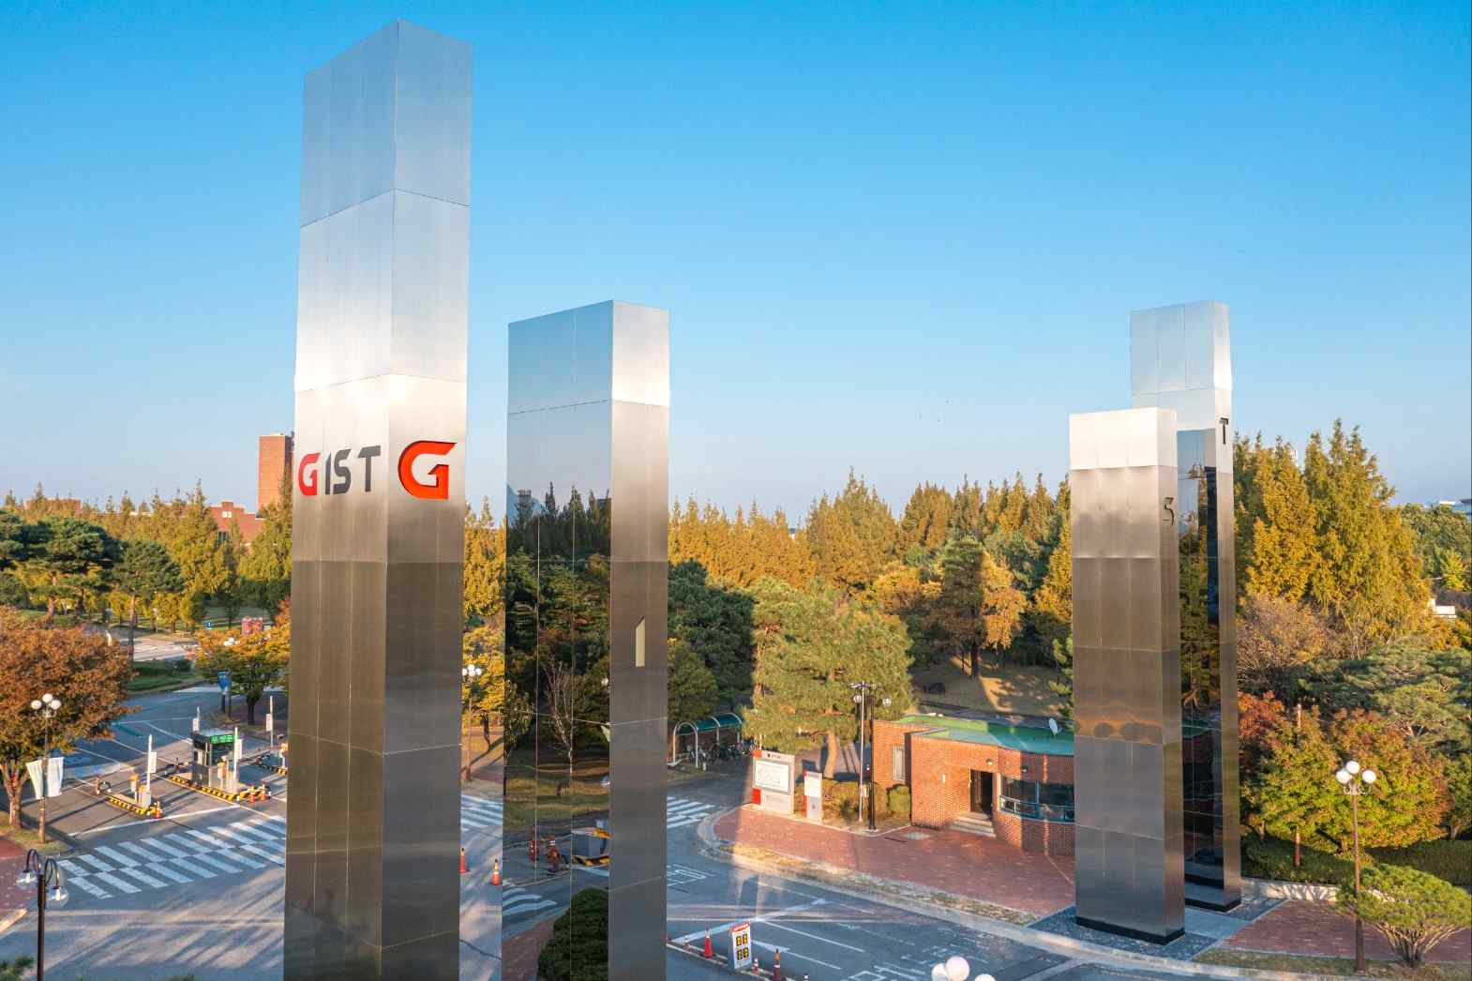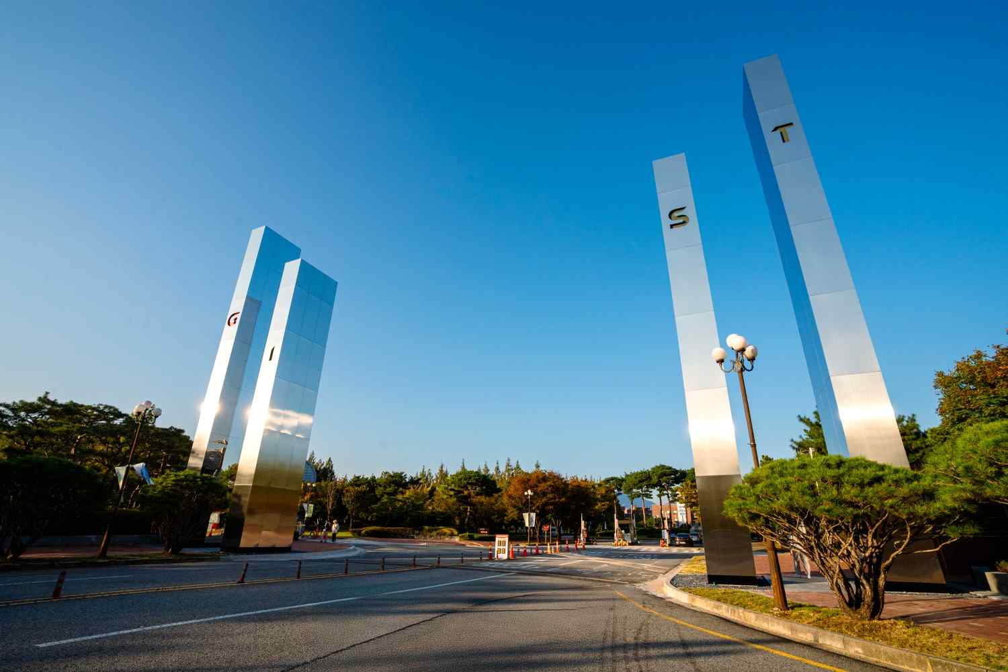

▲ The GIST Main Gate, which completed its renovation earlier this month, is establishing itself as a new landmark for GIST and a symbolic space connecting the region and the world.

The Gwangju Institute of Science and Technology (GIST, President Lim Ki-cheol) announced that it will hold a naming event, "GIST Main Gate, Find My Name," to select a name for the newly constructed main gate.

This event aims to find a name for the main gate that captures GIST's identity and symbolism while resonating with the local community and its members.

The participation period is open until 6:00 PM on Friday, October 31st. Each person can submit only one entry via the QR code provided on the event poster.

Submitted entries will be evaluated based on criteria such as ▲ symbolism, ▲ relevance, ▲ creativity, and ▲ popularity. The final selection results will be announced on the GIST website on November 11th.

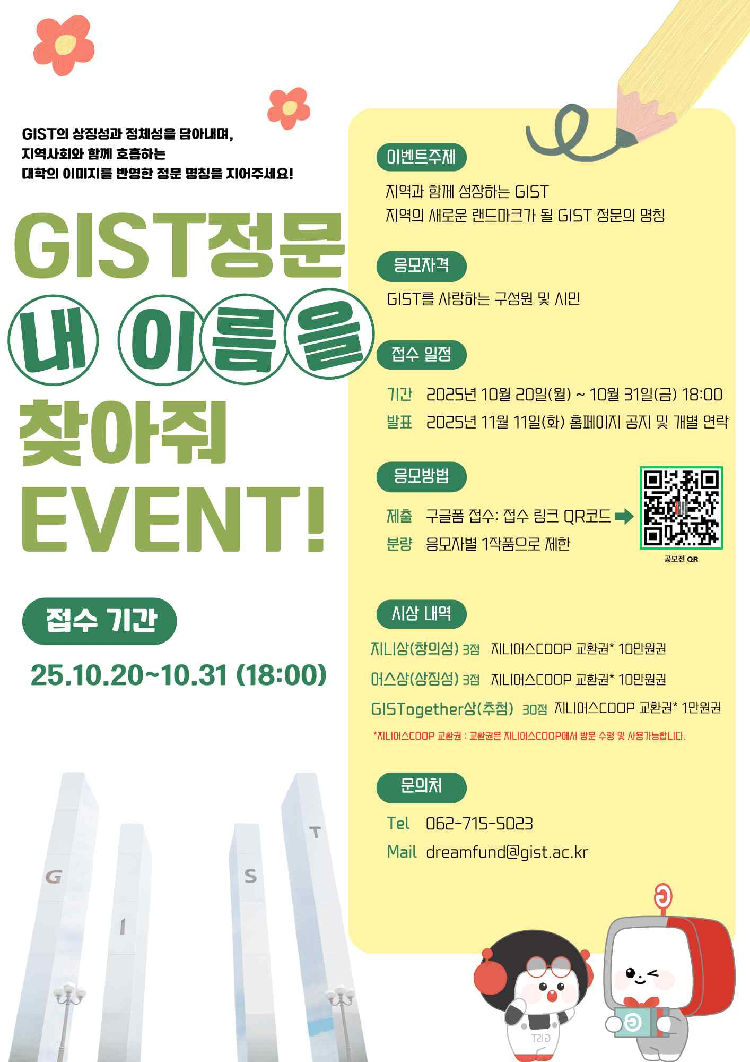

▲ 'GIST Main Gate, Find My Name' event poster

The GIST Main Gate, renovated earlier this month, has established itself as a new landmark for GIST, a symbolic space connecting the region and the world.

A preference survey was conducted on the three winning designs from the Main Gate Design Competition held late last year, and the final design, "GIST-POST," was selected and completed as the main gate sculpture.

"GIST-POST" consists of four pillars, each representing intellect, scholarship, passion, and youth. The main gate sculpture, made of metal, reflects the sky and surrounding landscape with its unique reflective effect, symbolizing GIST's ever-changing and growing identity. Furthermore, the columns of varying heights and circular openings symbolize communication and the light of truth.

Vice President for Public Affairs Yonghwa Chung said, "The 'GIST Main Gate, Find My Name' event is a meaningful process that breathes life into the newly constructed main gate. As a research-oriented university that has grown alongside the local community for the past 30 years, I hope this event will serve as an opportunity to share GIST's spirit and vision with the public."

Meanwhile, the GIST Main Gate Completion Ceremony is scheduled for Friday, November 14. For inquiries about the event, please contact the GIST Development Fund Team at 062-715-5023.



