"I built a light-powered robot myself!" GIST to host solar-powered robot experience program at the 2025 Art Science Festival

- Participated in the "2025 Gwangju National Science Museum Art Science Festival" on October 18-19, operating an eco-friendly energy education booth where visitors could experience the principles of solar power firsthand... Over 300 participants participated successfully

- As part of the "2025 Gwangju RISE Project," the GIST RISE Project Team planned an interactive science experience to enhance citizens' energy literacy and awareness of sustainability... Contributing to fostering future energy talent and expanding the local scientific culture

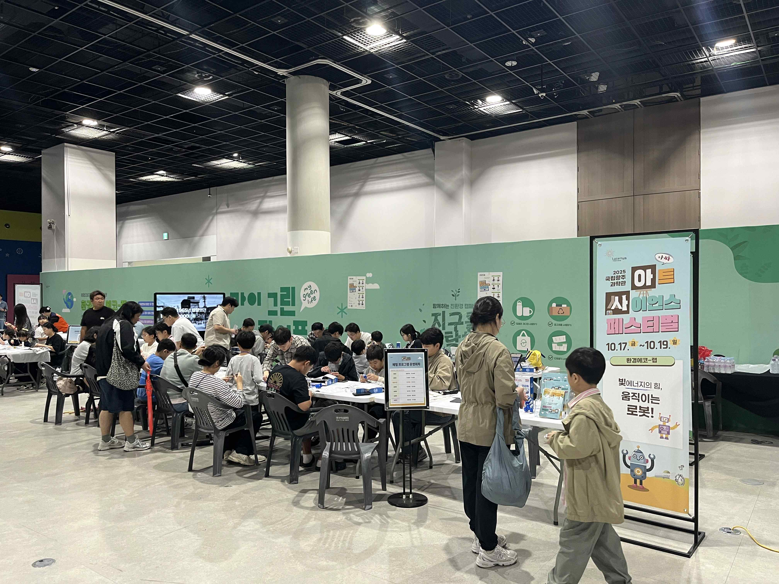

▲ The "Eco-Friendly Energy Literacy & Makerthon" program held at the Gwangju National Science Museum's Special Exhibition Hall.

The Gwangju Institute of Science and Technology (GIST, President Kichul Lim) announced that it participated in the "2025 Art Science Festival" held at the Gwangju National Science Museum from Saturday, October 18th to Sunday, October 19th. It operated a booth called "The Power of Light Energy, Moving Robots!", an eco-friendly energy experience program for children and teenagers.

This large-scale festival, hosted by the Gwangju National Science Museum for three days from October 17th to 19th, took place throughout the museum. Under the theme "Autumn Science Walk," the event presented diverse, fusion content that transcended the boundaries between science and art, offering visitors new experiences and scientific inspiration.

GIST recently participated in the ‘2025 Gwangju RISE Project,’ a regional unit project of the ‘Regional Innovation-Oriented University Support System (RISE)’ promoted by the Ministry of Education and the National Research Foundation of Korea, and was selected for the ‘Urban Campus Living Lab Operation’ project (Person in charge: Hongkyu Kang, Senior Researcher at the GIST Research Institute for Solar and Sustainable Energies) together with Gwangju National University of Education.

Accordingly, the GIST RISE Project Team (Director Inchan Kwon) is actively promoting programs to cultivate future energy talent and spread scientific culture through collaboration with local communities and universities.

This experience booth was operated for a total of 12 sessions over two days, with approximately 300 students and parents participating. The program consisted of energy literacy education to learn basic climate and energy concepts, a Makerthon activity using solar energy practice kits, and team presentations to solve everyday energy problems.

Participants experimented with changes in output depending on light intensity and the angle of the solar panel, and assembled a robot kit to visually observe the flow and conversion principles of electrical energy.

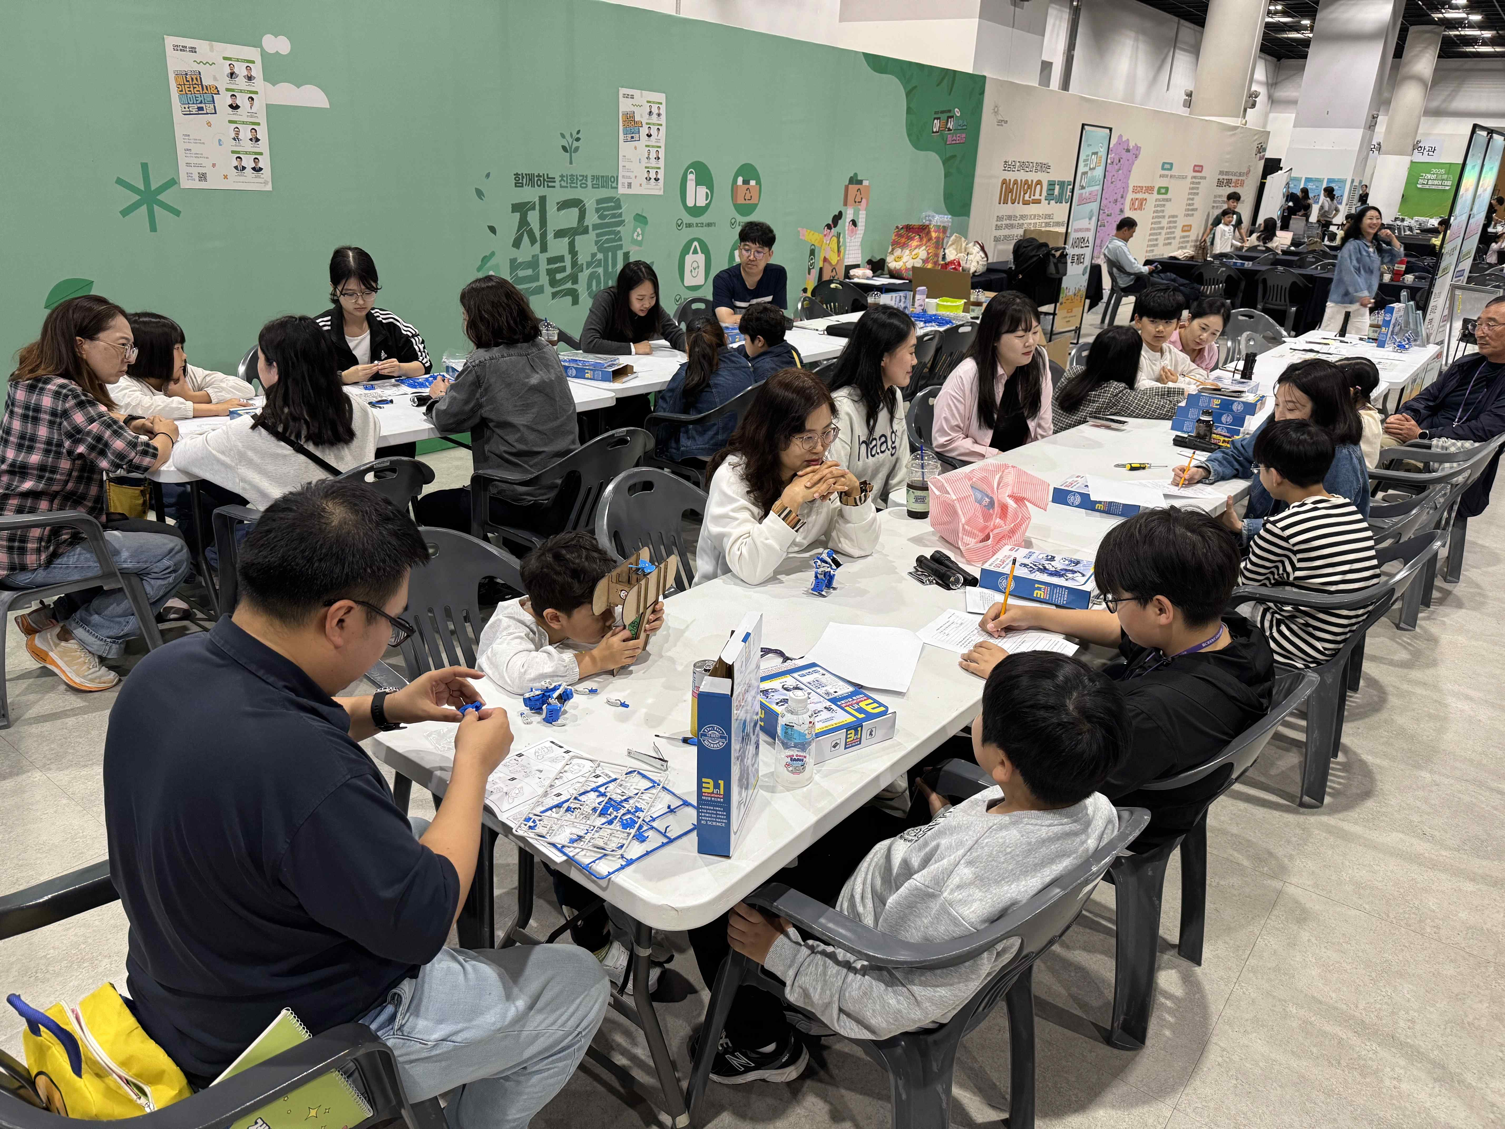

▲ Approximately 300 students and parents participated in the event, learning about the principles of eco-friendly energy and experiencing hands-on solar energy assembly kit training.

One participating student commented, "Seeing the robot actually move with solar power made me feel the power of electricity right before my eyes. Making it myself made science much more fun and fascinating."

Hongkyu Kang, a senior researcher at the GIST Research Institute for Solar and Sustainable Energies and the project leader, said, "I hope students will learn the principles of solar power firsthand and develop scientific thinking and collaboration skills through the experience of operating the robot." He added, "We will continue to expand participatory energy education in collaboration with the Gwangju National Science Museum and Gwangju National University of Education."

Meanwhile, GIST is collaborating with the Gwangju National Science Museum to jointly plan and operate science education services centered on exhibitions, education, and hands-on experiences. Through various citizen-participatory science and culture programs, GIST contributes to fostering the local science culture ecosystem and fostering future talent.



