"Experience the Future of Energy Science at GIST" GIST hosts 'Solar Energy Literacy & Makerthon' for children and youth

- On Saturday, the 11th, approximately 30 elementary and middle school students from Gwangju participated in a customized hands-on workshop divided into basic and advanced classes... They experienced everyday science by assembling solar panels and gained hands-on experience with GIST research equipment

- As part of the Gwangju Metropolitan City RISE (Regional Innovation-Oriented University Support System) project, GIST, the Korea Institute of Industrial Technology, and Gwangju National University of Education jointly operated the program... This program presents a model for regional cooperation and collaboration between local communities, universities, and research institutes

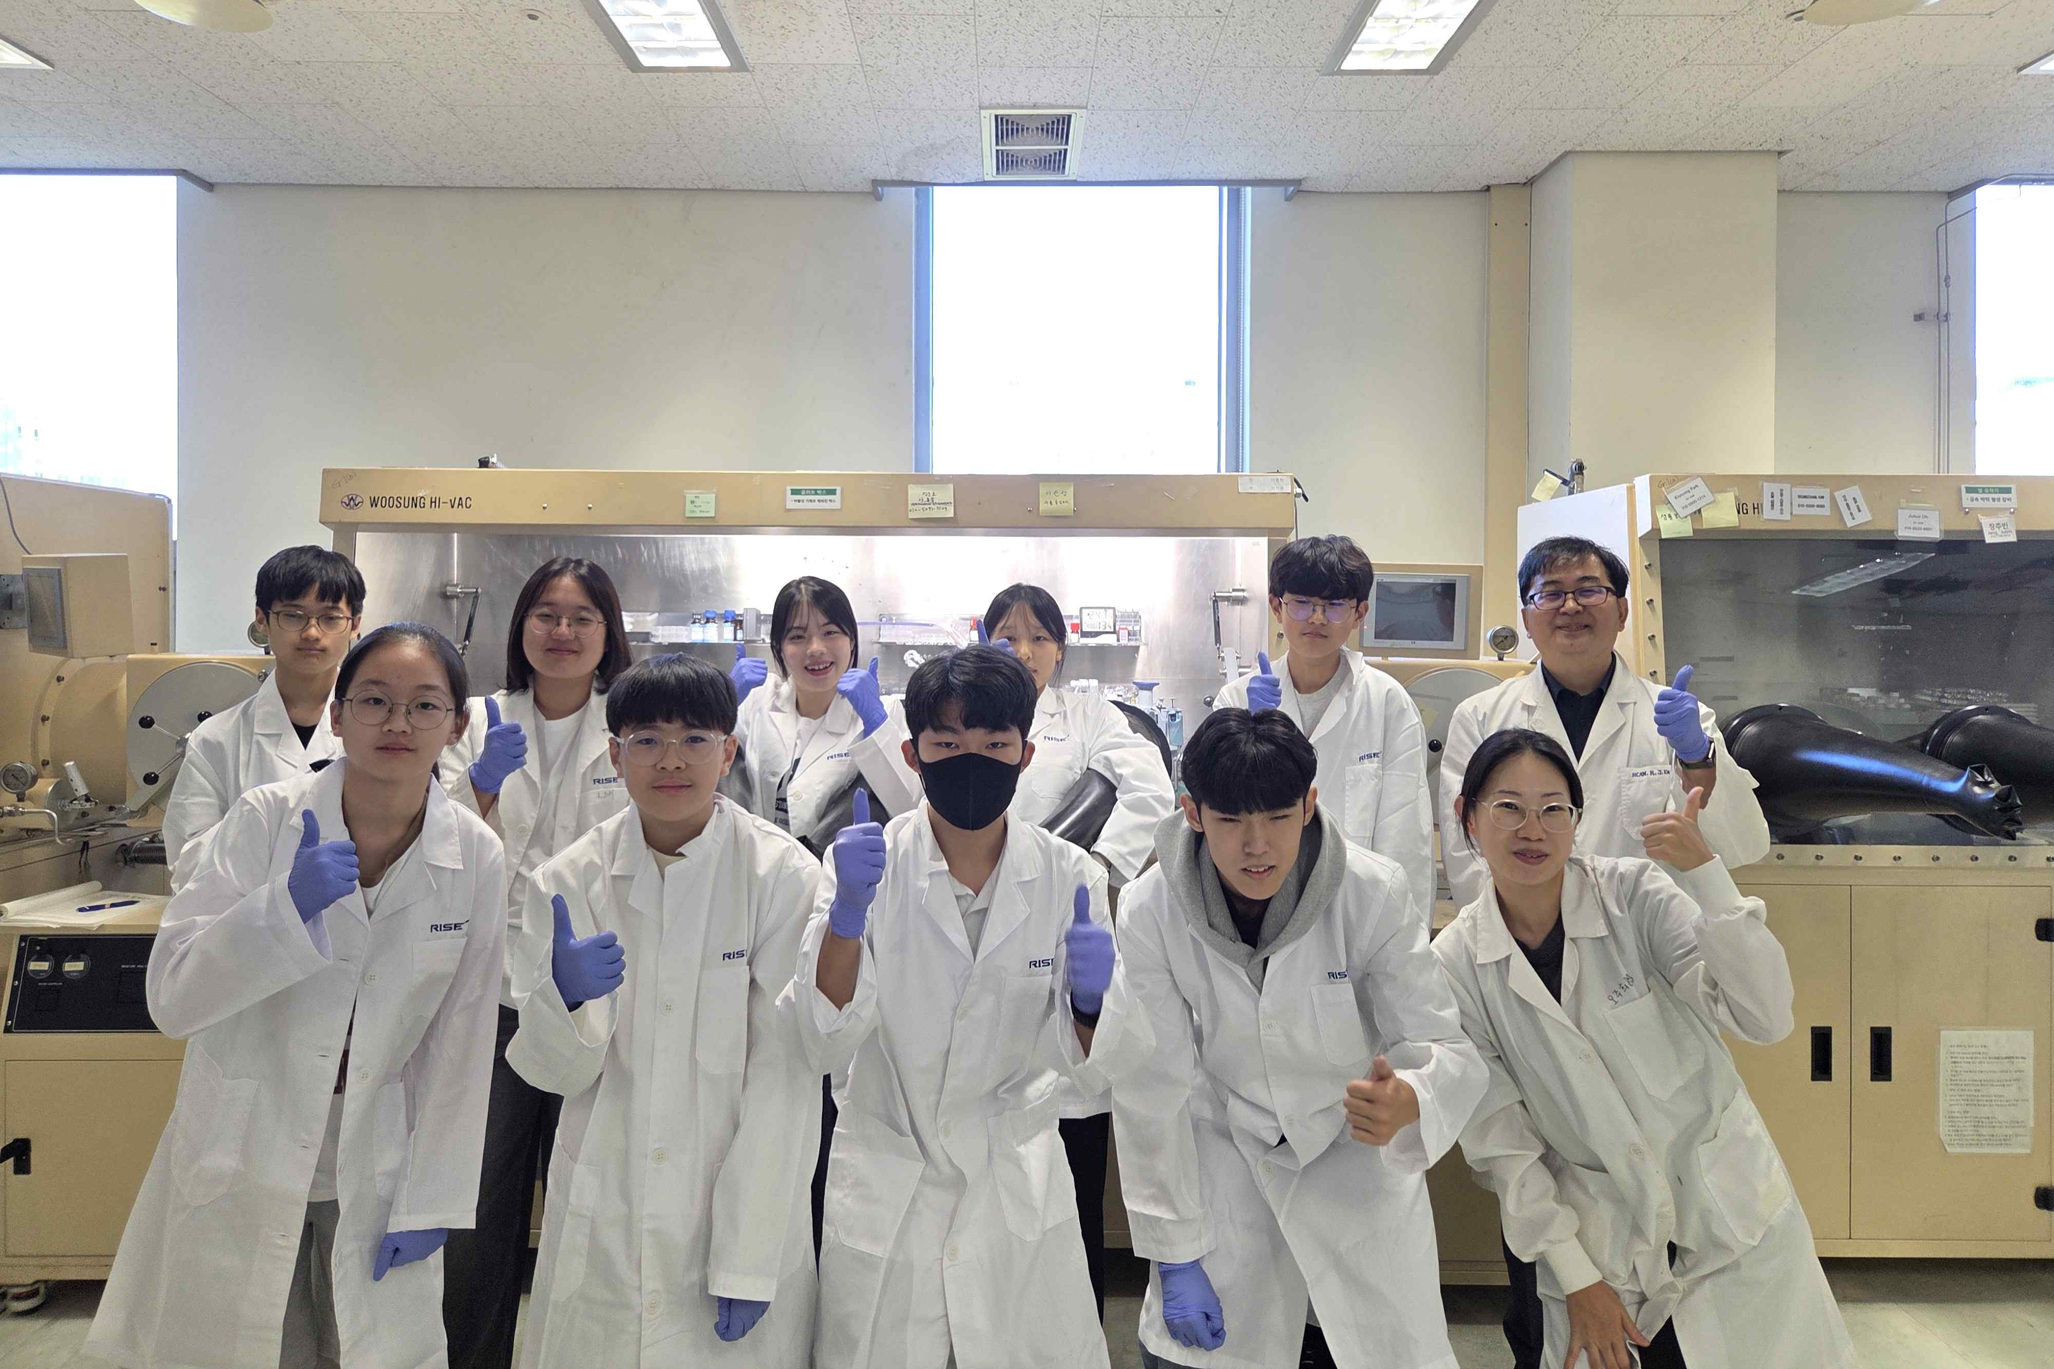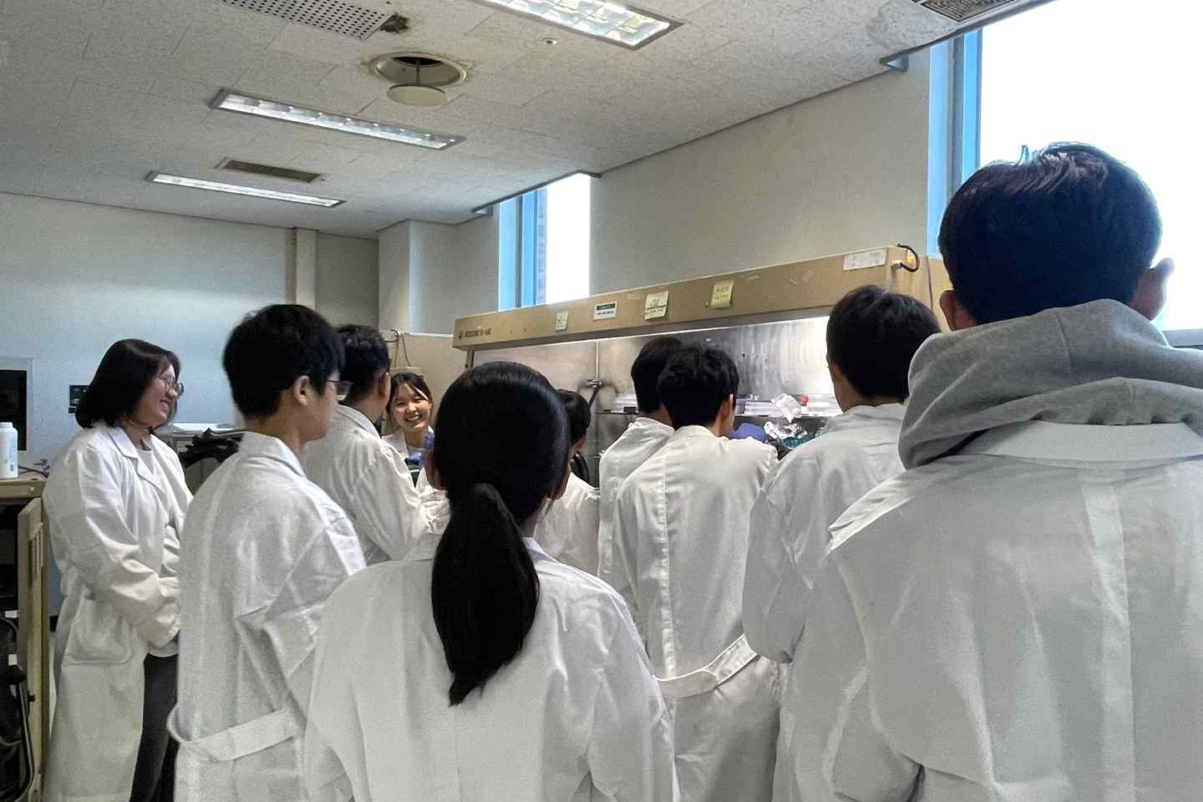

▲ The "Solar Energy Literacy & Makerthon" program held at the GIST Next Generation Energy Research Institute. Students learn about solar energy principles through lectures and experience hands-on training using research equipment in the solar energy lab.

The Gwangju Institute of Science and Technology (GIST, President Kichul Lim) announced that it hosted the "Solar Energy Literacy & Makerthon" program for children and adolescents at the GIST Research Institute for Solar and Sustainable Energies on Saturday, October 11th.

This program is part of the "Regional Innovation-Oriented University Support System (RISE)" project, promoted by the Ministry of Education and the National Research Foundation of Korea. The program was planned by the GIST RISE Project Team (Director Inchan Kwon).

GIST, along with Gwangju National University of Education, was selected for the "Urban Campus Living Lab Operation" project (Principal Investigator: Hongkyu Kang, Senior Researcher at the Research Institute for Solar and Sustainable Energies) under the 2025 Gwangju RISE Project. This program aims to foster collaboration between local communities and universities to discover future energy talent and promote scientific culture.

Approximately 30 elementary and middle school students from Gwangju Metropolitan City participated in the event. The program was divided into beginner and advanced classes, tailored to the participants' age and skill level.

The beginner class, aimed at elementary school students, involved prospective teachers from Gwangju National University of Education as assistant instructors. Students learned the basic principles of solar power and assembled a kit to experience its operation.

Students naturally learned how science can be applied in everyday life by observing the solar power devices they built in action.

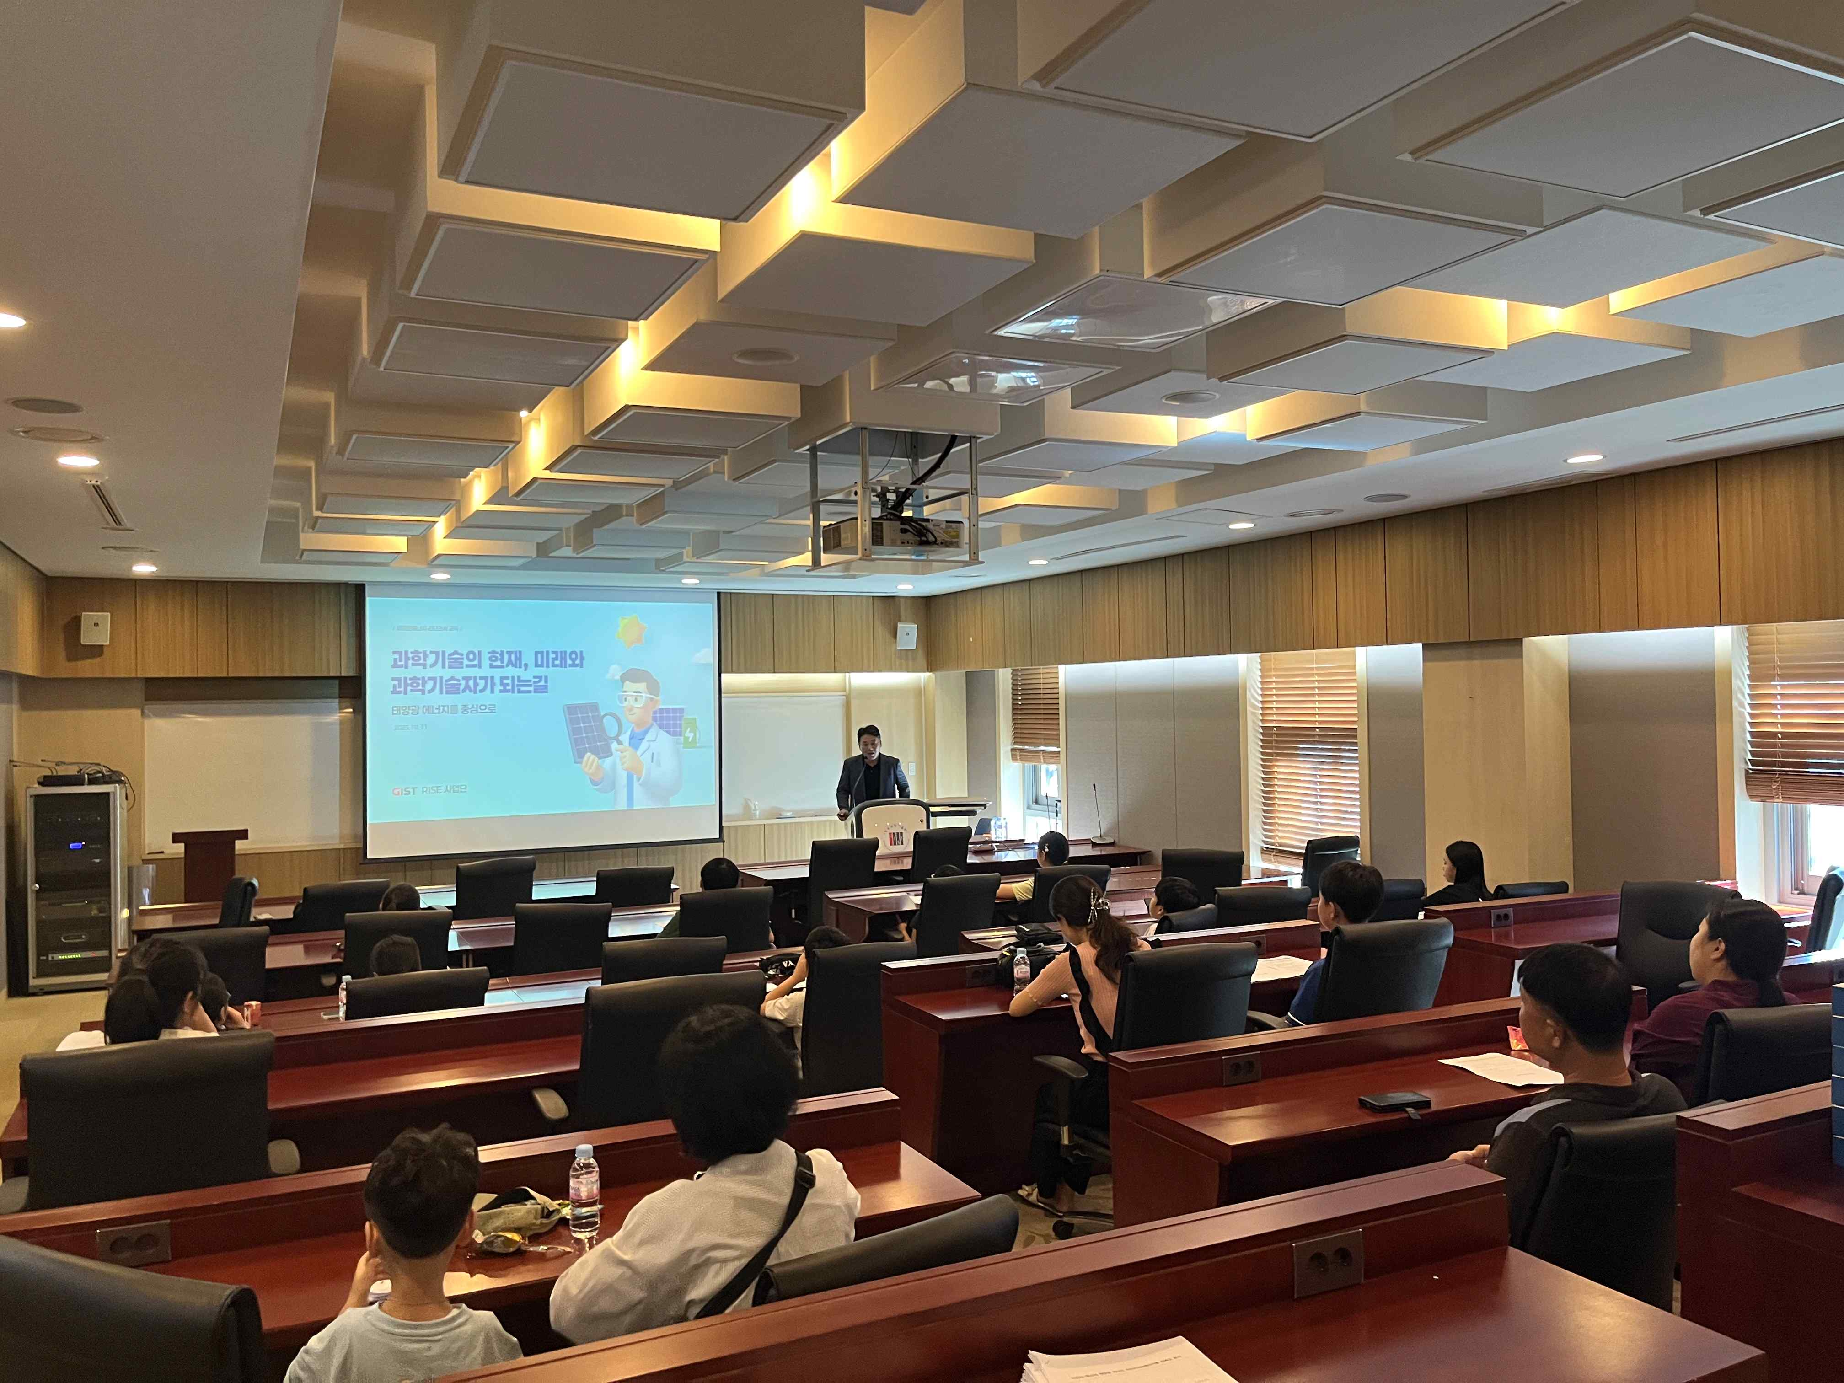

▲ The introductory class of the "Solar Energy Literacy & Makerthon" held at the GIST Research Institute for Solar and Sustainable Energies. The advanced class, aimed at middle and high school students, was led by Professor Hee Joo Kim of the Department of Chemistry at GIST. Graduate students served as assistant instructors. They toured the GIST solar power laboratory and conducted hands-on experiments. The students experienced firsthand the process of scientific research and development by handling actual research equipment.

The lecture was given by Senior Researcher Chae-hwan Jeong (former Director of the Southwest Regional Headquarters) at the Korea Institute of Industrial Technology. He brought his expertise to the lecturer, explaining the theories and realities of solar power in an easily understandable way. The students had the opportunity to understand the principles and applications of solar power through everyday science.

One student who attended the event said, "It was truly fascinating to see the science I'd only seen in books in action."

Hongkyu Kang, a senior researcher at the GIST Research Institute for Solar and Sustainable Energies and the project leader, expressed his aspirations, saying, "It was deeply rewarding to see students enjoy learning science through lectures and hands-on activities." He added, "Starting with this solar energy training, we will expand the topics to include batteries, hydrogen, and power systems, developing it into a comprehensive energy literacy platform."

This program, a joint educational model operated by GIST, the Korea Institute of Industrial Technology, and Gwangju National University of Education, is recognized as a successful example of regional cooperation achieved through close collaboration among universities, research institutes, and the local community.

GIST plans to continue expanding collaboration with local energy companies and related organizations to realize the goals of the RISE project, including shared growth between local communities and universities, talent development, and strengthening industry-academia-research collaboration.

Meanwhile, the GIST RISE project team is recruiting additional participants for the following programs: ▲ October 25th (battery), ▲ November 15th (hydrogen), and ▲ December 13th (power systems). Further details can be found on the GIST website and on the information poster (QR code).

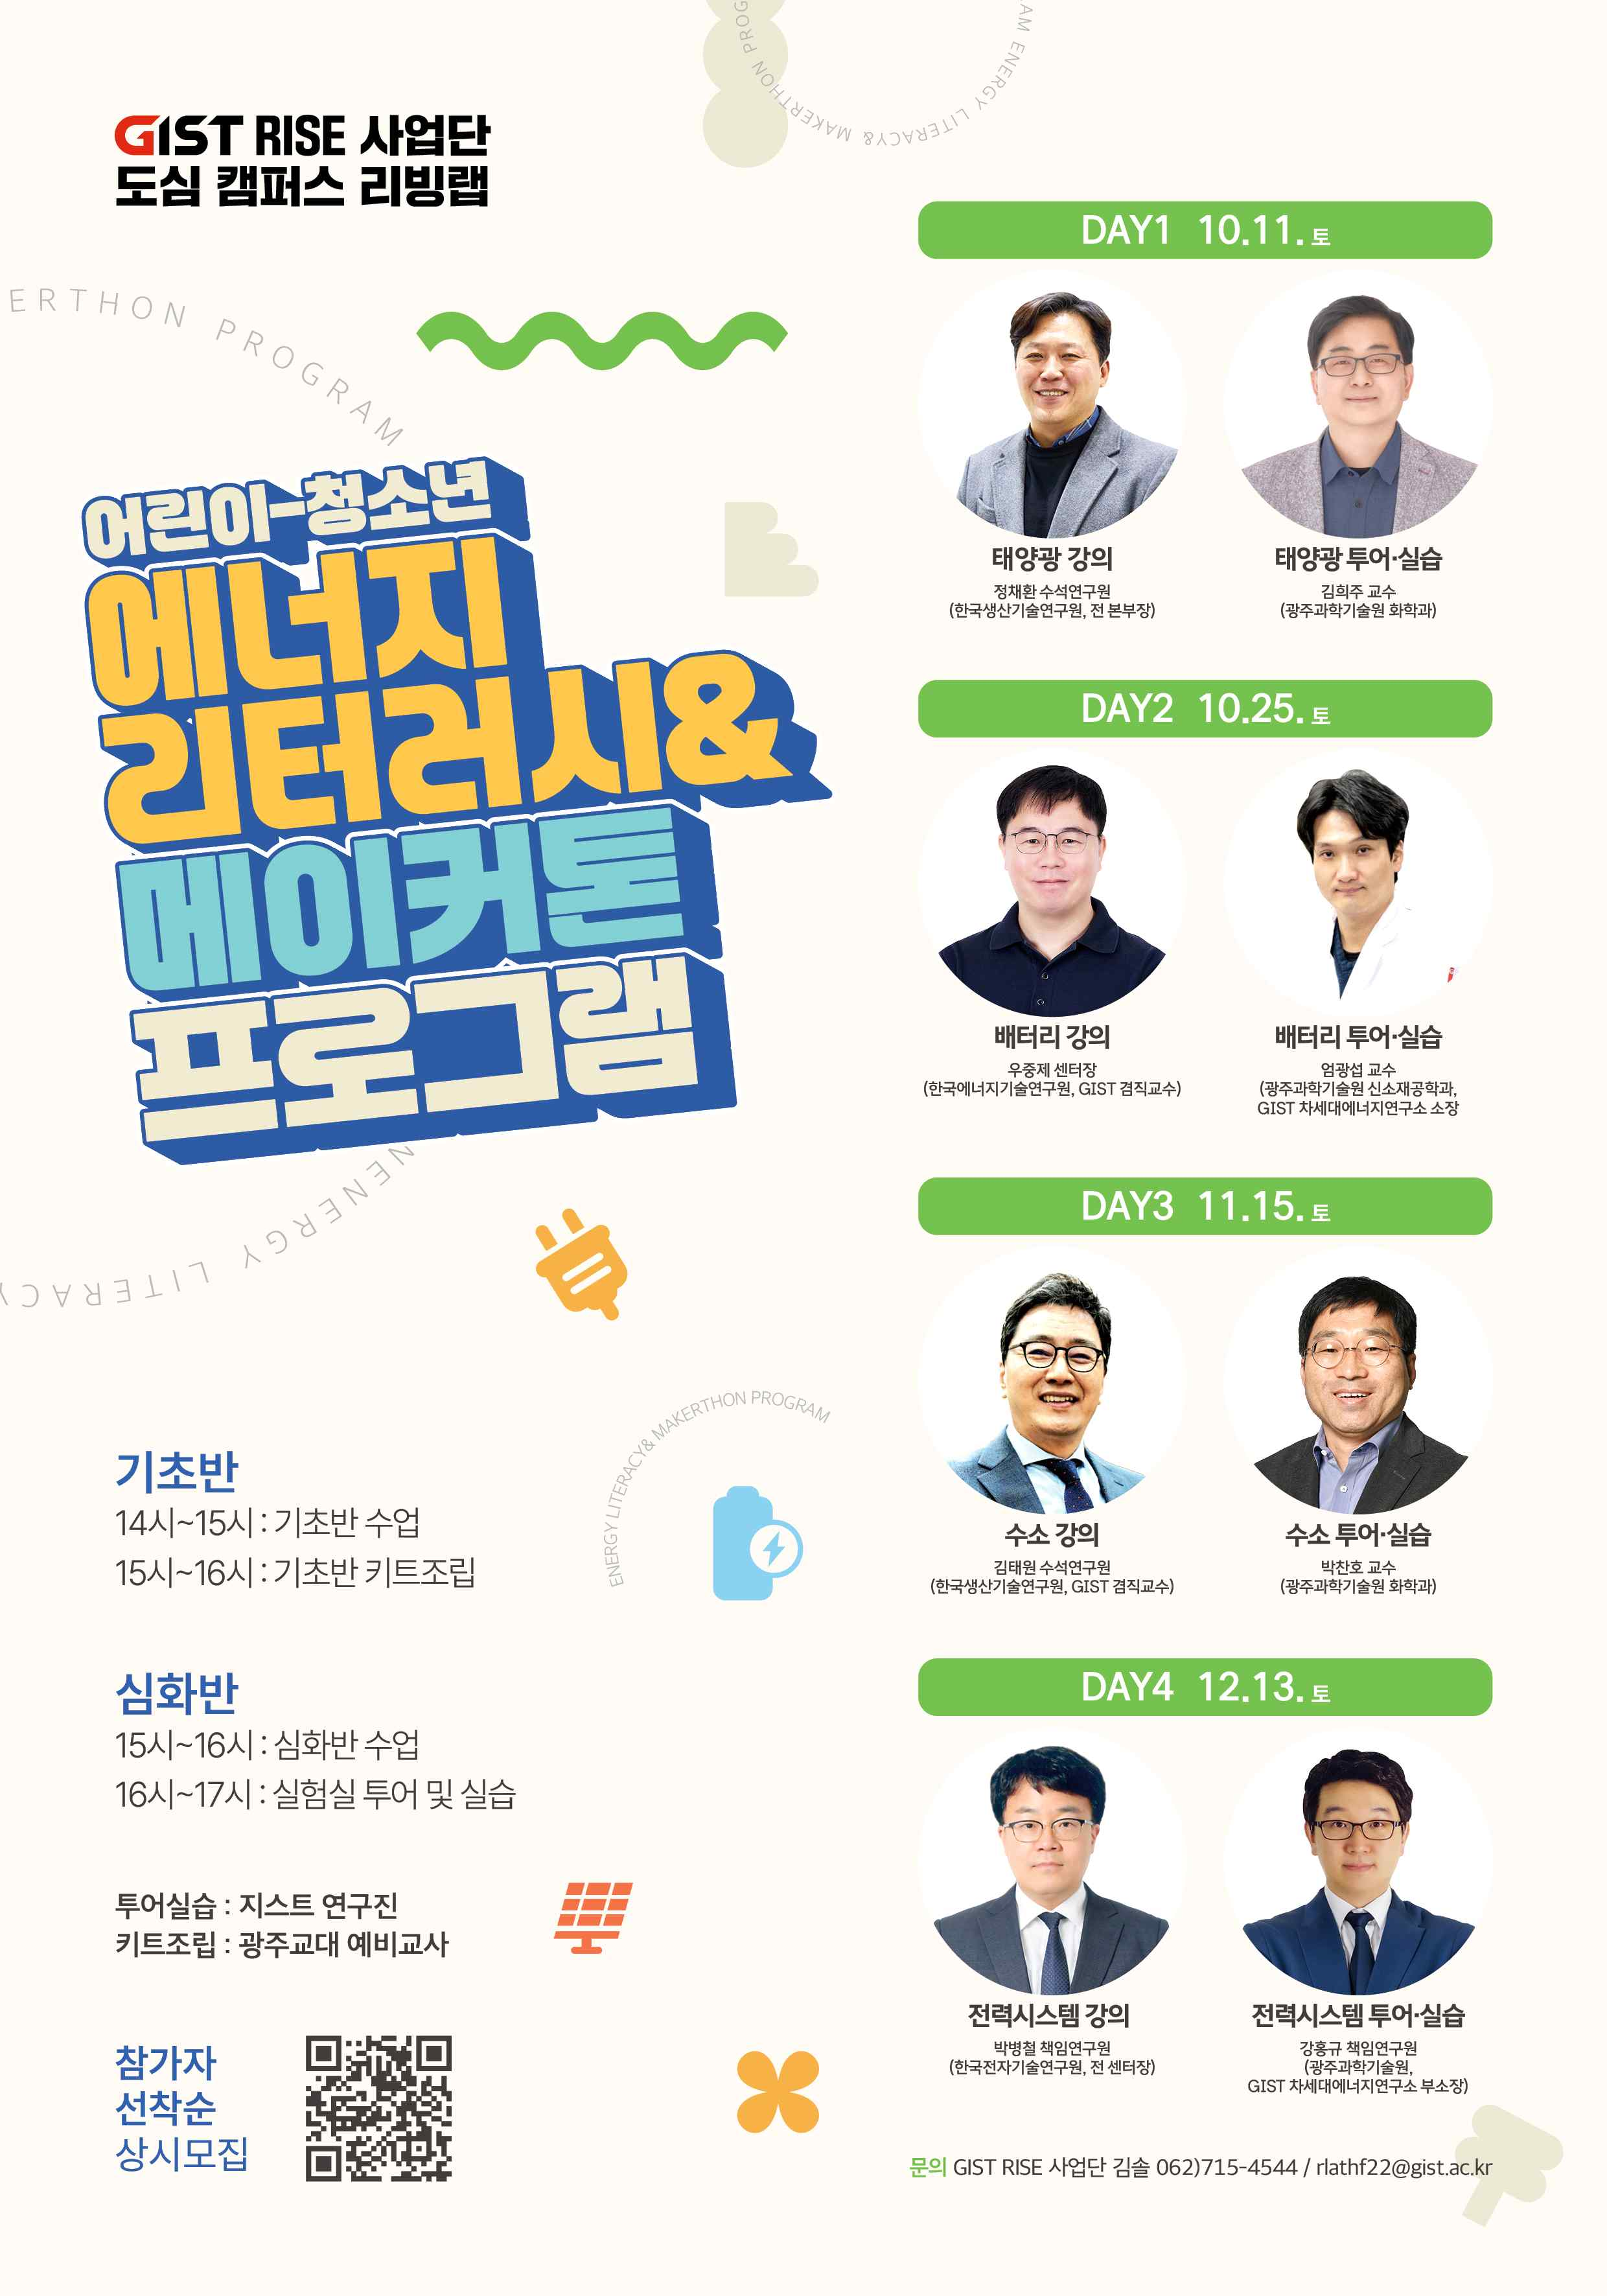

▲ A poster for the "Urban Campus Living Lab Energy Literacy Program" operated by the GIST RISE project team. It introduces the educational curriculum, which begins with solar energy and progresses through batteries, hydrogen, and power systems.



