GIST hosts the 59th Academy Breakfast Forum... former Personal Information Protection Commissioner Jong-in Yoon invited to give a lecture

- The 59th GIST Academy Breakfast Forum was held on Monday, September 29th at GIST Oryong Hall... Professor Jong-in Yoon of Ewha Womans University's Graduate School of Policy Studies was invited to give a lecture titled "The Age of Technology, Humans, and Community"

- The forum highlighted the communal values ​​and responsibilities posed by the latest technological advancements and data utilization, and discussed the roles of citizens, businesses, and the government... The forum emphasized the social impact of AI, big data, and digital transformation, as well as the need for ethical responses

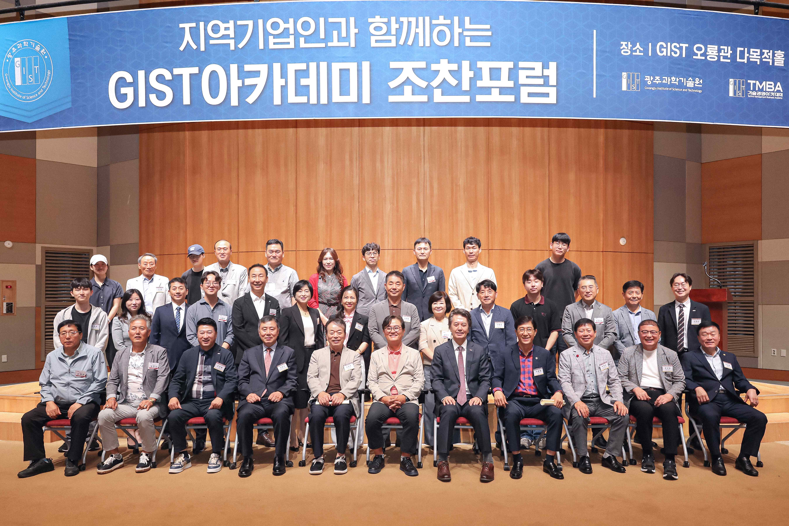

▲ GIST Academy hosted its September Breakfast Forum at Oryong Hall on Monday, September 29th, inviting Ewha Womans University's Visiting Professor Jong-in Yoon. Attendees pose for a commemorative photo.

The Gwangju Institute of Science and Technology (GIST, President Kichul Lim) announced that it held the 59th GIST Academy Breakfast Forum at Oryong Hall on Monday, September 29th.

Professor Jong-in Yoon, a visiting professor at Ewha Womans University's Graduate School of Policy and Administration (and former Chairman of the Personal Information Protection Commission), was invited as a speaker and delivered a lecture on the topic, "The Age of Technology, Humans, and Community."

Professor Jong-in Yoon, a government organization expert who entered public service in 1988, has served as the Secretary for Government Administration and Home Affairs at the Blue House, Vice Governor of South Chungcheong Province, Vice Minister of the Ministry of the Interior and Safety, and the first Chairman of the Personal Information Protection Commission. He is currently a visiting professor at Ewha Womans University's Graduate School of Policy and Administration.

In his lecture, Professor Yoon emphasized, “Technological advancements and data utilization go beyond simple convenience or efficiency improvements, and challenge all members of society to take responsibility and realize community values.” He added, “Today, data is not just a means of information; it is a core resource that drives innovation in all areas of society, economy, and politics.”

He then emphasized the impact of cutting-edge technologies such as AI, big data, and digital transformation on politics, economy, and society as a whole, and the need for mature leadership that proactively recognizes and responds to the ethical and social issues that may arise from technology.

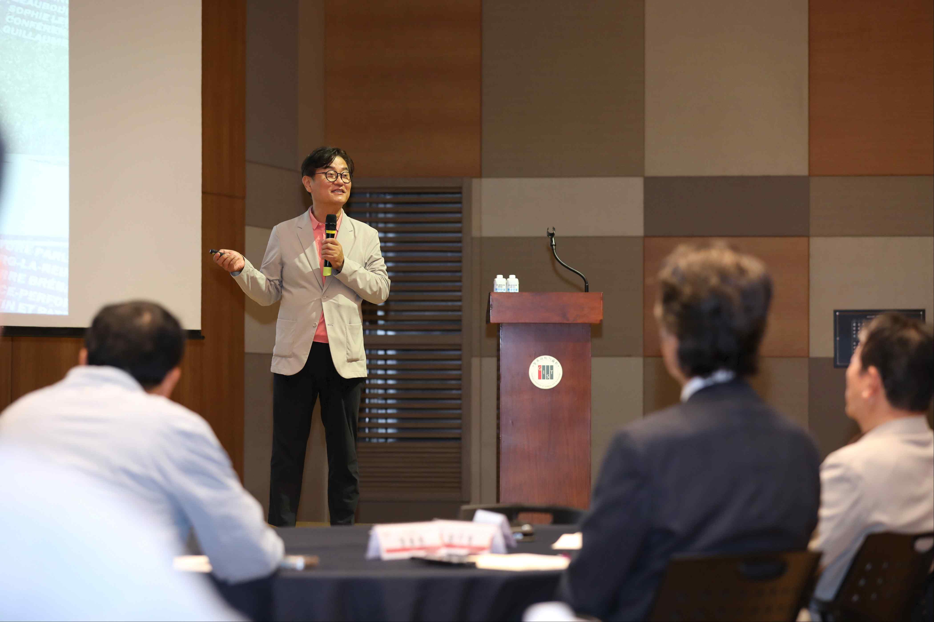

▲ Professor Jong-in Yoon of Ewha Womans University speaks on the topic "The Age of Technology, Humans, and Community" at the GIST Academy's September Breakfast Forum.

The lecture concluded with a Q&A session with attendees, discussing the importance of community values ​​and human reflection in a technology- and data-driven society.

Meanwhile, the GIST Academy, which oversees GIST's non-degree programs, operates the Techno Management Business Academy (GTMBA) as its flagship program. The Academy regularly hosts breakfast forums for local entrepreneurs and alumni, inviting experts from various fields on the last Monday of each month in March, May, June, September, and October.

The 60th Breakfast Forum will be held at 7:00 AM on Monday, October 27th in the GIST Oryong Hall Multipurpose Hall.



