"South Korea's Next-Generation Power Grid Experiment Begins in Gwangju" GIST opens 'Power Grid Research Center': Full-scale response to Korea's next-generation power grid demonstration project

- Power systems expert Professor Yun-su Kim appointed as Center Director with faculty from the Department of Electrical Engineering and Computer Science participating... Research in key areas such as distributed energy, electric vehicle charging, and energy storage systems (ESS) will be promoted, with collaboration among industry, academia, research institutes, and government agencies

- Leading the national power grid innovation as a demonstration base in the Gwangju-Jeonnam region... Policy- and industry-linked research will be promoted, including distributed energy and AI-based power grid control, microgrid demonstrations, and participation in the RE100 Industrial Complex Planning Committee

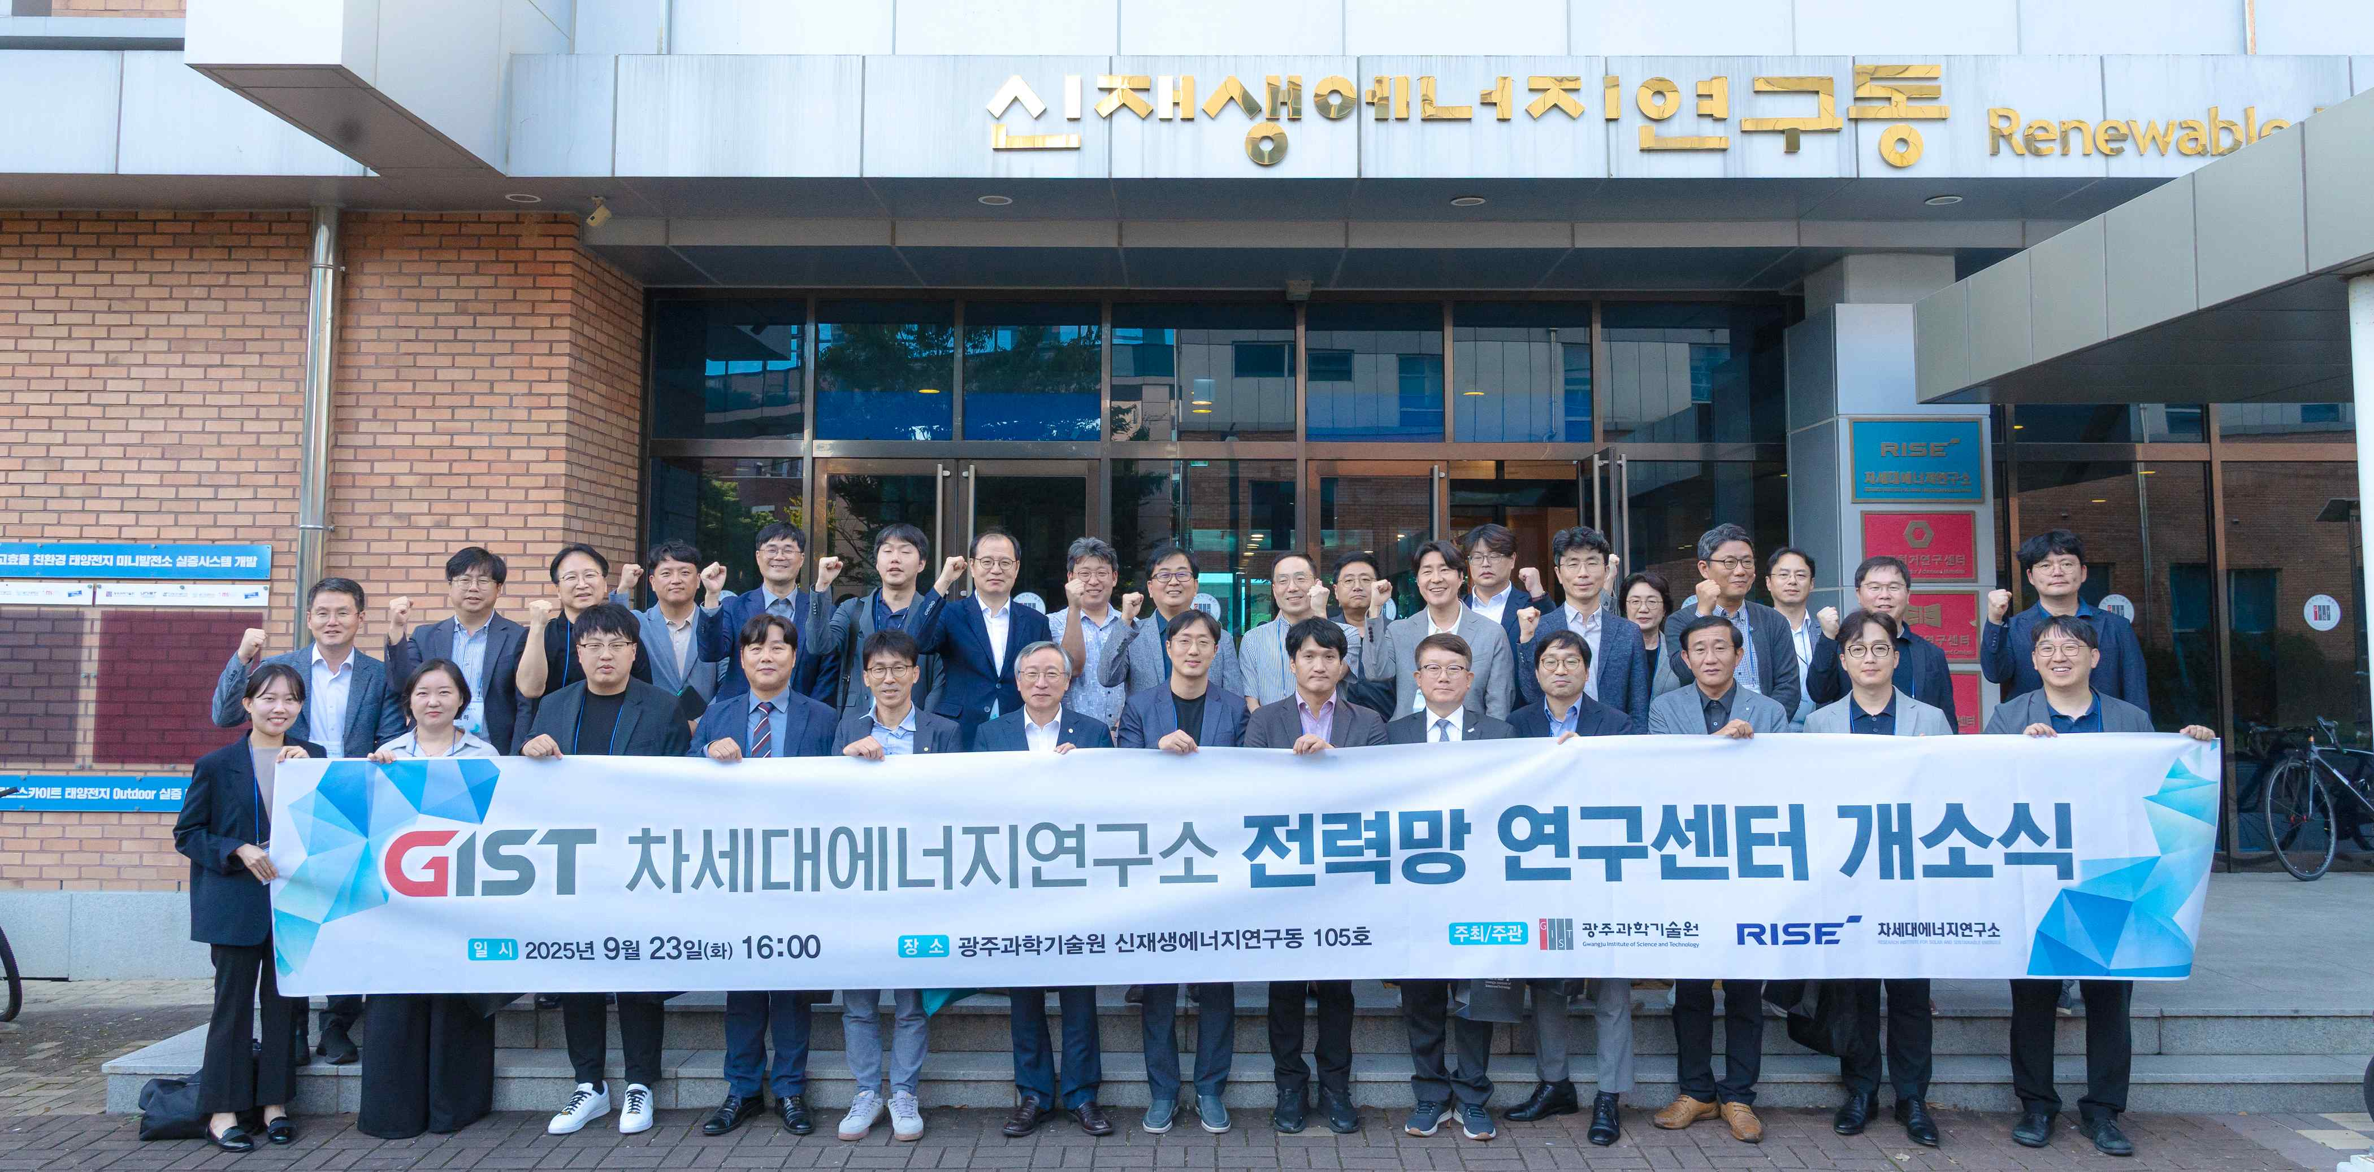

▲ Attendees pose for a commemorative photo at the opening ceremony of the GIST Power Grid Research Center.

The Gwangju Institute of Science and Technology (GIST, President Kichul Lim) announced the opening of the "Power Grid Research Center" (Director: Yun-su Kim, Department of Electrical Engineering and Computer Science professor) to lead distributed energy* and artificial intelligence (AI)-based next-generation power grid technologies and to actively respond to Korea's next-generation power grid demonstration project.

* distributed energy: Energy produced and supplied on a small scale in local or nearby areas, rather than at large-scale power plants. It includes various renewable energy sources such as solar, wind, and fuel cells, as well as energy storage systems (ESS) and virtual power plants (VPPs).

The opening ceremony was held on Tuesday, September 23rd, at the GIST Next-Generation Energy Research Center. Approximately 50 participants, including GIST faculty, local governments, research institutes, and corporate representatives, attended the event to discuss collaborative measures for next-generation power grid innovation.

The event was made even more meaningful with welcoming remarks from Director KwangSup Eom of the Research Institute for Solar and Sustainable Energies, followed by congratulatory remarks from Vice President for R&DB Yong-Chul Kim, Director Young-jip Kim of Gwangju Technopark, and Director Jun-sik Park of the Energy Industry Division of Gwangju Metropolitan City. Center Director Yun-su Kim then introduced the center's founding principles and GIST's next-generation power grid research capabilities, and announced the direction of research and demonstration efforts linked to national demonstration projects.

In particular, representatives from key organizations across industry, academia, research, and government participated, discussing a collaborative ecosystem that combines policy, technology, and industry, and establishing an opportunity to build a networking platform for next-generation power grid innovation.

* Approximately 20 organizations, including participating faculty from the Power Grid Research Center, Gwangju Metropolitan City, Gwangju Free Economic Zone Authority, Gwangju Climate Energy Promotion Agency, Gwangju Regional Industry Promotion Agency, Gwangju Technopark, AI Industry Convergence Business Group, KEPCO KDN, Korea Electric Power Corporation, Korea Power Exchange, Korea Energy Agency, Honam University, Chonnam National University, Korea Photonics Technology Institute, Korea Electronics Technology Institute, Electronics and Telecommunications Research Institute, Korea Electrotechnology Research Institute, Korea Institute of Energy Research, Korea Automotive Research Institute, and Gwangju Research Institute.

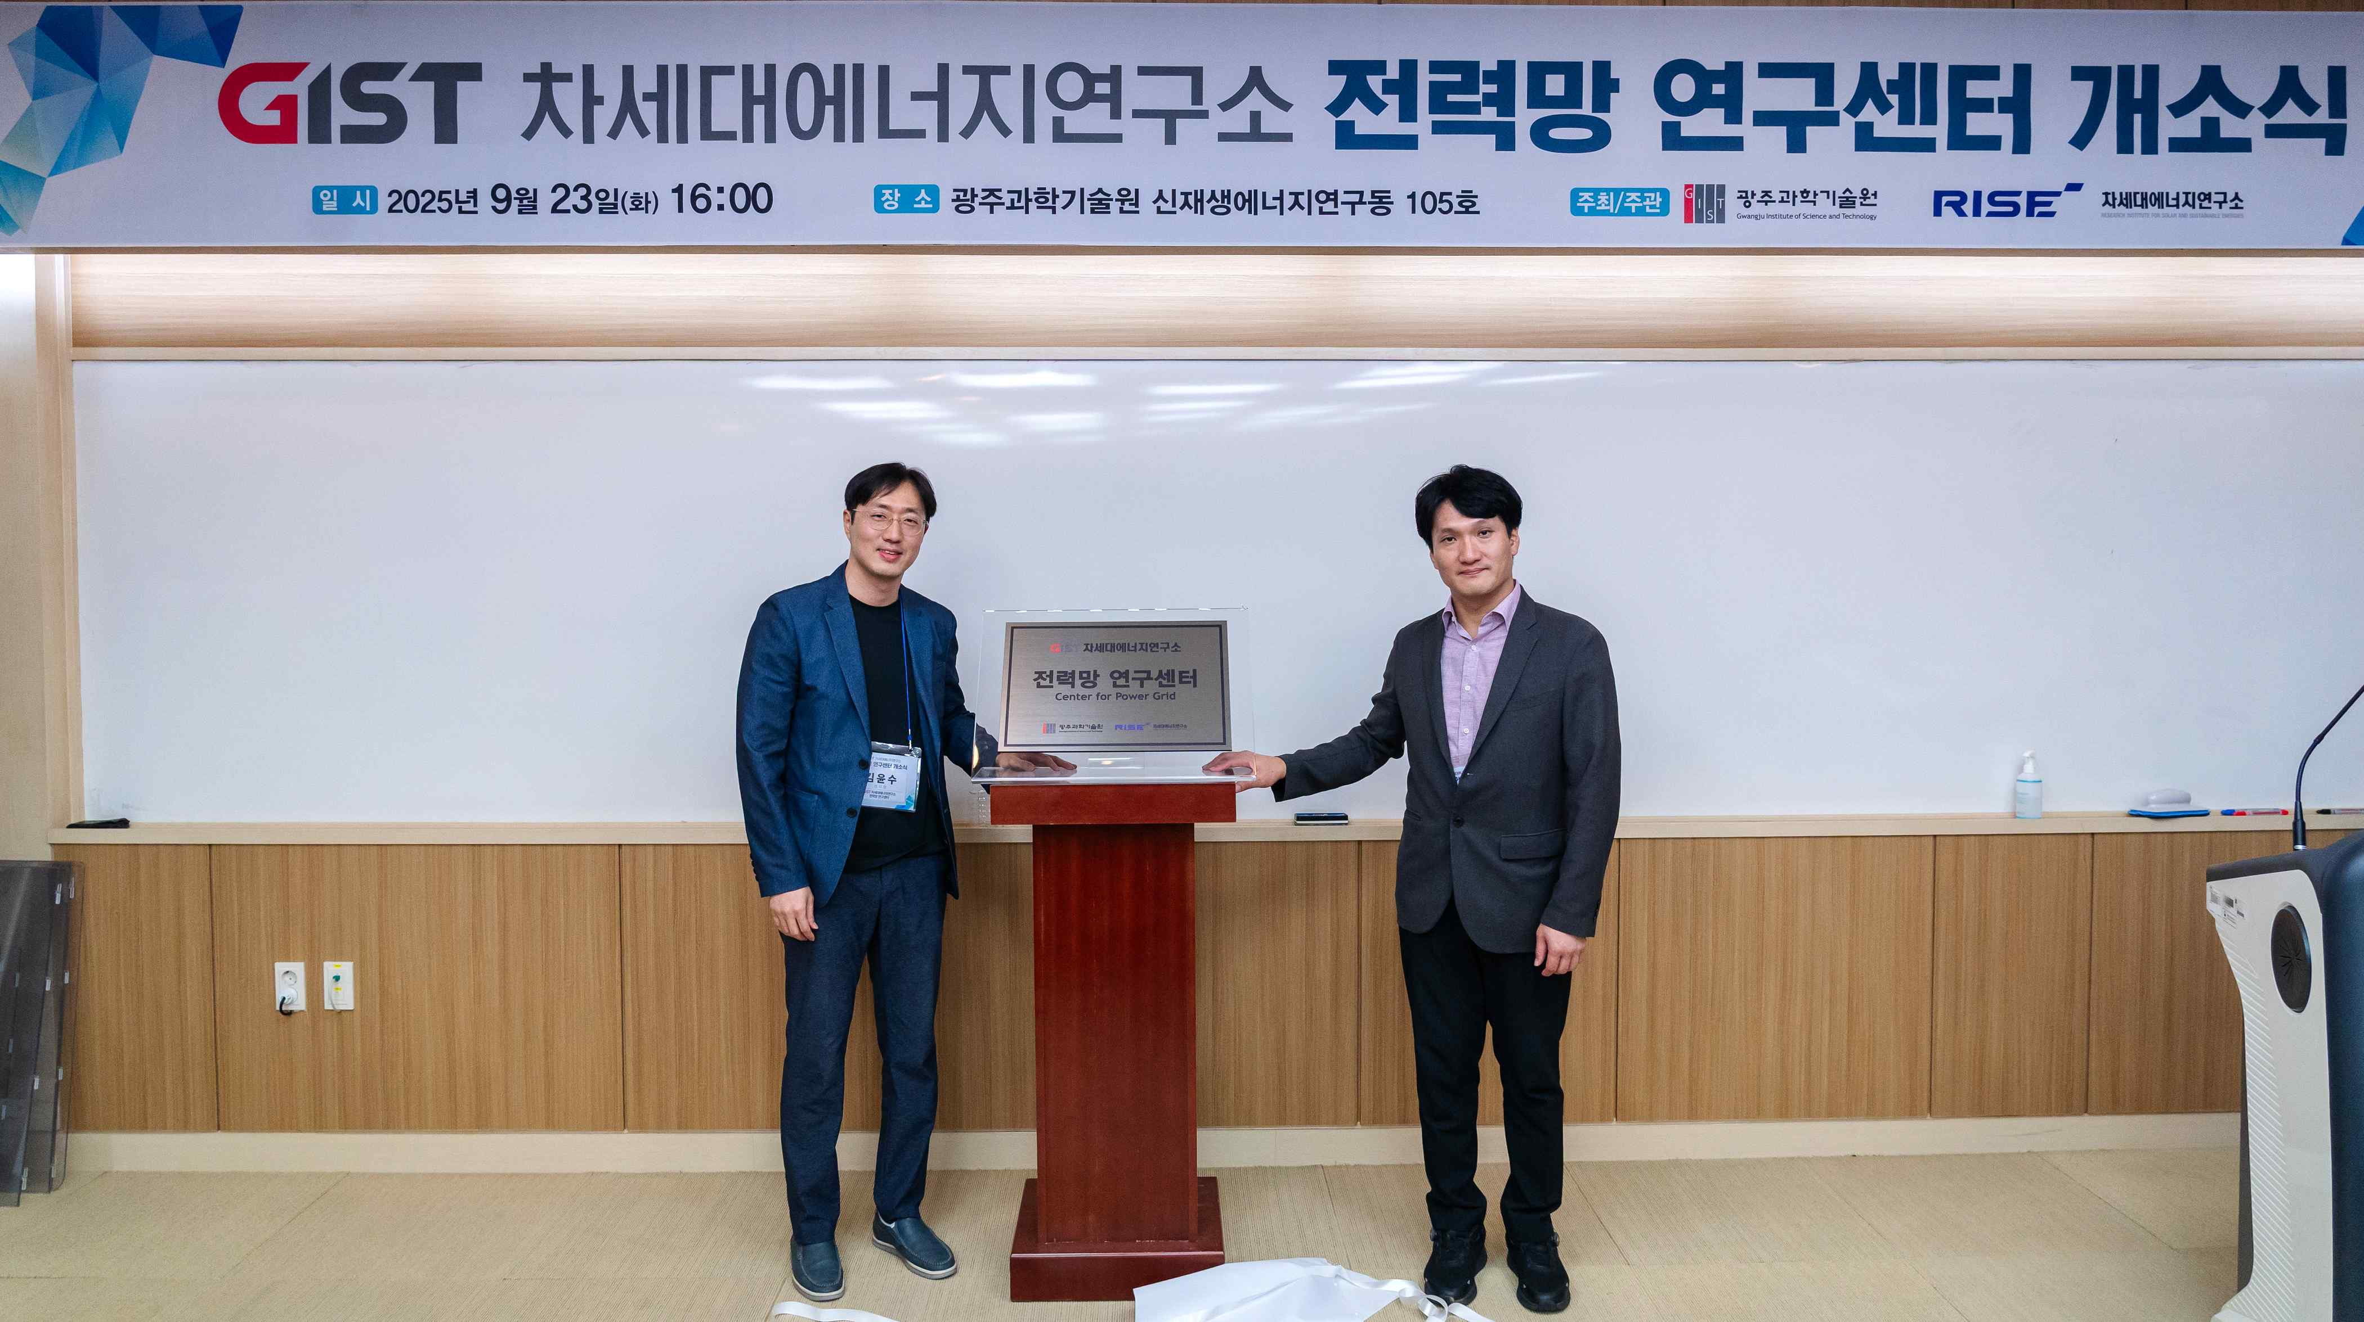

▲ Unveiling the signboard at the opening ceremony of the GIST Power Grid Research Center. (From left) Yun-su Kim, Director of the Power Grid Research Center, and Director KwangSup Eom of the Research Institute for Solar and Sustainable Energies.

The Power Grid Research Center focuses on research in key areas of next-generation power grids, including distributed energy, electric vehicle charging, and energy storage systems (ESS). In conjunction with the Ministry of Trade, Industry and Energy's "Building a Next-Generation Korean Power Grid" project, the center will utilize the Gwangju-Jeonnam region as a demonstration base and spearhead national power grid innovation and the development of specialized talent.

The center will include professors from the Department of Electrical Engineering and Computer Science at GIST, including Professor Yun-Su Kim (Center Director, Power Grid Operations and Control), Professor Jinho Kim (Virtual Power Generation and Power Markets), Professor Yongsoon Park (Next-Generation Inverters and ESS), Professor Chun T. Rim (Electric Vehicle Charging and Wireless Power Transmission), and Professor Euiseok Hwang (Energy Informatics and Cybersecurity). They will conduct multifaceted research, including AI and data-based power grid control, demonstration of microgrids linked to campuses and industrial complexes, and the establishment of a collaborative system among industry, academia, research institutes, and government.

Director Yun-Su Kim said, “The Next Generation Power Grid Research Center will serve as a key base for expanding national distributed energy and innovating the power grid. It will establish a model for cooperation among industry, academia, research, and government, and play a pivotal role in innovating the national power grid by linking it with the Ministry of Trade, Industry and Energy’s demonstration project based in the Gwangju and Jeonnam regions.” He added, “We will lead the construction of the next-generation power grid in Korea by integrating GIST’s capabilities in power systems, power electronics, AI, and big data.”

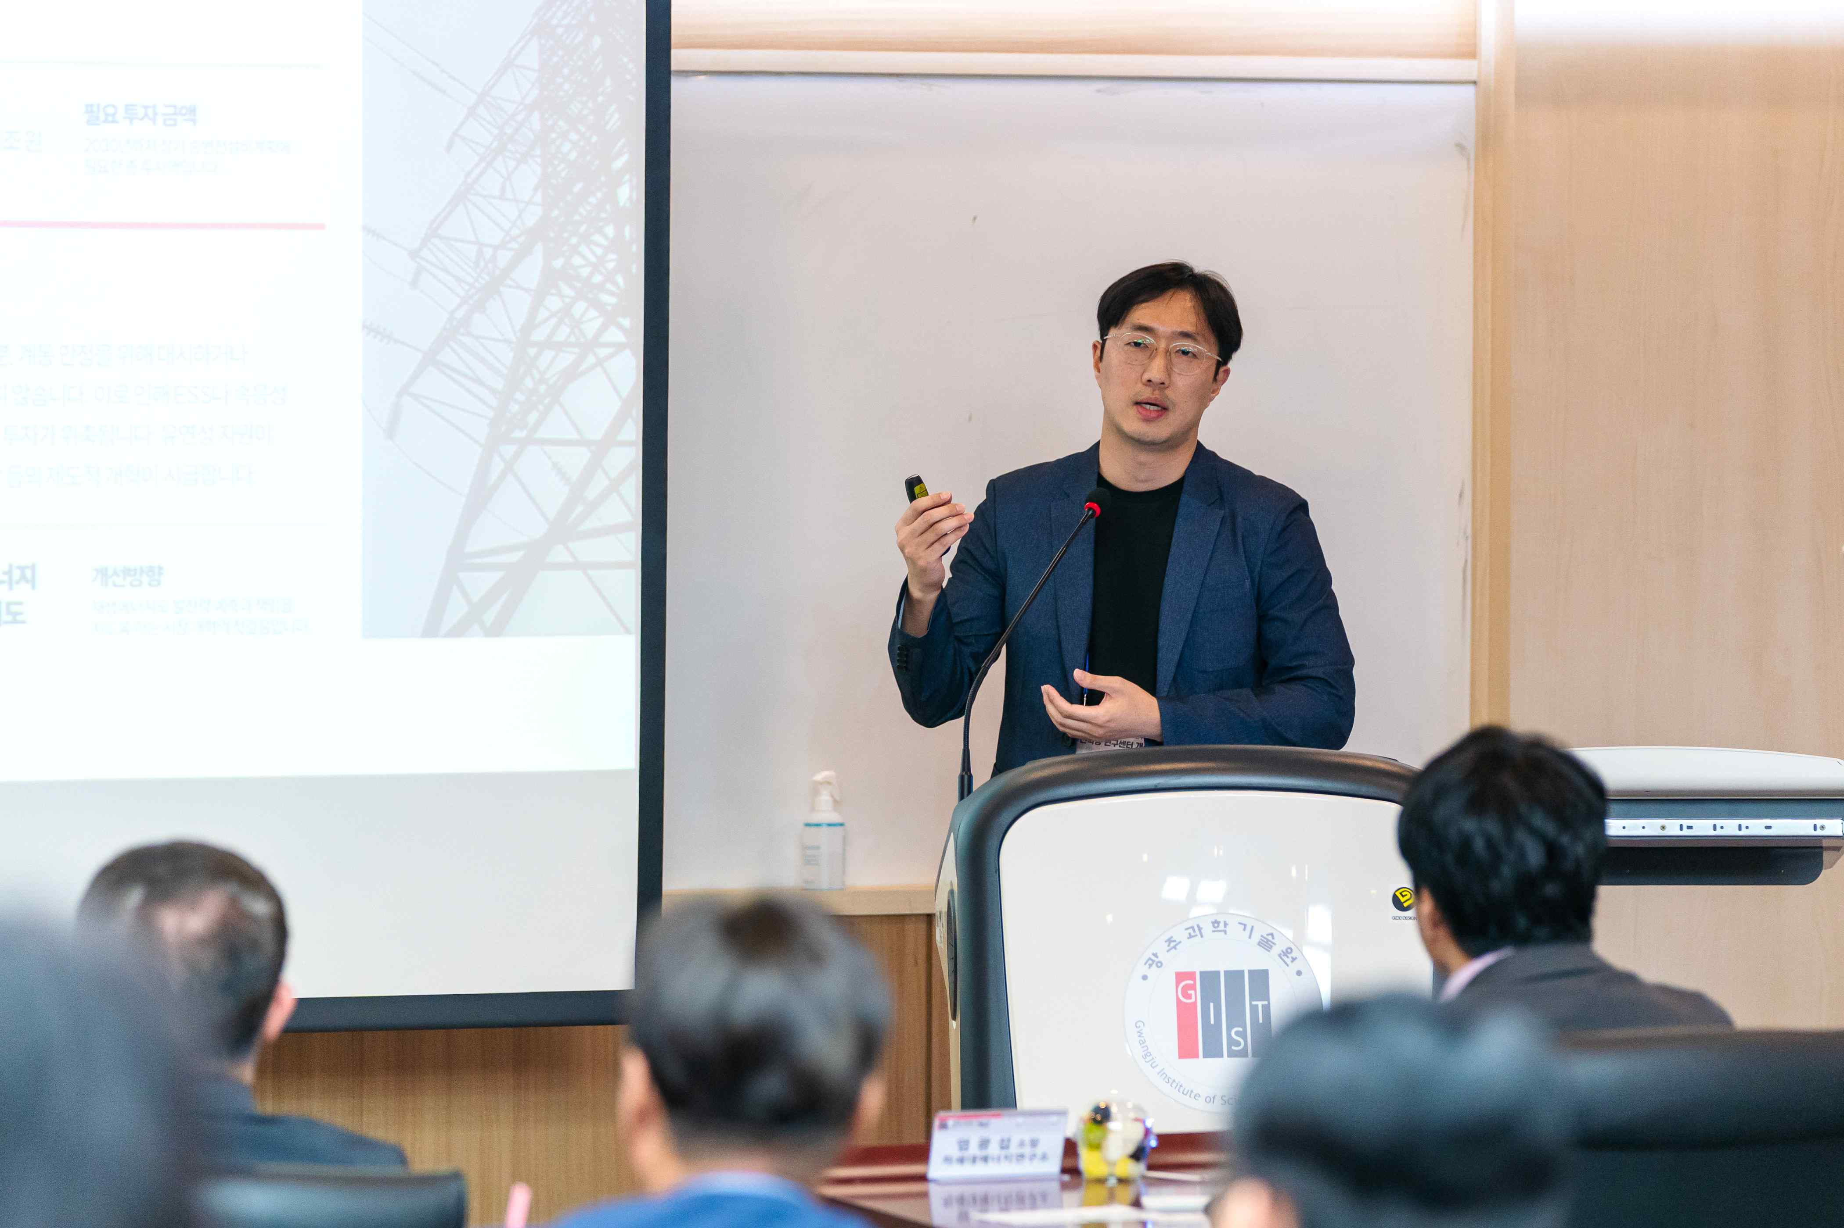

▲ Director Yun-Su Kim of the Power Grid Research Center introduces the center's vision and demonstration plans to attendees at the opening ceremony.

Director Kim received his Ph.D. in Electrical and Computer Engineering from Seoul National University and served as a senior researcher at the Korea Electrotechnology Research Institute (KERI) before joining GIST in 2018. He currently serves as an editorial board member of the IEEE Transactions on Sustainable Energy (TSTE), a world-renowned journal in the field of renewable energy, and as a member of the Ministry of Trade, Industry and Energy's Next-Generation Power Grid Promotion Team, bridging domestic and international research and policy.

With the opening of the Power Grid Research Center, GIST plans to invite domestic and international experts to discuss joint research and collaboration in the second half of this year, establish a demonstration site on campus, and participate in the planning committee for a regional 100% renewable energy (RE100) industrial complex. Through these initiatives, GIST aims to actively promote next-generation power grid innovation and RE100 policy implementation, focusing on the Gwangju and Jeonnam regions, and to leap forward as a national hub for future power grid research.



