"Supporting the growth and settlement of foreign researchers" GIST participates in the 'Science and Engineering Career Exploration Program' to support the career development of international graduate students

- As part of the "Full-Cycle Settlement Support Project for Overseas Researchers," hosted by the Korea Institute for Human Resources Development in Science and Technology (KIRD), the event was held in Gwangju on September 19-20... International master's and doctoral students and graduates from the four major science and technology research institutes attended

- Practical support programs are being implemented, including career exploration, job skills enhancement, and network building... Amidst the global competition for talent, this program, in conjunction with government policies, is expected to expand the domestic base for international researchers

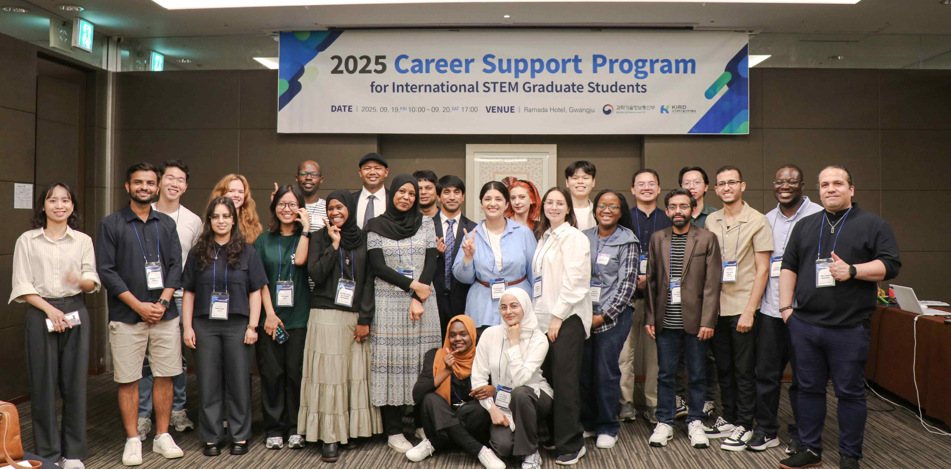

▲ International students who attended the science and engineering career exploration course held at the Ramada Hotel in Gwangju on Friday, September 19th and Saturday, September 20th, are taking a commemorative photo.

The Gwangju Institute of Science and Technology (GIST, President Kichul Lim) announced that it participated as a partner organization in the Gwangju-Jeolla region in the "International Graduate Student Science and Engineering Career Exploration Program," held at the Gwangju Ramada Hotel on September 19th (Friday) and 20th (Saturday) to support the career development and growth of international graduate students in domestic research and development (R&D) fields.

This program, organized as part of the "Full-Cycle Settlement Support Program for Overseas Researchers" by the Korea Institute for Human Resources Development in Science and Technology (KIRD), was attended by international master's and doctoral students and graduates from the four major science and technology research institutes (KAIST, GIST, UNIST, DGIST) and UST.

This year's program was divided into three regions: Daejeon and Chungcheong, Daegu and Gyeongsang, and Gwangju and Jeolla, to ensure practical support tailored to the research environments and characteristics of each region. This regionalization provided opportunities for more international researchers to participate.

In particular, as securing advanced scientific and technological talent has emerged as a key factor in national competitiveness, this program is expected to contribute to expanding the domestic activity base of foreign researchers in line with the government's talent attraction and settlement policy.

The program was designed to provide practical assistance to international researchers, including career exploration, job skills enhancement, networking, and one-on-one personalized consulting.

In particular, Dr. Nayan Chandra Das, a 2022 graduate of the Department of Electrical Engineering and Computer Science at GIST who is currently employed at Samsung Electronics, participated as a speaker and shared his successful employment story, drawing significant attention. Drawing on his experience and expertise in the domestic R&D field, he offered practical and helpful advice to junior researchers, drawing a positive response from the participants.

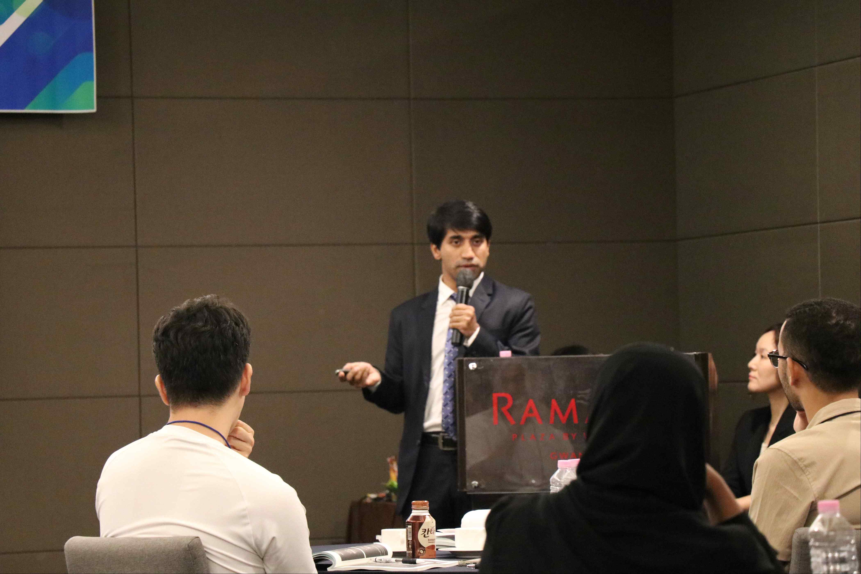

▲ Dr. Nayan Chandra Das, a graduate of the Department of Electrical Engineering and Computer Science at GIST who is currently employed at Samsung Electronics, is sharing his successful employment story as a speaker.

GIST President Kichul Lim, who attended the event, said, “This career exploration program is a valuable opportunity for foreign researchers to effectively demonstrate their expertise in the research field and society,” and added, “GIST will be a strong sponsor and support you until the end so that you can play an important role not only in Korea but also on the global R&D stage.”



