"Now is the time to calm your weary mind." GIST College of Engineering launches mindfulness gardening program to help students recover emotionally

- GIST College of Engineering held a mindfulness gardening program to commemorate its first year of operation... A lecture by Oe-sook Kim, CEO of the Healing Forest Social Cooperative, and a gardening experience were held to help undergraduate and graduate students reinterpret stress and reflect on themselves

- Growing companion plants allowed students to share healing and connection experiences, relieve the stress of academic and research fatigue, and connect with colleagues... "We will continue to expand support programs for academic and emotional growth."

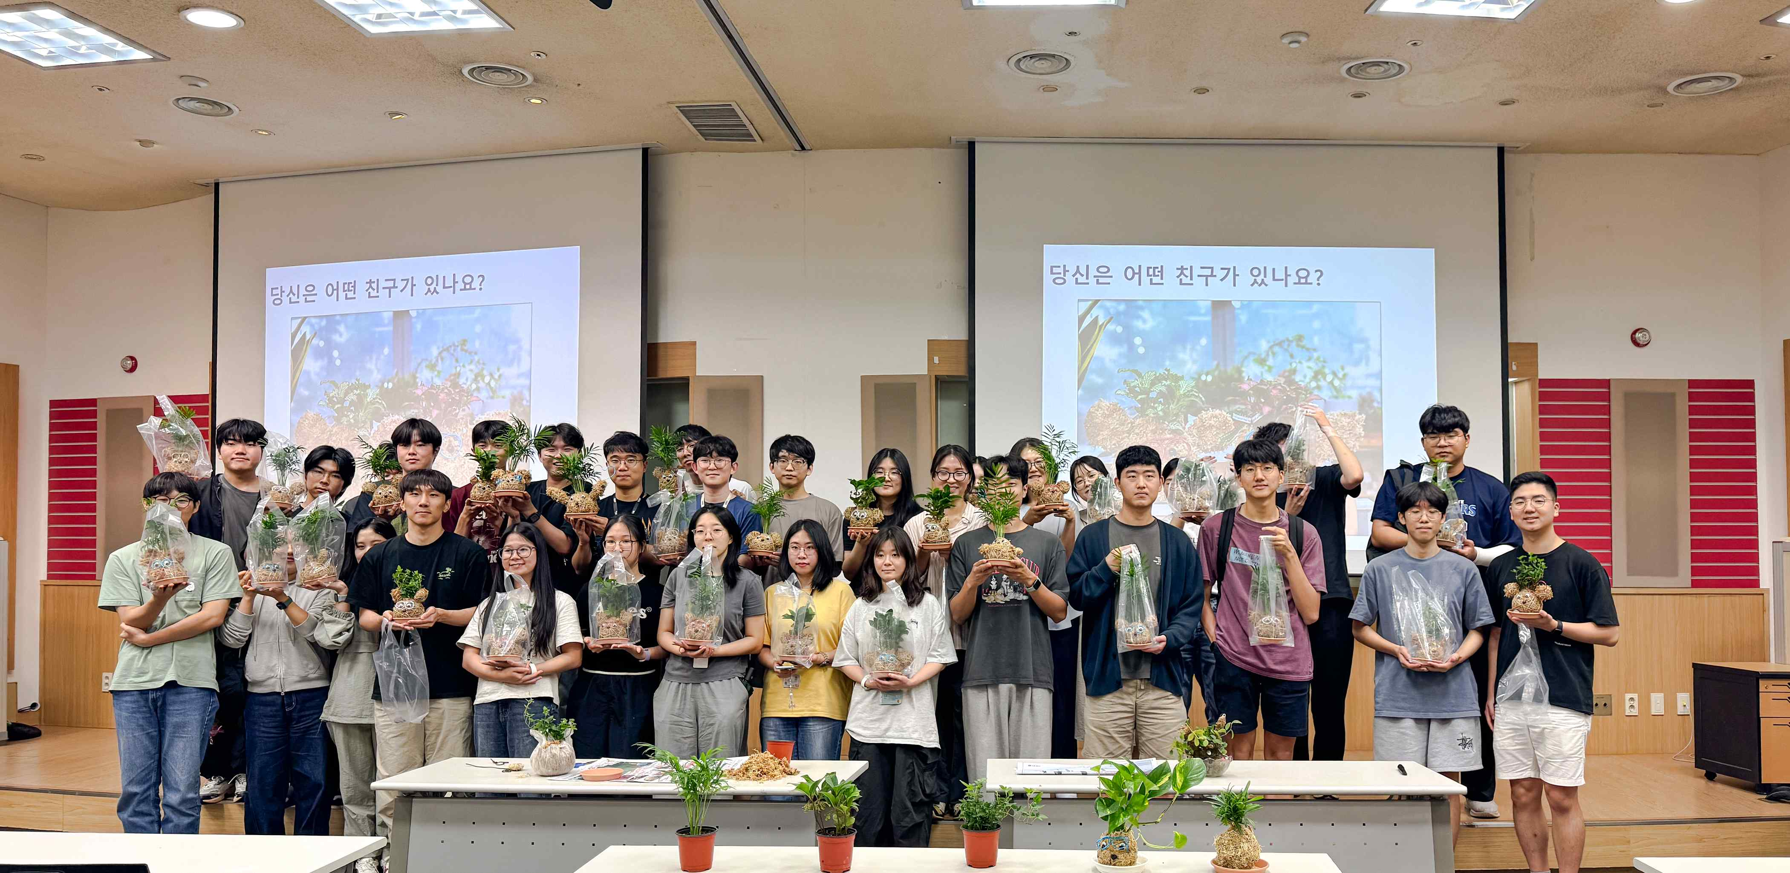

▲ Students participating in the GIST College of Engineering's mindfulness gardening program are taking a commemorative photo holding the topiaries they created themselves.

The Gwangju Institute of Science and Technology (GIST, President Kichul Lim) announced that it successfully held "Time to Grow Myself Like a Plant," a mindful gardening program for undergraduate and graduate students of the College of Engineering, at Oryong Hall on Tuesday, September 16th.

This program, designed to commemorate the inaugural year of the newly reorganized College of Engineering, aimed to alleviate the stress students experience during their studies and research and promote psychological recovery.

The event began with a lecture by Oe-sook Kim, CEO of the Healing Forest Social Cooperative. Through stories of plant survival and growth, Kim encouraged students to view stress from a new perspective and engage in self-reflection.

Following the gardening experience, participants cultivated companion plants and shared experiences of healing and reflection.

Approximately 70 undergraduate and graduate students participated in the event.

One student said, "I was able to find peace and solace in the midst of the repetitive daily routine and somewhat dry school life." He added, "Growing plants gave me a chance to reflect on myself and catch my breath, which was a huge help."

Another student expressed satisfaction, saying, "Although it was a short time, connecting with the plants allowed me to smile for the first time in a long time." A graduate student added, "It helped me clear my mind of the exhaustion from experiments and research, and it also provided an opportunity to connect with my colleagues."

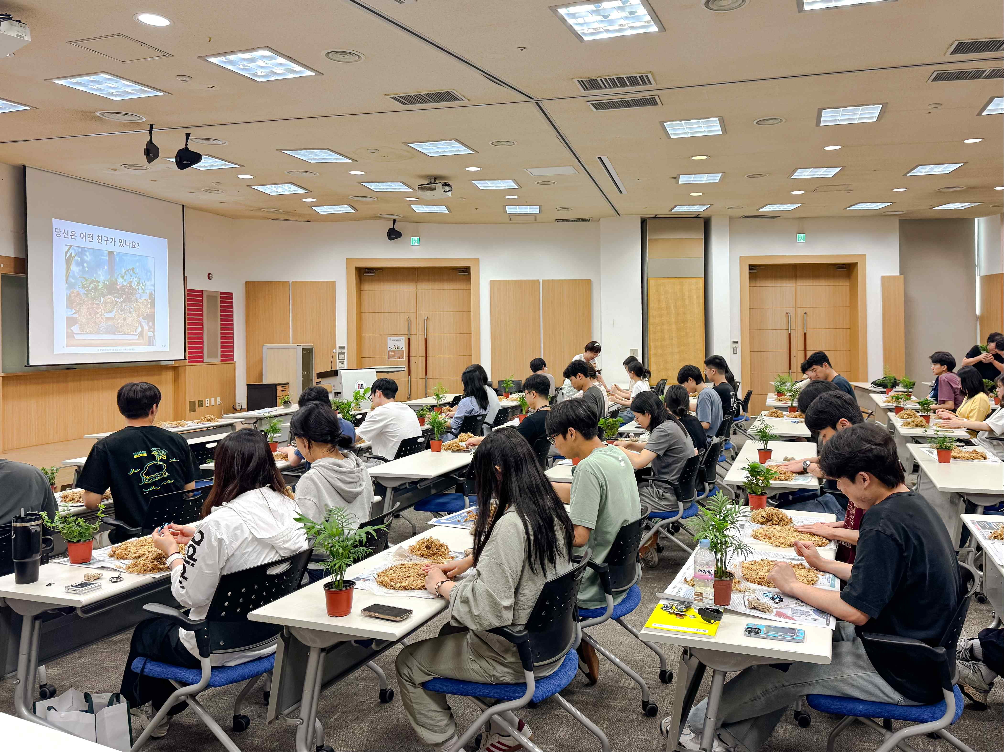

▲ Students in the mindfulness gardening program engage in a time of healing and reflection while creating companion plants.

Dean Ji-Woong Park of the College of Engineering stated, "This program was a meaningful opportunity for students to reflect and grow together." He added, "We will continue to expand our diverse support programs to help students achieve not only academic growth but also emotional recovery and balance."



