GIST and Samsung Electronics are recruiting industry-academic scholarship students for the fall 2025 semester through their "Intelligent Motor Track"

- Up to 15 master's degree program students will be selected annually for the Industry-Academic Scholarship program, which provides tuition and living expenses... Applications will be accepted until September 5th and this program will be linked to Samsung Electronics' DA Division recruitment, fostering specialized technical talent and strengthening global capabilities

- Enhance your competitiveness in the industrial field through a broad range of global field experience, including a six-week internship with Samsung Electronics' DA Division during the vacation period, participation in prominent domestic and international academic conferences, and visits to overseas research centers and partner companies

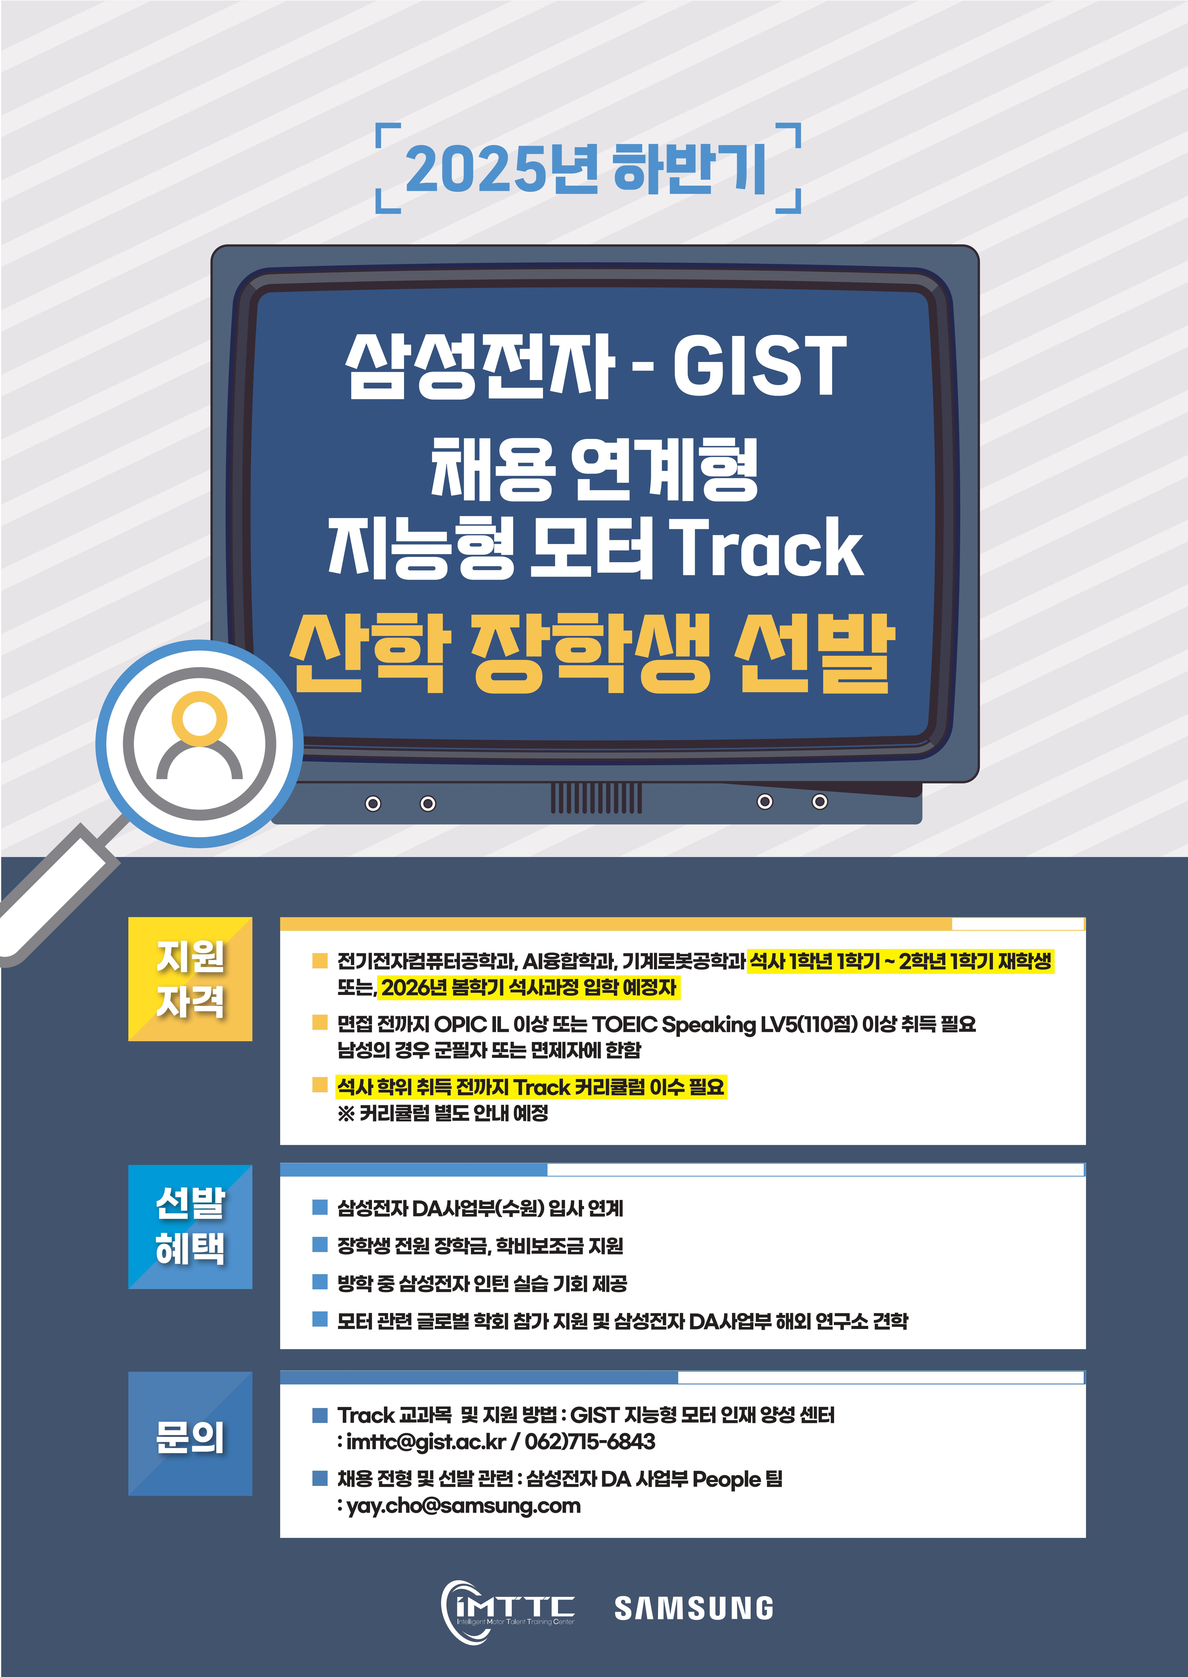

▲ 2025 Fall Semester Intelligent Motor Track Selection Promotion Poster

The Gwangju Institute of Science and Technology (GIST, President Kichul Lim) announced that it is recruiting new students for the 2025 Fall semester for its "Intelligent Motor Track," which operates in conjunction with Samsung Electronics' Digital Assistant (DA) Division recruitment program. Up to 15 students will be selected annually, all of whom will receive industry-academic scholarships.

Applications for this fall semester's Industry-Academic Scholarship program will be accepted from August 25 to September 5, with detailed application forms available from September 5 to 12. Various programs, including ▴ information sessions, ▴ lunch talks, ▴ tech forums, and ▴ "Samsung Motor Day," will be held during the selection process.

Eligible applicants must be first-year or first-semester master's students in the Department of Electrical Engineering and Computer Science, the Department of AI Convergence, or the Department of Mechanical and Robotics Engineering at GIST, or those expected to enroll in the spring semester of 2026.

Applicants must have an OPIC IL or higher or a TOEIC Speaking Level 5 (110 points) or higher before the interview. Male applicants must have completed or been exempted from military service. Selected students must complete the Intelligent Motor Track curriculum before earning their master's degree.

Students receiving the Industry-Academic Scholarship will receive a scholarship equivalent to tuition and a living allowance. They will also be eligible to participate in a one-time, six-week internship with Samsung Electronics' Digital Assistant Business Division during the summer and winter breaks before graduation. Students will also gain diverse global experience through participation in prestigious domestic and international academic conferences and visits to overseas research centers and partner companies.

This summer, students visited Samsung Electronics' research center and partner companies in Osaka, Japan, sharing the latest technological trends and expanding their global industry network.

Furthermore, a "Motor Boot Camp" will be held during the break to foster student interest and capabilities in the motor field. Tech forums and field trips, including visits to Samsung Electronics' Suwon and Gwangju plants, will also be offered.

The Industry-Academic Scholarship program is selected twice a year, in the spring and fall semesters, and operates separately from Samsung Electronics' open recruitment process. Applications for both the open recruitment and the Intelligent Motor Talent Development Center are not permitted.

Professor Pilwon Hur of the Department of Mechanical and Robotics Engineering, who serves as the Director of the Intelligent Motor Talent Development Center, stated, "The Intelligent Motor Track is a program designed to cultivate GIST's outstanding talent into competitive experts in the industrial field. We will actively support students in their growth into key players in the motor field."

Meanwhile, GIST has been operating the "Intelligent Motor Track" for master's degree students since April 2023 to cultivate experts in the field of intelligent motors, with the first graduating class graduating in February 2024.

This track integrates related majors such as mechanical engineering, electrical and computer engineering, and artificial intelligence (AI), requiring students to earn 15 credits in the fields of control, signal processing, design, convergence, and AI. In particular, the integrated project course, in which Samsung Electronics executives directly participate, is highly acclaimed by students and contributes to enhancing their practical skills.

Indeed, In-chan Ryu, the first graduate, achieved outstanding research results based on his experience completing the Intelligent Motor Track and joined Samsung Electronics to continue his career.

He stated, "The track program provided a crucial opportunity for me to strengthen my professional capabilities and grow."



