GIST Professor Kangwook Kim publishes "Measurement Uncertainty in Radio Waves: Theory and Practice," a "radio wave measurement guide" for the 5G and 6G era

- Co-authored by Professor Kangwook Kim of the Department of Electrical Engineering and Computer Science at GIST and Researcher Jeong-gyu Park of the National Radio Research Agency, this systematic "Radio Measurement Uncertainty Guide" by a team of Korean researchers reflects international standards and the latest communications environments

- Containing a comprehensive overview of domestic and international research trends and equipment operation experience, this customized guide is expected to provide practical assistance to measurement and certification professionals seeking to enhance radio measurement reliability in the 5G and 6G era

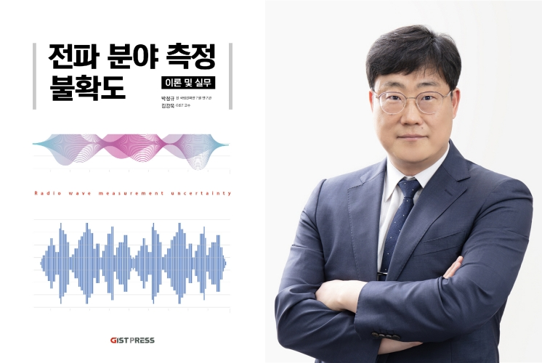

▲ Professor Kangwook Kim of GIST, author of "Measurement Uncertainty in the Radio Field: Theory and Practice"

A comprehensive book on "Measurement Uncertainty," a crucial topic in the fields of electromagnetic wave measurement, testing, and certification, is being published.

The Gwangju Institute of Science and Technology (GIST, President Kichul Lim) announced the publication of "Measurement Uncertainty in the Radio Waves: Theory and Practice," co-authored by Professor Kangwook Kim of the Department of Electrical Engineering and Computer Science and Jeong-gyu Park, a researcher at the National Radio Research Agency, through GIST Press, the university's publishing arm, on Friday, August 29th.

Measurement uncertainty is a key criterion for assessing the reliability of test and measurement results.

When performing a measurement and reporting the results, measurement uncertainty serves as the basis for assessing the reliability of the results.

Therefore, practitioners and technical managers in the radio field must thoroughly understand testing and measurement procedures. Combining this understanding with statistical and mathematical theory will enable more precise calculations of measurement uncertainty.

This book is structured step-by-step: basic concepts of measurement uncertainty in the radio field → statistical and mathematical foundations → practical application procedures.

The first part outlines the basic concepts of measurement and measurement uncertainty, as well as the statistical and mathematical foundations necessary for analysis. It then introduces the procedures and key concepts for calculating measurement uncertainty in radio testing and measurement, and presents practical application methods through various practical examples.

Furthermore, based on the internationally recognized Guidelines (GUM)* of the International Bureau of Weights and Measures (BIPM), this book provides a comprehensive understanding of electromagnetic measurement and certification technologies and international standards required in the latest 5G and 6G communication environments. By incorporating domestic and international research trends and actual equipment operation experience, this guide is expected to be a practical guide for researchers, engineers, and testing laboratory personnel alike.

It also includes measurement approaches linked to international standards such as IEC, CISPR, and 3GPP*, as well as measurement uncertainty calculation techniques specialized in the electromagnetic field. In particular, it covers measurement uncertainty evaluation methods in 5G/6G microwave band test environments and various practical cases, so that they can be immediately applied in testing labs.

* Bureau International des Poids et Mesures (BIPM): This international organization unifies and manages units and measurement standards used worldwide. Founded in 1875 with the signing of the Meter Convention, BIPM manages SI base units such as the meter, kilogram, and second, develops and verifies international measurement standards, and collaborates with national standards organizations to support accurate measurements and inter comparisons.

* Guide to the Expression of Uncertainty in Measurement (GUM): This international guideline provides a systematic assessment and consistent expression of uncertainty in measurement results. It provides definitions and types of uncertainty, assessment methods, and methods for reporting and synthesizing results. It is an essential standard for ensuring the reliability and comparability of measurements in scientific and engineering fields such as experimentation, testing, and certification.

* IEC (International Electrotechnical Commission): An organization that develops international standards in electrical and electronic technology. / CISPR (International Special Committee on Radio Interference): A committee under the IEC responsible for standards related to electromagnetic interference (EMI). / 3GPP (3rd Generation Partnership Project): An international project that develops and manages global standards for mobile communication technologies (3G, 4G, 5G, etc.) to ensure interoperability between networks and terminals.

Professor Kangwook Kim, who received his Ph.D. in Electrical and Computer Engineering from the Georgia Institute of Technology, joined GIST in 2006 and has been teaching and researching in the Department of Mechanical and Robotics Engineering and the Department of Electrical Engineering and Computer Science. He currently serves as Dean of the College of Information and Computing.

Professor Kangwook Kim leads the Next Generation Radio Measurement Technology Research Center and is researching core technologies for measuring the radio characteristics of next-generation mobile communications, including ground-penetrating radar, ultra-wideband antennas, and physics-based signal processing.

Co-author Jeong-gyu Park, a former researcher at the National Radio Research Agency, graduated from the Department of Physics at Korea University and earned a master's degree in statistical physics from the same university.

He subsequently conducted research on electromagnetic interference (EMI/EMC) measurements, measurement uncertainty of broadcasting and communications equipment, and measurement antenna techniques at the Radio Research Laboratory, the predecessor of the National Radio Research Agency. He also served as the Certification Manager at the Satellite Monitoring Center of the Central Radio Management Office and the Antenna Team Leader at the Radio Testing and Certification Center of the National Radio Research Agency.

Professor Kim stated, "In the field of electromagnetic testing, measurement uncertainty assessment goes beyond simple calculations and is a critical process for ensuring the reliability of measurement results. I hope this book will serve as a valuable guide not only for electromagnetic measurement experts but also for researchers new to the field."



