GIST hosts 'Technology Management Forum' to explore industrial transformation and regional innovation in the AI ​​era

- On Friday, the 22nd, at 2 PM, in Seoul, the topic was "AI, Industrial Transformation, and the Role of GIST"... Discussions on AI-based industrial restructuring and the sustainability of regional ecosystems were discussed, emphasizing the importance of practical technology management

- President Kichul Lim said, "GIST, with its AI education and research foundation and research outcome dissemination platform, will drive sustainable innovation by establishing a convergence technology management education model based on industry-academia-research collaboration."

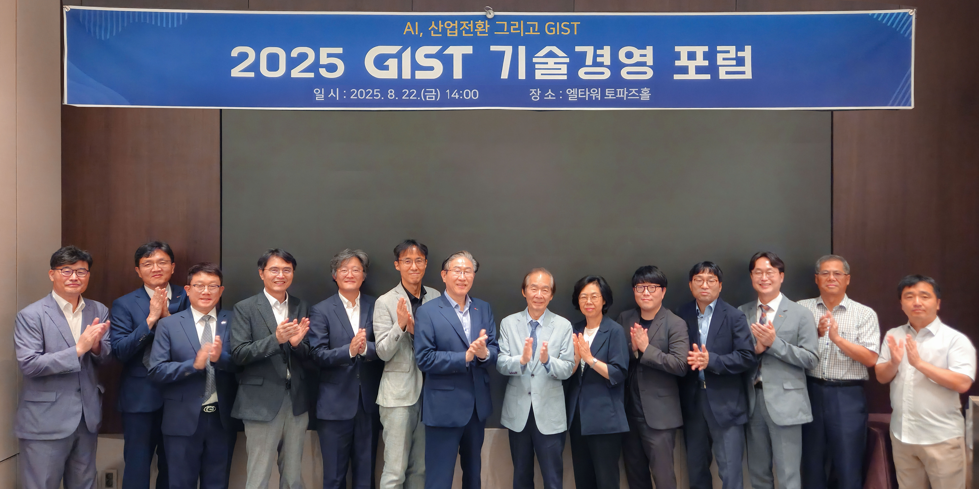

▲ Attendees pose for a commemorative photo at the "GIST Technology Management Forum (Topic: AI, Industrial Transformation, and the Role of GIST)" held at the Topaz Hall in the L Tower in Seoul at 2:00 PM on Friday, the 22nd.

The Gwangju Institute of Science and Technology (GIST, President Kichul Lim) announced that it held a Technology Management Forum on the topic of "AI, Industrial Transformation, and GIST's Role" at the Topaz Hall in the L Tower in Seoul at 2:00 PM on Friday, the 22nd.

The forum was designed to discuss the importance of industrial transformation and technology management in the era of artificial intelligence (AI) and to bring together industry, academia, and policy experts to explore future response strategies.

President Kichul Lim chaired the forum, and presentations were given by Jae-won Kwak, Distinguished Professor at the GIST AI Policy and Strategy Graduate School (editorial chair for Ajou Economy), Senior Research Fellow Min-hyung Lee of the Science and Technology Policy Institute (STEPI), and Professor Tae-kyun Kim of the Department of Business Administration at Chungnam National University.

Next, Young-seop Kim, CEO of Web Economy; Professor Jinho Kim of the GIST Department of Electrical Engineering and Computer Science; and Young-sang Cho, Professor of Industrial Engineering at Yonsei University, participated as panelists.

The event featured a wide range of discussions, including ▴ AI-based industrial restructuring and securing technological sovereignty; ▴ corporate strategies in the era of physical AI; and ▴ designing sustainable regional ecosystems. The panel also discussed the role of technology management in supporting industrial transformation and regional innovation in the AI ​​era.

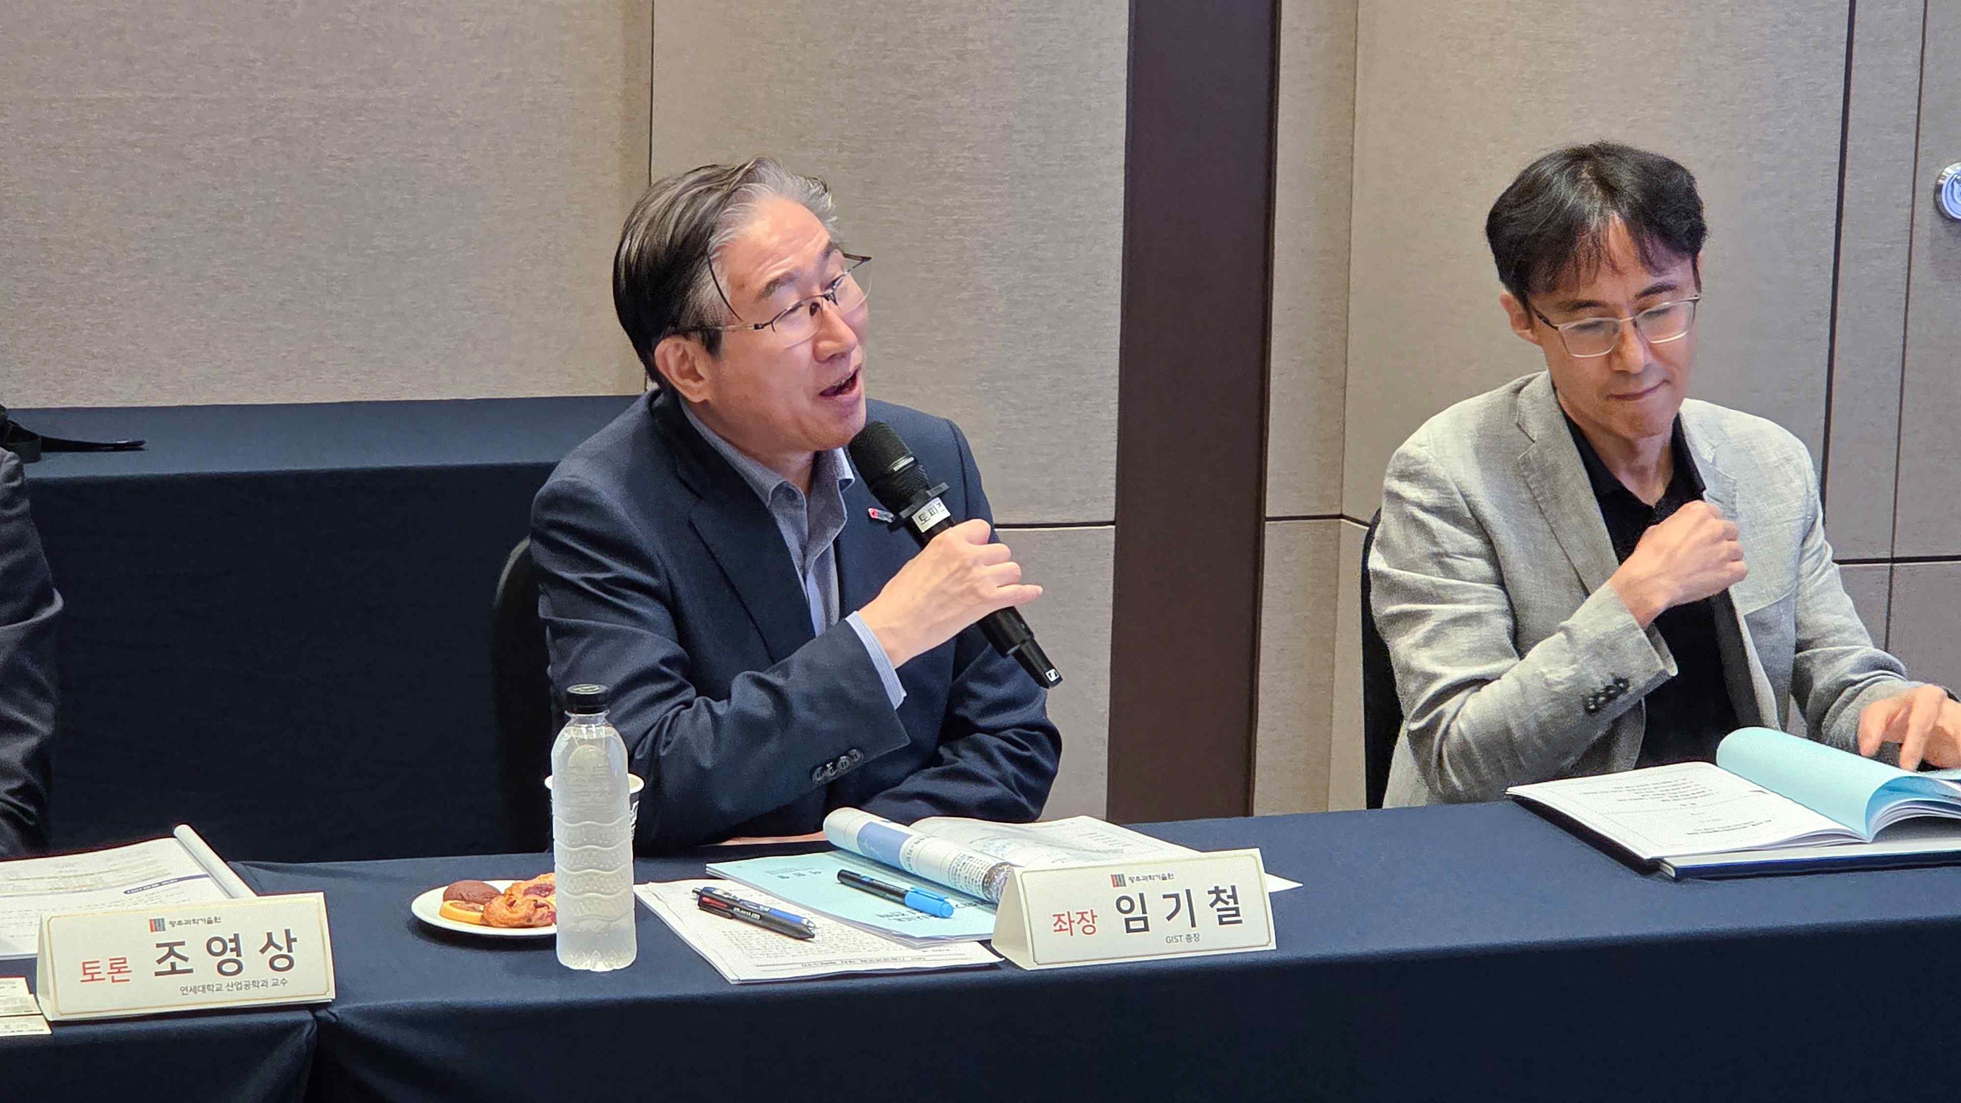

▲ President Kichul Lim moderates the "GIST Technology Management Forum."

STEPI Senior Research Fellow Min-hyung Lee emphasized, "We can respond to the era of technological hegemony only by reorganizing existing industries based on AI and securing technological sovereignty within the technology ecosystem." Professor Tae-gyun Kim of Chungnam National University stated, "In the era of physical AI, strengthening AI capabilities that can join the humanoid robot platform ecosystem is a key corporate strategy."

Furthermore, Aju Business Daily's Editorial Committee Chair Jae-won Kwak defined the forum as, "A holistic approach is needed to design the sustainability of regional ecosystems, and technology management is an integral tool to achieve this."

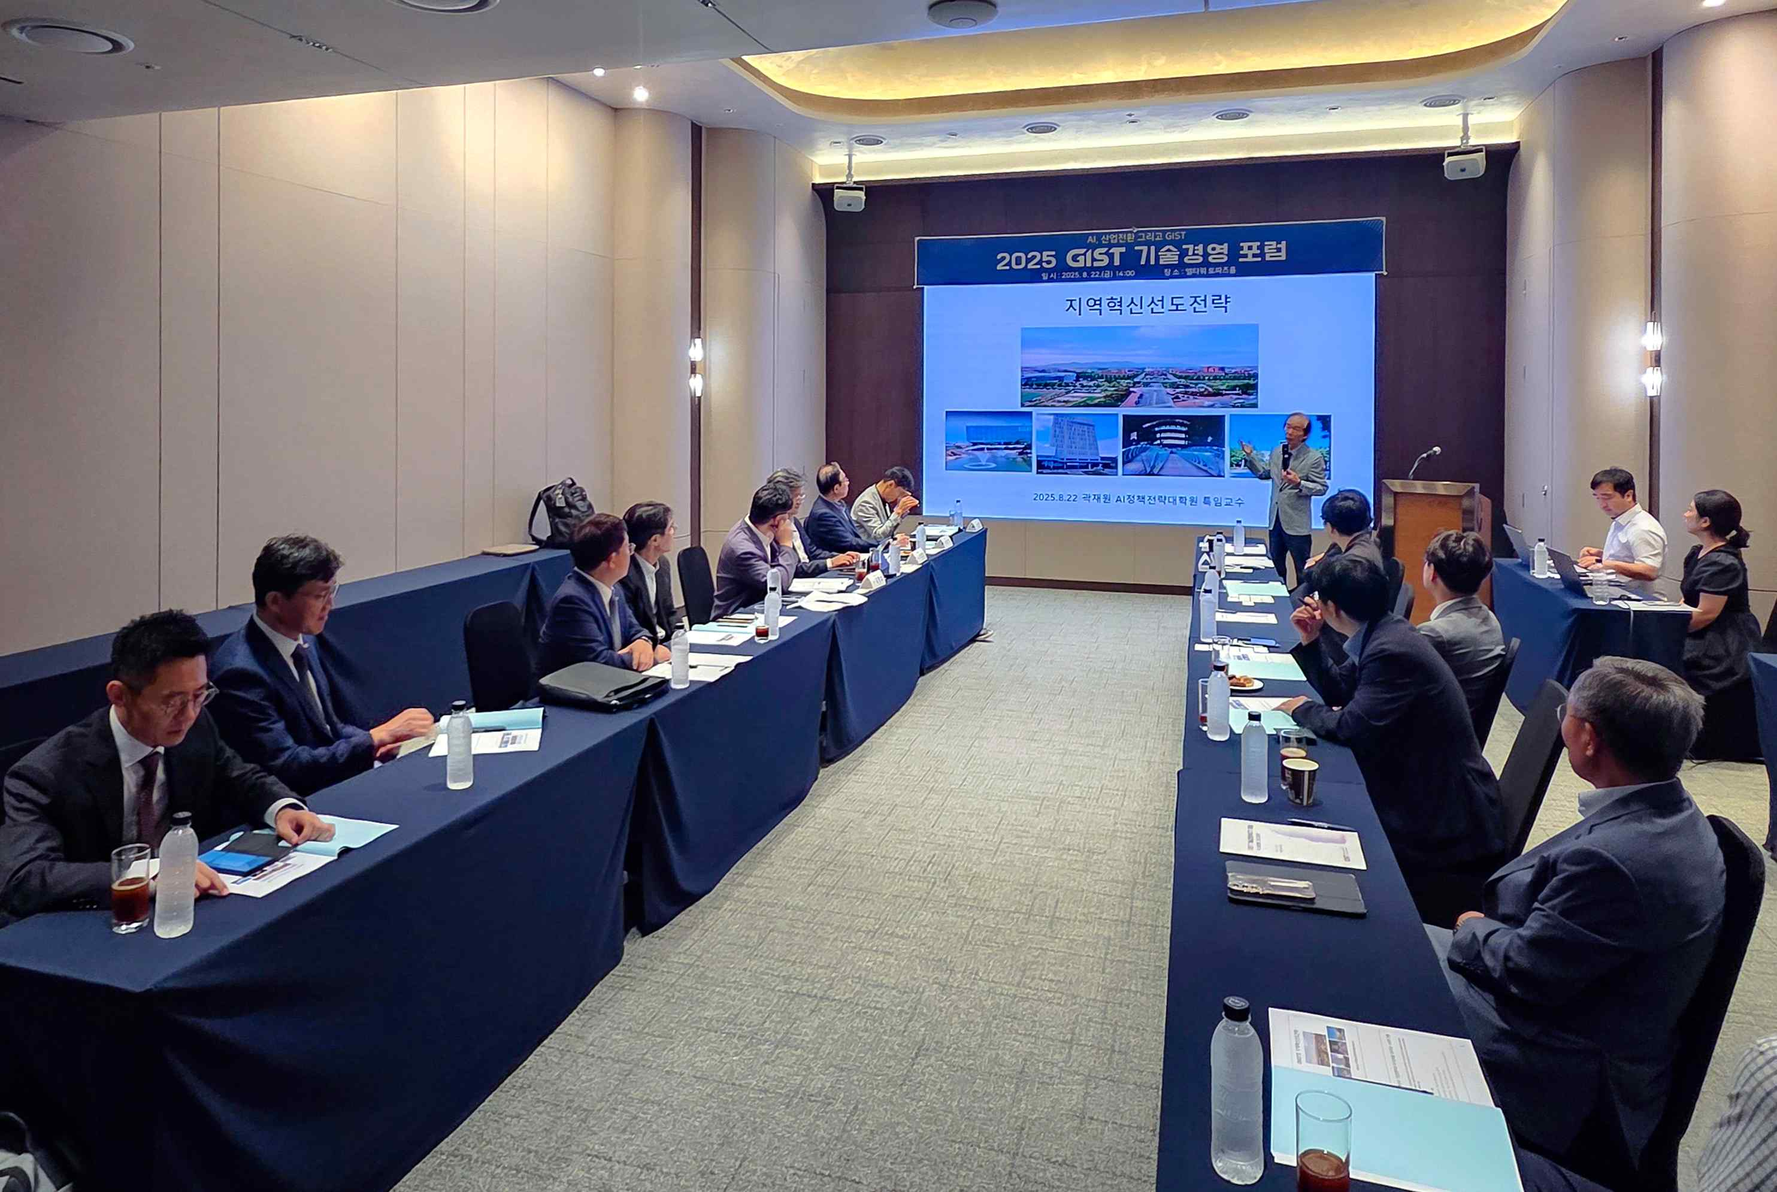

▲ Jae-won Kwak, a Distinguished Professor at the GIST AI Policy and Strategy Graduate School (and Aju Business Daily's Editorial Committee Chair), presents a presentation on regional innovation leadership strategies at the "GIST Technology Management Forum."

President Kichul Lim emphasized, "AI is not simply a technology; it is a core competency driving industrial transformation and securing technological sovereignty. Technology management is a strategic tool that connects these competencies to the regional economy and the global future."

He continued, "GIST, with its AI education and research foundation and platform for disseminating research results through startups and technology commercialization, is expected to revitalize the Gwangju-Jeonnam high-tech industry ecosystem, accelerate regional innovation, and cultivate global leaders capable of competing on the global stage." He added, "We plan to establish a convergence technology management education model through industry-academia-research collaboration to play a central role in sustainable innovation."



