GIST Department of Environment and Energy Engineering begins full-scale training of 'AI Circular Economy' talents: Special lectures and career counseling sessions with 13 public and research institutions, and the department alumni association with 100 graduates also ‘lively’

- On July 4 (Friday), a career-related event was held with the Korea Research Institute of Chemical Technology to commemorate the establishment of the ‘AI Circular Economy Clustering Interdisciplinary Major’... The Department of Environment and Energy Engineering Alumni Association was also held, creating a platform for exchange between generations

- Dean Youngjune Park said, “Expecting sustainable development through education tailored to industrial demand and industry-academia-research cooperation”

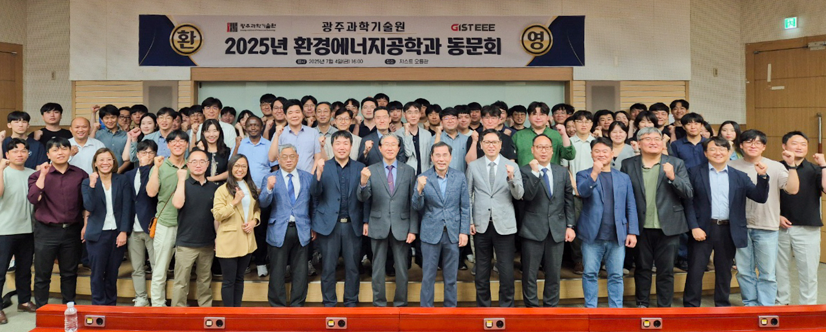

▲ On July 4 (Friday), the GIST Department of Environmental and Energy Engineering held an alumni meeting, and attendees took a commemorative photo.

The Gwangju Institute of Science and Technology (GIST, President Kichul Lim) announced that on July 4 (Friday) at Oryong Hall, it held a special lecture and job fair for companies to commemorate the launch of the ‘AI Circular Economy Clustering Interdisciplinary Major’ and to foster talent based on industry-academic cooperation.

This event was designed to introduce the purpose of the newly established interdisciplinary major that combines AI technology and the concept of circular economy in the Department of Environment and Energy Engineering, build a cooperative network with related industry-academic-research organizations, and help students explore their career paths and strengthen their employment capabilities.

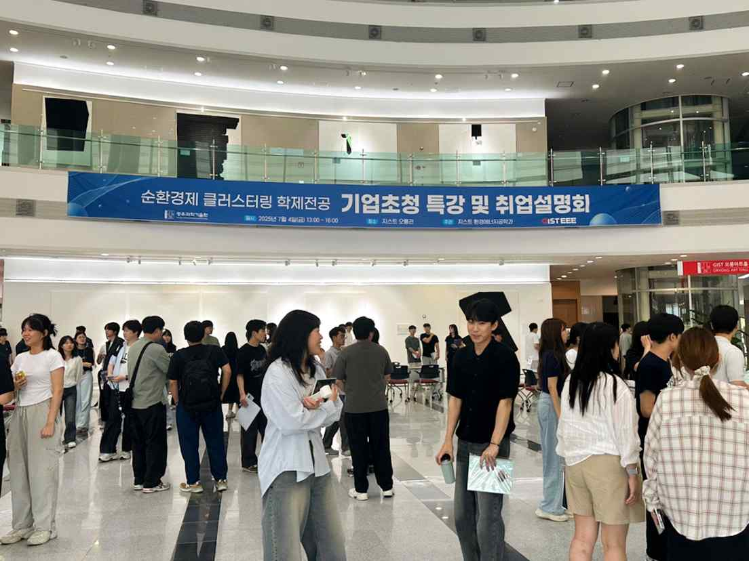

▲ On July 4 (Friday), the Department of Environment and Energy Engineering at GIST held a special lecture and job fair for companies to commemorate the launch of the ‘AI Circular Economy Clustering Interdisciplinary Major’ at Oryong Hall to foster talent based on industry-academic cooperation.

13 major public institutions and research institutes in the environment and energy field, including the Korea Research Institute of Chemical Technology, the Korea Electrotechnology Research Institute, the Environmental Industry & Technology Institute, the National Institute of Environmental Research, the Korea Water Resources Corporation, and the FITI Testing & Research Institute, participated, and about 130 GIST students attended, showing great interest.

The event began with a presentation introducing the background and operation direction of the new ‘AI Circular Economy Clustering Interdisciplinary Major.’

Next, ▴ Ho-sik Park, Director of the Research Strategy Division at the Korea Research Institute of Chemical Technology, gave a special lecture on ‘R&D Promotion Direction,’ and ▴ Moon Son, Senior Researcher at the Korea Institute of Science and Technology (KIST), gave a special lecture on ‘Development of Resource Recovery Technology Using AI and Battery Technology,’ sharing major technology trends and prospects for future industries.

After the special lecture, employment booths were operated by each institution, providing students with the opportunity to receive practical employment information and job counseling.

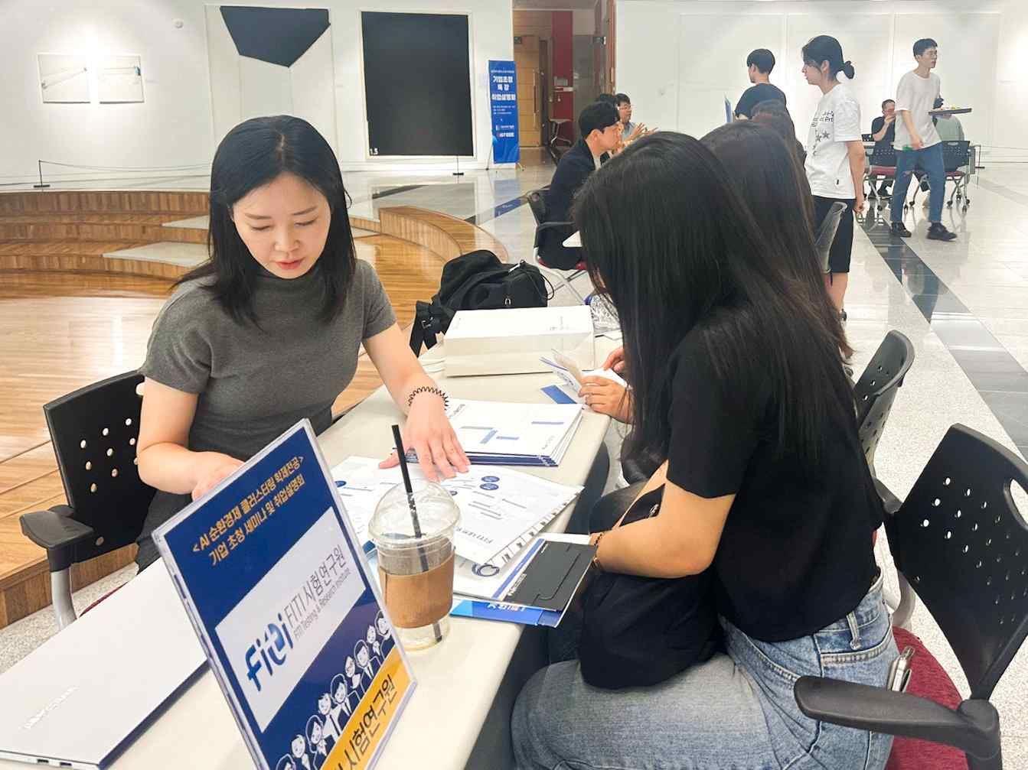

▲ Students who visited the employment booths of each institution are receiving practical employment information and job counseling.

Meanwhile, about 100 graduates visited their alma mater and interacted with current students at the Environmental and Energy Engineering Alumni Association held on the same day.

The alumni association became a place for active communication such as career mentoring for current students, employment advice, and discussions on research cooperation, and it was a meaningful time to strengthen the bond between members and exchange various opinions for the development of the school and department.

Dean Youngjune Park of the Department of Environment and Energy Engineering, said, “The AI Circular Economy Clustering Interdisciplinary Major will continue to develop through customized curriculum and industry-academia-research cooperation that meets industrial demand,” and added, “This event was a very meaningful place as a starting point.”



