GIST's 'EVOM AI Piano' attracts global AI leaders at US Newsweek AI Summit: Korea's first AI composition and performance system, successful debut on world stage

- Cutting-edge art technology that uses AI to compose and play music on the spot by understanding emotions through real-time conversations... Exhibited alongside global companies such as Google Cloud, well-received by leading overseas companies and experts

- Recognition of innovative technology based on specialized large-scale language models... Attention paid to expansion potential into various fields such as healthcare and mobility “I feel that innovative technology that adds emotional value is receiving global attention”

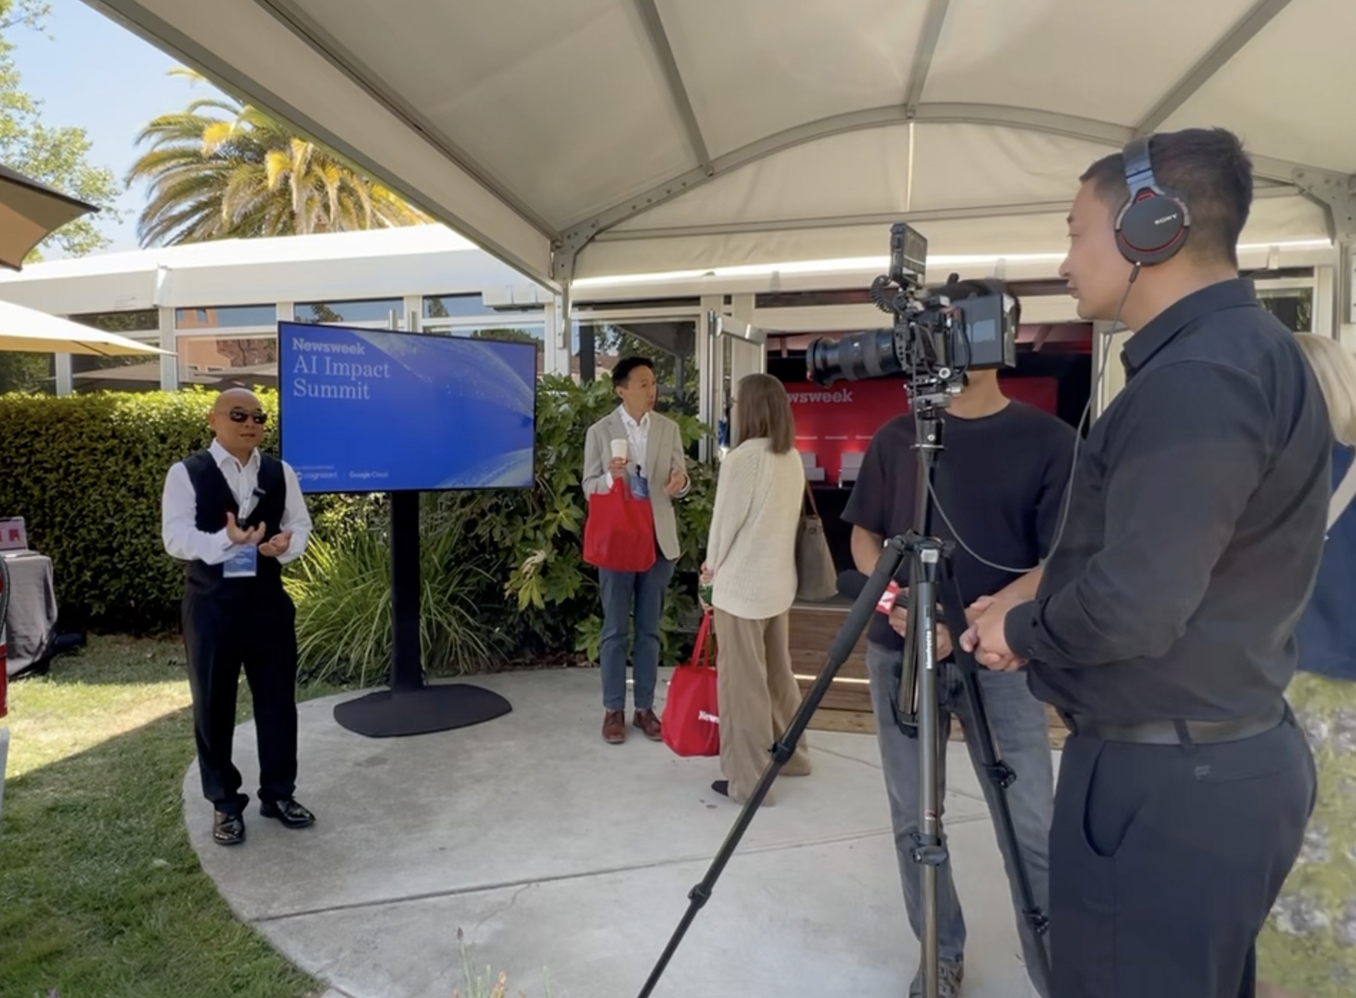

▲ GIST Institute for Al Director Chang Wook Ahn is being interviewed by local media at the ‘Newsweek AI Impact Summit’, a global AI event held in Sonoma County, California, USA from June 24 to 25.

The Gwangju Institute of Science and Technology (GIST, President Kichul Lim) Institute for Al (Director Chang Wook Ahn) announced that it was specially invited to the international AI event ‘Newsweek AI Impact Summit’ held in Sonoma County, California, USA from June 24 to 25 and successfully exhibited and demonstrated the ‘EVOM AI Piano’, Korea’s first AI composition and performance system.

‘Newsweek AI Impact Summit’ is a global AI conference hosted by the American current affairs weekly Newsweek, and is held annually in major cities in North America and Asia. Global AI and IT companies such as Google, Microsoft, Zoom, and Nvidia, as well as leaders from various fields such as healthcare, energy, marketing, policy, and climate, gather to share the present and future of AI technology.

The ‘EVOM AI Piano’ recently introduced by the GIST Artificial Intelligence Research Center is a cutting-edge artistic AI system equipped with ‘EVOM’, Korea’s first AI composer developed by Professor Ahn Chang-wook.

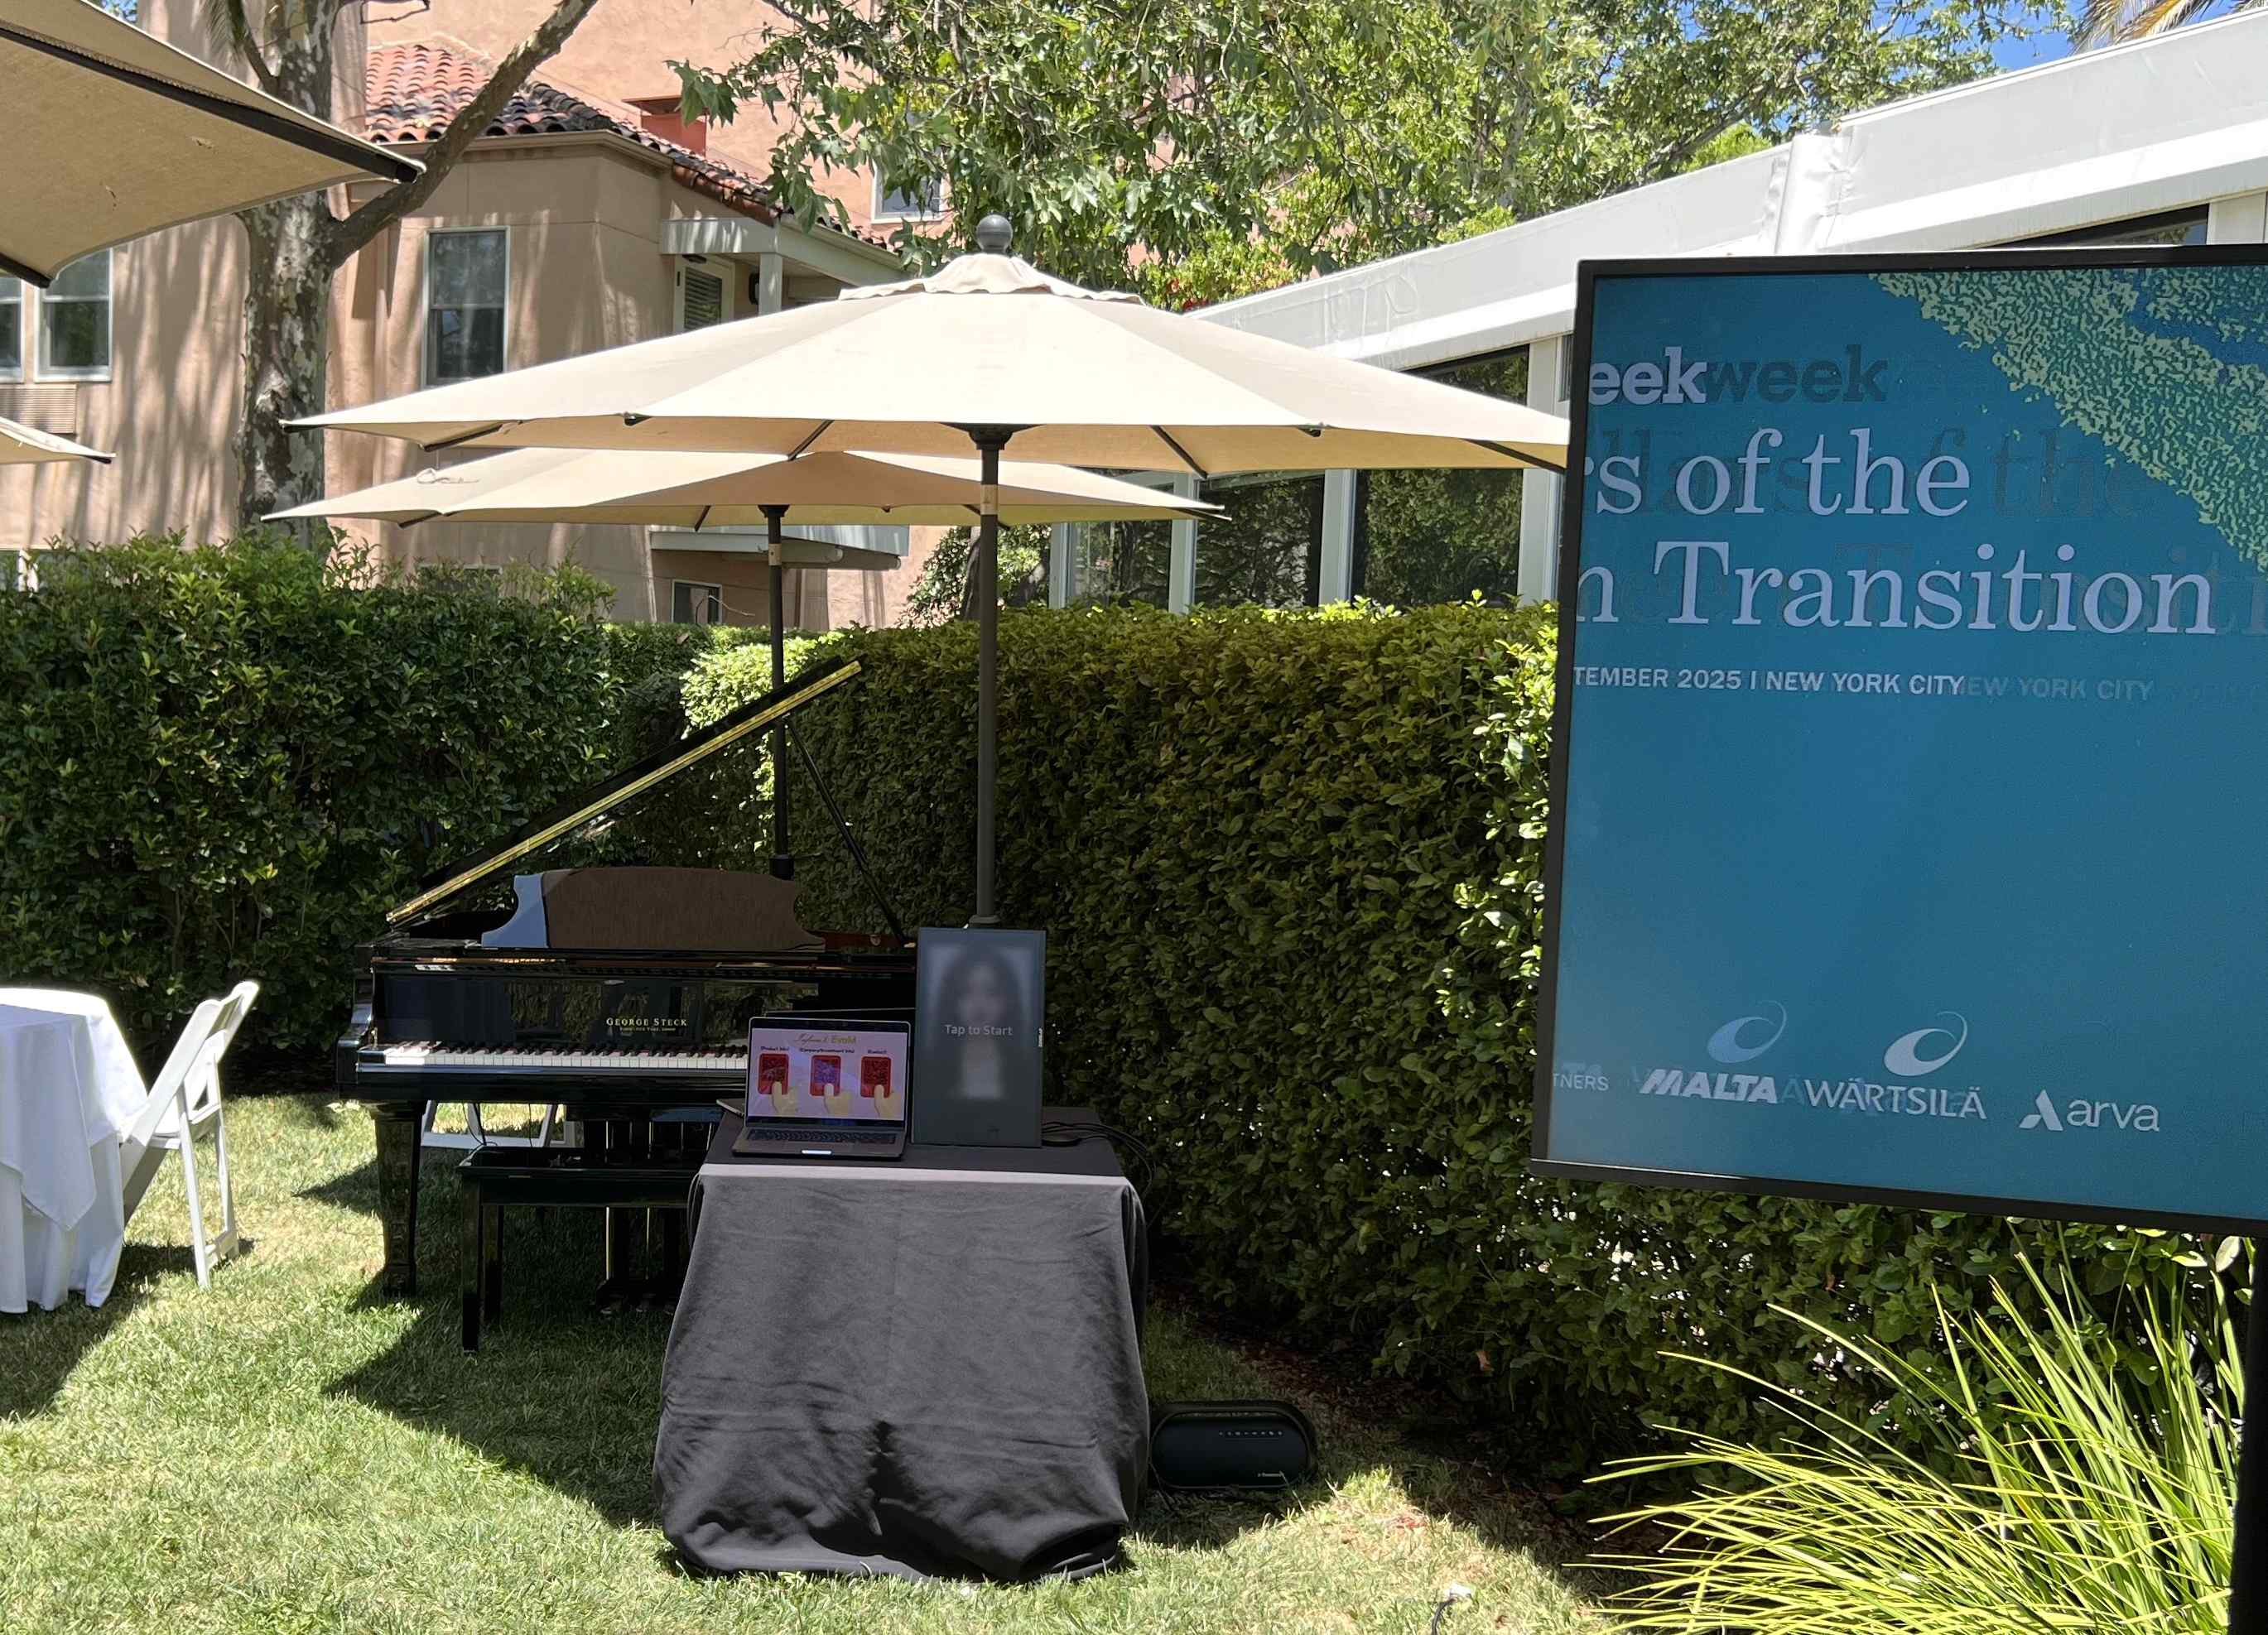

▲ The ‘EVOM AI Piano’ developed by the GIST Institute for Al was specially invited and exhibited at the ‘Newsweek AI Impact Summit’, a global AI event held in Sonoma County, California, USA from June 24 to 25.

It has the function of understanding the user’s emotions and situations through everyday conversations, and analyzing musical elements such as genre, tempo, and tonality in real time based on this to compose and play on the spot.

In particular, it implemented an advanced technology structure that extracts musical creative elements from text conversations and transmits them to the AI ​​composition system in real time by applying a ‘context mapping engine’ based on a specialized large language model (sLLM).

‘EVOM AI Piano’ was exhibited along with Google Cloud’s next-generation AI image generator ‘Veo’ and global IT consulting firm Cognizant’s ‘NeuroAI’, and received great attention from leading global companies including Google and leaders in the medical, policy, and climate fields.

During the event, the ‘Ibom AI Piano’ received a great response by not only performing background music (BGM) between the main sessions, but also presenting impromptu compositions and emotional performances through real-time conversations with the audience.

Dr. Victor Raúl Castillo Mantilla, President and CEO of the Colombia International Hospital and Cardiovascular Foundation (FCV), expressed deep interest and anticipation for the possibility of actual introduction, saying, “If the grand piano in the hospital lobby is replaced with the ‘EVOM AI Piano,’ it will become an art space that helps patients achieve emotional stability and recovery.”

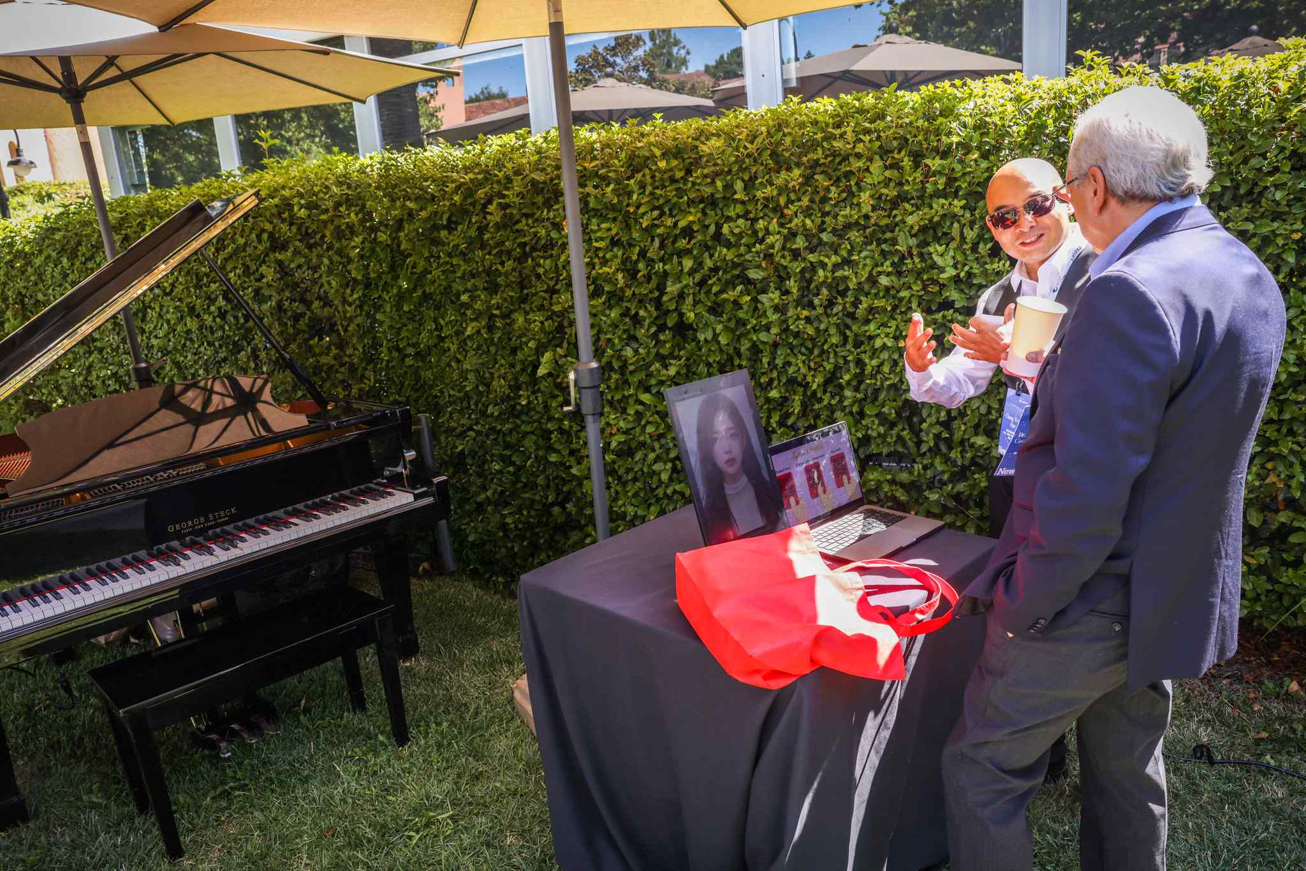

▲ Dr. Victor Raúl Castillo Mantilla, President and CEO of the Colombian International Hospital and Cardiovascular Foundation (FCV), is experiencing the ‘Ebom AI Piano’ developed by the GIST Institute for Al at the ‘Newsweek AI Impact Summit’, a global AI event held in Sonoma County, California, USA from June 24 to 25.

Mansoor Basha, CTO of Stagwell Marketing Cloud, which is leading the strategy to integrate Google Cloud’s AI technology into the marketing platform, said after experiencing it firsthand, “My child really likes playing the piano, and I really want to let him experience the ‘EVOM AI Piano’,” and “The technology’s everyday friendliness and user experience were impressive.”

Roman Vasilev, head of new business development at Toyota Boshoku Innovation Center, noted the potential of the technology, saying, “We are meaningfully inspired by services that incorporate entertainment elements in the future autonomous vehicle industry.”

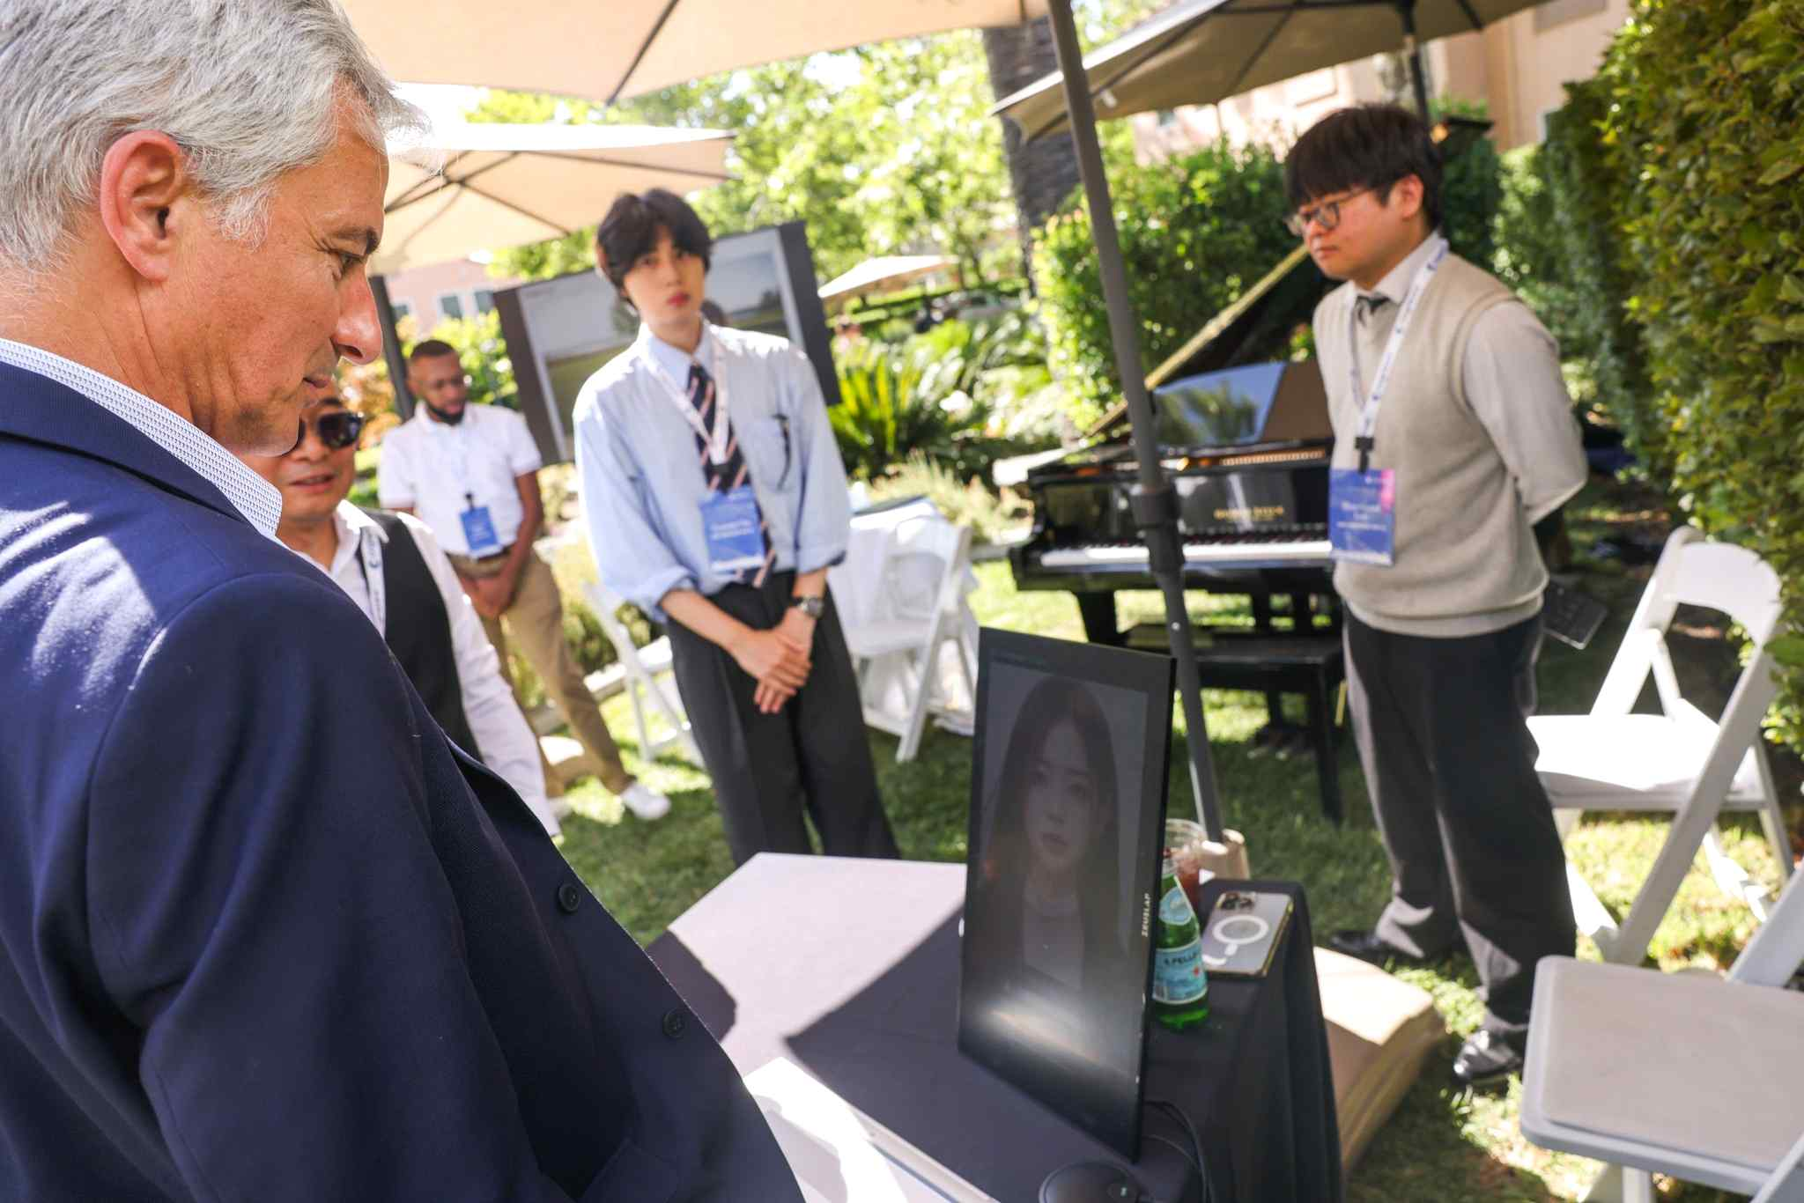

▲ Roman Vasilev, head of new business development at Toyota Boshoku Innovation Center, is experiencing the ‘EVOM AI Piano’ developed by the GIST Institute for Al at the ‘Newsweek AI Impact Summit,’ a global AI event held in Sonoma County, California, USA from June 24 to 25.

GIST Institute for Al Director Chang Wook Ahn said, “This exhibition was a valuable opportunity to inform the world’s leading C-level leaders of the potential of GIST’s independently developed AI composition technology,” and “I realized that the ‘EVOM AI Piano’ is receiving attention as an innovative technology that adds emotional value to various fields such as medical fields, homes, and future mobility industries beyond simple artistic expression.”

He continued, “I participated this year as a special invitation, but next year, I will aim to receive the ‘AI Impact Award’ and work to have our technology officially recognized worldwide.”



