"Gwangju leaps forward as a center city for the electric vehicle industry" GIST holds 'BATTERY X GWANGJU' forum

- The first day of the opening of the ‘2025 Gwangju Future Industry Expo’, held on the 25th (Wednesday), will provide an overview of the current status of the future battery industry in Gwangju Metropolitan City and its development strategy... Around 100 people from industry, policy organizations, and academia will attend

- GIST, Gwangju Metropolitan City, Gwangju Free Economic Zone Authority, and Korea Electric Power Corporation will discuss strategies to respond to the era of transition to electric vehicles... Strengthening the foundation for regional cooperation encompassing technology, industry, and policy

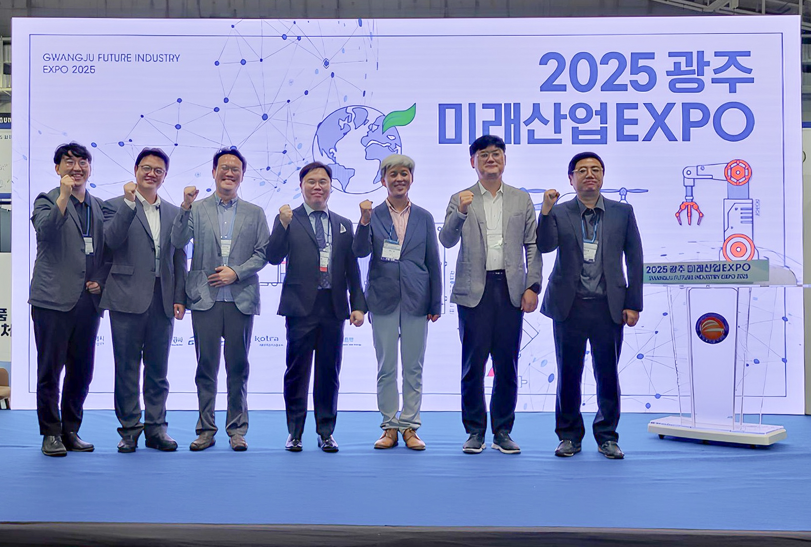

▲ On Wednesday, June 25, the forum ‘BATTERY X GWANGJU: At the Center of the Electric Vehicle Transition’ was held at the Kim Dae-jung Convention Center FUTURE LAB, and key speakers and related parties took a commemorative photo.

A forum was held to look into the future battery industry status and development strategy of Gwangju Metropolitan City.

The Gwangju Institute of Science and Technology (GIST, President Kichul Lim) announced that it successfully held a forum on the theme of ‘BATTERY X GWANGJU: At the Center of the Transition to Electric Vehicles’ at the FUTURE LAB (special stage) of the Kim Dae-jung Convention Center on Wednesday, June 25.

This forum is expected to serve as a catalyst for laying the foundation for organic cooperation among technology, industry, policy, infrastructure, and talent, and substantially strengthening the Gwangju electric vehicle and energy industry ecosystem.

This event was held on the first day of the opening of the ‘2025 Gwangju Future Industry Expo’ and was co-hosted by Gwangju Metropolitan City, Gwangju Free Economic Zone Authority, Korea Electric Power Corporation, and GIST, and co-hosted by GIST Energy Valley Technology Institute, GIST Next Generation Energy Research Institute, Gwangju Technopark, Korea Institute of Energy Research, and Korea Automobile Research Institute.

The forum was attended by approximately 100 people from the energy and automobile industries, policy organizations, and academia.

The Gwangju Free Economic Zone Authority introduced the investment environment centered on the smart energy industrial complex and announced the possibility of linking with the battery industry and support strategies.

Gwangju Techno Park shared the battery industry infrastructure and corporate support policies in the region and explained its efforts to create a full-cycle ecosystem from technology development to growth support and commercialization.

In the expert lecture session, presentations were given on topics such as ▴ ‘Gwangju, a leading city in K-battery modules and systems’ (Jung-je Woo, Director of the Gwangju Eco-friendly Energy Research Center, Korea Institute of Energy Research) ▴ ‘Linkage between the Gwangju automobile industry and the battery industry’ (Hyeon-cheol Lee, Director of the Gwangju Regional Headquarters, Korea Automobile Research Institute) ▴ ‘Packing technology, NP technology, SOC/SOH, and abnormal diagnosis technology’ (Seong-bin Im, Director of Sebang Lithium Battery Development Headquarters) ▴ ‘Battery safety and reusable battery system evaluation method’ (Su-yeon Lee, CEO of Sispia) ▴ ‘EV battery safety standard changes and policy trends’ (Hyeong-jin Jang, Director of the Korea Transportation Safety Authority Automobile Safety Research Center).

Kwanghee Lee, Director of the GIST Energy Valley Technology Institute, said, “Gwangju is a city that has complete vehicles, battery infrastructure, and policy will,” and added, “I hope that this forum will not end in simple discussions but become a starting point that leads to practical cooperation.”

In addition, he stated, “GIST Energy Valley Technology Institute will strengthen its role as an implementation platform that organically connects technology, industry, and policy and takes the lead in solving field-centered problems.”

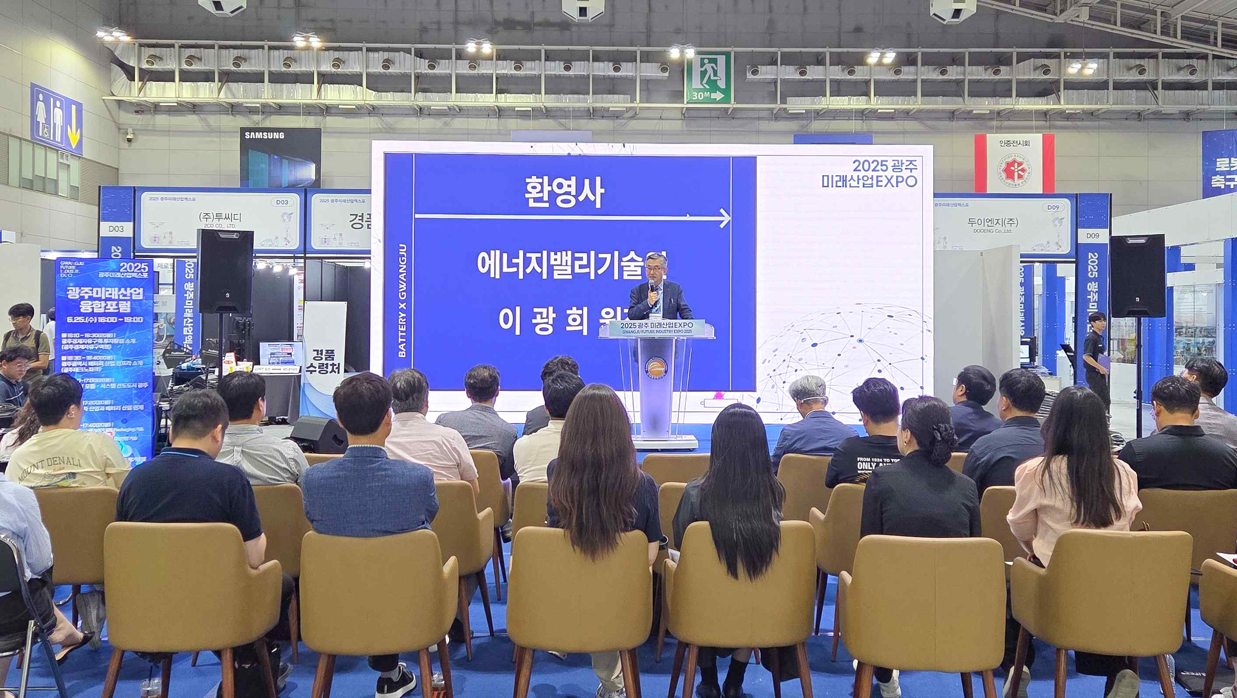

▲ GIST Energy Valley Technology Institute Director Kwanghee Lee is giving a welcoming speech at the ‘BATTERY X GWANGJU: At the Center of the Electric Vehicle Transition’ forum held at the FUTURE LAB of the Kim Dae-jung Convention Center on Wednesday, June 25.

Meanwhile, the ‘2025 Gwangju Future Industry Expo,’ the largest industrial exhibition in the Honam region held at the Kim Dae-jung Convention Center, will be held for four days from Wednesday, June 25 to Saturday, June 28, with approximately 270 domestic and foreign companies participating and operating 570 booths to showcase the latest technologies and products of future industries.



