GIST leads overseas brain turnaround with AI convergence research... Ministry of Science and ICT launches ‘InnoCORE’, the fourth major science and technology institute: Full-scale recruitment of 400 postdoctoral researchers begins... GIST leads research on early diagnosis of brain diseases

- GIST and 4 other science and technology institutes, promoting collaborative convergence research with top researchers from industry, academia, and research and postdoctoral researchers (postdocs)

- Selection of 8 research groups including AI model, bio, and energy, full-scale recruitment and attraction of 400 postdocs through overseas briefing sessions

- Guaranteeing stable treatment of approximately 90 million won per year and additional support through matching with companies and research projects

- Preventing overseas outflow of doctoral-level talent and attracting global talent by expanding the domestic postdoc research ecosystem

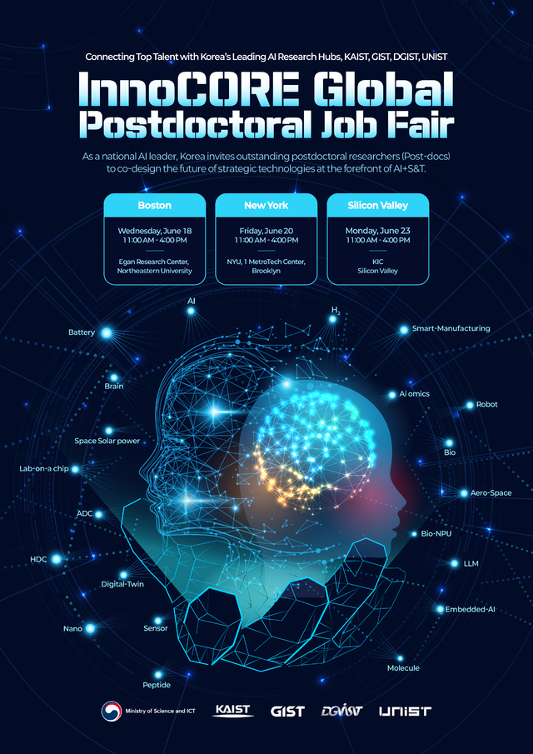

▲ Poster for InnoCORE Research Group Postdoc Recruitment Overseas Briefing Session

The Gwangju Institute of Science and Technology (GIST, President Kichul Lim) and the Ministry of Science and ICT (Minister Sang-im Yoo, hereinafter referred to as the ‘MSIT’) have selected eight ‘InnoCORE* research groups’ to lead advanced strategic research in the AI ​​convergence field (AI+S&T*) in cooperation with three science and technology institutes*, and are starting full-scale recruitment of 400 top-level postdoctoral researchers at home and abroad.

* KAIST (Korea Advanced Institute of Science and Technology), DGIST (Daegu Gyeongbuk Institute of Science and Technology), UNIST (Ulsan National Institute of Science and Technology)

* S&T: Science&Technology

* InnoCORE: Meaning of fostering core (CORE) research personnel to lead innovation in the AI ​​convergence field

Recently, as competition to attract advanced AI and science and technology talents has intensified worldwide, including in Europe and China, a strategic response is urgently needed in Korea as well.

The Ministry of Science and ICT and the Korea Advanced Institute of Science and Technology plan to focus on preventing brain drain and re-attracting domestic doctoral-level talents through this recruitment of postdoctoral researchers, as well as attracting excellent new talents from overseas.

In particular, this project will actively utilize the growing trend of international exchange and movement of scientists to focus on attracting postdoctoral researchers, who are excellent new researchers who can more easily move between countries.

◇ InnoCORE business overview and background

The InnoCORE Project is a four-major science and technology research institute grant project that supports collaborative convergence research with excellent domestic industry-academia-research institutes centered on AI+S&T.

However, the more important purpose of this project is to actively support the growth of excellent young researchers who will create the best research results and their advancement into the domestic industry-academia-research ecosystem through group convergence research centered on postdoctoral researchers who recruit 400 of the best postdoctoral researchers at home and abroad.

Furthermore, in line with the R&D paradigm shift where AI utilization in the science and technology field is in full swing*, the focus is on fostering advanced talents in the AI ​​convergence field.

* Demis Hassabis, who developed AI-based protein structure design and prediction technology, will be awarded the 2024 Nobel Prize in Chemistry

In particular, considering the urgency of not falling behind in the global competition to secure science and technology talents centered around AI, it was reflected in the 2025 supplementary budget, and 300 billion won will be invested over 5 years, starting with 30 billion won (6 months) in 2025.

As seen in the recent case of DeepSeek*, although postdoctoral researchers are young researchers with high potential to create results and become key players in the advanced technology research ecosystem, they have been strongly perceived as temporary workers in Korea, and support for expanding the domestic postdoc ecosystem, such as the scale of support and treatment, has been somewhat lacking.

* The average age of the core algorithm developers of China's DeepSeek is in the late 20s to early 30s, and they create research results 2-3 years after receiving their Ph.D.

Looking at specific figures, MIT, a world-leading university, employs 1.4 times more postdoctoral researchers than full-time faculty members, playing a key role in cutting-edge research, but the number of postdoctoral researchers employed at the four major science and technology research institutes is only half that of full-time faculty members.

Furthermore, the average annual salary of postdoctoral researchers at the four major science and technology research institutes is 41% of that of MIT, showing a frequent outflow of high-level science and technology talents overseas, such as domestic Ph.D. holders getting jobs as postdocs in the United States.

※ ('24. Number of full-time faculty) MIT 1,090 / 4 science and technology institutes 1,388
('24. Number of postdocs) MIT 1,534 / 4 science and technology institutes 792
('24. Average annual salary of postdocs) MIT approximately 80,000 dollars / 4 science and technology institutes approximately 48 million won

In order to create a postdoc research ecosystem that supports the domestic settlement and growth of new doctoral degree holders with excellent research capabilities into international researchers, an annual salary of 90 million won is guaranteed to postdocs selected through this project.

In addition, it plans to actively pursue additional support by matching companies participating in the research group or other research projects to attract excellent talent who were receiving higher salaries overseas.

◇ 8 InnoCORE research groups selected

Immediately after the finalization of the 2025 supplementary budget (May 2), the four science and technology institutes selected eight InnoCORE research groups in AI convergence fields, including ▴ AI model, ▴ manufacturing AI, ▴ AI bio, and ▴ AI energy, through external expert evaluation.

In this process, in addition to research innovation, the specificity of the postdoctoral researcher recruitment plan and growth support plan that fit the purpose of the project were evaluated.

Among the InnoCORE research groups, GIST will lead the ‘AI+Nano Convergence Research Group for Early Diagnosis of Brain Disease’ and will lead leading research that combines AI and nanotechnology in the future medical innovation field of early diagnosis of brain disease. The research group will be joined by excellent domestic and foreign institutions such as Chonnam National University Hospital, KIST, and Harvard to build a world-class convergence research foundation.
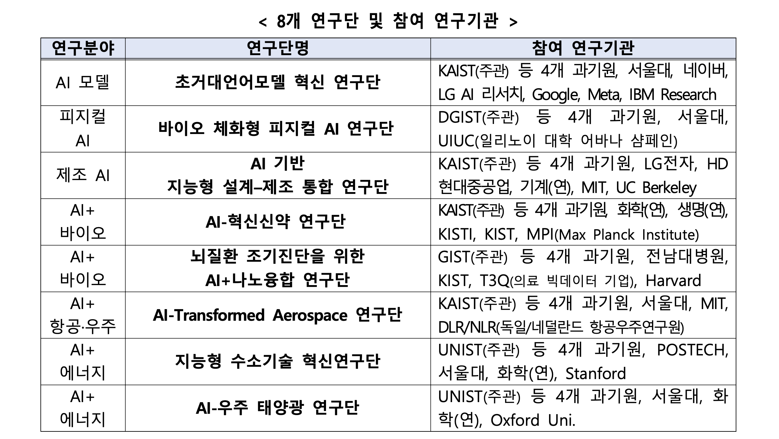

The eight InnoCORE research groups will be operated as open research groups in which not only science and technology institutes conduct convergence research, but also domestic and foreign industry, academia, and research institutes that require collaboration actively participate.

Furthermore, not only science and technology institute faculty members but also researchers from participating research institutes will participate as postdoctoral researcher mentors, and we plan to actively link them with their advancement into government-funded research institutes and companies. The eight selected research groups will finalize detailed research plans by the end of June and begin full-scale research in July.

◇ Postdoctoral researcher recruitment plan

The four science and technology institutes will begin the process of recruiting 400 postdocs in accordance with the research content of their research groups.

In particular, in order to actively promote the recruitment of excellent new talents from overseas and the re-introduction of new Korean researchers living overseas, overseas recruitment briefing sessions and promotional activities will be intensively carried out in June.

Overseas recruitment briefing sessions will be held in major global hubs where advanced talents with doctoral degrees in AI convergence fields are concentrated.

Starting with the Boston area, where many Korean students are studying abroad, where Harvard and MIT are located, on Wednesday, June 18, ▴ the New York area, where KAIST-New York University joint campus and the Global AI Frontier Lab are operated, on Friday, June 20, ▴ the Silicon Valley area, where Stanford University and AI big tech companies are located, on Monday, June 23, local briefing sessions will be held.

In addition, it plans to carry out global promotions through global academic journals such as Nature, Science, and LinkedIn, as well as promotional activities and active headhunting efforts using overseas cooperative organizations of participating research institutes, the Korean Scientists and Engineers Network (KOSEN), the Association of Overseas Korean Scientists and Engineers, and the Korean Student Association.

GIST President Kichul Lim said, “AI convergence is a key field leading innovation in all fields of science and technology, and attracting postdoctoral researchers who will lead this is a critical task that will determine national competitiveness,” and added, “Through this Innocore project, we will spare no support so that excellent domestic and foreign talents can grow based on a stable research foundation at GIST and other Korean science and technology institutes and actively contribute to the domestic research ecosystem.”

He continued, “As a hub for AI-based convergence research, GIST will play a key role in fostering future talent and research innovation by utilizing international cooperation networks.”



