Insun Choi, a representative Korean contemporary artist, holds a large-scale solo exhibition at GIST Oryong Art Hall

- Until July 25th, <Confession of Painting> exhibition, 200th issue, presents the essence of philosophical abstract painting centered on large-scale works

- From minimal abstraction to colorful color fields, works full of 'vitality' provide an overwhelming visual experience

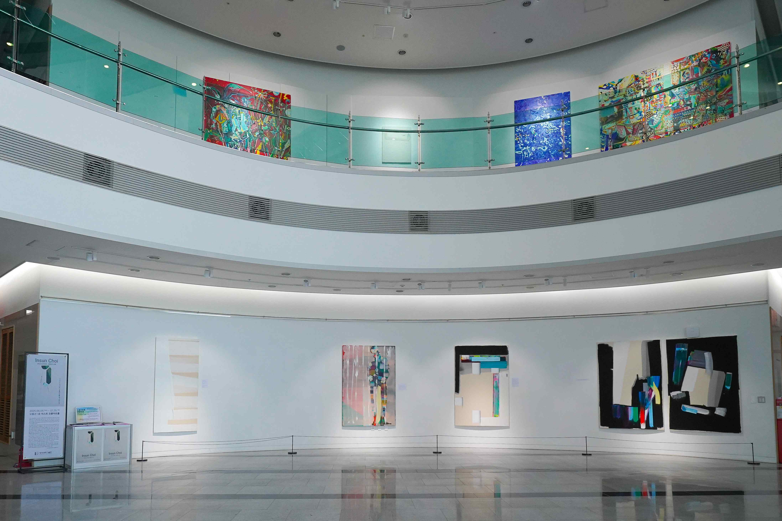

▲ 2025 Oryong Art Hall 3rd Exhibition Overview

A large-scale solo exhibition of Insun Choi (professor of painting at Hongik University), a graduate of Gwangju Inseong High School and a representative artist of Korean modern art, will be held at the Oryong Art Hall of the Gwangju Institute of Science and Technology (GIST, President Kichul Lim) from June 5 (Thursday) to July 25 (Friday).

The subtitle of this exhibition is <Confession of Painting>, and it is composed mainly of large abstract paintings the size of 200 sheets, providing an overwhelming visual experience.

In the early 1990s, Insun Choi received attention by winning the grand prize in the Republic of Korea Art Exhibition, the Joongang Art Exhibition, and the Hankook Ilbo Young Artist Invitational Exhibition.

After a brilliant debut, the artist stirred up the art world in the 1990s with his minimal abstract works. His <White Produced in Winter> is housed in the National Museum of Modern and Contemporary Art and is considered a representative work of Korean minimal art.

Since the mid-2000s, the artist's work has expanded from minimal abstraction centered on achromatic colors to the 'era of color fields', and to the <Art Museum Interior> series that shows colorful colors and aspects of modern cubism.

His work was sold at auctions at Sotheby’s in New York and Christie’s in Hong Kong, leading to international recognition. Insun Choi, who presents passionate works through colorful colors and shapes with intense strokes and freely moves between figurative and abstract, is unfolding a passionate world of creation as if testing the limits of an artist.

His world of works with a dynamic spectrum is based on ‘vitality’, and is constantly creating a new world through attempts at new things and creative acts that create differences from the past.

A total of 27 works will be exhibited in this Oryong Art Hall invitational exhibition, continuing the tradition of minimalist paintings centered on achromatic colors in the late 1990s, while the expanded possibilities of abstract paintings newly built on top of it are at the center.

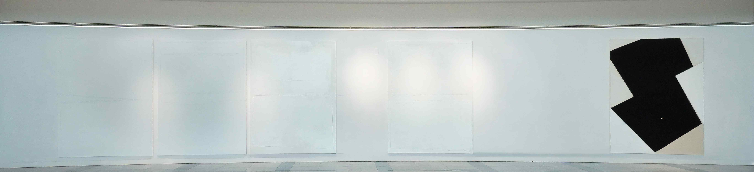

▲ Main work on the first floor of the 3rd Oryong Art Hall in 2025

Through <Confession of Painting>, the artist continues to ask the question of ‘what is painting’ that he has been obsessed with. At the same time, he is creating a time of deep reflection through painting.

He approaches the essence of painting through a process of constant interpretation, judgment, and discovery, from all things visible, such as objects, events, people, and environments, to states that are not visualized, such as the mind and thoughts. For Insun Choi, painting is ‘an act of exploring thoughts and sculpting thoughts.’

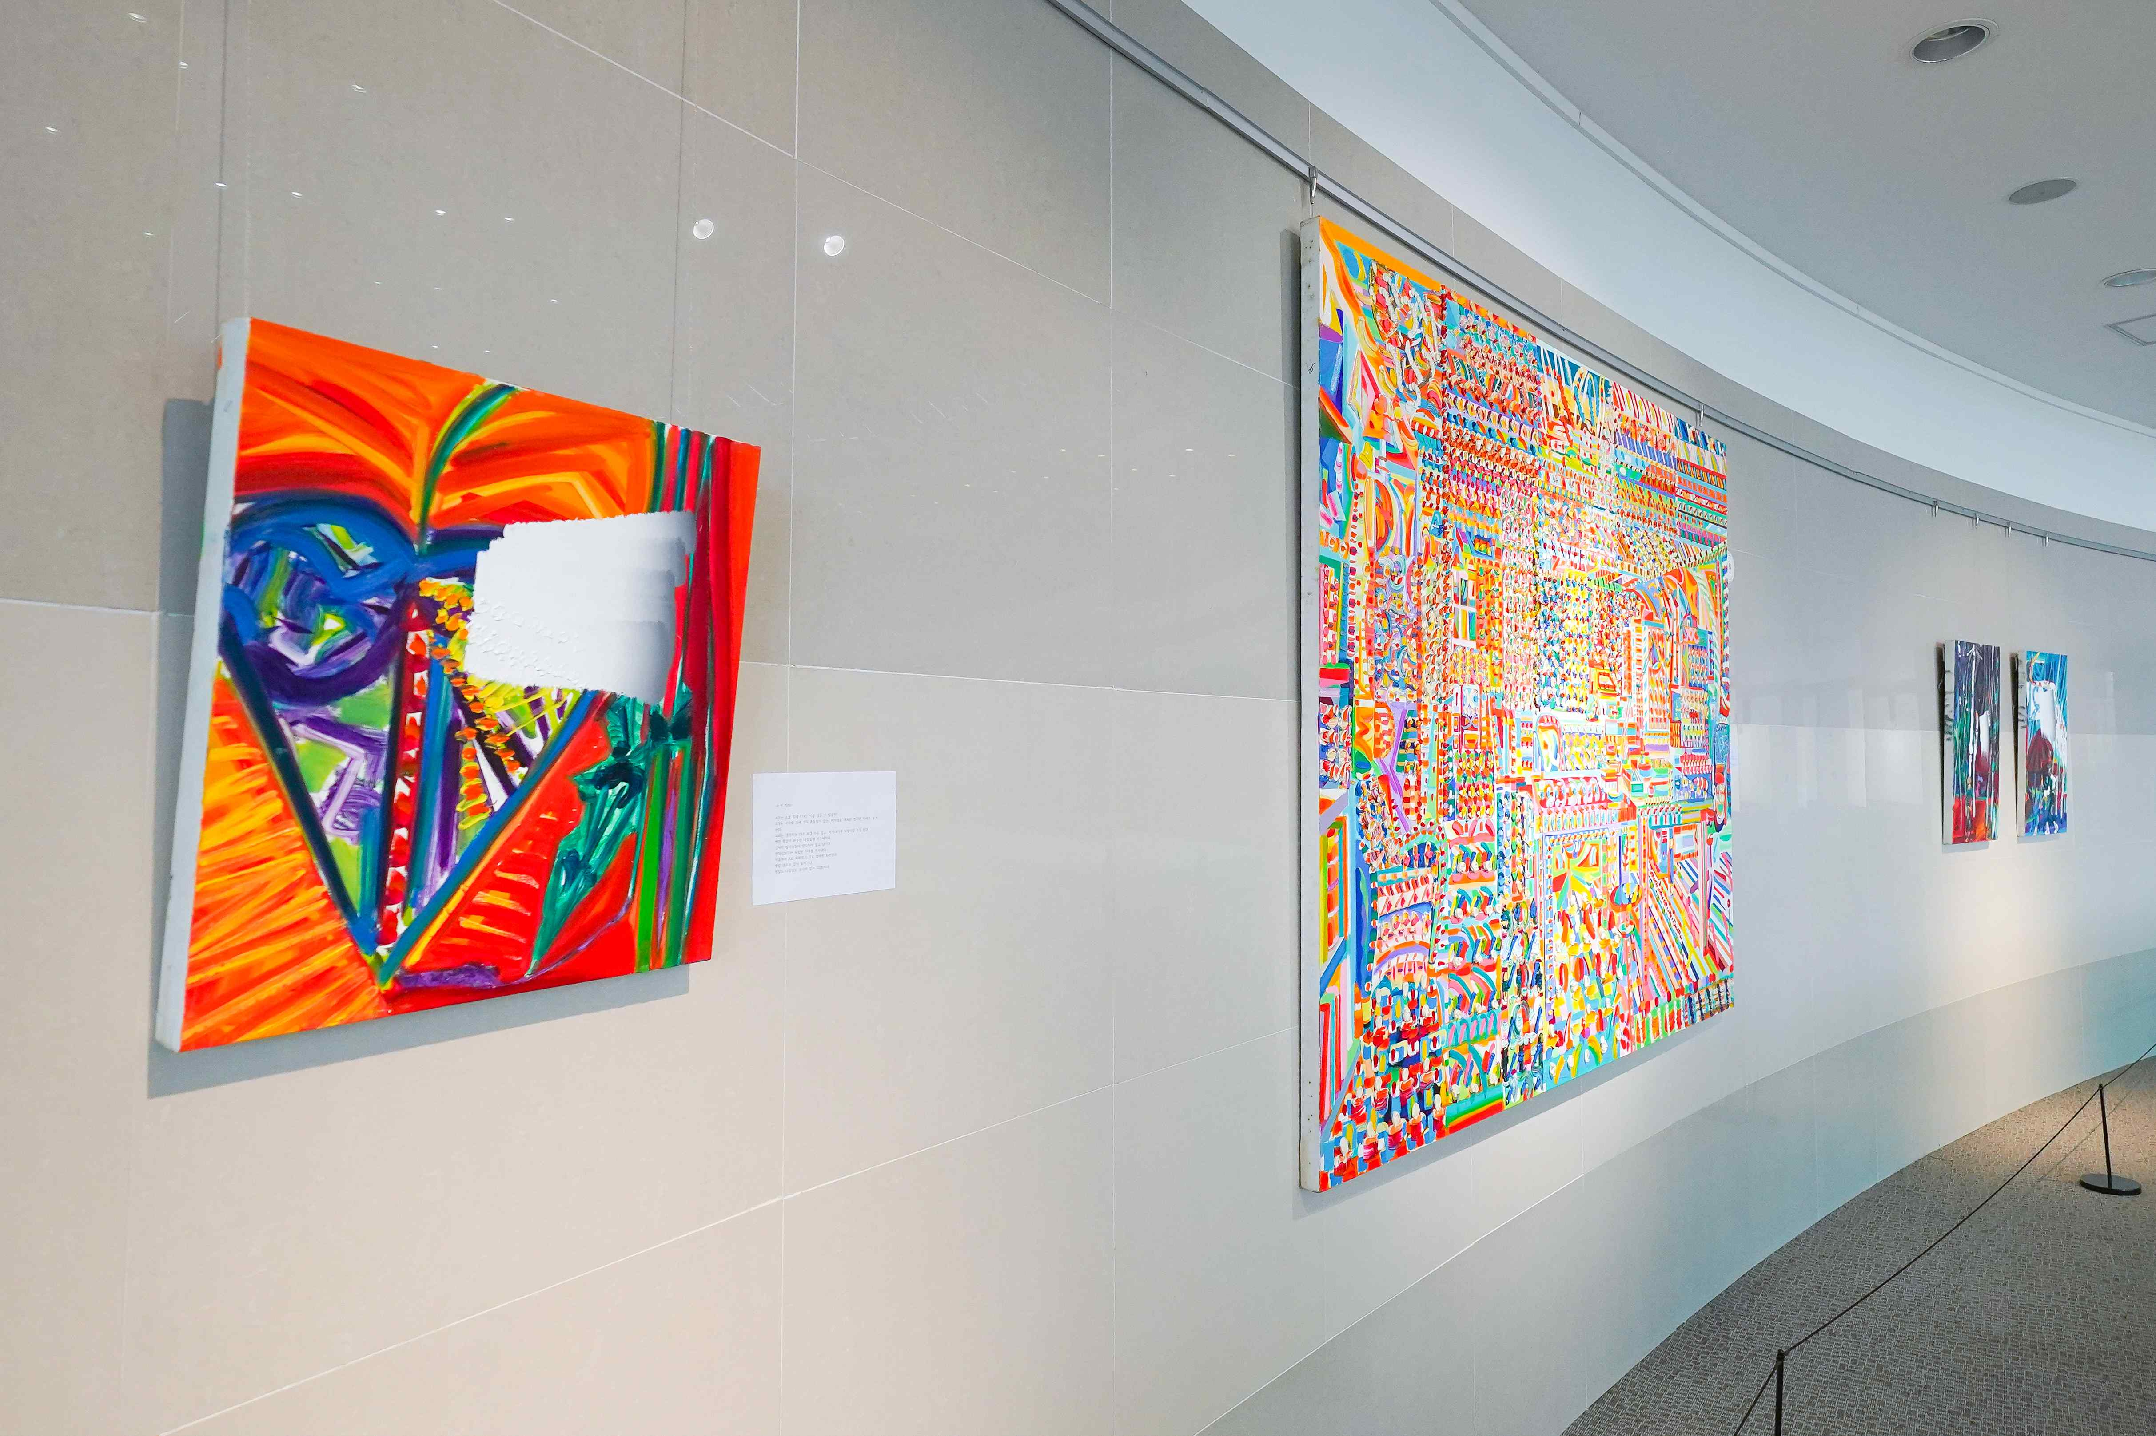

▲ 2025 Oryong Art Hall 3rd 2nd floor exhibition work

His work is the result of various mechanisms of the human mind such as thoughts, emotions, senses, and intuition condensed into a single screen.

For the artist, exploring painting means deep thinking and insight into the essence of life. In his daily life where thoughts become art and paintings become his body, artist Choi In-seon reveals the profound weight of the latent existence within us through <Confession of Painting> with a fierce spirit of artistry.

In addition to his activities as an artist, he established the Incarnation Cultural Arts Foundation in 2018, and annually selects about 7 young artists, awards them with art awards, and sponsors art scholarships and creative support funds (10 million won per person). He has been spreading good influence by contributing to the medical expenses of children and the elderly with about 1.7 billion won of his own money.

In addition, the Chuncheon Art Creation Studio is practicing social contribution through art by operating regular workshops for disabled artists.

This exhibition is open to the public from 9:00 AM to 6:00 PM on weekdays until July 25 (Friday), and a meeting with the artist is scheduled for July 4 (Friday). (For inquiries regarding weekend opening/T. 062-715-2622)

Meanwhile, Oryong Art Hall is an exhibition space created on the inner walls of the 1st and 2nd floors of Oryong Hall, a multipurpose building for events, meetings, lectures, and seminars, for GIST to communicate with the local community. Starting with the first invitation exhibition in December 2022, it has held a total of 16 exhibitions including this <Insun Choi_Confession of Painting> exhibition, practicing the value of sharing as an ‘open cultural and artistic space.’



