"Campus Brand Leads to Student Welfare" GIST souvenir sales first proceeds of 10 million won donated to 'Thousand Won Breakfast'

- GIST Development Foundation, GIST Souvenir Store ‘Genius COOP’, the first 10 million won of its profits will be returned to student welfare... Spreading a sustainable sharing campus culture

- On Friday, May 30, GIST management, foundation board members, and student representatives shared the value of sharing while having a meal together

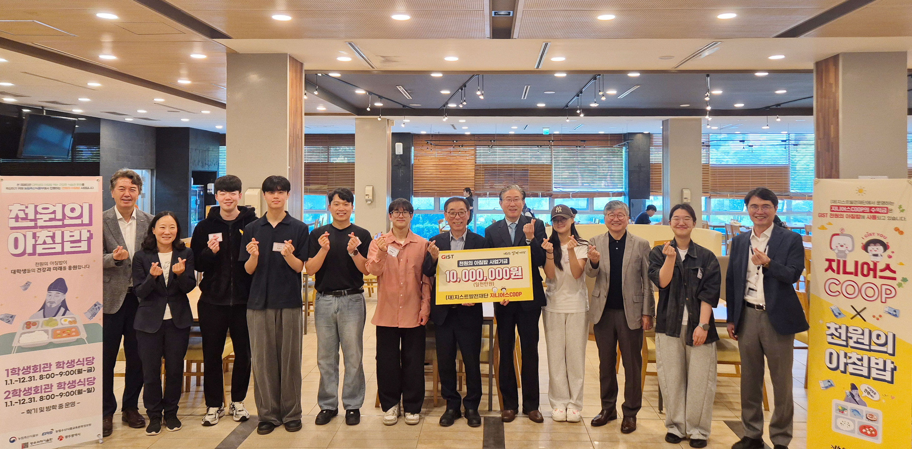

▲ On Friday, May 30, the GIST Development Foundation donated 10 million won in sales proceeds from the first sale of the pop-up store ‘Genius COOP’, which is being operated on the GIST campus, to the ‘Thousand Won Breakfast’ project and took a commemorative photo.

The Gwangju Institute of Science and Technology (GIST, President Kichul Lim) announced that the GIST Development Foundation (Chairman Hae-myeong Kim) donated 10 million won from the first sales of the pop-up store ‘Genius COOP’ operated within the GIST campus to GIST’s ‘Thousand Won Breakfast’ project.

‘Genius COOP’ is a pop-up store planned and operated by the GIST Development Foundation that reflects GIST’s symbolism and brand value, and has contributed to promoting the school brand to GIST members and visitors to the campus and spreading campus culture. This donation is significant in that it went beyond a simple profit-making project and led to practical welfare support that students can feel.

The donation ceremony was held at 8:30 a.m. in the GIST 2nd Student Center, and was attended by President Kichul Lim, key officials, the Development Foundation board of directors, and student representatives. Attendees shared a ‘thousand won breakfast’ together in the student cafeteria and sympathized with the meaning of a virtuous cycle in which sales proceeds are returned to student welfare.

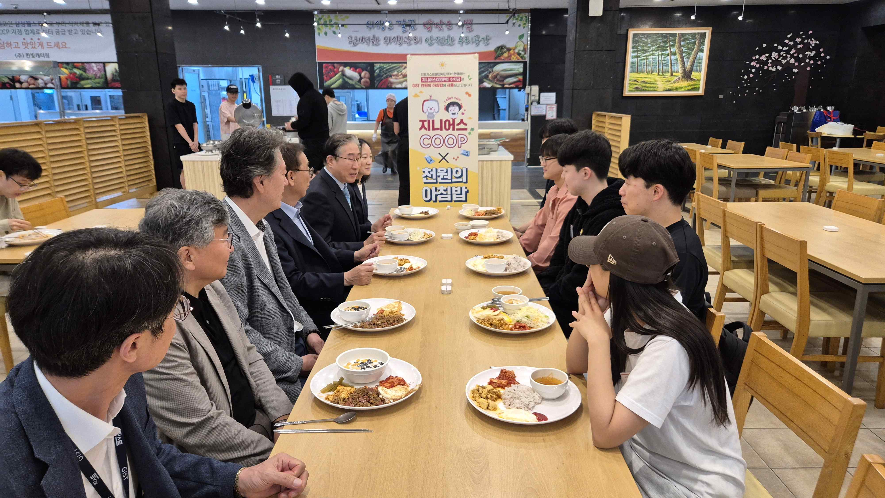

▲ On Friday, May 30th at 8:30 AM, President Lim Ki-chul, GIST key officials, GIST Development Foundation board members, and student representatives shared a 1,000 won breakfast at the GIST 2nd Student Center and shared a common ground on the donation culture.

Meanwhile, the ‘1,000 won breakfast’ project provides students with a nutritious breakfast for just 1,000 won, contributing to the formation of healthy eating habits and improved academic concentration, and is a representative student welfare program that has consistently received a great response from GIST students.

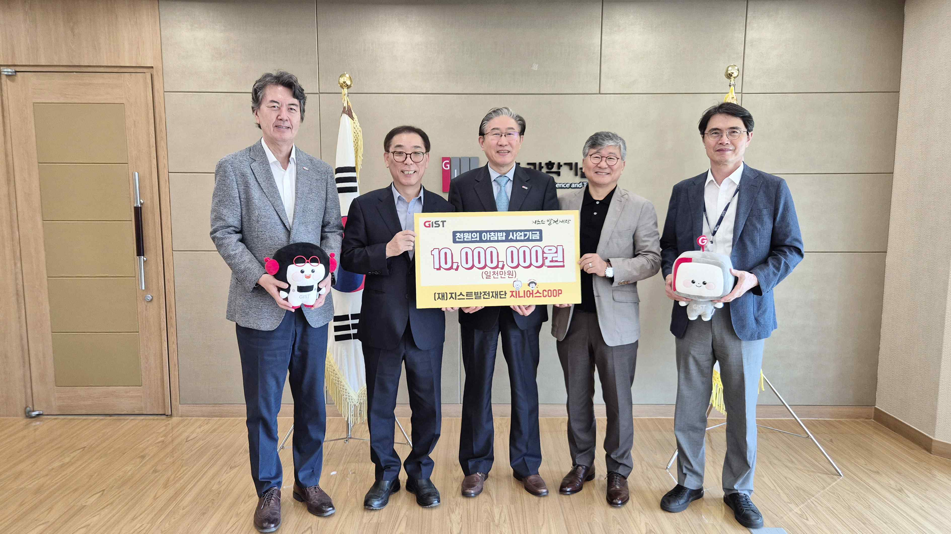

▲ On Friday, May 30th, the GIST Development Foundation donated 10 million won from the first sales of the pop-up store ‘Genius COOP’ operated on the GIST campus to the ‘1,000 won breakfast’ project and took a commemorative photo. (From left) GIST Vice President for Public Affairs Yonghwa Chung, GIST Development Foundation Director Eun-mo Choi, GIST President Kichul Lim, GIST Development Foundation Director Deok-seon Cho, GIST Vice President for R&DB Sungho Jeong

Hae-myeong Kim, chairman of the Development Foundation, said, “I am very happy that the meaningful first proceeds from Genius COOP will be used to provide breakfast for students,” and added, “We will continue to make various efforts to establish it as a sustainable sponsorship model.”

GIST President Kichul Lim said, “This sponsorship is a good example of GIST’s campus culture that goes beyond simple donations and provides real benefits to students, and is created by members together.” He added, “We will continue to expand various experiential donation programs with the Development Foundation.”

Meanwhile, the GIST Development Foundation announced that it plans to use all of the proceeds from the sales of Genius COOP for donation projects to improve the welfare of GIST students.



